Dear Friend,

You subscribed to email updates from Empower Local Refugees to Thrive by PRERNA4REFUGEES, a project on GlobalGiving. Here’s the unedited update from the field

Second Quarter Report:

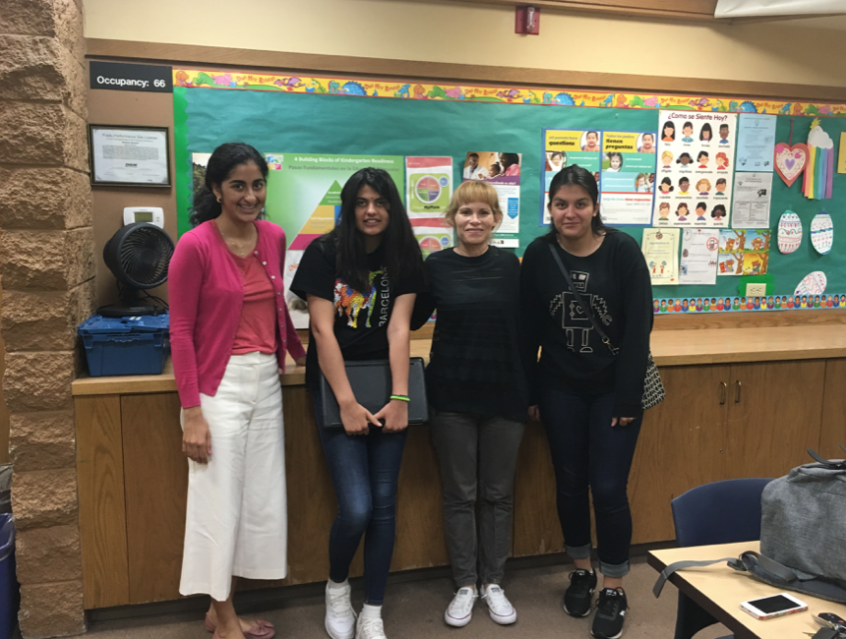
College Prep for Youth
College admissions workshop was held on Saturday, July 13th, 2019 from 1:00-2:30PM at the Newark Public Library’s community meeting room.
Malaina Kapoor, Prerna volunteer and a cultural assimilation lead spearheaded this effort from a youth education forefront and was a great success. It was well attended and the students gained a lot of insights for a better future. Felicia Fahey, Counselor with Bay Area College Consultant who guides families on the college admissions journey, helped answer a variety of questions regarding financial aid, essay ideas and more, and has been a great partner for PRERNA in supporting the youth.

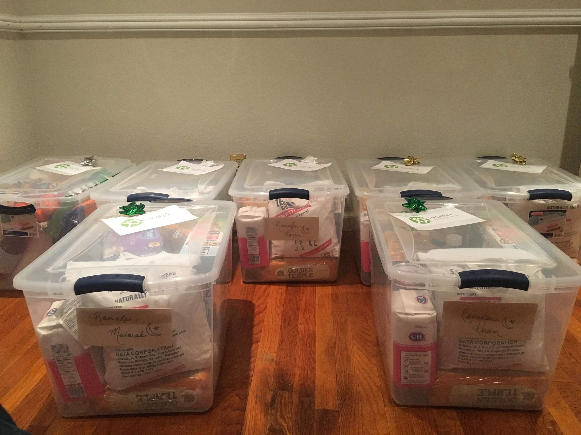
EID Support for all Refugees!
Supporting our Muslim refugees during an important occasion like EID is a very fulfilling experience. Spearheaded by Shahin Mastan in 2018 and two of our team leads (Rabbia and Shahin) in 2019, we undertook the endearing effort of provided EID baskets filled with groceries and essentials to our refugee families. This has now become an annual tradition that we hope to follow.

Adobe Corporate Support for Collaboration
PRERNA participated in Adobe’s 3rd Asian Community Fair celebrating Asian Pacific Heritage Month. Several of our PRERNA leads and volunteers : Karen, Shreyani and Reena attended the event and represented the services that PRERNA offers its refugee families to increase awareness and visibility. It was a well attended event and we were able to gain significant interest from the employees of Adobe about our mission and even got a few eager volunteers who signed up to help us in the future.

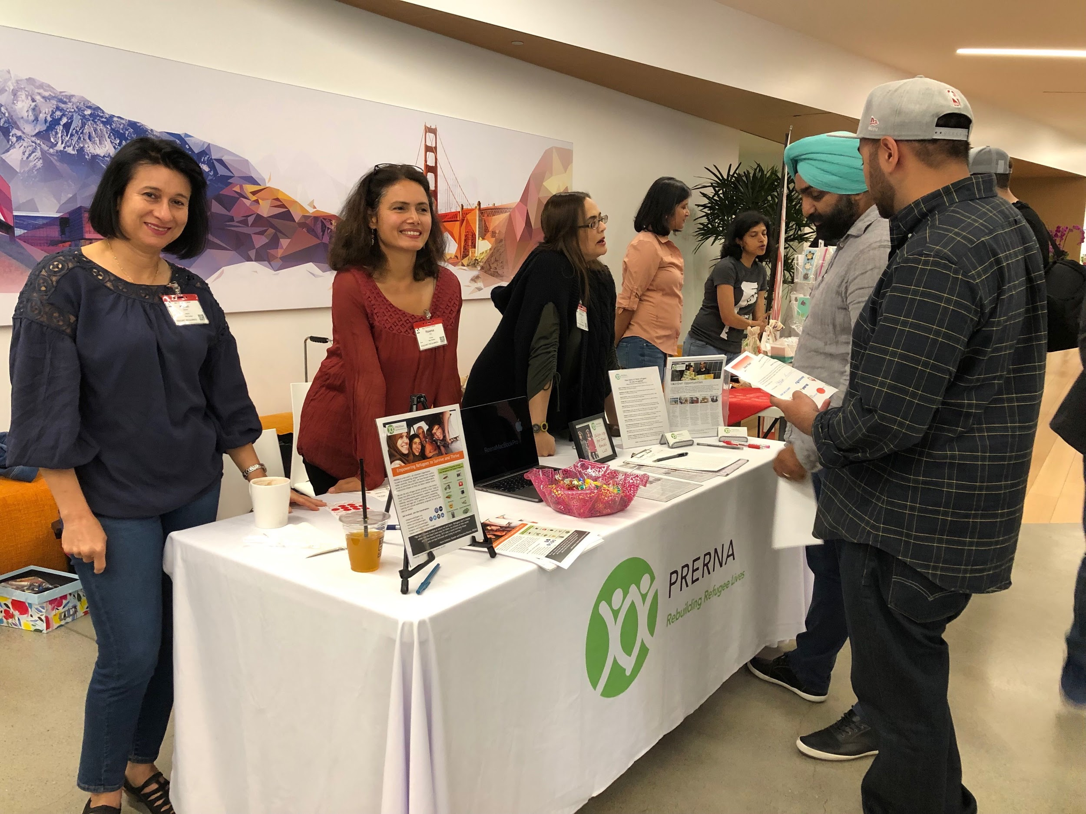

Bicycles for the Youth with one of our great partners, Community Cycles
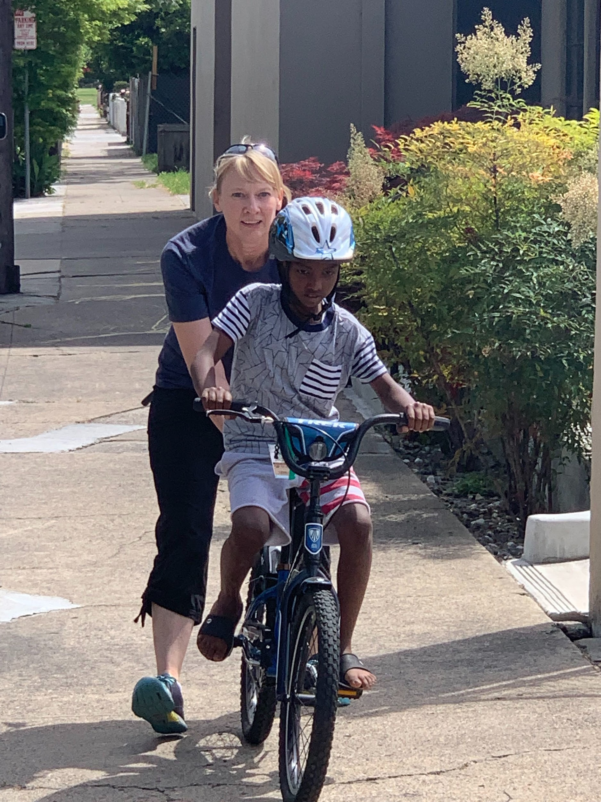
Here are some pictures from our trip to Community Cycles, one of our partners! It was a pleasure to watch Menkem and Diana learn to ride bikes for their 1st time and work together with one of our most loyal partners. We couldn’t help capture the excitement and apprehension on their faces. Our dear partners were kind enough to provide us training wheels, helmets, locks and bell ringers for the bicycles. One of our supporting families, Lema Marcos has agreed to help them so that they can learn how to ride without training wheels in a few weeks.
As part of helping new families settle, PRERNA arranged for several used furniture from Bay Area Furniture Bank, several volunteer in-kind donations and other purchases including new mattresses supported the Okubay family in getting started!
Megan McCormick, our education lead has been driving a plan for the family with the help of several volunteers. The kids are adjusting well in school, the daughter is already scoring an A+ in Math and the family is gaining fluency in English. The family has adjusted very well, considering they have been in the country less than a year.
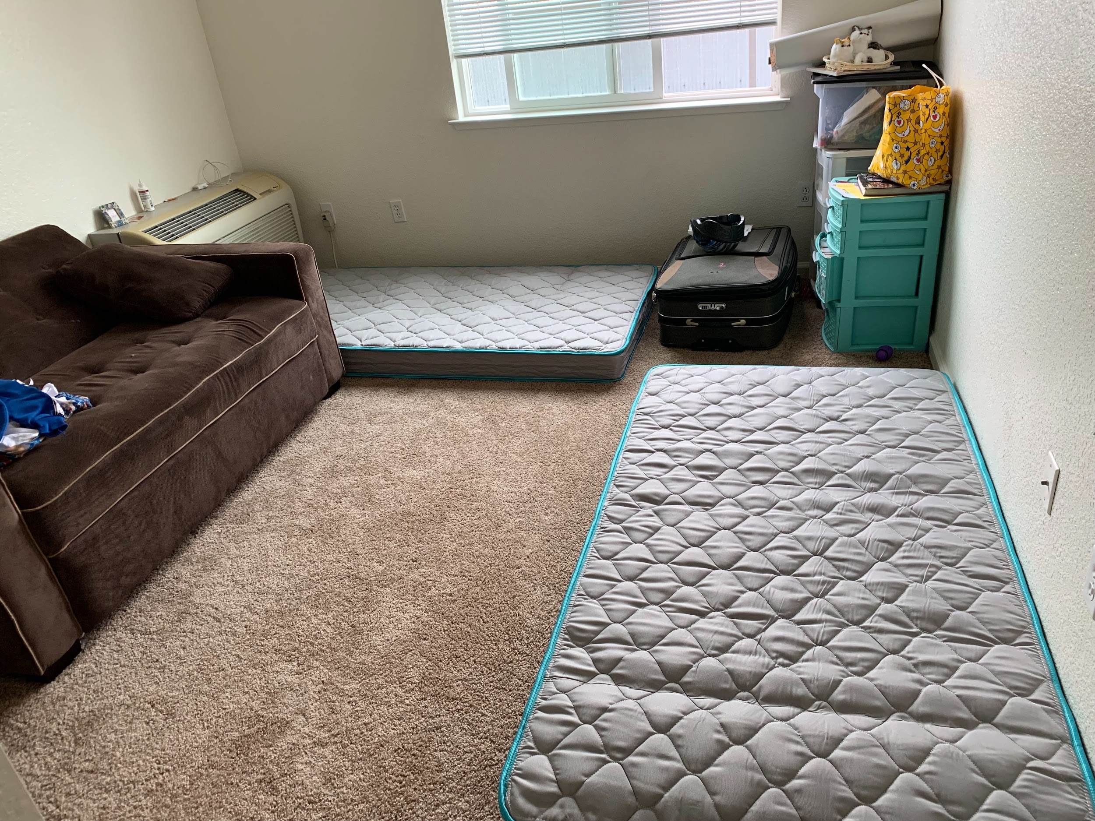
Exposing new families to Libraries & Cultural assimilation
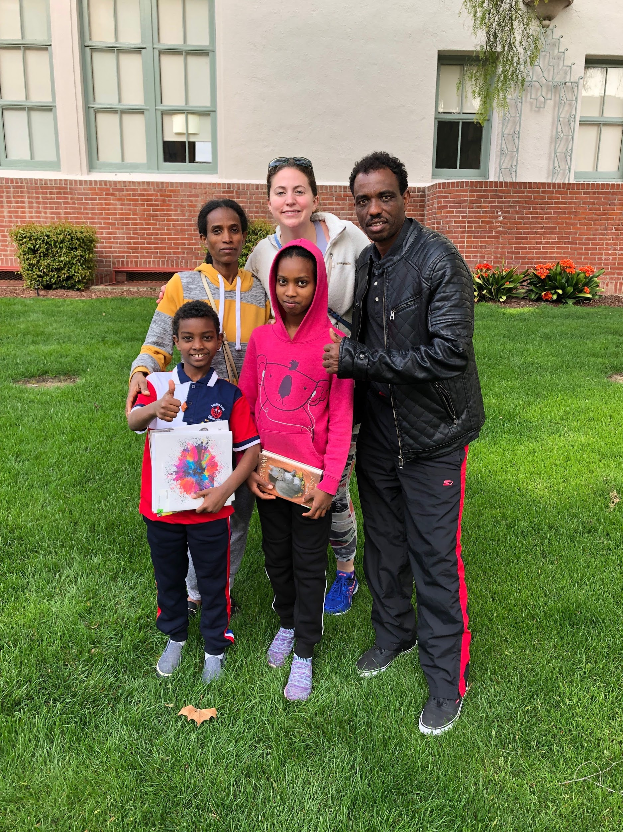
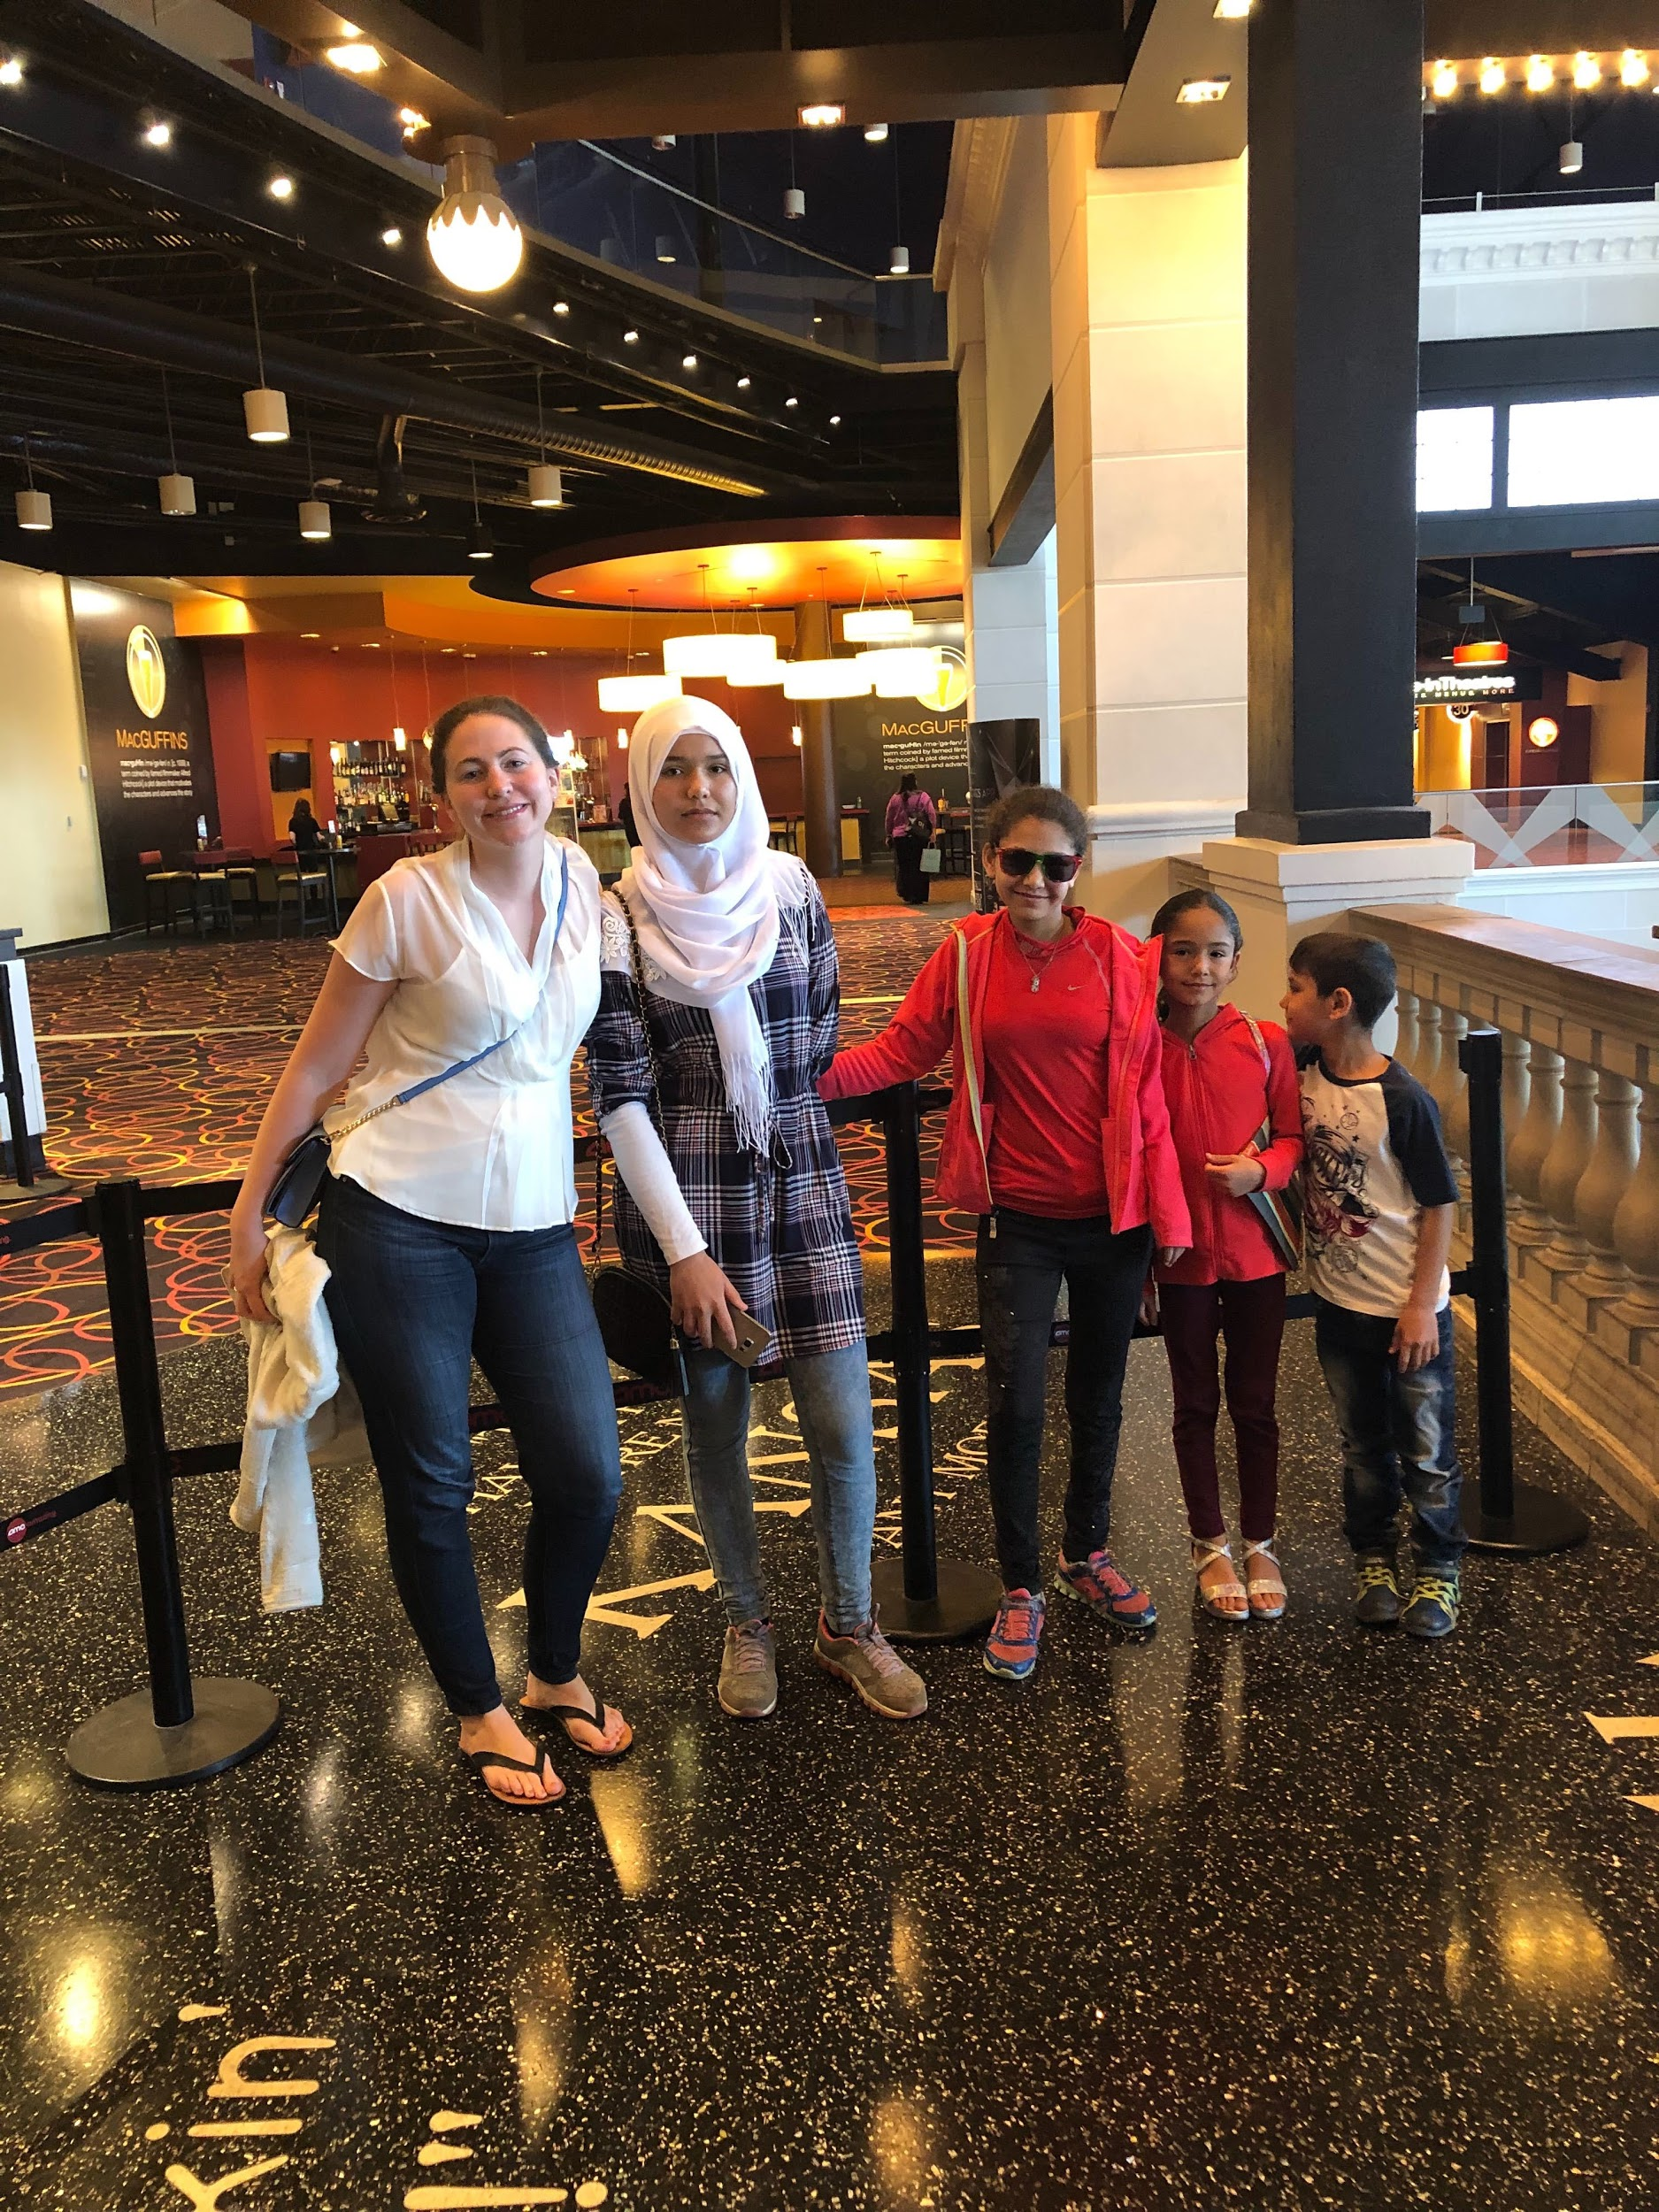
An important part of cultural assimilation and educational awareness is integrating within the society and improving their conversational english. As part of this effort, Megan (our educational lead) took the Okubay family to the library to sign up for cards and enjoying some silver screen time with a recently arrived Syrian family.

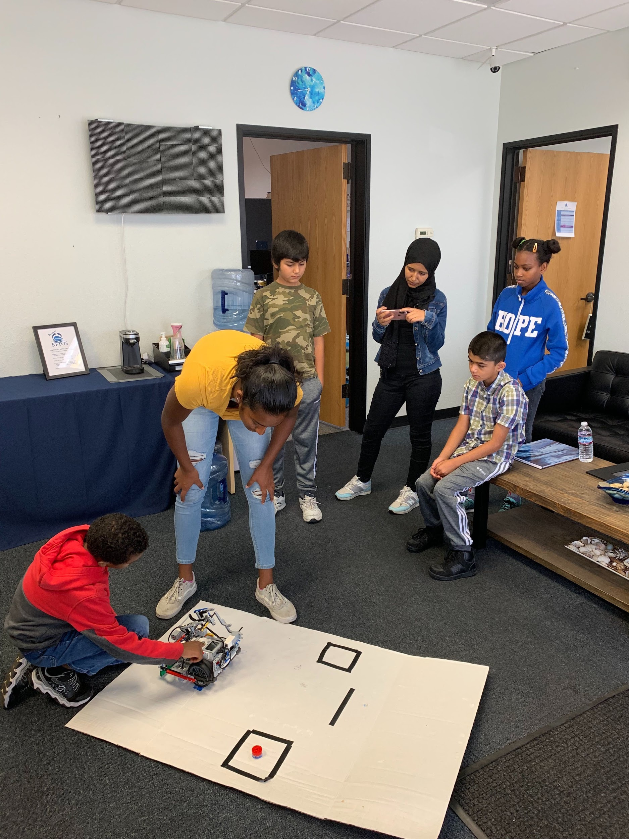
As part of empowering youth in engineering and getting more interest, PRERNA youth : Hasika and Ayush have been conducting STEM workshops,

A snapshot of the Second Youth Workshop :- Focus was a lot around robotics, mechanics of motion, software coding for games, playing games while inciting some competitive spirit…

Exciting times ahead….

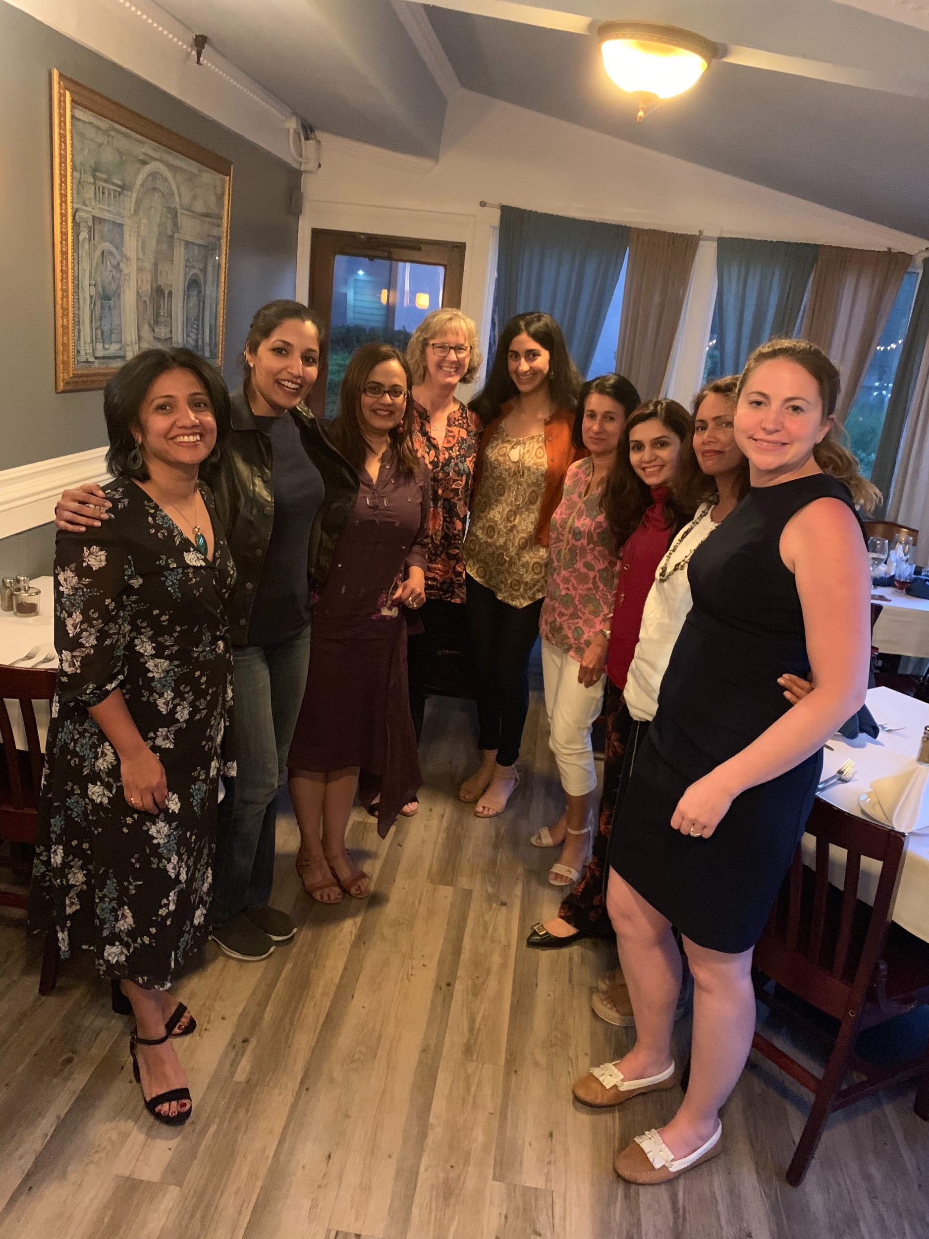
Our Amazing team leads celebrating every milestone and every smile that we helped achieve as a group!!!

