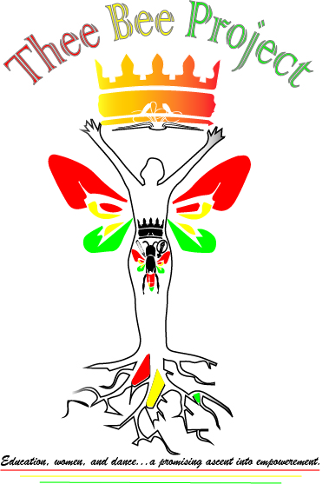
Name: Thee Bee Project, Inc.
Established: January 1st, 2013
Country: United States of America (New York)
Country of Target: Guinea
www.theebeeproject.org

Mission: To empower Guinean women and children, through the assurance of basic needs and provision of educational resources.

Goals:
- To assist socioeconomically disadvantaged women and children
- To empower women and children physically, mentally, and emotionally
- To advocate for the equitable provision of educational opportunities
- To promote Guinean Culture and uplift its values

About:
Thee Bee Project, Inc. is a 501(c)(3) non-profit organization founded in 2013 to assist socioeconomically disadvantaged children and women living in Guinea (West Africa) by satisfying their basic needs and providing of educational resources in order promote their wellbeing. Furthermore, Thee Bee Project actively participates in the promotion of the rich Guinean culture in order to exhibit its beauty and uplift its values.

Secured education and basic needs are fundamental in the wellbeing of a population. In a country of 12 million, over 43% of the Guinean population finds itself below the international poverty line, which implies that they are devoid of most basic needs. Of the 43%, women and orphans are the biggest victims of poverty. Consequently, proper education is restricted due to financial strains, lack of resources, and lack of access. With a total youth literacy rate of about 60%, only 22% of females are literate. The illiteracy rate tends to be higher in women due to cultural and societal factors that downplay the importance of female education and place higher value on male literacy. In regards to the 700,000 orphans in Guinea, measures to help them function in society and secure a promising future are often lacking and inadequate when present. Many of the orphans find themselves completely abandoned, or inadequately cared for due to the meager resources in orphanages. Thee Bee Project’s goal is not only to secure access to schooling, but to also to provide educational resources that will allow socioeconomically disadvantaged women and children to sustain themselves physically, mentally, and emotionally.

Since it’s creation, Thee Bee Project, Inc has endorsed in a number of activities in Guinea, Conakry to fulfill its mission of assisting those most vulnerable in the population. As the primary sponsor of the Orphanage and Rehabilitation Center Regina Maris, yearly distributions of food, clothing, toiletries, sanitation products, toys, educational supplies, and funds have been made in order to sustain the orphanage and prepare the children for a bright future. Additionally, donations of funds, newborn necessities, and breast cancer awareness material have been distributed to the maternal ward at Donka Hospital, one of the biggest public hospitals in the country. Thee Bee Project is currently expanding its outreach to other orphanages and organizations in Guinea that care for care of chronically ill children and their mothers. The plan is to collect funds for and secure sponsorship for Guinea based humanitarian organizations in need of assistance.

Why Education?
﻿Imperfection reins many educational systems, however Guinea's educational system's imperfections trouble me the most, owing to my irreducible native tie to the country. Those in the lower socioeconomic status suffer at great expense due to lack of resources, lack of accessibility, and in some cases cultural barriers. Consequently, many potential professionals are hindered from completing their educational requirements without interruption.
Thee Bee Project specifically targets orphans and elementary school children living in remote areas to provide educational resources and basic needs. The goal is to assist, encourage the children, and install a fundamental attachment to education. With such provisions, it is predicted that students will continue their educational paths, and parents and the government will be encouraged to support them.

Why Women?
Guinean women for a long time have been faced with social oppression, which in turn affects their accessibility to education and proper care. Although the situation is improving, many women of low socioeconomic status still battle daily accessibility challenges. Thee Bee Project is put in place to reduce those challenges and strive towards the provision of better physical, mental, and emotional care for Guinean women. In this process, women will be educated and encouraged to fight for the minimization of the social oppression that overshadows their strength

Culture
Thee Bee Project is strives to promote Guinean culture through various modalities, ranging from clothing, to art, music, dance, and etc.

