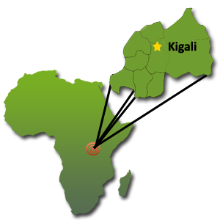
How will stoves help Rwanda?
Rwanda is a tiny country in the middle of Africa, about the same size as Hawaii. But it has 10 million people – that’s a lot of people in such a small area!
There are lots of mountains, but not many trees. So there are lots of people who need wood to cook, but not much wood to cook with. Green Stoves will use less than half as much wood, so people will cut down fewer trees and save the environment!
Helping Kids
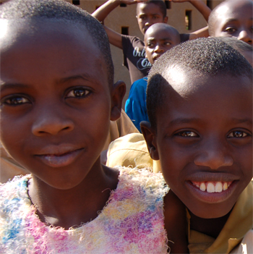
The last 20 years have been very hard for Rwanda. Many, many people died in wars and from diseases. There are many thousands of orphans. Many of the orphans have lots of younger brothers and sisters they have to look after. A lot of young people who should be in school have to work very hard to feed their families. Green Stoves will give these young people more time to study or to work and support their families.

Helping Gorillas
Among the most famous residents of Rwanda are the mountain gorillas. Every year many tourists climb the mountains to see these wonderful, rare and endangered creatures. If too many trees are cut down then the gorillas will have nowhere to live and no food to eat – then there will be no gorillas left. This would be terrible for the gorillas and also for the people of Rwanda. Tourists are good for them as they bring money to the country that can be used to build houses, clinics and schools

What is a Green Stove like?
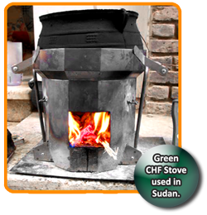
There are all sorts of Green Stoves for different places and different needs. When you go camping you need a different kind of stove from the one in your kitchen. In the same way, different people around the world need different types of stoves. CHF is finding out what kind of stove will be best for the people of Rwanda.
Many people who lived in camps in Sudan use our Green Stoves. But for Rwanda we will design a different stove for people who live in towns and the country.

