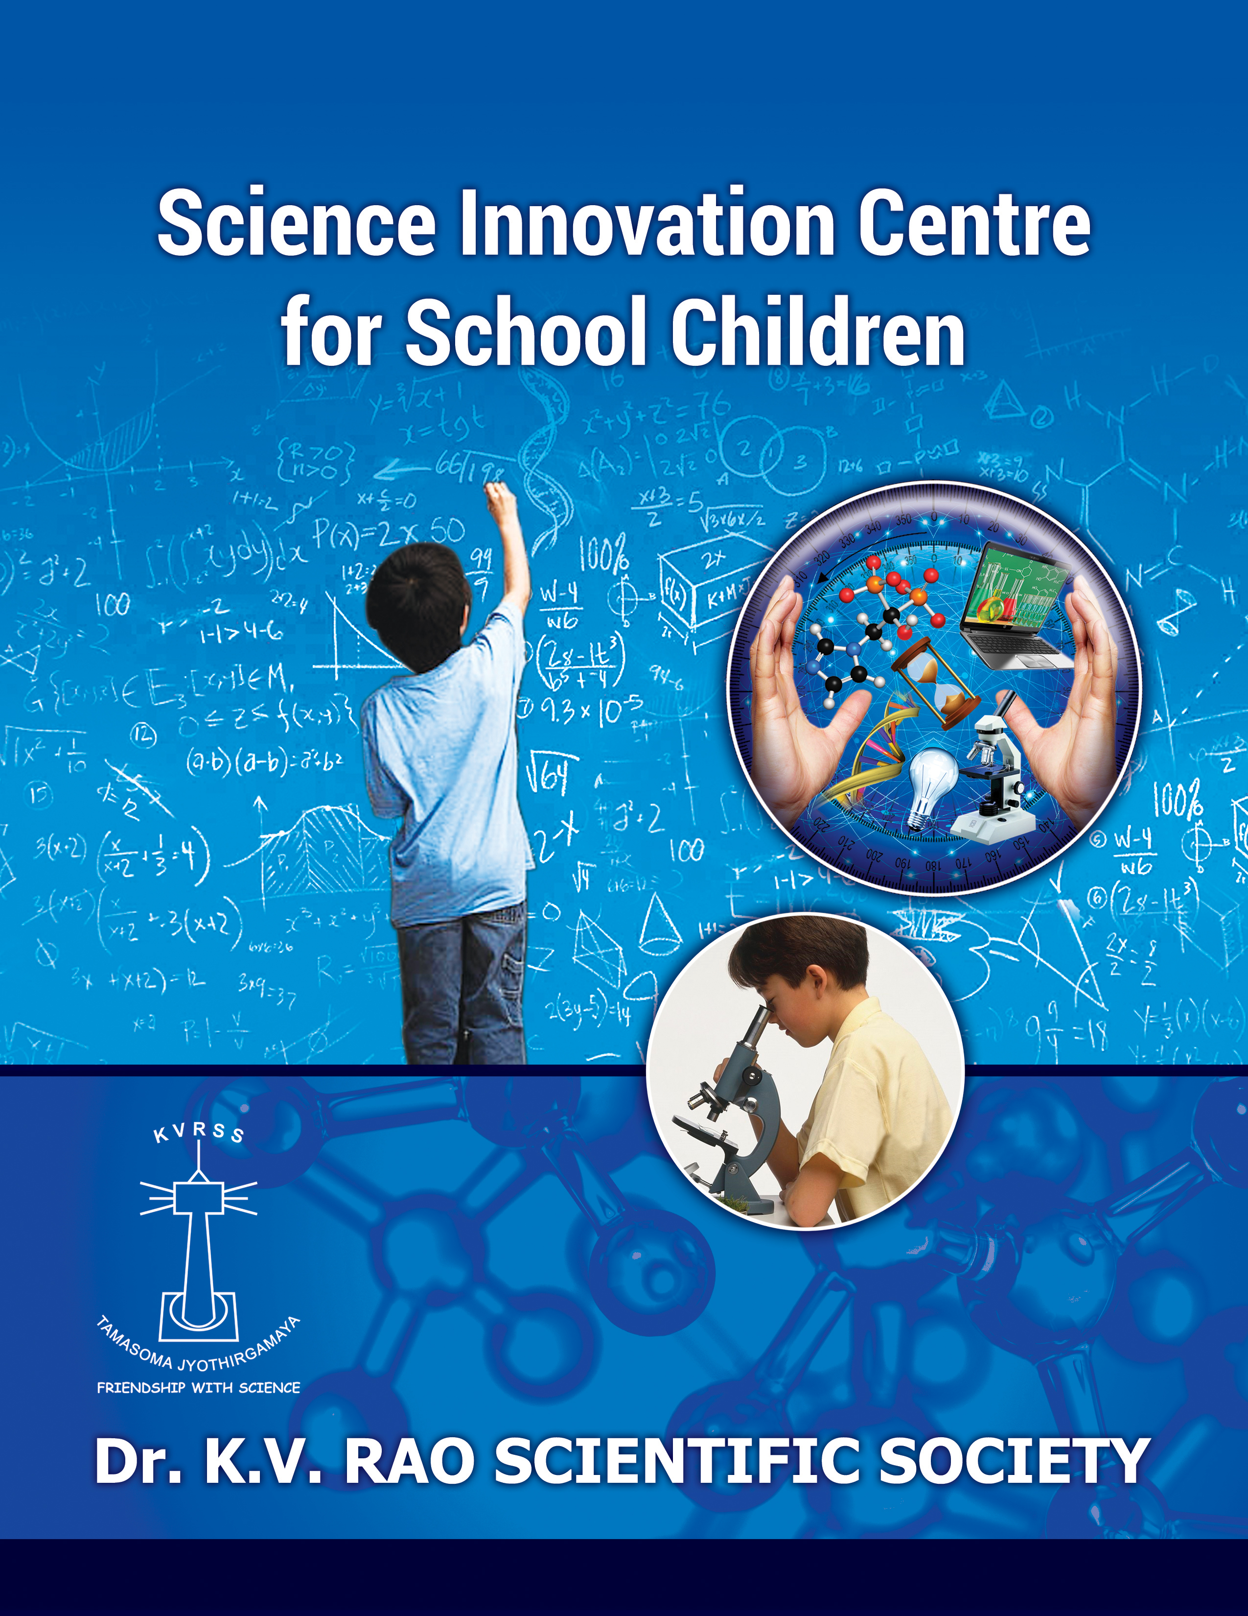
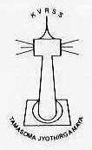Dr. K.V.RAO SCIENTIFIC SOCIETY

Science Innovation Centre for School Children

- Brief Summary about the Organisation and its Past Experience
The Dr.K.V.Rao Scientific Society was formed in 2001 in the memory of Late Dr.K.V.Rao who had retired as Superintendent Chemist of Geological Survey of India. Among his important research contributions are the pioneering work on chemical analysis for mapping the various ores and geological deposits in India which formed the basic data of the natural endowments of the country. A scientist with multiple interests, he has also developed techniques for macro-elemental analysis of materials using AAS technology, designed community de-flouridization plants and potable family drinking water kits in Flourosis-endemic villages. After retirement, he has also used his scientific skills for chemical analysis and studying of Environmental Pollution on monuments like Taj Mahal, Charminar, Gomateshwar Statue, Thousand Pillar Temple, Ramappa Temple etc.
The passion of Dr. K. V. Rao by taking part actively in promotion of young scientists has been instrumental in bringing about this Society. Dr. K. V. Rao Scientific Society was formed in 2001 with a view to promoting scientific temper by making learning of science experiential and thereby encourage school students and young scientists to pursue a career in science. The activities of the Society are coordinated by a committee comprising of colleagues of Dr. K.V. Rao and eminent scientists from various reputed scientific institutions.
Our organization is a totally non-profit, till date the Society has bootstrapped by raising funds from close friends and family members of Dr. Rao.
KVRSS has been serving the student community of Andhra Pradesh (now Telangana and Andhra Pradesh) for the past 16 years in Science. The Society has now started to reach the student community of Karnataka, Kerala & Tamil Nadu also in its activities. The Society provides various opportunities for them to make Friendship with Science ina fun-filled way and at the same time acquire, achieve and contribute to progress in science. At KVRSS we believe science is an essential part of our culture, a powerful tool for thinking and that science education is necessary to the progress of world.
The Society has successfully built a solid foundation over the last 17 years and plans to develop into an institution which adds to the pool of scientists and where leading scientific work can be done and establish itself as an organization par excellence in its pursuit of popularising and promoting science.

Mission
Popularise Science and Enthuse School Children Towards Pursuing a Career in Science Through
- Conducting science related events for school children:
- Science quizzes and debates
- Science fairs and innovation contests
- Interactive Sessions with Scientist
- Capacity-building of local talent for teaching science in schools:
- Involving science teachers
- Setting up science laboratories & clubs
- Evolving innovative methods of teaching science
- Setting up of Mobile laboratories for children in remote /rural areas

- Assisting schools lacking equipment/resources for teaching science.

Promote Science at Research Level by
- Assisting Research students at Doctoral or Post Doctoral level by way of awards, scholarships and funds
- Developing Scientific Resource Pool through continuous involvements of scientists
- Undertake programmes for advancement of Research in various branches of Basic Sciences
- Recognising Research Supervisors for their contribution to advancement of Science

As part of our ongoing activities related to building / developing the capacities of the children / adults in utilizing existing resources on Science streams by reading, experimenting and getting involved in the subject, we are addressing each and every shortfall by our interventions i.e.

a. Research Awards

The awards are presented to young scientists, below 30 years of age, from various branches of basic sciences, viz., Chemistry, Physics, Biology and Mathematics. The event was started in 2001 with the state of Andhra Pradesh and now stands extended to the states of Telangana, Andhra Pradesh, Karnataka, Kerala and Tamil Nadu,
The award carries a cash award of Rs. 20,000/= only and a trophy for the winner and a cash award of Rs.10,000/= only and a trophy to the runners-up in each category. Each year about a hundred research students from various research institutions apply for the awards.

b. Science Quiz Awards
KVRSS conducts Science Quiz Competition for school children of Telangana and Andhra Pradesh each year.
The Society invites school students (of Classes 8 to 12) to participate from all the districts of Telangana and Andhra Pradesh. To facilitate this process, the districts of Telangana and Andhra Pradesh have been divided into five zones and each zone is represented by a city where the quiz is held. The Quiz competition is conducted in Visakhapatnam, Vijayawada, Tirupati, Warangal and Hyderabad.
The top three teams in each Zonal quiz are given cash awards and certificates. Top two teams from each of the zonal finals compete in the mega final which is held in Hyderabad. More than 800 students from about 300 schools participate in the event each year.
The winners and runners-up in the finals are not only awarded cash prizes and certificates but are also conferred with Annual Science Awards during the annual function of KVRSS generally held in the month of April.
c. School Talent Awards
Telangana and Andhra Pradesh Councils of Science & Technology select 30 students in the age group of 10 to 17, every year to represent at the National Children's Science Congress held by Department of Science & Technology, India. KVRSS Society conducts an interactive session for these 30 students to prepare them for the National programme.
A panel of eminent educationists interacts with these children and selects 6 meritorious students (basis: merit -cum-need) for giving scholarship up to 12th class.
The selected candidates are presented with a merit certificate a trophy each and a scholarship of Rs 5,000 per annum. Thirty Students from various districts of Telangana and Andhra Pradesh participate in this program every year.
d. SPARK Innovation Awards
With a view of fostering spirit of scientific enquiry and promoting innovation among school children, KVRSS holds an annual science fair wherein the Spark Innovation Awards are given for entries displaying use of scientific concepts for solutions to an existing problem through some novel concept / method / process / device. The competition is open to school students in the age group of 13 to 18 from the states of Telangana, Andhra Pradesh, Karnataka, Tamil Nadu and Kerala.
The prizes are given in two categories: (i) Category A: Class 7 to 9 and (ii) Category B: Class 10 to 12. About 600 students from about 100 schools participate in the event every year.
e. Eminent Supervisor Awards
The Society started its activities in 2001 by awarding Young Research scholars below 30 years of age. Over the years of starting the awards many senior scientists from different institutions have been supporting the Society by nominating their research students for presenting research papers in the competition. And many students under some of these research supervisors have done exceedingly well and won awards.
The students were judged by various panels of judges, establishing the quality work being done by these groups which is a reflection of the Supervisor's contribution to research. In recognition of their high impact research work some senior scientists from whose groups multiple students have won awards from the Society are honored each year.
f. Annual Memorial Oration Awards
Since inception of the Society, each year during the annual function an oration is delivered by an eminent Scientist. These Lectures have become extremely popular as the orators take up complex scientific issues and explain in simple language to school children and general audience. Eminent scientists at Director level, Vice-Chancellors of various Universities have been among the oration speakers.
To encourage school children towards science the Society arranges lectures by scientists regularly and the students also get to interact with the scientist. The speakers include senior scientists from various research institutions and our Young Scientist Awardees.
g. KVRSS Talks
This not only enriches the knowledge of the students but also gives them an insight into the current trends in research. Young Research awardees are invited to present talks as the school students get impressed with the thought that a Scientist can also be young and modern like them and that a career in research is an exciting one too. The awardees who present the lectures, on the other hand, get an opportunity to present their work in presence of a young and eager audience yet to understand the real meaning of research and it is a challenge to make the children understand their work.
h. KVRSS Labs
A Science Laboratory is being developed for school children to cater to the requirement for those schools in the vicinity that do not have the basic facility for conducting science experiments. Lab activities are not only mandatory for higher classes but also provide hands on experience to the students on different aspects of science allowing them to explore, experiment and learn and understand topics much more effectively and easily. This not only generates an interest in the subject of science but also increases their awareness levels.
The Society intends to develop the labs such that it can cater not only to the experiments as per the syllabi of the schools but also develop the facility to help children in senior classes for their science projects wherein we provided materials and experimental set up and also help them conduct their work in our premises. The facility will start functioning on a regular basis very soon. However, some infrastructure has been developed and a few demonstrations in Chemistry and Physics have already been held in the premises for school students.
The place is also being developed as an innovation and creative centre with many table top scientific models to explain the concepts of science, some interactive models like thermal and hydro plants, large gear systems, model defluoridation units and other where the concepts of science have been used for the betterment of the society.
The future goal is to reach rural school students and students with less amenities through mobile laboratories which can go to their door step and bring about awareness as well as train the students in scientific concepts.
i. Collaborative and Other Events
Many schools and scientific institutions have started seeking the services of KVRSS in the conduct of their events. Some of them are mentioned herein:
i) Mathematics department of University of Hyderabad conducted a programme for school students during International Year of Mathematics in 2011 for which KVRSS was asked arrange the event. We were able to mobilise around 2000 school students for the event.
ii) Kendriya Vidyalayas group of Andhra Pradesh celebrated their golden jubilee year in 2012 and KVRSS conducted a Maths quiz, as part of the celebrations, for about 40 schools.
iii) KVRSS organized an event at Chinmaya Vidyalaya, Begumpet, to celebrate National Science Day on 28th February 2017 in their school. A scientific talk and an interesting chemistry experiments demonstration by Prof. Sai Prakash and team were presented.
iv) Osmania University, Department of Genetics & Biotechnology had organized a National Conference on the occasion of Golden Jubilee Celebrations of Department of Geneticsin which KVRSS was invited to be a part and support the students, undergraduate, graduate and research, by awarding the best presentations.

v) ISRO conducted out-reach programmes for schools in science on National Science Day and enlisted the services of KVRSS for the conduct of the same.

Teaching of Science through demonstrations of experiments is regularly conducted for school children. Team from KVRSS, as well scientists various organisations like IUCAA, NIN, OU have been participating in this activity and is hugely popular among students.

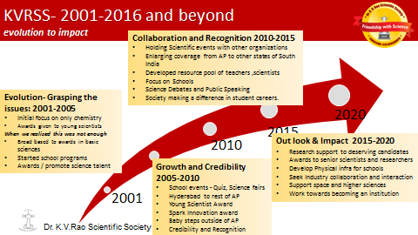

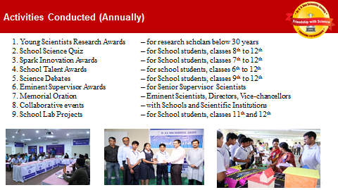

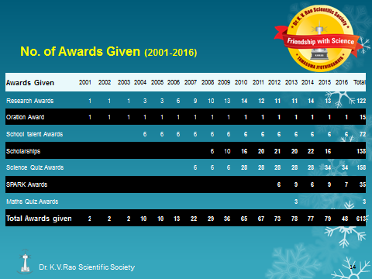
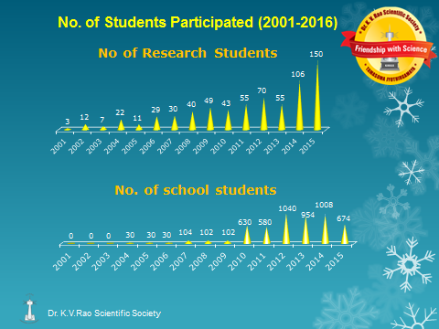

- Project Statement
We have observed that many schools in the twin cities of Hyderabad and Secunderabad do not have adequate infrastructure and space for the science laboratories. Lab activities are mandatory for higher classes as they provide hands on experience to the students on different aspects of science allowing them to explore, experiment and learn and understand topics much more effectively and easily. This not only generates an interest in the subject of science but also increases their awareness levels.
The state of Telangana has about 7 million children in 7-17 age groups. The state has a wide reaching school system. There are 4.2 million children who study in the 1st-7th Standards. Though the state has been able to largely address the problems of access, there are very serious quality learning issues across the state. Annual Status of Education Report (ASER), by Government of India survey results show that while the national averages for children who can read sentences and do subtraction are 66% and 65% respectively, the averages for Telangana are 47% and 53% respectively. The report also shows that only 27% children in 5th std can do division. Today the poorest children in the state go to Government schools and often end up getting very poor quality education. They have no access to computers, any science labs or challenging math puzzles. They also suffer from lack of proper English learning skills - both spoken as well as reading. Most of the schools in these areas also lack good library facilities. This has resulted in many children finding science an alien, irrelevant and a hostile subject. Thus there is a dire need to provide facilities to develop and nurture the potential of children in science. Many students are also of the opinion that, even if there is some lab equipment, it is either inadequate or obsolete..
Also, the current method of noting readings and setting up apparatus leaves students with little time to think scientifically and analyse the data. In this entire process, the joy of learning Science is completely lost.
We would like to contribute a little towards this generation of interest in science among youngsters through the activities of Society.
- Conducting general Science experiments of relevance to school students
- Providing specific equipment for talented students interested in innovation.
- Demonstration of various experiments in creative methods for easy understanding of the concepts
- Regular interactions with scientists to understand the issues being addressed through research
- Conducting weekend workshops for students needing assistance in understanding the concepts through hands-on training
- Creating a Science Hobby Centre for students interested in science activities

A dedicated laboratory and an innovation and creative centre for school children with best / high end facility and trained staff could help promote interest in the learning of science. The Society has acquired infrastructure facility of about 3500 sft to establish a science laboratory and library.
The schools in the neighbouring areas, in particular the Government and Govt. Aided Schools will be able to use this facility. The Society plans to address a limited number of schools initially and increase the reach in a phased manner.

The final goal is to reach out to students from rural areas and those with inadequate facilities through Mobile laboratories and thus develop as an institution par excellence in promotion and popularization of science among students.

Project Benefits
School students in the age group of 7 -17 of private as well as Government schools from the localities in Hyderabad city as mentioned above in the implementation process will be able to utilize the services of the Lab. It will offer a wide coverage of subjects, Physics< Chemistry, Biology, Mathematics, environmental Sciences, etc. Experiments based on school curriculum as well as novel and creative experiments to make science easy to understand.
It will provide students with facilities and the opportunity to learn science with activities and present science as a vibrant and creative process. Use of multimedia as a teaching-learning tool will make the process more interesting and will connect with the new generation students.
The project will also prepare teachers with knowledge, skills and confidence to teach with hands-on activities.
Student community gets nurtured in the basic concepts of science, which is essential for their growth as well as that of the nation.

- Proposed strategy to address the problem
Scope of Services:
Services to be provided through the science lab are essentially in two categories:
(i) Improve facilities to make the learning of Science a vibrant and creative process and
(ii) Improve quality of Science teaching.
In the first phase of the programme, i.e., initial two years will focus on providing and improving lab facilities to children, while the second phase wii be for expanding its scope by introducing interventions on teacher training.
As a pilot project, this intervention will cover the school students in the age group of 7 -17 from 5 to 10 schools (private as well as Government) in localities nearer to the location of the facility of Hyderabad city.
The facility will also conduct seminars / discussions to the target groups, Lectures and workshops on specific science subjects and topics.

Providing access to Physical laboratory for experiments to High School children:
It is envisaged that this progarmme will provide opportunity to school students to conduct all the experiments based on school curriculum as well as provide space, equipment and guidance for those students who wish to conduct innovative projects.
Already some equipment has been procured and the necessary apparatus will be procured as per the timelines.
List of experiments as per curriculum is already being collected and will be made available for easy reference during the actual conduct of the experiments.
Till date Science is taught in class rooms, with more emphasis on theory and very less exposure to practicals and almost negligible hands-on experience. This means that there is a large time gap between theory and practicals thus reducing the impact of what has been learnt. Also the number of students in a class in most of the schools is very high and makes it difficult for them to understand the concepts.
We, at KVRSS, believe that only real labs provide hands-on experience to students on different aspects of Science and allow then to explore, experiment, learn and understand concepts more easily and also make the experience more interesting and enjoyable.
Thus the objectives of the Science Lab are:
i) To provide students with facilities and opportunity to learn science with activities
ii) To present science as a vibrant and creative process to develop interest in the subject
iii) To provide relevant technology and infrastructure for use in teaching and learning.
iv) To prepare science teachers with knowledge, skills and confidence to teach hand-on science activities, to improve presentation skills and self-development.

4. Project Financials
Project Cost
Budget: Financial resources required for implementation

Support Needed & Costs
Capital cost for establishing Laboratory (Chemistry, Physics & Biology) as enclosed in Project cost.

Laboratory Equipment for the disciplines above as per our equipment guidelines.

Innovative and Interactive Models to be displayed for concept understanding. Materials and apparatus to be provided for students to work on their creative ideas.

Furniture & Fixtures for the laboratory as per the Lab facility infrastructure plan.

Teaching and mentoring support

Library setup (with all reading, audio & visual material) along with furniture.

KVRSS Science Innovation Centre
A Capital Cost
Particulars | Units | Unit cost | Total Cost
A1: Science Lab Equipment
*Equipment cost | 1 | 1000000 | 10,00,000
A2:Audio Video Equipment
01 OHP, 01 Lap Top, 01 Screen | 1 | 150000 | 1,50,000
Audio equipment Set - Amplifier and Sound System | 1 | 60000 | 60,000
A3:Scinence Library
Reference Books and shelves and Furniture | 1 | 500000 | 5,00,000
A4:Furniture for Lab
Lab Furniture (includes tables, sinks, fuming cupboard, racks for chemicals and cupboards for apparatus) | 1 | 300000 | 3,00,000
A5.: A/Cs | 6 | 40000 | 240000
TOTAL : A |  | 20,50,000 | 22,50,000
B Recurring Cost
Particulars | No. of units | Unit cost | Per Annum
B1:Human resource
3 Teachers (1 each for Chemistry, Physics & Biology) @ Rs. 12000 per month | 12 | 36000 | 4,32,000
02 Lab Assistant @ Rs. 10000 per month | 12 | 20000 | 2,40,000
01 Office Assistant @ Rs. 8000 per month | 12 | 8000 | 96,000
Chemicals and other consumables | 12 | 10000 | 1,20,000
TOTAL : B |  | 74,000 | 8,88,000
C. Summary of total Project Cost
Particulars | No. of units | Unit cost | Per Annum
A:Capital Cost |  | 20,50,000 | 22,50,000
B:Recurring Cost |  | 74,000 | 8,88,000
TOTAL |  |  | 31,38,000
The budget does not reflect the cost of developing mobile labs, which is a future plan.

5. Timelines

Implementation process:
- Science Laboratories for best on-hand practical experimentation under supervision of qualified teachers
- An agreement and MOU will be signed with the schools in all the localities for the facility to be availed by the school children.
- Phase – I: Schools in the 5 Km vicinity of the lab facility.
- Phase – II: Schools in the 10 Km vicinity
- Phase – III: All interested Schools of Hyderabad.

- And also KVRSS will prepare a schedule for each school for systematic implementation and usage of the lab and library by the school children and this will be strictly followed.
- Planning of various activities for establishment & implementation of the proposed Project

Time lines for various activities :
Sl No. | Activity Description | Time Duration | Remarks
1 | Finalization of Survey & tie up with Schools in the vicinity of 5 KM | Four weeks | Since some survey is already done
2 | Finalization for procurement of all general resources for laboratory – Manpower, Equipment, Furniture, etc | Four weeks
3. | Procurement of Specialized equipment for Lab | Six months | Once the regular lab starts, equipment will be procured as per requests from students
3 | Installation & Commissioning of Laboratory | Eight weeks
4 | Finalization of Survey & tie up with Schools in the vicinity of 10 KM | 6 Months from start of project
5. | Finalization of Survey & tie up with balance Schools of Hyderabad | Two years after establishing the lab
6. | Construction of Library storage racks | Eight weeks
7. | Procurement and Organising of Books | Six weeks | There is already a small collection of books

6. Some Milestones of KVRSS
- First of its kind recognition :
The awards by the Society are generally first awards in the career of any student, particularly at research level. Awards from the Society are considered very prestigious and students look forward to the awards. The participation of scientific community in the Society's activities at various levels is voluntary and based on the Fair practices of the Society. All the Scientists associated with the Society's activities and all the participants have acknowledged this aspect. Awards from the Society have helped many students in furthering their careers.

- More than 40 awards are presented each year
The Society’s activities started in 2001 with selection of one young scientist (researcher) from the field of chemistry and giving KVRSS research award. As the Society grew, the number of categories (scientific disciplines) and corresponding awards increased. Progammes for school students were started in 2004 and now the Society gives more than 40 awards in various categories every year.

- Acknowledged by DST
Department of Science and Technology (DST) conducts National Children Science Congress across all the schools of India. Students from each are selected from districts level to state level and then to national level. Our Society conducts an interactive programme for school children, mostly from rural areas, selected for National level from the States of Telangana and Andhra Pradesh. A panel of eminent educationists interacts with the children and selects projects for awards and scholarship from the Society. DST has acknowledged that we are the only Society which provides financial assistance to these children till their schooling in this particular event.

- Postal Cover on Dr. K.V. Rao released in 2015
To commemorate 15 years of service to science by Dr K.V.Rao Scientific Society a Special Cover as a tribute to Dr K.V.Rao, in association with Department of Posts, A.P. Circle, Hyderabad was issued on March 21, 2015. Sri G.M.N. Sastry, Deputy Director General (Chemistry), Geological Survey of India, Hyderabad and Prof. Amitabha Chattopadhyay, Distinguished Scientist, CCMB, Hyderabad and released by Col. M. Eleesha, IPoS, Postmaster General (HQ), A.P. Circle, Hyderabad graced the occasion.

- Supported by NASSCOM Foundation
The Society received support from NASSCOM Foundation, the social arm of NASSCOM (the internationally recognized trade body representative of the Indian IT-BPM industry). KVRSS has been registered by the Foundation to receive support from its various member companies. As part of its Big Tech initiative the Society has already received support from Microsoft and Google and as part of its Big Bridge initiative the Society received computers and laptops from hardware companies.

- Infrastructure Development
The house where Dr.K.V.Rao had lived has been endowed to the Soicety and we have already developed lecture halls and have been conducting all our events in the premises. A science lab is being developed for school children to provide hands-on learning.

- Resource Pool
It gives us great pleasure that many of the awardees support us in many ways, as judges, for delivering scientific talks, conducting events and sometimes with some equipment.

- Extending Reach
The activities which were started in the state of Andhra Pradesh (then combined state and now the states of Andhra Pradesh and Telangana) has been slowly extended to other states and now the activities are being conducted for the students of Telangana, Andhra Pradesh, Karnataka, Tamil Nadu and Kerala.

- Institutional Support
Many institutions are now coming forward to work in association with us. Schools approach us for conduct of scientific programmes and research institutions like TCIS, University of Hyderabad, ISRO are supporting us in our outreach programmes.,

