GET Ahead Project STEAM Centre Proposal  
 *“The principal goal of education is to create people who are capable of doing new things, not simply repeating what other generations have done – people who are creative, inventive and discoverers.” Jean Piaget*

* South Africa has an enormous scarce skills shortage of students studying Engineering and Science related careers
* In the TIMSS (Trends in International Mathematics and Science Study) 48 countries participated - South Africa came 47/48 for Maths and 48/48 for Science
* 10% of South African matrics passed Mathematics s and Science with a Bachelor pass in 2015. Only 23% passed with an average of more than 30 % in Mathematics
* In the most recent World Economic Forum Report on Education South Africa ranked 148/148 for education
* In a Department of Higher Education and Training Gazette of 2014, 8 of the top occupations where there is a skills scarcity in South Africa are STEM related
* Less than 10 % women are interested in STEM related careers
* Globally 14% of the STEM related workforce is female, in South Africa it is only 7%.

What role can GAP play in redefining the economic success and innovation of the future of South Africa?

Get Ahead as a cluster of schools is progressing well in relation to statistics in South Africa with higher than average matriculation results than the rest of the province. However, it is no longer enough to simply remove the opportunity disparity for children living in poverty by improving educational outcomes. A foundation of relevant skills, innovative thinking and leadership development, must be built to ensure that youth are able and motivated to realise their potential. GAP can position itself as an educational leader in the district, retaining and attracting top students, and becoming a model for what is possible by:

* Offering a 21st Century Education by teachers who understand the pedagogy of inquiry based, project-based learning
* Ensuring that we develop the right skills match in our students to embark on modern sought after STEM related careers after school
* Providing top teaching in world class facilities in Maths and Science and Life Science
* Cultivating the innovators of the future through the ARTS
* Developing relationships and partnership with industry & business in our local community, exposing children to different career paths tying the relevant skills to lessons in the classroom
* Ensuring our students are confident, well- spoken and strongly grounded to face the future in order to live up to their individual potential
* Offering a comprehensive guidance program including psychological assessments, individualized learning paths, and career mapping to ensure we have very informed students who through self- discovery will be able to solve problems and plan their own futures

What are the existing resources and limitations at GAP?  
  
Current tech and IT Infrastructure resources at Get Ahead are superior to the rest of the district; however, overall STEAM integration is inhibited by a number of factors:

* Teaching pedagogy and practices (particularly at the College), remain tied to old school methodology – black board, with lessons delivered in a one- to- many framework
* Math and science marks remain disappointing in part because there is no science lab that allows for the practical application of concepts learned in the classroom. There is also a disconnect between what is learned in the classroom and how it is applied in the real world
* Technology as a subject area is restricted because of a lack of facilities
* STEAM subjects are still taught in silos and the physical facilities make it challenging for the teachers and student to make cross - curricular connections between the subjects
* There is no real facility to support the further development of the ARTS. Creative arts have a positive impact on the school community but space and materials are limited. The choir is successful, but could achieve even greater success if there were proper acoustics and space to practice

STEAM CENTRE - Proposed Resources – Physical & Human  
  
*“Education must shift from instruction to discovery – to probing and exploration.”*

A STEAM Centre, located on the GAP Campus, purpose built utilizing the original school building will need to incorporate the following resources:  
  
Physical Resources:

* Science and Life Science Laboratories – fully fitted for experiments
* Workshop space with wood-lathes and other equipment for technology as a subject (bridge building and robotics)
* Flexible class rooms space which could become board room space
* Maker- space which is flexible with mobile workbenches. This space should be so flexible that all workbenches can be moved into the storage and it can be used as a hall for productions and assemblies
* Outstanding acoustics for drama and choirs in open learning space
* Wet space for art
* Experiments and art display space
* Media nooks and reading corners
* Manipulatives – Lego and Zoobs
* Quiet space – for reading and independent work
* Sound proof music room(s)
* Office space
* Catering facilities
* Outdoor space for physical education and fun activities
* Lots of natural light and heat
* View of the beautiful mountains
* Environmentally friendly
* Green space for eco agriculture - modern vegetable gardens, cutting edge agricultural models
* Mobile flexible furniture
* State of the art technology
* Creative space which offers opportunity for multiple activity
* Storage for all mobile work benches and crates with work that students produce
* State of the art IT infrastructure

Human Resources

A number of key people will need to be hired to ensure the STEAM Centre’s potential is fully maximized. They include:

* **Head of Innovation**: responsible for the overall educational IT Strategy, working with the Executive Director, School Heads, and IT specialist across all three schools and to maximise the cross curricular use of the STEAM Centre
* **Centre Coordinator :** manages the staff at the centre, coordinates activities, manages community outreach programs
* **Receptionist:** bookings, general admin and catering for external parties.
* **Laboratory Assistant:** to set up experiments and plan change of classroom settings according to a time table
* **IT Staff** – to look after tech resources, help desk, set up equipment
* **STEAM Educators**: made up of dedicated STEAM staff from the schools
* **Cleaning and maintenance staff**

Activities and Community Outreach

The vision of the STEAM Centre starts with, but goes well beyond the GAP Community. The Centre will be utilized by the many constituents in the broader community including students from schools throughout the district, new graduates, adults and the teaching community.

In house activities:

* 100 Get Ahead students at any given time in a range of activities in the makes space and connected teaching spaces
* Fully occupied during normal school hours by Get Ahead students 7:30 – 16:00.
* WhitGap students transported to the centre on a weekly basis
* Extended day activities for all STEAM subjects - practical exposure
* Holiday workshops in cultural activities: Chess, choir, best speaking, debate, drama, art, music - playing instruments

External Activities – Teachers/Students from district schools

* Friday afternoons and Saturday mornings -classes in STEAM related subjects for students with high potential from local township schools (Partnering with DBE)
* Teacher Professional Development for Township Schools (Partnering with the DBE)
* Teacher and Professional Development for Top Town Schools
* Incubator Student Programme for Maths and Science - NMMU

External Activities –Queenstown Education Resource Centre (QERC)

* Holiday Workshops on STEAM and Technology integration for Teachers.
* Holiday Workshops in collaboration with local universities on STEAM integration.
* STEAM Workshop for females/ young girls planning to go into Engineering and Science related studies
* ISASA workshops to Independent Schools in SA in STEAM integration and 21st Century Innovation. Becoming the lead school in reaching out to schools by offering workshops on 21st Century Teaching and Learning. Bringing in top quality national and international trainers
* Winter School for students with high potential in STEAM related subjects from schools across the Eastern Cape (Partner with a local BB and Hostels for accommodation)
* Evening Classes from 17:00 – 20:00 in ICDL etc. to local companies in the newly formed industrial hub of Queendustria
* Careers Days for Queenstown broader community also benefitting our students. Bring role models to present on STEAM Topics (Science Circus by Science students from local universities – showing that Science is fun). Every aspect of STEAM can be showcased
* Training facility for Professional Development for local teachers in ICT e.g. ICT4RED.

External Activities –Community Outreach

* Saturday mornings / holidays
* Computer Literacy for parents ICDL training/Edunova
* Computers Literacy for gogos (grannies)
* Maths and Science workshops in problem areas for students from under resourced schools

**TEACHER DEVELOPMENT AND STEAM TEACHING**

**The programme will have four pillars**:

1. **Cultivate** and train our **school leaders** to have the skills to drive quality and curriculum development and assessment in their schools by being outstanding instructional leaders and meticulous administrators in their schools**.**

**2. Develop** and train **teachers** so that they are able to inspire and encourage young people to reach their potential in our programme specifically in the identified scarce skills fields. Equipping teachers with a “STEAM in a Box” to take STEAM pedagogy into their schools and offering field visits to ensure that training is carried through to the school and to track the success of training.

**3. Prepare** today’s **students** to be employable in a 21st Century economy by focusing on strengthening STEM (and arts) education, incorporating Maths and Sciences into all aspects of the curriculum and educating students to be entrepreneurial thinkers.

**4. Connect** the learning community with **business** and develop a link with the skills being taught to their real world application. Ensuring that there is a good match between the student’s performance in school and his/her choice of **study** and eventual **career.**

**CREATING A LEARNING COMMUNITY**

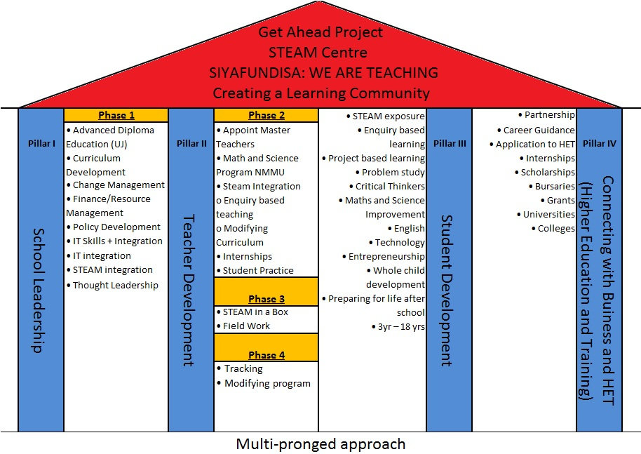

STEAM CENTRE – Potential Impacts on Students and Broader Community

* Get Ahead will become and educational leader in STEAM integration from Foundation Phase through to Matric. By connecting, math, science and innovation to real world applications and hands on experimentation, the knowledge and skills acquired by students at Get Ahead will be a reason to attract and retain the top students in the community
* The STEAM Centre will unite the GAP Schools as a single entity with clear purpose and direction creating a source of pride and community
* Developing students who are confident and ready to problem – solve through project- based learning and visual, auditory and tactile learning models. These interdisciplinary skills are vital for living in a knowledge – based technological world.
* Encouraging students to exercise their musical, spatial, bodily, interpersonal intelligences supported staff that are full trained and engaged. Students will discover their right and left brain hemispheres through connecting the ARTS with Maths and Science and Technology
* Supporting students by providing the time and space to discover their interests and individual strengths, leading them to more successful future outcomes
* Attracting teachers from over schools in the district by providing access to training, resources and professional development in STEAM subject areas
* Providing educators with a **cross-curricular resource centre** providing teaching and learning materials and include follow-up in-school teacher support
* Generating a c**ommunity hub**, where internet access and computer tools can support young people in the pursuit of post secondary training and accreditation, while also supporting adults in the community with literacy training, computer skills or other employability skills building programs

Measurement and Evaluation of success

We will know the STEAM Centre is succeeding in its mandate when we see evidence of the following impacts/activities:

* Get Ahead is staffed by inspired teachers who love teaching at Get Ahead
* The retention rate of students improves as fewer students leave to go to Top Town schools.
* Overall academic result of students improve as well as improved Maths and Science results in Grade 12 which are sustained year after year
* More students able to enter into scarce skills careers like engineering and science.
* Students chose STEM subjects for Grade 10
* Discovery and development of artistic, music and performing arts talent
* Get Ahead showcases not only student’s talent, but also hosts external science shows, art exhibitions, and cultural events.
* Get Ahead is an educational hub for all schools in the district (top town and township schools) in the community who access the STEAM Centre for specialized learning programs
* The teaching/education community utilizes the STEAM Centre for professional development through ongoing specialized training opportunities, formal courses, and professional conferences
* The community is accessing the space to support their professional development or using the lab to pursue their post secondary studies
* Business and industry use the space to develop and train their staff
* Along with educational partners like DBE, DHET, Rhodes University, NMMU, GMMC, UJ and Ryerson University we continue to develop meaningful connections and initiatives that support student learning and success as well teacher professional development that improves the overall quality of education offered in the district