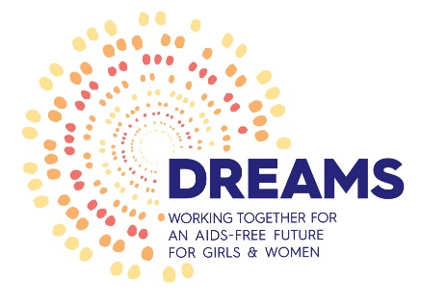
PAVING Project: Community Mobilisation & Norms Change under the DREAMS initiative

Background: The PAVING Project focuses on community mobilisation and norms change under the DREAMS initiative in the context of a multi-sectoral response to HIV and GBV. The project is providing technical assistance (TA) through capacity building of selected Ward Committees, traditional/local leadership, Community Based Organisations (CBOs) and other NGO partners using the SASA! Model in priority wards of 3 districts in KZN and Gauteng. The skills transfer, through capacity building, has been designed to ensure sustained ability by traditional/local leadership, CBOs and other NGO partners to facilitate primary prevention of GBV programmes beyond the DREAMS life cycle.

Objectives of this SASA Training:
- To create a safe environment for communities and individuals to raise challenges and gaps around Gender Based Violence and HIV prevention.
- To promote networking and social contacts among different stakeholders in the community
- To promote PAVING/DREAMS and ownership of the SASA! intervention model and accountability amongst communities
Desired outcomes:
- Improved level of knowledge and understanding of impact of GBV and HIV in communities
- Improved working relationship between local service providers and communities
- Improved visibility and commitment by community leaders on addressing GBV and HIV prevention
Target group: Ward 3,5,6,11,12 & 90.

For more information, please contact Andrew Sethole (PAVING/DREAMS SASA! Community Activist) on 011 057 5805/076 902 9304

“For every woman and girl violently attacked, we reduce our humanity. For every woman forced into unprotected sex because men demand this, we destroy dignity and pride...” Nelson Mandela

