Project Concept paper

CONSTRUCTION OF A study CENTRE FOR THE VULNERABLE KIDS
In KIBWA NABWERU UGANDA
BY
MARIA AND WITH SUPPORT FROM

COALITION FOR HUMAN RIGHTS EDUCATION
(COHRE)

Compiled by
Project Team
Coalition for Human Rights Education
P.O. Box 14060 MENGO Kampala
Hoima Road Zone 2 Nansana, Wakiso
Tel: +256703548069
Website: www.humanrightseducationuganda.org

E-mail: cohre2@gmail.com JULY 2017

1.0 Introduction and Background
1.1 Vulnerable Children in Uganda
According to a report by UNICEF (May, 2012), an alarming number of young children in Uganda are surviving on Urban harsh streets; scavenging for scraps of food, begging, stealing or doing the most menial of jobs. This is simply because some of them were abandoned by their families who either couldn’t or wouldn’t look after them: others were orphaned through AIDS, others are trafficked from the North Eastern part of Uganda notably Karamoja region.
And according to (child poverty Report 2014), Child Poverty in Uganda is at 55% for under-fives, and 38% for 6-17 year. Over 500,000 children in Uganda are orphaned. This means that over 57% lack environment to which child growth is favorable as most live in multidimensional poverty, and are deprived in crucial areas of their rights, i.e. health, nutrition, shelter, education, child protection, information and parental
Many children grow up harshly either because there are no nearby schools they can go to develop their thinking or simply because some of them were abandoned by their poor families, society and state. And a good number has grown up with parents that couldn’t or wouldn’t look after them or simply were orphaned through AIDS. As a result the population of the children involved in child slavery and child laboring at the hands of the people supposed to take care of them is alarming. With about 7% of reported children crime being sexual abuse and almost 30% married off and 23.7% experience a pregnancy before they see their 18th birthday.

All children need someone they can talk to, love and trust to develop a sense of self-esteem and belonging, attain education and skills. These children, many of whom have never experienced a kind word or deed in their lives, simply drew the wrong card in life. There is a huge need for Uganda's vulnerable and orphaned children to be provided with a safe and loving family that can provide an environment for them to be children and grow up as children. It is with such situations in mind that the Coalition for Human Rights Education (COHRE) has set as one of its objectives to look and provide a more conducive environment for the vulnerable and orphaned children in order to advocate for their rights and provide an avenue where they can play, learn and develop their inborn skills and learn more with love and care.
However due to a lack of space and funding, we can only support children on an already formed platform. This is why Maria’s St Ann captured our attention.
COHRE intends to demarcate and develop the classroom block on Marias donated land and supervise its construction that will work towards helping in educating, informing, counseling and resourcing information that helps these children towards life improvement and assist in helping them develop as children.
COHRE has focused its attention to services that have demonstrated efficiency, cost effectiveness and having a significant impact on improving the lives of children in need by liaising with willing schools to offer education for free in Nakaseke with Christ on the rock and Nansana Kampala with Brain Trust School Nansana and on the list we would like to add St Ann.
COHRE believes that creating a this classroom Block will give children stability, better focus and a more resourced environment to help and support their growth and well being. This is because we believe that among the most vulnerable groups, children suffer great injustices of state economic neglect and social injustices and save these children from exposure to harsh realities of living helplessly and poor.
2.0 Focus of COHRE
2.1 Children Centre and educational Block
In addition to other projects, COHRE’s core project is the centre for orphaned, in need, and vulnerable children. COHRE’s primary focus is to provide care and education for the underprivileged children in society, priority is given to the children for whom education is a dream: Orphaned children and vulnerable; abandoned children, children from remote villages whose families have inabilities and are helpless and to whom the growth of children is a burden by lack of means.
At this centre, children are to be provided with a secure environment, care and education. The children, who are abandoned, orphaned and those in abusive situations need stability and support of volunteers and the community. The different skills these children may have will be identified and developed at this School and help prepare them to state funded schools through placement. This will enable them to develop active citizenship skills and an increased prospect of becoming self reliant adults.

2.2 Project Objectives
- To provide a secure environment and education for under-privileged children such as abandoned children, orphaned, and those in dire need—and give them a backbone and an opportunity to live better lives.
- To promote awareness of the rights of children to education and life and make aware the importance of children care.
- To rehabilitate these children into believing in themselves and give them the confidence to be what they want to be through skill development and training.
- To allow children growth and development through interaction and counseling in order to promote positive living and better lives.
- To raise awareness and help prevent abuse through training children in human rights education to encourage awareness of their rights and capacity to learn to say no to abuse and develop ability to respect the rights of others.

- To help reduce levels of human rights violations to these children and set a national and family example towards love, respect and care.
- To initiate formal and informal activities such as sports activities which will keep the children busy and away from engaging in actions that lead to stress, trauma, isolation and vulnerability.

2.3 Project Outcomes
- The benefits will include increased awareness of how to appreciate children and create a peaceful and stable development in terms of awareness of the role of children in the community.
- Training programs will address a variety of institutional, organizational and individual skills thus improving competencies and efficiency in handling their potential and development.
- Most importantly, the children will gain knowledge, respect, and awareness of their individual rights in life and how to safe guard the rights of others.
- Gain a stage that prepares them to better and balanced educational accessibility.

Linkages between COHRE, Service Providers and the Communities
One of our strategies will be to create a continuous relationship between St Ann, education service providers, and the community leaders, parents and school authorities. This will enable the peaceful co existence and help community understand the work of the project through giving counseling and interaction in our joint discussions, mobilization and talking to the children in and out of the centre during outreach participation.
2.4 Activities
- Construction of an open hall and partitioning of the rooms with plywood.
- Fencing of the children’s school block as a security measure so as to have a strategic control of the children.
- Development of a curriculum and training materials into the different syntax of methods.
- Liaise with the neighboring schools and training institutions in order to provide shared education and training services to the children.
- Conduct social events and public dialogues for orphaned children to express their views
- Project monitoring and evaluation

1.2 COHRE – the Organization
Coalition For Human Rights Education (COHRE) is a registered Non-Governmental and Non - profit organization comprising of members drawn from diverse backgrounds who have come together to promote human rights through teaching communities basic human rights and help change the attitudes and welfare of those affected children, women and social neglected minorities. It was formed in Uganda by Seven individuals to support people who have been victims of serious Human Rights violations in order to learn about their experiences and to help improve their well being, while at the same time, teaching people throughout the Country how to work together to develop their knowledge and social understanding of the meaning of Human Rights, and how to prevent abuse. We believe that awareness of one’s rights can help guard against excessive power of individuals exercising inappropriate control over other lives. This knowledge can positively create a fairer, more tolerant society hence giving everyone a chance to flourish as a human being.
The multidisciplinary members comprise of teachers, financial consultants, and Social workers. In the past, COHRE has resourced funds and donations from different well wishers to help in equipping needy learning centres and associations with furniture donated by University of western Sydney to centres and schools that we partner with in our effort on human rights awareness programs.
To encourage its beginning and with support from Australian Council of Human Rights (ACHRE), COHRE was donated financial support from Rotary of Sydney. The donation helped in securing registration and assisted in our social services to the community helping the HIV positive women and children and supporting aggravated minorities and LGBTI persons. As part of our contribution to fighting injustices and violations of human Rights, COHRE leadership has taken part in international conferences to present core papers and has collaborated with LGBTI organizations in the country to brainstorm ways to end harassment.
MISSION:
To promote and improve human rights situations, health and livelihoods of the people and marginalized groups through dialogue, debate, advocacy with and for the vulnerable and marginalized groups for the betterment of individual and community.
VISION:
A society where knowledge and awareness creates a well informed citizens to influence pro vulnerable, pro marginalized, equitable living and sustainable de Our Values:
Human rights and justice:-
We base our work on respect and dignity for all people.
Sustainability
Develop to meet basic human needs through empowering our members, community and our partners.
Equality
We work for marginalized and the vulnerable to offer a voice that can be heard regardless of human differences.

Education and knowledge sharing
Our organization is aimed at learning from human rights errors and educate through shared experiences.
Cooperation and partnership
We believe that to succeed we need to work together and partner with other organizations and individuals through interaction, workshops, seminars and capacity building.

2 Project Description

2.1 Aims and objectives of COHRE
- The main aim of COHRE is to explore human rights failures and educate through experience by working hand in hand with survivors of human rights failures and abuse in order to use their experience to help educate others hence reduce the existence of neglect, abuse and abandonment.

- To reduce human rights abuse through education and sensitization aimed at sharing knowledge towards better living and in so doing create a more secure and happier environments with humane wisdom, knowing how to improve their lives and those of others.
- To actively contribute towards and participate in functional literacy programs and skill training for the underprivileged and marginalized members of the community in order to fight extreme illiteracy and promote awareness aimed at attaining basic human needs like shelter, food, medicine, education among many in order to better lives through learning.
- To improve knowledge about human rights and encourage understanding the relationship between human rights and the respect of rule of law in order to create a stronger society empowered to realize own human rights and those of others and understand effects of peaceful and respectful living.
- To actively develop and promote strong networking schemes with other organizations, Government, local and foreign NGOs and the community for the fulfillment of the above objectives and to liaise, coordinate and otherwise co-operate with organizations within and without Uganda having similar objectives.

Activity schedule/work plan

Item | Activity | Timeframe | Assumption
1 | Feasibility study and getting permission from the local authorities for construction | December 2017 | Funds available
2 | Constructing an open hall | Feb -March 2018 | Materials are available and on site
3 | Partitioning of the hall into small rooms using plywood | April 2018 | No delays or in construction
4 | Construction of toilets | May 2018 | Materials on site and plans completed on time
4 | Fencing with perimeter wall barriers  To protect centre | June 2018 | Availability of material and funds
5 | Construction of tanks and water pumps | July-August 2018
6 | Monitoring and Evaluation | September 2018 | The advisory board meetings are regular

Please Note:

1. Appropriate environmental, construction, and occupational health and safety standards will be in place in the management of safe work practices and in the application of local environmental and building code standards. Uganda’s school council is being contacted for permission and renewal of operational permit
2. The requisite acquittal reports on conclusion of the project will include evidence of expenditure, such as receipts and written reports on tangible outcomes.

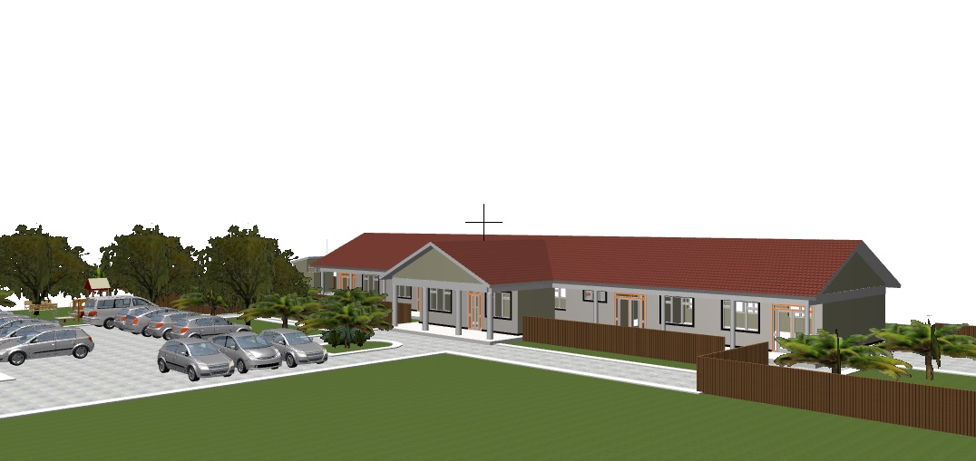

No. | Item | No of Units | Unit Cost USD | Total USD
 | WALL
1 | Bricks | 3000 | 0.075 USD | 225 USD
2 | Cement | 15 bags | 10 USD | 150 USD
3 | Sand | 3 trips | 36 USD | 108 USD
4 | Labour | 10 Days | 30 USD/Day | 300 USD
 | Sub Total |  |  | 783USD
 | MAIN-BLOCK
1 | Cement | 30 bags | 10 USD | 300 USD
2 | Sand | 10 trips | 36 USD | 360 USD
3 | Bricks | 20000 | 0.075 | 1500 USD
4 | Timber | 50 pieces | 20 USD | 1000 USD
5 | Others i.e. binders, poles ,nails | variety | General | 1000 USD
6 | Iron sheets | 50 pieces | 25 USD | 1250 USD
 | Sub Total |  |  | 5410USD
 | Others
3 | Water tank | 1 | 400 USD | 400 USD
4 | Compound grading | Hire | 500USD | 500USD
6 | Labour |  | General | 1300USD
 | Sub Total |  |  | 2200USD
 | Latrine
1 | Cement, sand, stones | 1 trip each | general | 145 USD
3 | Labour |  |  | 108 USD
1 | Monitoring and evaluation | 1 Consultant | 500 USD | 500 USD
 | Sub Total |  |  | 753 USD
10 | Total Cost |  |  | 9146 USD
Budget

This budget is only indicative and the figures can change with changing costs, inflation rates and as the strategic planning meeting may decide. This rate was as per today’s Dollar rate of 1 USD-3395 Uganda Shillings.

