PARKVIEW ORPHANS ACHIEVERS SHELTER PROJET(POAS)
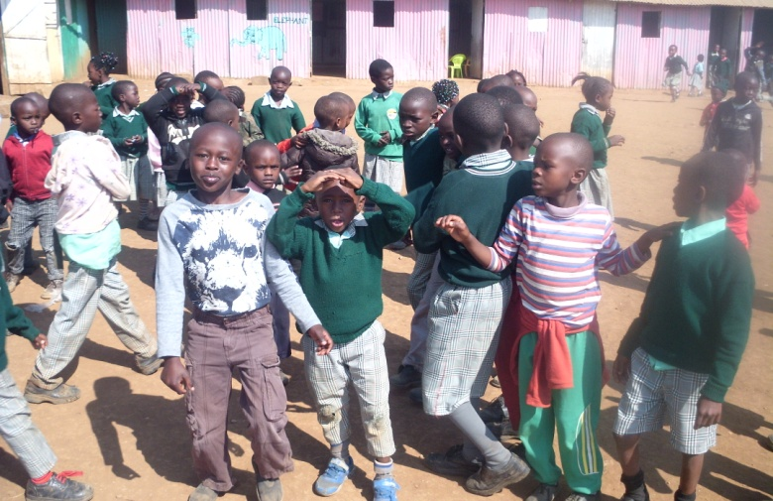
MOTTO
TOGETHER LET’S ERADICATE MARGINALISATION
Parkview orphans achievers shelter is a none profit and a non government organization consisting of a school feeding center counseling and psycosocial center for HIV and AIDS orphans
we offer formal and informal education for the orphans and also offering them with basic necessities at our center
We operate at tuala township oloosirkon kitengela sub county in kajiado county
We Operate in order to provide the orphans with a better life livelyhood and the total welfare of their life so that they can enjoy their life like the ordinary children
We partner with the community and well wishers who would wish to join us in providing a better life for those innocent souls guided by the love of God, we are obliged to offer those orphans a better life in accordance with the international children rights for eradication of poverty in the community
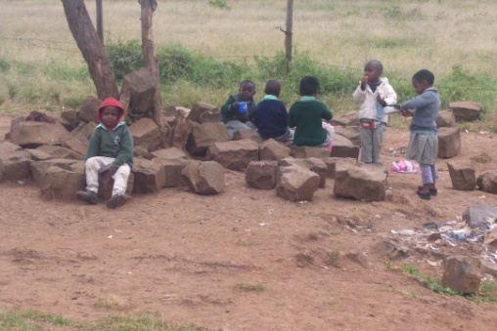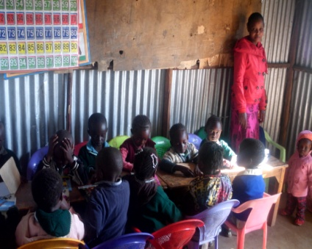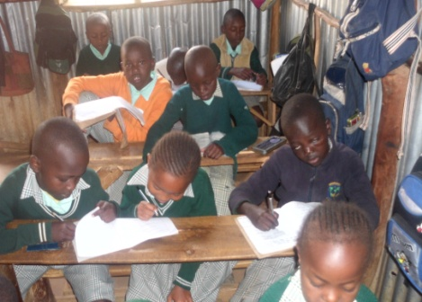

OBJECTIVES
- To promote access to education and basic necessities to orphans and venerable children
- To equip the children with suitable learning materials
- To train and nature children providing them with suitable skills to be self reliant in future
MISSION
Restore, encourage give life and hope, mentor and transform the broken heart of neglected abandoned and rejected children in the society
VISION
To build a huge global childrens shelter programme, rescue and life transforming and restoration center
APPEAL
We are appealing to any peron, organization or company to join hands with us to help those unfortunate children to enjoy ordinary life like the normal children in the society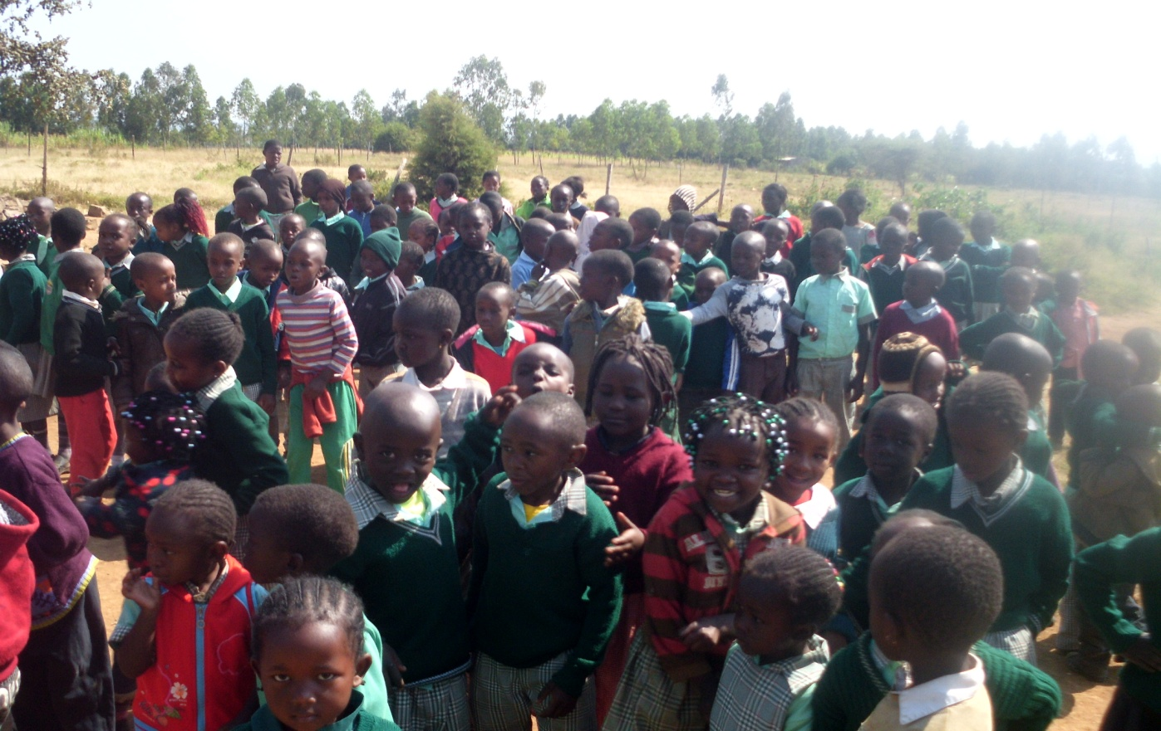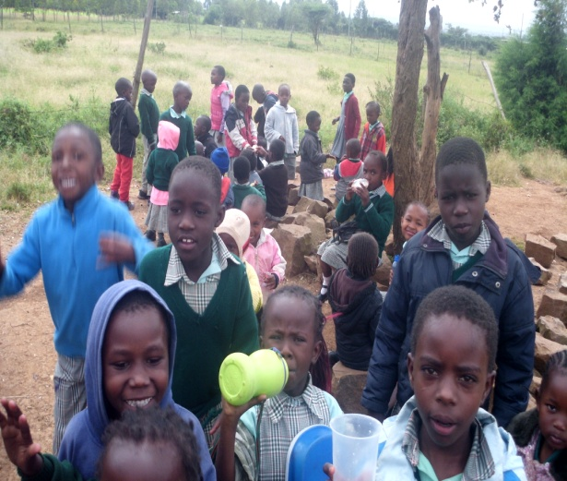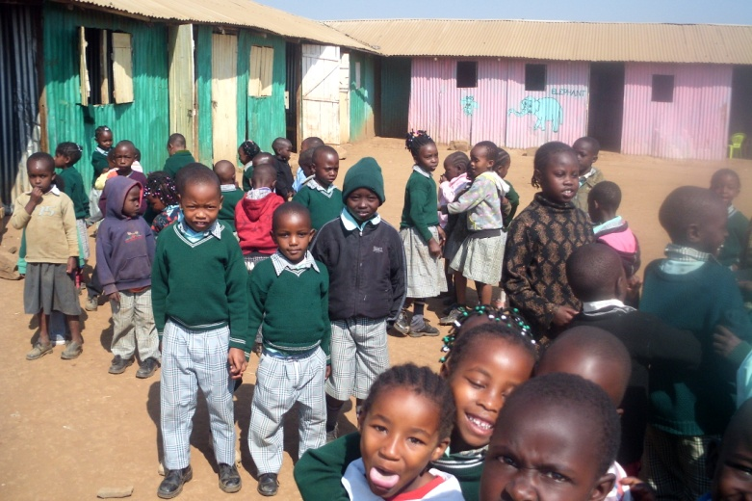
SUPPORT US TODAY
Banking account details co-operative bank of Kenya
Account No 01128504192800
PARKVIEW ORPHANS ACHIEVERS SHELTER PROJET(POAS) SPECIAL SCHOOL PROGRAM
OLOOSIRKON-KAJIADO COUNTY-KENYA
2 KM PAST NAZARENE UNIVERSITY
P.O BOX 1135-00511,ONGATA RONGAI
MOBILE: 0725733814/N 0734460513;
EMAIL:parkviewachieversschools@gmail.com

