Friendship for the Rohingya

Rohingya Response
The humanitarian crisis caused by escalating violence in Myanmar’s Rakhine State is causing suffering on a catastrophic scale. As of 27 January, 688,000 new arrivals have been registered since 25 August (UNOCHA). In response to the crisis, Friendship has setup clinics, maternity clinic, WASH (Water, Sanitation and Hygiene) infrastructures, social spaces for women and children, bamboo bridges, solar for static clinics, and billboards to create awareness on ‘ensuring dignity for all’.

Working Area Map
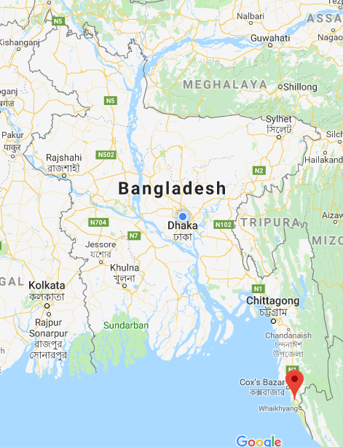 | 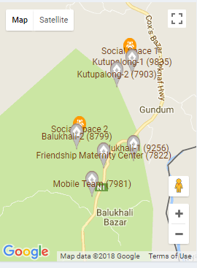
Cox’s Bazar, Bangladesh | Friendship Intervensions in Ukhiya Upazilla, Cox’s Bazar

Friendship’s Response for the Rohingya
In service  Health services 143,944  Food and nutrition packet distribution 18,340  Static clinic 11  Friendship Maternity Center 2  Bamboo bridge 5  Dignity billboard 30  Social space 9  Deep tube well 51  Latrine 150  Bathing Space 150  Solar for static clinics 8  Installation of solar street light 60 | In progress  Static clinic 2  Social space 2  Bathing Space 60  Latrine 60  Deep tube well 20  Installation of solar street light 20

Selected Videos
- Addressing the urgent needs of the Rohingyas
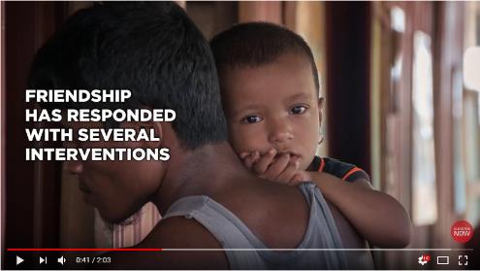

- Friendship Health Clinics providing essential health services for Rohingyas
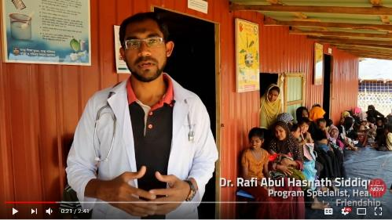

- "I have never seen anything like this"- Marc Elvinger, Chairman, Friendship Luxembourg
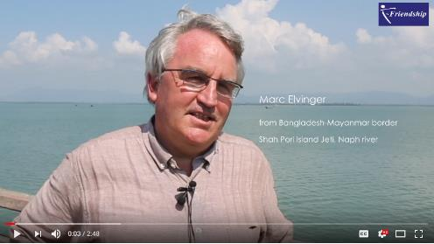

Selected Blogs
- Field visit in the Rohingya camps in Cox’s Bazar, Bangladesh - by Marc Elvinger, Chairman Friendship Luxembourg
- Water is Life
- Born in Bangladesh
- Friendship Clinics Offer Badly Needed Health Services
- Dignity for All
- Wanton water and Rohingya floods- Bangladesh in double jeopardy

Photos from Rohingya Camps
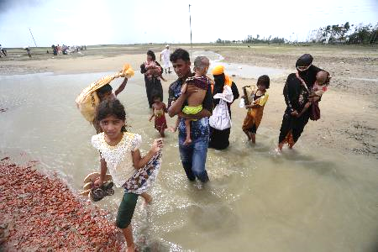  Arrival of Rohingya | 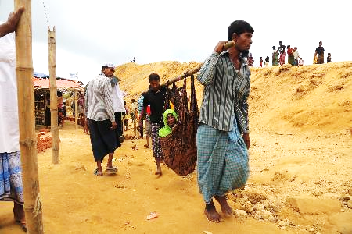  Carrying an elderly woman
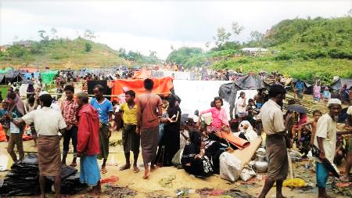  Rohingya camp during August 2017 | 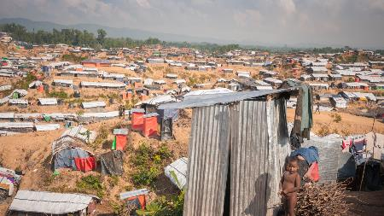  Rohingya camp
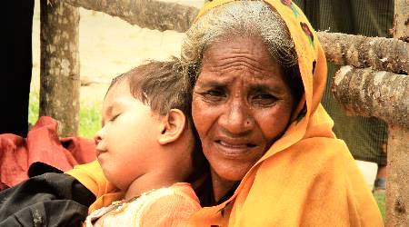 | 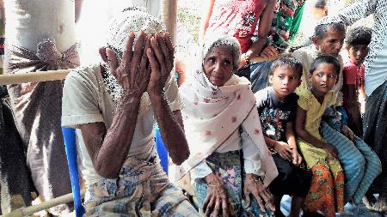
Waiting for help | Rohingya people waiting for health service
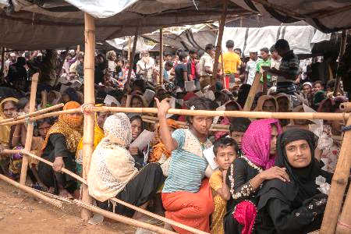  At relief distribution camp | 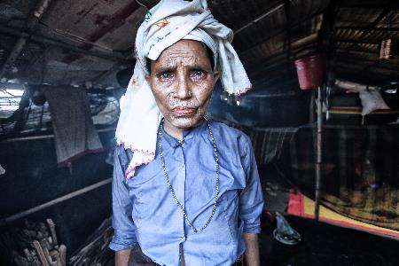  Rohingya woman

Photos of Friendship Rohingya Interventions
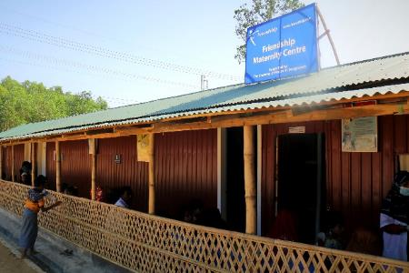  Maternity Clinic | 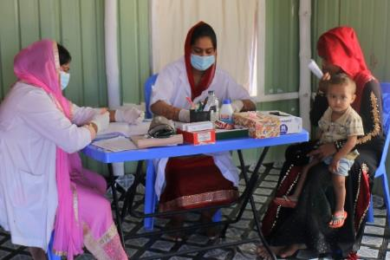  Health Clinic
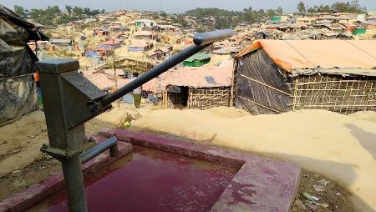  Deep Tube Well | 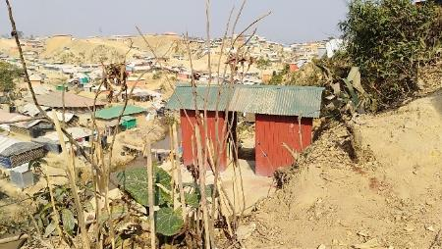  Toilet, Bathing Space and Vegetable Gardening
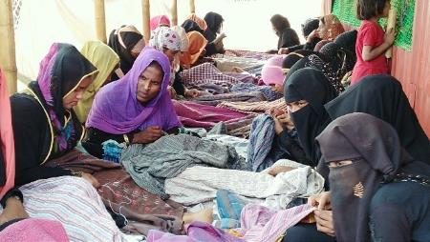 | 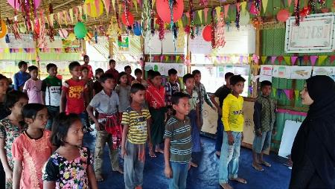
Women Sewing at Social Space | Child Friendly Social Space
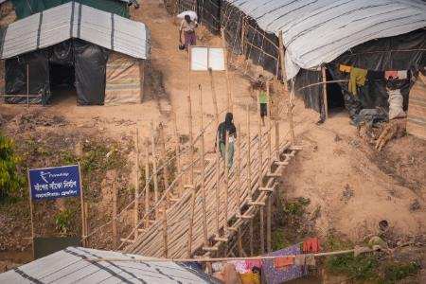  Bamboo Bridge | 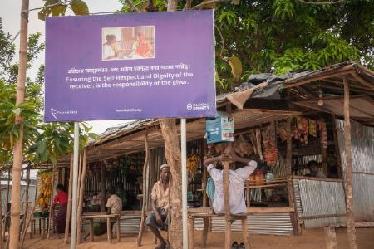  Dignity Billboard

Friendship Overview
Friendship is a needs-based non-government organization (NGO) that aims to strengthen marginalized communities and empower people to reach their full potential through a sustainable, integrated development approach. Founded by Runa Khan in 2002, Friendship began with the innovative concept of a floating hospital with the vision of carrying healthcare to the ultra-poor in the remote communities. Since then, Friendship has developed a structured, three-tier healthcare system to provide comprehensive quality healthcare and information. Recognizing that the broader goal of enabling these communities to improve their living conditions and gain control over their lives requires more than healthcare support alone, Friendship has progressively built its distinctive integrated community development model, which includes: Health, Education, Climate Change Adaptation and Disaster Management, Inclusive Citizenship, Sustainable Economic Development and Cultural Preservation. Friendship supports communities mainly in the shifting northern river islands, known as “Chars”, of the Brahmaputra and Jamuna rivers and in the coastal areas of the Bay of Bengal.

Selected Videos
- Friendship: Nurturing Dignity and Hope
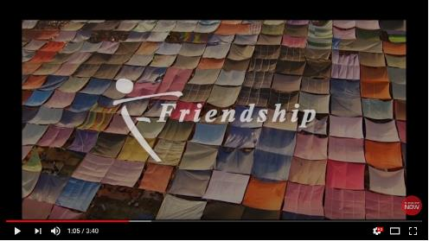

- Climate change in Bangladesh - a film by Yann Arthus Bertrand
- Friendship receives Aga Khan Award for Architecture 2016
- Michael Hall (/Dexter) visits Friendship’s Hospital ship
- Greenpeace’s iconic Rainbow Warrior II becomes a hospital ship
- National Geographic - Preserving Bangladesh's Boatbuilding Heritage
- “Voice of Bangladesh” - a documentary by Vito Labalestra

BROCHURES
- Friendship Overview Brochure
- Friendship Strategic Plan 2017-2019
- Friendship Annual Report 2016

