Friendship Rohingya Support Project Overview
Background to the Rohingya crisis
Bangladesh is experiencing one of the worst humanitarian crises in history, as of 15 February 2018, (ISCG) reported that almost 671,0000 Rohingya refugees have entered Bangladesh since the Myanmar military attacks. 58% of new arrivals are children and 60 per cent are girls and women including a high number of pregnant (3 per cent) and lactating women (7 per cent). The estimated total affected population of existing refugees, new arrivals and host communities is 1.2 million people.
Violence in Rakhine State which began on 25 August 2017 has driven an estimated 671,000 Rohingya across the border into Cox’s Bazar, Bangladesh. The speed and scale of the influx has resulted in a critical humanitarian emergency. The people who have arrived in Bangladesh since 25 August came with very few possessions. They are now reliant on humanitarian assistance for food, and other lifesaving needs. The Rohingya population in Cox’s Bazar is highly vulnerable, after generations of statelessness and no access to health or education before the severe traumas inflicted by the Myanmar Army, Police and local Rakhine Buddhist mobs. They are now living in extremely difficult conditions the majority do not have sufficient food, shelter or cooking fuel.
According to the United Nations, the humanitarian crisis is “the fastest growing refugee crises” A visit by UNHCR (United Nations High Commissioner for Refugees) in the area found “people suffering real hardship and some of the most difficult conditions seen in any current refugee situation”. U.N. Human Rights chief Zeid Ra'ad al-Hussein said that he strongly suspected "acts of genocide" may have taken place against the ethnic minority in Myanmar's northern Rakhine State since then. He also suggested that reports of the bulldozing of mass graves in Myanmar showed a "deliberate attempt by the authorities to destroy evidence of potential international crimes, including possible crimes against humanity."
Inter Sector Coordination Group, led by UNHCR & IOM, are working with the Bangladeshi government army, INGOs, and NGO’s to arrange essential shelter, food, water, medicine, sanitation, and protection. The overall humanitarian response for the Rohingya refugee crisis is facilitated by a sector-based coordination mechanism, the Inter-Sectoral Coordination Group (ISCG), established for refugee response in Cox’s Bazar. The ISCG Secretariat is guided by the Strategic Executive Group (SEG) that is designed to be an inclusive decision- Ministry of Foreign Affairs leads the coordination of the overall Rohingya crisis. The Bangladesh Army has taken the lead of the coordination of the relief and other intervention efforts of all the actors and is arranging space for the afflicted population in temporary settlements. But the resources currently available to help the community are simply inadequate.
Population movements within Cox’s Bazar remain fluid, with increasing concentration in Ukhia. People arrived at the new site before infrastructure and services could be established. Humanitarian partners are now building necessary infrastructure in challenging conditions, with extremely limited space.
Conditions are so cramped in the settlements that some of the shelters have been built on 45-degree slopes. The close quarters fall short of accepted international standards for refugees. Some 91% live in highly congested makeshift plastic tent settlements and camps in hill areas, the refugees are in urgent need of emergency food and nutrition support. Children, including newborns, are dying every day of pneumonia and water-borne diseases. In many cases they have not received any treatment or medication at all, as access to medical is banned for the Rohingya in Myanmar.
The speed and scale of the influx has placed extensive pressure on public services in host communities and may have a long-lasting environmental impact. Firewood collection has exacerbated ongoing serious deforestation in areas surrounding refugee camps, resulting in a dwindling supply of cooking fuel. Steep hills (also elephant highways) that were once covered in trees and foliage have now been cleared to make way for the tarpaulin shelters. Now bare and sandy, the banks have become more vulnerable to landslides in rainy conditions.

Families have also been digging up the roots to use as firewood for cooking so there is nothing holding the soil together. The soil is eroding, the rains are likely to start falling in April and could last until September, while May and June tend to be the wettest months. The flash floods could leave hundreds of thousands vulnerable to disease and unable to get aid, as flooding will cut off parts of the settlements, the IOM has warned.

Although there is discussion about repatriation and an agreement has been signed between the governments of Bangladesh and Myanmar, hardly anybody believes that in the present circumstances any significant number of Rohingya are likely to be taken back by the authorities in Myanmar and, indeed, be at all ready to voluntarily return to the country. Friendship is thus envisaging all its activities in favor of the Rohingya with the mindset that this crisis is not going to be over soon and that every intervention should be planned so as to be sustainable in the mid- if not long term.

Friendship’s analysis of the current Rohingya situation
Friendship started its intervention with Rohingya from early October 2017, primarily in the field of Healthcare, WASH, and Child Friendly Spaces (and later entered into reforestation and solar electrification).
Our assessment of the most crucial and urgent needs to be addressed are as follows:
- A total of 831,597 people have settled in the camps of Kutupalong and Balukhali including the expansion zones - with the population still increasing, though at a significantly reduced pace for the time being. New arrivals have been settling deeper into the camps in remote areas with roads and infrastructure yet to be completed by the army. They thus have even more difficulties in accessing the limited services that are made available.
- People have cut down trees in the hills in order to create living space, (fuel for cooking) thus increasing risks and posing a great threat for the environment. Since the monsoon season has been extended this year, there is a high risk of landslide, which could cause mass-scale casualties in the camps. Moreover, the area is cyclone prone which poses a major threat for the fragile shelters.
- Severely inadequate and poor arrangement of shelter for the new Rohingya people. Shelter kits have been provided by IOM to some families, but many families have not registered and have made their own shelters using low-quality tarpaulins and bamboo. Children are succumbing every day to pneumonia, measles, skin diseases and water-borne diseases. Several outbreaks such as dysentery and diphtheria have occurred.
- In many cases, several families are sharing one tent (made of low quality tarpaulins) because of inadequate arrangements for shelter. Because the shelters are closely packed together and open fires are used for cooking inside, a fire outbreak could have devastating results in the camps.
- There is a severe crisis of clean drinking water and a woeful lack of toilet facilities. Many of the initially and hurriedly installed latrines and water pumps are inadequate. The water and sanitation (WASH) situation is at a dangerous level and there is a high risk of outbreak of widespread waterborne diseases especially with the upcoming monsoon and cyclone season.
- The nutrition status of children, pregnant women and nursing mothers is at the lowest. Because of lack of availability of nutritious food, many mothers are unable to breastfeed their new-born babies.
- Many have lost relatives and are traumatized. The situation is worse for the children, many of whom lost their parents and siblings or even worse saw them dying in front of their eyes. Unless they receive counseling and similar support, their future may be one of mental disorder. There is also the real possibility of increasing domestic and internal community violence – as the host community are experiencing higher food and infrastructure costs, posing a major threat for society.
- There are children living on their own because they lost both parents back in their home country or have lost contact with their families and now themselves are struggling to survive because of lack of food and medicine.
- More than 70% of the inhabitants in the camps are women and children as the majority of the young and middle-aged men have been the victims (either killed or lost) during the recent violence.
- There are thousands of newborn babies, nursing mothers and pregnant women who have limited access to required medical services, food, and healthcare. Many women also have babies that are not their own, as they picked them along their escape routes from deceased parents.
- Increased concern for worsening of safety and security particularly for women and children at night in the existing and new camp areas. Since the settlements are mostly beyond the reach of the national grid system, there is no access to electricity and lighting systems. The risk of abuse and exploitation of children and women is high, as is the risk of accident.
- With rainy monsoon and cyclone season there will be acute need for warm clothes (for new born & young children under 12, Jackets and pullovers for adults) and blankets for the afflicted community, most of whom ran in fear with only the essentials they were wearing
Ongoing Responses from Other Organizations:
- Medical services are being provided by Upazila Health Complex, International Organization for Migration (IOM), Red Crescent Society of Bangladesh, Médecins Sans Frontières (MSF), International Federation of Red Cross and Red Crescent Society, and Action Against Hunger (ACF) in the forms of both hospitals and emergency healthcare from makeshift centers. Ad-din Hospital and BRAC started their activities in the shape of “Emergency Medical Service” in the area. The numbers are still inadequate and cover only a limited number of Rohingya living in specific sections of the camps. More importantly, due to geographical constraints some agencies mostly reach areas close to the Ukhia- Teknaf main road and as such communities living farer away from the main road (at a distance of 4-8 kilometers in areas of difficult access) are at risk of being deprived of basic healthcare. New roads to create access will be finalized by end of March.
- Nutrition support is lead by UNICEF and supported by Action Against Hunger (ACF).
- The Department of Public Health Engineering (DPHE) & Gonoshasthaya Kendra are providing safe drinking water. Water and sanitation support is also provided by BRAC, IOM, ACF, TIKA (Turkish Cooperation and Coordination Agency), NGO forum etc. However, water points and latrines are highly inadequately available, women and children walk long distances up hills carrying water. Due to long distance from the main coordination points and absence of walkable roads, some of the agencies have experienced challenges in mobilizing the required logistics and manpower for the construction of water and sanitation points in the more distant parts of the camps.
In addition, many of the tube wells installed early in the process are now running dry because they have not been deep enough to cope with the huge demand for water and the water at the higher surface level has been exhausted. Similarly, many of the latrines initially installed are insufficiently deep and thus already not functional.
- WFP (World Food Program) is running an extensive food distribution program, access to food Aid is through registration cards, coordination for distribution at specific points is conducted by Bangladesh Army. The distribution of food contributed by individuals and informal groups is being properly managed by the Army. However, the overall scarcity and variety of food remains.
- Reproductive health services are being provided by UNFPA.
- Shelter kits are being provided by IOM & UNHCR, however there is still significant short fall
- There is limited intervention to help people recover from trauma
- Limited number of agencies are working in the field of electricity or lighting. However, GBV safety and security remain a major concern.

Friendship Rohingya Response

Friendship started its operation based on its analysis on needs and as per the Refugee joint response plan. Friendship’s intervene includes the following locations in Ukhia sub-district of Cox’s Bazar:
- Kutupalong
- Balukhali

The settlements are divided into individual camps and zones within camps.

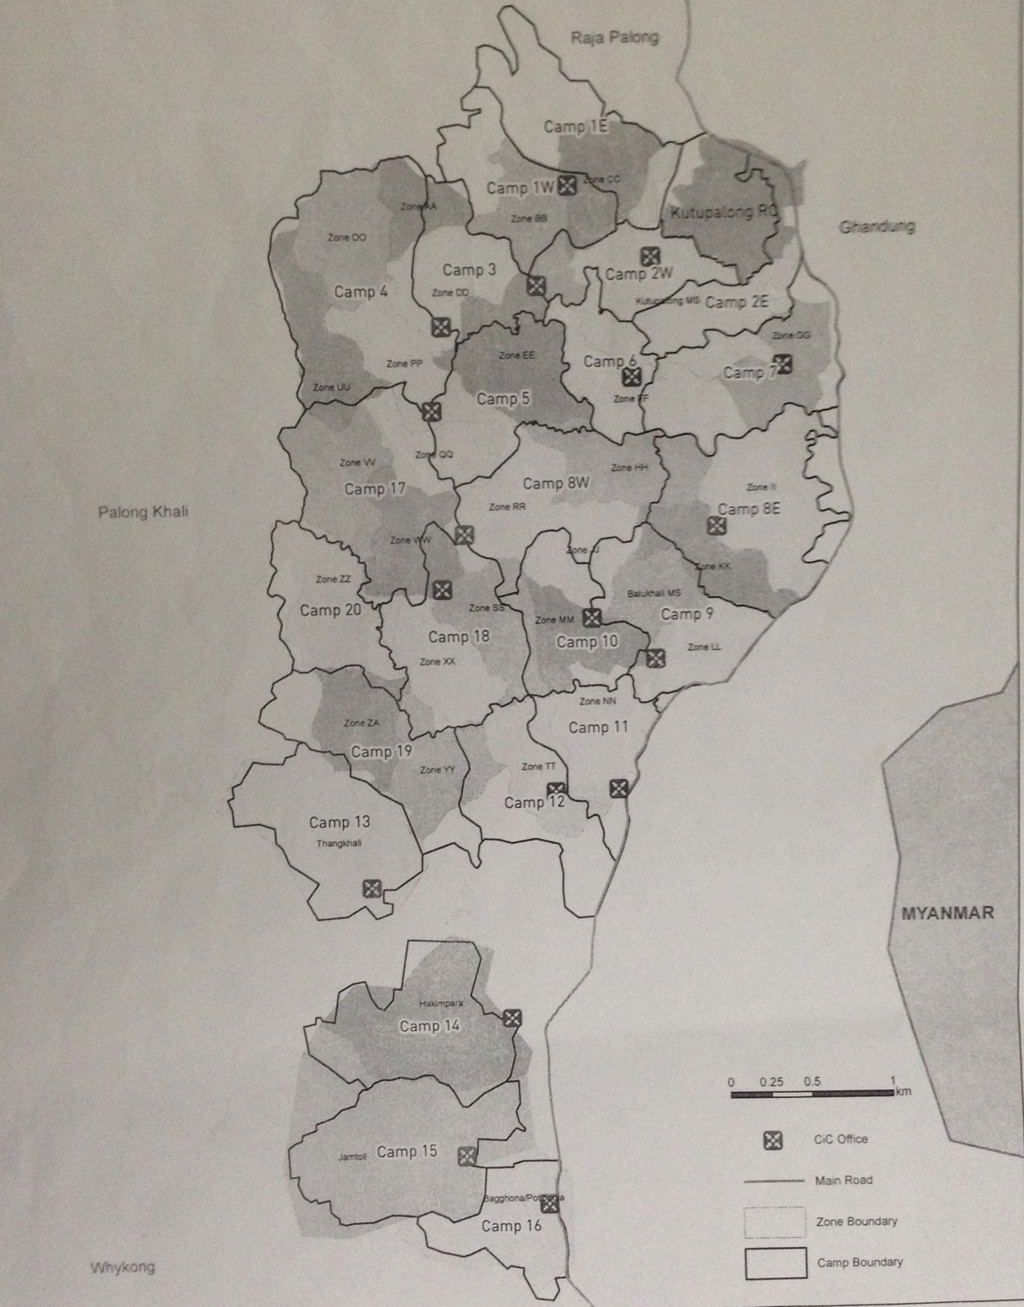

Figure: ISCG zones and camp division Rohingya Refugee in. Source: ISCG Camp Boundary in reference to Zone boundary (as at 25th Jan 2018)

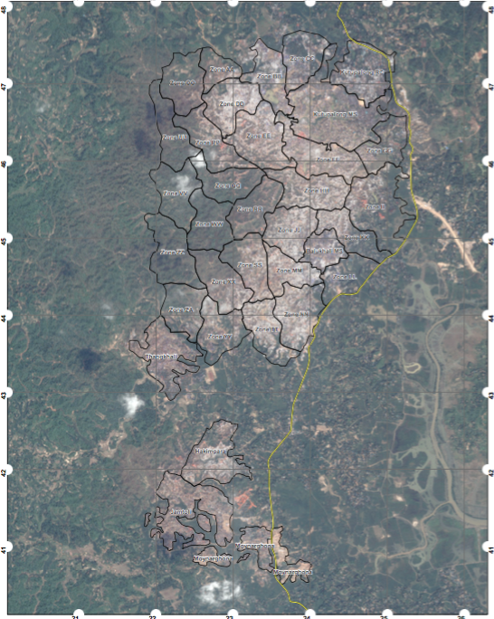

Figure: Drone image of zones division and population concentration of Rohingya in Kutupalong and Ukhia camps divided into zones Source: Relief Web

The following emergency interventions by Friendship are in operation in those zones.
1. Emergency healthcare support
2. Water, Sanitation, and Hygiene support (WASH)
3. Lighting solutions (for the safety and security of women and children)
4. Recreation and socialization centers for helping people overcome the aftermath of trauma
5. Ensure geographical connectivity and linkage
6. Reforestation pilot project

1. Emergency healthcare support: Friendship, over the years, has built a reputation as a reliable healthcare provider during major emergencies, such as floods and cyclones. Friendship’s innovative healthcare system and integrated service approach, coupled with a strong healthcare team both in the Head Office and Field Offices, can provide timely delivery of reliable primary and secondary care services in the remotest of locations during major disasters (including in coastal areas, where the Rohingyas are taking shelter)

Friendship is serving around 3,000 patients a day with its current interventions with Rohingyas. The healthcare services for Rohingya community include:

- Basic clinics:
Friendship has 8 such clinics up and running, whereas 5 more are under construction and will be operational by mid-May. Characteristics of basic clinics:

- There are 2 paramedics, 1 Friendship Community Medic-Aide, 1 organizer, one locally based cleaner, one security guard working from each of the basic clinics.
- The clinics are based out of the makeshift settlements so that these can be accessed by the most vulnerable of the Rohingya populace.
- The clinics run from temporary sheds.
- Business hours: from 9 AM- 4 PM.
- Serves approx. 100 patients a day.
- Provides primary healthcare, consultation, medicine, and referral services.
- There is one tube-well and two latrines in each of the clinics.
- A solar panel power source has been installed.

- Comprehensive Maternity Clinics: Friendship has constructed a comprehensive maternity clinic in order to serve child birth delivery cases (including cesarean). The clinic is envisaged to serve 150 delivery cases per month with 3000 beneficiaries receiving maternal and neonatal care services per month. Characteristics of the comprehensive maternity clinic:
- Operating from fixed facilities.
- There are a counseling room, Doctor’s consultation room, labor room (normal delivery), pre-operative, operation theatre (OT), post-operative, ward, pathology room, sterilization room and store room
- The entire structure is being made of prefabricated materials
- Open 24/7. There is enough staff to provide services throughout the day.
- There will be 2 medical officers, 3 paramedics, 3 nurses, 3 community based skilled birth attendants, 2 pathology technicians, 2 pharmacists, 1 counselor.
- Full-time gynecologist and on-call anaesthetist are going to be involved.
- There is an MoU with government hospitals so that referred beneficiaries from maternity clinic are provided with immediate health management services
- Service delivery: The following services are being delivered from the comprehensive maternity clinics:
- ANC and PNC checkup
- Normal and Elective caesarian delivery
- Screening, treatment, and referral for Sexually Transmitted Infections and Reproductive Tract Infections.
- Pathology
- Behavioral change communication.
- Counseling
- Nutrition of pregnant mothers and new-borns.
- Limited curative care for women and their husbands
- Basic neonatal care and Healthcare for under-5 children

- Birthing center: Since beginning of December, Friendship is operating a birthing center within the Rohingya camps. In terms of service delivery, the basic birthing center has all characteristics of comprehensive maternity clinic except for the fact that the basic birthing center does not serve caesarian cases. Instead, such cases will be referred to the comprehensive maternity clinic.

- Health Outreach: Friendship has all its operation in the hilly areas of the camp sites to provide services to the people settling deeper into the camps. The basic clinics have been established in strategically selected locations. However, given the hilly areas in the sites, it is sometimes difficult for pregnant and lactating women, children, people with disability, and elderly to walk such long distances to come to the clinics. To mitigate such problems, Friendship is currently implementing an extensive health outreach project in the Rohingya zone, which includes 24 satellite clinic teams at this moment. Each of the teams comprises one paramedic, one community medic-aide, and one organizer. The basic primary healthcare services along with ANC and PNC check-up, health education and patient referrals are provided by the satellite clinics.

- mHealth: Friendship, with the fund from ECHO (via ACF), has initiated the first and the only mHealth project till date in the Rohingya camp.
Friendship has been implementing its own mobile app based healthcare project in the northern riverine islands for more than 5 years now. With the help of the mHealth app, Friendship’s already existing Community Medic-Aides (community based female health workers) in the north are able to provide with more reliable healthcare services.
In the first phase of the project with Rohingya, Friendship has customized the already existing mHealth app, keeping in mind the unique healthcare needs of the Rohingya coming to Bangladesh (particularly the possibility of malaria, diphtheria, and other communicable disease outbreaks, and difficult referral process). Family planning, Sexual, Reproductive, Maternal, and Child healthcare are important components of the mHeath project with Rohingya. The follow-up in regard to ANC, PNC, neonatal care and maternal care, nutrition status, etc. has been more convenient and real-time because of the existence of the mHealth project.
12 teams have been trained on mHealth project so far and deployed in the Rohingya camp. Each of the teams has one paramedic (medical assistant) and one program organizer. The paramedics have been provided with medical equipment, medicine, and mHealth enabled mobile tablet.
The project started from January 2018 and has already shown strong impact in the Rohingya camps, mainly in terms of identification, follow-up, and referral of cases. Based on this successful pilot project, Friendship is envisaging to expand the project in the Rohingya zone.

Some other specialized key services already provided or envisaged to be provided from the health outlets in the Rohingya camps:

a) Child immunization and deworming: Within all its health outlets, Friendship envisages to arrange providing logistical support for creating access to the Government-run Expanded Program on Immunization, deworming, and Vitamin A capsule distribution. Piloting is already going to be started with 5 clinics.
b) Special attention for prevention of a Malaria outbreak: Because of its being in a malaria-prone area, the location is at serious risk of a malaria outbreak. There is adequate medication and treatment available across all health outlets in regard to Malaria.
c) Nutrition support for Children, Pregnant women and Nursing mothers: Nutritious food packages are distributed among pregnant women and nursing mothers and children under 5 years of age. So far, 700 nutrition packs and 700 medicine packs have been distributed.

Friendship healthcare infrastructure and facilities in the Rohingya zone can be reached/ accessed by more than 100,000 Rohingya.

2. Water, Sanitation and Hygiene (WASH) support

Most latrines and tube-wells by other agencies have been constructed close to the Ukhia- Teknaf main road, whereas many of the inhabitants in the more remote locations are deprived of anything like adequate access to water and sanitation. As per our initial estimation, the total number of tube-wells and latrines already installed within the Rohingya camps needed to be increased at least 3 times the present number in order to create adequate access for everyone.

Friendship has taken initiative in this sector in the following areas:

- Tube-wells: 60 deep hand-operated tube-well have already been installed. Each tube-well is accessible by 300 individuals. The tube wells installed in the early days of the crisis were not deep enough, and have stopped working, as the water at those shallow levels has been exhausted. Friendship is installing deep-level tube wells which are bored to a level of 650 – 800 feet (200 – 250 meters).
The presence of such deep-level hand operated tube wells is particularly important in hilltop areas, so that long journeys just to fetch water are avoided, particularly for women and elderly.
- Sanitation: 180 gender-segregated latrines are already constructed. The superstructure is made of tin sheets in order to ensure proper hygiene and to ensure that no environmental hazard occurs.
- Bathing space: A total of 180 gender-segregated bathing spaces are constructed so far.
Bathing spaces and latrines (along with hand washing facilities) are constructed in clusters and thus the resources and spaces are maximized.
- Provide hygiene support in the form of soap, bleaching powder, sanitary napkins, slippers, dustbins, etc.

3. Lighting solution: Friendship plans to have all its operation equipped with fully functional lighting solutions powered by solar energy. The lighting solution is functional at all basic clinics, maternity and birthing centers, child and mother friendly spaces. Lighting for WASH projects are underway.
In order to ensure safe and secure movement at night, particularly for women, children and the elderly, Friendship has selected location and worked on design to install solar powered street lights. Implementation of the lighting solution is underway and will be expanded subject to availability of more funds.

4. Child and Mother Friendly space:
Friendship wants to initiate one “comprehensive child friendly space” close to each of the 13 basic clinics, in order to ensure that both physical and mental health are taken care of simultaneously for the Rohingya communities. Indeed, Child Friendly Spaces are safe spaces where communities create nurturing environments in which children can be provided with psychosocial support, through an access to free and structured play, recreation, leisure and learning activities. Along with education, these activities provide structure, normalizing activities, safety, socialization, and adult supervision which strengthen children resilience and promote their well-being. These spaces prevent children from developing more serious psychosocial problems. CFS’s also provide a venue for monitoring protection or any other issues that may affect children, and ensure relevant referral to other services.
In each of the spaces, there are in total 3 batches of children and adolescents (depending on the needs and number of children, the number of batches may vary). Each batch of sessions span over two hours. Each of the batches has 50 children on an average, thus serving 150 children from each of the child friendly spaces. However, the number can vary depending on the number of children around the spaces.
On the other hand, there is only one group each day for pregnant and lactating women and adolescent girls.
The major characteristics of the activities targeted toward the children are:
- The children are provided basic education such as alphabets and counting via playing activities.
- Children learn rhymes and short poems to engage their creative side. The languages used will be mostly their native language Arakanese (Rohingya volunteer), coupled with English.
- Drawing and Art competition are held to help facilitate their education and sharpen their mental skills
- Games such as Kabaddi, Skipping, Running Races and some cultural games are arranged to keep them physically active and introduce the element of healthy competitiveness.
- The children are integrated with Friendship’s regular dignity program through story telling activities. Lessons on dignity are shared with them and they are encouraged to come up and share the dignity stories from their lives. Friendship recognizes that many of those children lost everything back in Myanmar and dignity is one thing that should be nurtured among them at an early age.
- There are Community Medic-Aides visiting the spaces on regular interval, providing hygiene lessons to the children, and checking the basic nutrition indicators for the children. As and when required, the children are referred to the clinics.
There are child friendly toilets and washing spaces for the children in each of the CFS’s. Children’s convenient access and usage will be ensured at those points.

5. Ensure geographical connectivity and linkage: The settlements are based mostly within areas of small hills. Sometimes it takes 1-2 hours to travel only 500 meters between hills, since there is no walkable way. Friendship has constructed, with the support of local community members, 5 bamboo bridges in order to ensure connectivity between the hills. In addition, this has made it possible for many of the inhabitants to travel and seek healthcare and other services (both from Friendship and other agencies) which they would otherwise find extremely difficult or even impossible.

6. Other initiatives
Apart from the above mentioned, following additional activities have been implemented by Friendship as of now:
- In total 700 food packs have been distributed among Rohingya families. Each of the packs included Rice, Lentil, Salt, Sugar, Oil etc.
- We have distributed 700 medical kits (consisting of antiseptic solution, orsaline, menthol, hygiene soap, shampoo, etc.) among the families so far.
- In total, 2,000 comprehensive hygiene packs for Rohingya families have been distributed.

Envisaged activities with the host communities

During the initial stages of the influx when humanitarian actors had not yet arrived and were not ready to render services, the communities in Ukhia have had an active and remarkable role in hosting the massive influx of Rohingyas, letting them share their land, sometimes providing food and other support. However most of the preexisting local people in Ukhia are themselves impoverished. With one of the highest SAM and MAM rates in Bangladesh and weak healthcare and WASH infrastructure, the local communities in Ukhia were already requiring extensive interventions in healthcare, nutrition, WASH, education, livelihood, etc.

The influx has cost the host community in environmental degradation, rising food, fuel and transport costs and increased competition for scarce employment. The Global Humanitarian response plans take into account that the host population is just as underprivileged as the Rohingya and thus the services take into account host population numbers. In the absence of such support, increasing competition and conflict between the host communities and the newly arriving Rohingya will be unavoidable.

Certain of the Friendship infrastructures, and in particular the maternity centers, are beneficial equally to the host community and to the Rohingya (all other infrastructures are also open for use to the host community but in practice less likely to be used by, for being located in the remoter areas of the camps).

In addition, Friendship is in the process of developing and initiating livelihood and WASH projects specifically targeted toward host communities.

Dignity and respect in giving

In all of its interventions, Friendship is ensuring that the beneficiaries are treated with dignity, respect and compassion. Awareness of these values will also be promoted throughout Friendship’s working areas.

Staff wellbeing

Friendship currently employs more than 190 staff on a full-time basis for Rohingya work. In addition, staff from the Head Office and other field offices also regularly travel for supervision, monitoring, and assisting in carrying out specialized works.

It is sometimes easy to forget that those who work intensively to provide relief to others in such difficult conditions may become traumatized by the experience. Friendship however ensures that attention is paid to the wellbeing of its staff by making available adequate recreation time as well as regular medical and psychological care.

Should the newly recruited staff for work with Rohingya no longer be required for this work, Friendship should be in a position to continue to employ most of them in regular healthcare projects, in particular in the Syamnagar Friendship Hospital, which is planned to open mid-2018, and in new hospital ships which are planned to go into operation early 2019 in the context of a project funded by the Islamic Development Bank from early 2019.

Coordination
Friendship is coordinating with the relevant Government ministries (Ministry of Disaster Management and Relief, Ministry of Finance, Ministry of Health and Family Welfare, Ministry of Public Administration, etc.), with the Army, with local level authorities and other NGOs working in the area, as well as with Rohingya community leaders, in order to identify gaps and develop the most appropriate action plan for filling in those gaps. A central coordination mechanism has been set up locally by the Army and is operating effectively.
As a Bangladeshi NGO with local knowledge of the area and the language, Friendship is able to operate quickly and effectively. Following are some of the key points in terms of coordination:

- Friendship is a part of ISCG (Inter Sectorial Coordination Group), which consists of different international and national development agencies working with Rohingya. The effort is led by UNHCR & IOM.
- Friendship participates every week in the ISCG organized coordination meetings at the district level for different sectors such as child protection, WASH, and health.
- Friendship collaborates with WHO and the Government of Bangladesh (Director General of Health Services) through regular daily reporting system.
- Friendship participates and contributes in coordination meetings organized by local Government authorities (Health, WASH, etc.)
- The sites, logistics, and services are coordinated in collaboration with NGOB, DC, RRRC and the Army in order to avoid duplication with other stakeholders and simultaneously ensure optimum outputs.
- The Friendship project sites are incorporated within the map developed by UNFPA, in partnership with other development agencies. This allows to coordinate and avoid duplication of services.
- Friendship is part of different clusters and sub-sectors active in Cox’s Bazar- which comprise all major international and national agencies working with Rohingya. Friendship also participates regularly in the cluster and sub-sector weekly meetings.
Friendship has been appointed as the child protection focal point in one of the zones.
- Friendship receives technical and advisory support and shares resources with ACF and Secours Islamique France (SIF) for its projects with Rohingya. Secours Islamique France sends experts on WASH, Health and Child related matters, in order to assist Friendship in program design, site selection, curriculum development, program implementation, and monitoring. Cooperation with ACF is in particular, but not only, on nutrition matters on which ACF has particular expertise.

Friendship’s experience in crisis management

Friendship works in the Northern remote islands and Southern coastal belt areas of Bangladesh which are affected regularly by natural disasters, including destructive floods or cyclones. It organizes extensive relief programs each year for the victims of floods (rescue and food distribution) and rehabilitation support to help people recover and rebuild as the floods recede. Friendship has also played a major role in relief work after some of the major nation-wide disasters that have hit Bangladesh in recent years, such as cyclone SIDR in 2007 and cyclone Mahasen in 2013.

Following cyclone SIDR and cyclone Mahasen, around 3,000 houses were constructed for people whose homes had been destroyed. Friendship’s strong and well-established healthcare system is mobilized each year to provide essential healthcare to thousands of disaster-affected people.

In addition, after the Taliban attacks and fearsome fighting in the Swat district of Pakistan in 2007, Friendship worked with the refugees in Malakand, providing healthcare by means of mobile bus and satellite clinics, moving from one camp to another and serving patients. Friendship also provided food relief, installed tea stalls for helping people recover from trauma, and created playgrounds for traumatized children.

More than 5.1 million man-days of disaster relief have been distributed so far by Friendship.

Over the years, Friendship has built a solid reputation as a reliable healthcare provider during major emergencies, such as floods and cyclones. In addition, Friendship has a solid track record in interventions in Water, Sanitation and Hygiene, including in the context of major disasters.

Friendship has an experienced management team capable of working in difficult conditions. and major disaster situations. Identifying, recruiting, and retaining highly motivated staff is among its major strengths.

Conclusion - financial and non-financial resources Friendship is looking for

Friendship recognizes the fact that the severity of this crisis as well as the needs of the Rohingya community are enormous and urges all our donors to contribute towards these essential humanitarian activities.

Whereas all envisaged actions could be expanded if further resources can be mobilized, Friendship aims, at in an initial stage, at mobilizing financial resources in an amount of approximately 2.420.000 EUR to implement its intended initial activities in Health (1.550.000 EUR/6 months), WASH (600.000 EUR/3 months), Child Friendly Spaces (250.000 EUR/6 months) and Bridge construction (20.000 EUR). Friendship has already raised around 1.9 million Euro from donors in France, Luxembourg, UK, Netherlands, and Sweden. Budgets can be shared for specific components upon request.

Apart from cash contributions, Friendship is working on mobilizing volunteer health professionals and would appreciate relevant in-kind contributions from all parties - this may come in the form of medicine, medical equipment, warm clothes, etc.

About Friendship

Friendship Bangladesh has been working for over 15 years to help address the needs of remote and marginalized communities in Bangladesh. We mainly work in the shifting northern river islands and the southern coastal areas, which due to their remoteness and geographical location, lack infrastructural development, and are subject to a high frequency of natural calamities. The organisation delivers services in six Sectors: Health, Education, Disaster Management and Infrastructure Development, Good Governance, Sustainable Economic Development and Cultural Preservation.
Friendship’s holistic needs-based approach to delivering sustainable solutions through these sectors has developed to become a successful integrated model.

Friendship’s Philosophy and Principles

We are a needs-based organisation. We begin by working in close collaboration with the local communities to understand their needs and with our 15 years of day-to-day experience we have developed our integrated development approach. This promotes ownership by the local communities and facilitates effective collaboration to deliver services. It ensures efficient use of resources and long-term sustainability.

Our belief is formed on the recognition that, problems to be solved are multi-faceted and interlinked; for example, economic welfare requires a population that has access to healthcare and education. Successful healthcare relies upon knowledge of basic hygiene and a sanitation infrastructure, education cannot be promoted successfully where students suffer from hunger and improvements cannot be sustained if the results of people’s efforts are regularly wiped out by natural disasters.

We work with partners, donors, institutions and corporates who wish to collaborate with us and who share our values and principles, working towards the sustainable development of some of the most marginalized communities in the world.

ISCG situational report Coxs Bazar - 11th March 2018 2 Situation update: Rohingya Refugee crisis (Inter Sector Coordination Group, Cox’s Bazar, December 5, 2017) Food & Agric report

