Skill Development Training for 120 Slum Youth
Supported by- Global Giving
This was a most challenging year in the history of Ruchika’s intervention. This quarter was full of threats and pressure for all trainees due to sudden outbreak of Corona Virus like fear, anxiety, wariness, loss of livelihood and many other issues associated with Corona pandemic and subsequent national lockdown as a measure to prevent transmission of the virus. However, with all these odds , the pandemic has given us opportunities for stress regulation, research for alternative learning, Online communication and many other ways of communication and social order.
Our country’s skill development ecosystem is the backbone of tomorrow’s workforce. It not only provides vocational training but also assures that the same is translated into meaningful employment through demand supply mapping of skillsets across sectors. The pandemic outbreak has affected our trainees in the first half of the year undergoing training physical training, but we could manage it by implementing the training program on a virtual platform.
With a great courage and dedication, our team started working by arranging online classes right from the beginning of national lockdown. We reached out to all the trainees telephonically and gave them courage and strength, counseled them as much as possible to remove fear and panic from them.
The program was primarily designed to improve the skills and employability of slum youths and making them competitive in the job market by providing demand-driven contemporary skills training with job placement support and enable them to aspire to assimilate into the new economy labour market.
Project Goal:
Creating a cadre of skilled youth with provision of market relevant skills along with entrepreneurial development proficiency and life skills and to create opportunities for the development of talent of underprivileged youth to be bareroot entrepreneur and to compete in the employment market.
Project Objectives:
- To impart market relevant skills like Cutting and Tailoring, Beauty and Wellness, Industrial Sewing Machine Operator etc to the underprivileged youth especially those from slums and street.
- To develop entrepreneurial proficiency among the students to be able to start their bareroot enterprises soon after they complete their training.
- To impart employability skills among the students to compete in the competitive job market.
- To provide functional education during the skill training tenure to enable them to acquire knowledge, skills and attitudes in reading, writing and numeracy based on the needs and problems of the of the learners and their community.
- To provide training facility at the door step of slum women who are not able to access the vocational training center services due to financial crunch and social stigma.
- To provide relevant life skills to the students to enable them to equip them with the social and interpersonal skills that enable them to cope with the demands of everyday life.
- To build self-confidence, encourage critical thinking, foster independence and help the students to communicate more effectively.
Target Group:
The project targets to slum youth in the age group of 18 to 35 years. Of course focus is given to the slum girls and women as they are the most neglected ones.. During the year, we targeted a total number of 100 youth to be trained in different vocational trades.
Activities:
Following activities were conducted during the year.
Mobilization:
- Meeting with community stakeholders:
The program defined vulnerable youth as out of school individuals and high school graduates who are between 18 and 35 years of age, who have no further opportunities for study, who are jobless or underemployed. They lack income-earning skills and training and are therefore considered vulnerable to poverty and exploitation.
Meeting with community stakeholders were organized at community level to ensure access for vulnerable youth to Employability Training Program opportunities by communicating with the target groups of youth, their parents, community leaders and community representatives, Women SHG leaders, Anganwadi workers in the project areas to optimize penetration and reach of this initiative to the most vulnerable and deserving youth at various levels of vulnerability and readiness. The meetings were organized to bring the utmost level awareness of the skill development initiatives in the community so that more people can avail the benefit of the programme.
- Mobilization through Placed Students:
We connected the already placed students who received training from Ruchika. These students shared their experiences and their achievement with the youths in the community and motivate them to take the same benefit from the program as well as get livelihood. This helps the youths and parents to know the real benefit of the program which motivate the other youths in the community to take admission and access the training as well as get livelihood.
- Publicity:
Our Coordinator have planned to mobilize the students from the slums of Bhubaneswar. Our slum and field workers of the organizations are also engaged in the same mobilization activities. During the mobilization process our mobilizers show the live footage of vocational training centre and training activity to all the parents so that they can see assess the facilities that we are providing. Through this process creates enthusiasm among the parents and students to take admission in the training program.
Sl.no | Name of Training Trade | Total Students Registered | Target for Enrolment | Total Students selected and enrolled
1 | Cutting & Tailoring (Training Centre) | 25 | 40 | 20
2 | Cutting & Tailoring (Door Step-1) | 26 | 20 | 26
3 | Industrial Sewing Machine Operator | 33 | 30 | 30
4 | Beauty & Wellness | 10 | 10 | 10
 | Total | 94 | 100 | 86
Following is the details of the mobilization during 2020.

Facilitation / Skilling:
Following skills are imparted to the students:
- Cutting and Tailoring:
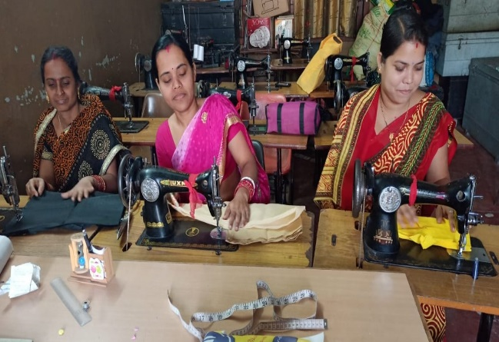
With change in fashion & style, the stitching of garment also changes. Hence in view of the changing market demand and fashion, courses on cutting and tailoring have been designed .
Ruchika provides Cutting and Tailoring skill with life skills were provided to each batch for a period of 6 months. The trainee were imparted with both theory and practical training throughout these period. They were also prepared to compete in the job market. Ruchika provides training at the central office premises for those who can afford to come to the training centre and it also have 2 door steps training centres in the slums for those who can come to the training centre due to their financial or social problem. A total number of 46 students completed Cutting and Tailoring training. The numbers remain lower than the target because of Covid pandemic.
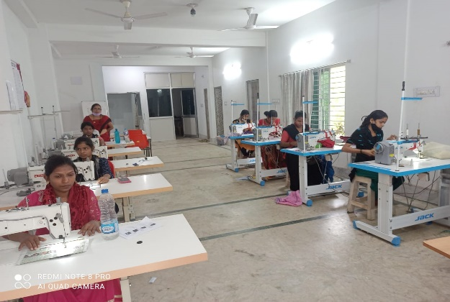
- Industrial Sewing Machine Operator:
Industrial Sewing Machine Operations involves stitching of components of garments together using a sewing machine. The role of a sewing machine operator is very critical to the industry as it enhances the quality of the product. These industries have heavy demand for employment of trainees. Most of the students get placement in these industries. This time a total number 30 students enrolled into the training program.
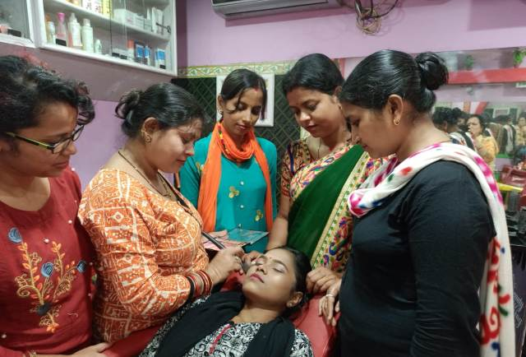
- Beauty and Wellness:
To empower Women in beauty and Wellness skills, we are giving them an opportunity for personal development and earning options. Women falling in the age of 18-35 years are imparted training for 6 months. This training opened up new avenues for aspiring young women, who with a little push can now earn their own living and more importantly, support their families economically. It prepares women for work in salons or to set up their own micro-enterprises or they can be able to start an initiative at home.

Assessment:
Ruchika usage assessment to collect data to inform and guide training investments. Assessments are also used to address skill gaps to help the training but also energize the trainee. The previous learning skills of the selected students are assessed before joining the course. Then the competency tests are conducted after completion of each skill competency. Then a final assessment is conducted. If the student successfully completes the training and achieved the necessary competencies. After that the trainee is awarded with certificate of the training. 10 students have completed this training and have been awarded with certificates.
Sl. No | Name of the Trade | Total Enrolled | Total drop out | Total Assessed | Total Completed
1 | Cutting & Tailoring (Training Centre) | 20 | 5 | 20 | 20
2 | Cutting & Tailoring (Door Step) | 26 | 5 | 21 | 21
3 | Industrial Sewing Machine Operator | 30 | 0 | 30 | 30
4 | Beauty & Wellness | 10 | 0 | 10 | 10
 | Total | 86 | 10 | 81 | 81

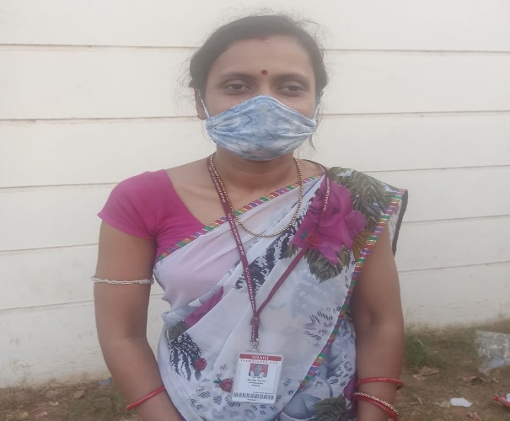
- Placement:
Ruchika assess the industry requirement and existing skill gap to adopt most suitable course curriculum methodology. Our Placement strongly influence the entire training cycle, from the student mobilization to trainer quality, industry engagement and understanding the needs of local employers. In order to ensure the better placement, Ruchika follows a lot of process like mock interview, direct contact with local employers, searching market demands and so on. Based on these processes we prepare our students for the placement.
During this pandemic year, we placed 25 students passed out with different trades in different sewing Industry like Sai Experts Pvt Ltd, Aditya Birla Groups, and in some local parlour and at the same time 56 students are become self-employed. All the students have placed with handsome salary. We track our trainees through regular interaction and motivate them for the retention in the job.
Barefoot Entrepreneurship:
Barefoot Entrepreneurship is the ultimate objective of our Training program. We trained our students to become a self-entrepreneur with a sustainable effort. Trainees coming from poor families are provided with continuous 6 months training with friendly atmosphere. During the training the trainees are trained on initiating a micro enterprise, organizing land, labour, capital, machinery, customer relations, costing and pricing, market linkage etc. After the successful training program, the trainees are provided with placement the same time if the trainee is interested for self-entrepreneur then he/she is provided with handholding support to start a micro enterprise. Following is the details of the placement and barefoot entrepreneurship for the year 2020.
Sl.no | Name of the Trade | Trainee completed Training | Trainees Placed | Started Barefoot Enterprises | Yet to be Rehabilitated
1 | Cutting & Tailoring (Training Centre) | 20 | 0 | 20 | 0
2 | Cutting & Tailoring (Door Step) | 21 | 3 | 18 | 0
3 | Industrial Sewing Machine Operator | 30 | 21 | 9 | 0
4 | Beauty & Wellness | 10 | 1 | 9 | 0
 | Total | 81 | 25 | 56 | 0

Activities undertaken During Covid-19 lockdown:
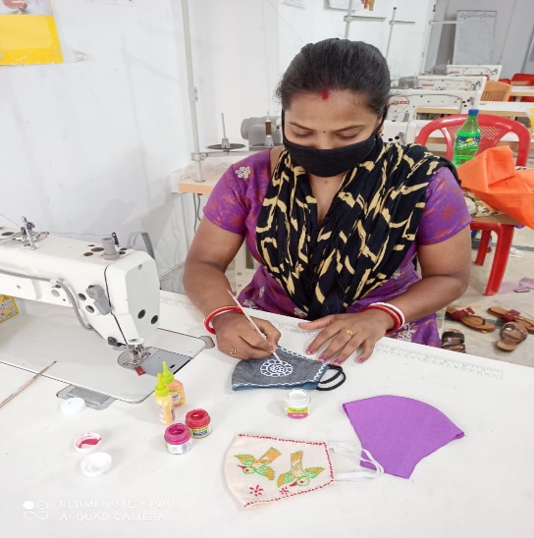
During the Covid lockdown the slum dwellers lost their source of income and faced a shortage of food. Such population including daily labourer’s, petty businessman, shop assistants, factory workers and rickshaw pullers are become economically inactive during this time.it means per capita income in the slums had dropped during this lockdown. It was our responsibility to help the needy ones. During such situation, our trainees prepared mask, and distributed in the slums of Bhubaneswar. In addition to these, fruits have been distributed among the children. Ruchika have resolved to continue distribution of rations to the needy families during the lockdown.

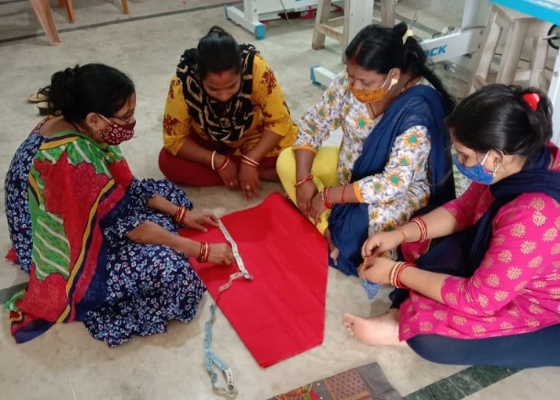
Ensure safe operations during covid-19:
The Pandemic affected slum people very badly. To avoid such infections Ruchika followed all covid guidelines and rules like frequent handwash, use of mask during the training and Sanitation etc. The sanitizers were kept in the entrance of the classroom and all trainees were screened before entered to the training. The classroom was regularly cleaned up and sanitized by the staffs to ensure safe classroom and avoid infection.

