Success story of Mrs. Sangeeta
Trade: Tailoring & Stitching of Dress materials
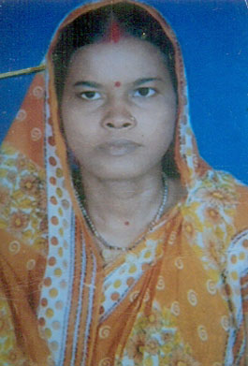
Sangeeta (not her real name) Sahoo is now around 33 years old women. When she was an adolescent her poor parents got a good marriage proposal from a well to do family. As she was very beautiful, the groom liked her and marries her. Since she was from a poor family, her parents could not able to give dowry. After marriage, she lived with her husband happily for three years and had a baby girl. Her husband was an auto driver. Life was so good for her. Unfortunately, her husband met with an accident and bed ridden for more than 6 months. Her family suffered a lot because he was the only bread-winner of her family. Gradually the economic condition of her family deteriorated and She decided to do something to help her family. She came to know about our free vocational training program and joined immediately. After six month's training and her jeal for learning she stood first in her batch. She completed the training and got "Rehabilitation Kit" (Sewing machine and stitching articles) from Ruchika to establish her own 'Tailoring & Dress Making Unit' in her home. Gradually her shop is gaining confidence and popularity and ladies customers are coming to her shop for stitching their dresses. She is now earning around six thousands rupees per month. From this money she is managing her family, husband's medicines and daughter's education. She is very happy and thankful to Ruchika and global giving for making her the bread-winner of her family.

Glimpses of the Rehabilitation Kits donation ceremony
