Project Title: - Skill Development Training for 120 Slum Youths
Supported by: Global Giving

We are happy to present the Progress Report of the intervention from January to December 2020 of the Project entitled “Self Sustainability of Underprivileged Youth through Skill Development Education Program” before the donor agency and all other well-wishers. With the support of Global Giving, this year of intervention has been successfully completed. Despite Indian government’s Skill India initiative, a large chunk of its population, nearly 93 % never received any vocational or technical training. According to the Periodic Labour Force Survey (PLFS) 2017-18, merely 1.8 % of the population received formal training on technical aspects and employment ready skills. While roughly 6 % received informal training on job skills, self-learning etc. unfortunately, half of the youth that is trained is not employed as per PLFS data. Approximately three in every five skilled women were recorded as unemployed. This clearly indicates an alarming rate of unemployment in India. Vocational skill helps young people in the better performance of their jobs as they acquire a great learning experience. Working professionals get a chance to hone their skills while making money. It consists basically of practical courses through which one gains skills and experience directly linked to a career in future. It helps students to be skilled to acquire better employment opportunities. It not only increases the better chances of employment, but also creates opportunities for higher earnings levels, increases job satisfaction, improve flexibility and mobility. After all, the students acquire a lifelong learning. In view of the skill crisis and increased unemployment emergencies among young people especially those living in Bhubaneswar urban slums and streets, Ruchika started its first Vocational skill intervention program in the year 1990 in Bhubaneswar, Odisha, India with the support of the Deptt. Of Panchayati Raj, Govt. of Odisha .
Project Goal :
Creating a cadre of skilled youth with provision of market relevant skills along with entrepreneurial development proficiency and life skills and to create opportunities for the development of talent of underprivileged youth to be barefoot entrepreneur and to compete in the employment market.

Project Objectives :
➢ To impart market relevant skills like Cutting and Tailoring, Beauty and Wellness, Industrial Sewing Machine Operator etc to the underprivileged youth especially those from slums and street.
➢ To develop entrepreneurial proficiency among the students to be able to start their barefoot enterprises soon after they complete their training.
➢ To impart employability skills among the students to compete in the competitive job market.
➢ To provide functional education during the skill training tenure to enable them to acquire knowledge, skills and attitudes in reading, writing and numeracy based on the needs and problems of the learners and their community.
➢ To provide training facility at the door step of slum women who are not able to access the vocational training centre services due to financial crunch and social stigma.
➢ To provide relevant life skills to the students to enable them to equip them with the social and interpersonal skills that enable them to cope with the demands of everyday life.
➢ To build self-confidence, encourage critical thinking, foster independence and help the students to communicate more effectively.
Target Group :
The project targets to slum youth in the age group of 18 to 35 years. Of course focus is given to the slum girls and women as they are the most neglected ones. During the year we targeted a total number of 100 youth to be trained in different vocational trades.
Activities : Following activities were conducted during the year.
- Mobilisation :

Mobilization is basically a process in which we contact and reach community to identify and select beneficiary or the trainees for training programme. Time and again we have experienced that "Community outreach and mobilization are an important and challenging activity in the entire programme and it plays a very decisive role in the success of the programme. Hence, considering mobilization as one of the strongest pillars of skill ecosystem, Ruchika follows a defined strategy and approach for mobilization

Publicity : Our Coordinator used to mobilize the students from the slums. In addition, the slum teachers and field workers of the organisation are also engaged in the mobilization activities. During mobilization our mobilisers show the live footage of Vocational Training centre and training activity in the field to all the parents so that they can see and assess the facilities we are providing. This activity also creates a lot of reliability among the parents and enthusiasm among the candidates as they can directly connect with the people now.

Mobilization through Placed / Rehabilitated students : During mobilization we also connect the parents and possible candidates with our already trained and placed students and those who have been rehabilitated with the help of Ruchika. These students share their experiences, their personal journey and their achievements. Since we try to connect with the candidates who belong to the same place, this whole activity brings a lot of authenticity and reliability among the parents and candidates.

Parent-Trainers Meet: We have started conducting a regular parent’s meet with trainers. This is to bring the trainers and parents closer. Many times we have experienced that due to parent’s pressure candidates drop out from the centre, since parents don't have clarity on the programme and features. To bridge this gap we are conducting regular meeting with the trainers so that parents get aware of the programme, understand its importance and how it will change their child's life.

Meetings with Community Key Persons : We have also started meeting and training the community representatives such as Corporators, Women SHG leaders, Anganwadi workers, Asha Workers and Slum Presidents etc. to bring the utmost level awareness of the skill development initiatives in the community so that more people can avail the benefits of the programme. Ultimately these key people become our contacts and resource who mobilize the students for the training program.

2. Facilitation / Skilling :With a goal and vision to retain interest of students in learning required skill set for respective job role, and involve learners in their self-development and careerdevelopment during training and during their first job -We Engage our Learners. We make a learner understand how to set career direction, and shape a work-life for maximum success. Following Skills are imparted to the students .
a. Cutting and Tailoring:
Cutting and tailoring skill are imparted with a minimum of 6 months duration. This training is imparted central in the office premises for those who can afford to come to the training centre. In addition, we also have two Door Step Training Centres in the slum communities for those who cannot afford to come to the training center due to financial or social problems.

b. Industrial Sewing Machine Operator :This sewing machines are operated in the cloth industries and these industries have heavy demand for employment of trainees. Most of the students get placement in these industries.

c. Beauty and Wellness :The student take theory training at the training centre and practice in a specialised Beauty centre operating near the organisation. Trainers training is one of our area of expertise. The trainers / facilitators are frequently trained on training methodology, assessment processes, changing dynamics of job markets, skill requirements in the market, entrepreneurial proficiency development etc.

- Assessment :The previous learning skills of the selected students are assessed before joining the course. Then the competency tests are conducted after completion of each skill competency. Then a final assessment is conducted and if the students successfully complete the training and achieved the necessary competencies then she/he is awarded certificates. The organization follows a strict assessment and certification policy to maintain the quality of the training program. By now Ruchika has developed a brand value for its training program.

- Placement :
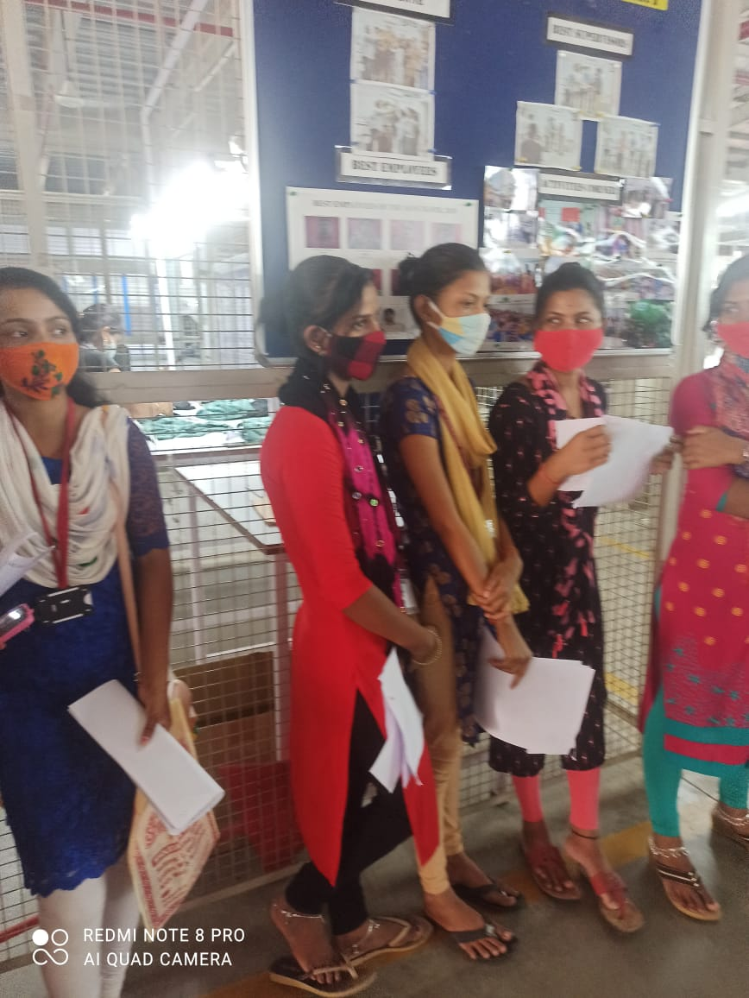
Prior to actual training, Ruchika assess the industry requirement and existing skill gap to adopt most suitable course curriculum content methodology. Another important task is to identify the right trainee. Our mobilization team continuously monitor the level the catchment areas for potential candidates who are then taken through a screening process before enrolling to check their seriousness as well as ability to function in the targeted role. We deliver leadership, team and personal development training to learners in order to make them employable. With interactive content and training session we help learners to enjoy successful careers, and contribute positively to the success of their organizations. During initial period of their employment, we track our trainees through regular interaction and handhold them to ease the induction process. Our Coordinator used to do all the task.

- Barefoot Entrepreneurship :
Our ultimate objective is to produce barefoot entrepreneurs from our training centre. The students are trained on entrepreneurial development proficiencies during their course curriculum which include initiating a micro enterprise, organizing land, labour, capital, machinery, forward and backward linkages, customer relations, costing and pricing, market linkages etc. After the training program if the student is interested, he/she is provided with handholding support to start a micro enterprise. The Barefoot Entrepreneurs are also provided with support and guidance for at least 6 months.

- Life Skill Education :
Life skills education, have found to be an effective psychosocial intervention strategy for promoting positive social, and mental health of young youths which plays an important role in all aspects such as strengthening coping strategies and developing selfconfidence, emotional intelligence and social behaviour. Since most of the students who come to the training centre are young girls of slums they are taught different life skills like coping mechanism, social behaviour, health and hygiene practices, education on sexual health, decision making etc.
- Functional Education &Skilling :
Many of the students who come from lower social strata from slums are in need of functional education as it is found that a high degree of regression of their academic proficiency when they join the training center. Hence they are not able to understand the technical aspect of the training. Therefore we teach them through functional skilling – which means they are trained exactly what they need to understand to acquire a skill.

Success Stories:
1.Puspalata( Not Real Name) of Siripur slum and her child was relinquished by her husband. It was difficult for Puspalata to survive without any work. As she studied upto +2 and had no experience to work as daily labour, life was a challenge for her. In the mean time she learned about Ruchika Vocational Training program and immediately joined Industrial Sewing Machine Operator Course. After completion, she joined Aditya Birla Exports in Bhubaneswar and earned Rs. 8000/- per month. Now she is able to look after her small family and put her child in the school.

2. Dream comes true :
Supriya (not real name)of Pandav Nagar slum married after her education and now is the mother of one child. Her husband works in a small company and earns a little for the family. She had a great interest to be a Beautician and a dream to set up a Beauty Parlor in Bhubaneswar. Before marriage it was not possible for her as she had no training and as her family’s economic condition was not good. When she learned about Ruchika’s training program she immediately came and expressed her interest to take Beauty and Wellness training. After completion of 6 months training course she was interested to set up her own Beauty and Wellness Centre in Bhubaneswar. Hence Ruchika helped her to get a Bank of loan of Rs. 50,000/- and with this money she started a Beauty Centre viz. “RIDHISU Beauty & Spa at Rabi Talkies Square. Now she earns more than 15,000/- per month.
