YIDA Mission

YIDA (Youth Initiative for Development in Africa) is a youth-led Community Based non profit Organization that is formed to Educate and Create jobs in the refugees and non-refugees, to live a sustainable life. This initiative is formed by the youth in the refugee camp with the Aim of Educating children. Through mobilizing the other youth and mobilizing the community, to participate in the construction of the school. We train community youth members and prepare them to become teachers to increase on teaching staff by volunteering. We use the scares resources to sustain Education in the community. For example, we make picture books for children and other learning materials from old magazines, newspapers and paper bags. These solutions have increased the number of school going children by 10% in three different villages of the refugee camp.

Our Programs

1. Childhood Education
90% of the children in the Kyaka II community they don’t have access to early childhood education. It makes them start primary when they are very mature and they end up performing poorly in school to 60% of primary pupils failing to complete and dropout. We initiate early childhood centers in the communities.

Kyaka II refugee settlement is densely populated with about 27,000 people mainly from D.R. Congo. 50% are the children, there are no enough schools to support the number of the growing refugee children, and 50% of the children, about 3400 are out of school. The community needs more schools for the increasing population due to political instability in D. R. Congo. We have the target to put 500 children with 3-8 years back to school. Children will access quality education freely.
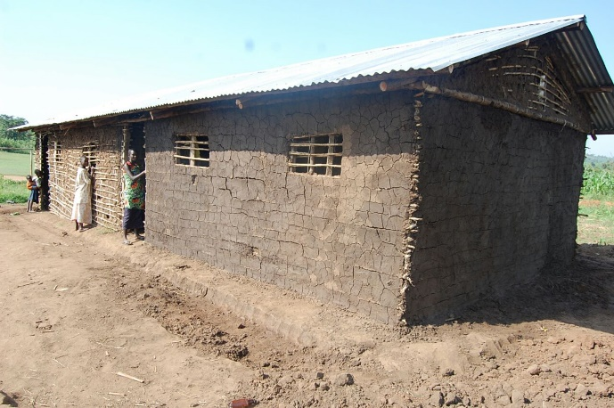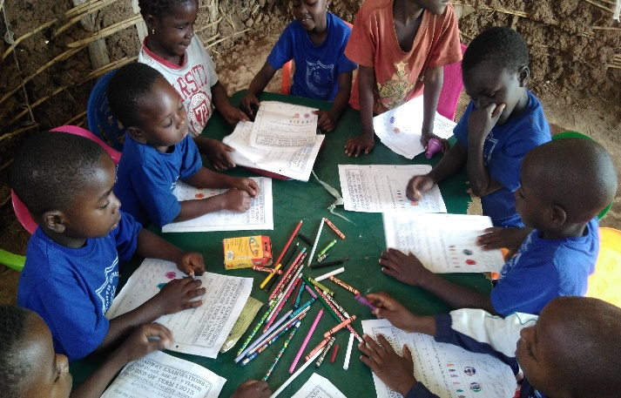
We are initiating three school with the target to educate 500 children this year.

How it works
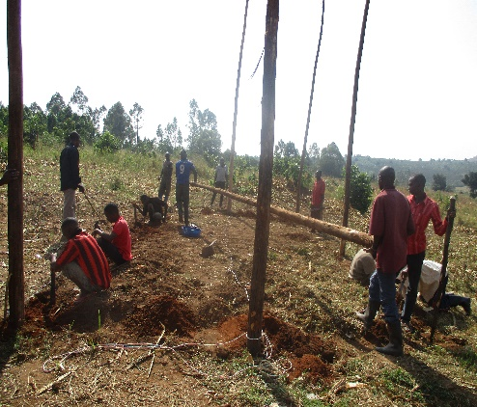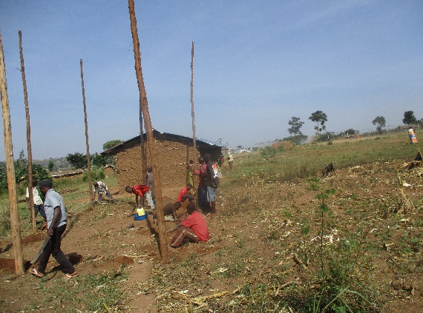
We mobilize the community through their leaders to come up with the learning centers. We fundraise from some community to have the startup capital for the new center.

How it is impacting the community?
317 children have quality education that is easy accessed and the number of schools going children have increased by 10%. 16 Youth are being employed and other 4 are volunteering.

2. Scholarship program
We support student to apply for the existing opportunity, by connecting them to Organizations and Individuals that are willing to sponsor students. We provide necessary skills to students that are needed by the sponsors. We connect students to access education from all levels of education, trainings and vocational.
How it works
We find opportunities on internet and from individuals from sponsoring organizations. We find the eligibilities and the due dates for that particular opportunity, then we start to mobilize students that can meet the eligibilities and prepare them for some qualifications and skills they need to have like leadership experience and internet service, depending on the type of scholarship available. Some of the opportunities we are trying are YALE, ALA, The MasterCard Foundation Scholars Program, Cornerstone Leadership Academy and Individuals that can sponsor students.
Impact
We have managed to connect one student to attend High School at Cornerstone Leadership Academy in Uganda and 5 children have been sponsored by individual donor to attend kindergarten in the schools YIDA initiated in the community.

3. Entrepreneurial Education Training
We provide Leadership, Entrepreneurship and Education training. Leadership and Entrepreneurship is provided to all youth in the community to startup their own businesses and those willing to volunteer with YIDA. For any Youth to work with YIDA, is required to have been trained. Because this are the basic skills that are needed to develop our community.
Education training is provided as a private coaching to students in the community during holidays, it involves how a student can behave to succeed in school. This training intends to reduce the school dropout due to failures.
We train teachers to have teaching skills.
How it works
We invite university students who are our friends to come and train the youth about entrepreneurial leadership during their vacations.
We also connect teachers to be taken for further studies on how to care for the younger kids at Kindergarten school.
Impact.
YIDA employees 10 youth that are well trained with relevant skills. The education training has improved the academic performance in the community hence reducing the school drop out by 10%.
We have connected 17 youth to get scholarships to study teaching skills to younger children by UNICEF

