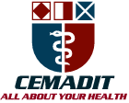
Research Center for Analytic Diagnosis and Imaging Trends (RECEADIT)
School of Health, Biomedical and Computer Sciences (SHBCS)
2020-2021 Academic Year
P.O. Box 19, Belo-Kom, Belo Sub-Division, Boyo Division, Cameroon, North-West Region,
West Africa - Tel: (237) 6 83 41 86 00 or (237) 6 77 68 99 32
CEMADIT@yahoo.com http://www.meditech-group.org

Motto: Health Care Research and Education for Services to Humanity

MEDITECH GROUP
CEMADIT
ALL ABOUT YOUR HEALTH

MEDITECH GROUP
RECEADIT
ALL ABOUT YOUR HEALTH

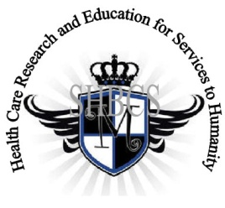

Ministry of Higher Education Ministry of Public Health Registration No. 3342 of August 31, 2011 Registration No. 4042 of August 31, 2011

GlobalGiving RECEADIT Mbam Community Health Care Project (29930)
Thirteenth Project Report of Friday, February 26, 2021
On behalf of our RECEADIT Humanitarian Team, I take this opportunity to thank you so very much for your generosity and willingness to join us and to partnership with us on our journey of serving humanity through the Guidance, the Blessings, the Love and the Grace of God Almighty.
We are glad to provide you with the following progress report and updates for our “Mbam Community Health Care Project (29930)” thanks to your generosity:
1) As we reported in our Twelfth Project Report of Thursday, October 29th, 2020, the builders had stopped all construction work on the New Clinic Building (See First Illustration Photo) due to the intensified, ongoing war, aimed at eliminating young males 12 to 32 years old. The situation still has not changed. Instead, it is gotten worst and the main road from Belo to Fundong, where this Project is located, has been blocked (See Third and Fourth Illustration Photos);

2) Although the situation has gotten worse and it is still very dangerous to continue with the construction work, especially because of lack of building materials and more importantly, the risk of losing human lives, we have managed to construct an external kitchen for patients’ caretakers to use to prepare food (See first Illustration Photos);. We moved into the New Clinic Building on Tuesday, September 1st, 2020 (See Second Illustration Photos); and

3) For this Thirteenth Project Report, our Community Health Care Workers, who are mainly female graduates of our School of Health, Biomedical and Computer Sciences (SHBCS), have still, at least, continued to keep the Clinic open for emergency cases, such as attending to Internally Displaced People in the Mbam rural Community (See Fifth Illustration Photo).

The nurses still have not been able to continue with their Home Visits. We must point out here again, with lots of regrets and disappointment, that our School of Health, Biomedical and Computer Sciences (SHBCS), as well as all other schools in this part of the country, have not been operational since October 2016 due to the serious, ongoing political crisis and war in Cameroon.

We will continue to provide you with monthly reports and updates of our other projects, activities, accomplishments, and challenges.
We hope that you will continue with us on this our journey of serving humanity through the Guidance, the Blessings, the Love and the Grace of God Almighty, a journey which has taken us to this “MbamCommunity Health Care Project” through our new link: https://goto.gg/29930

Jilly M. Ngwainmbi, RECEADIT Project Leader

Illustration Photos

First Photo

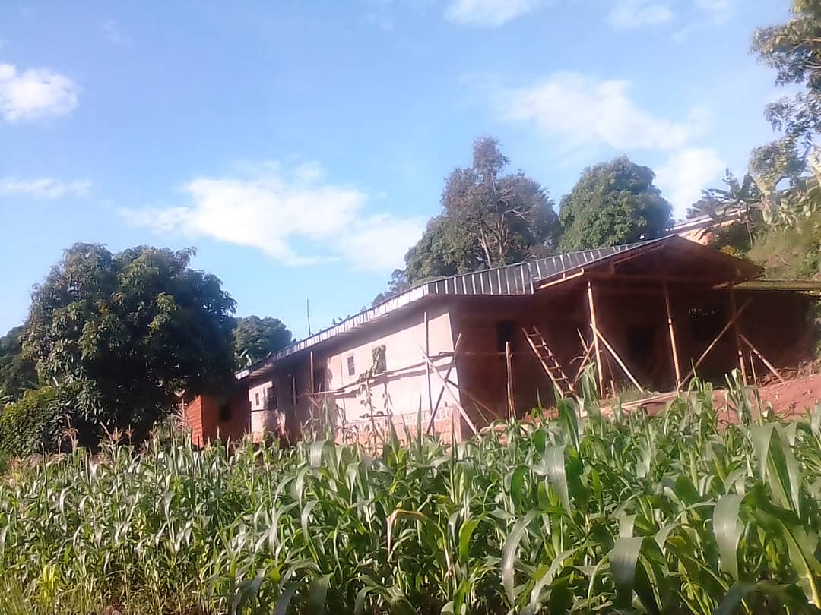

Completed First Floor of the Mbam Community Health Center Showing The Outside Kitchen Behind it

Second Photo

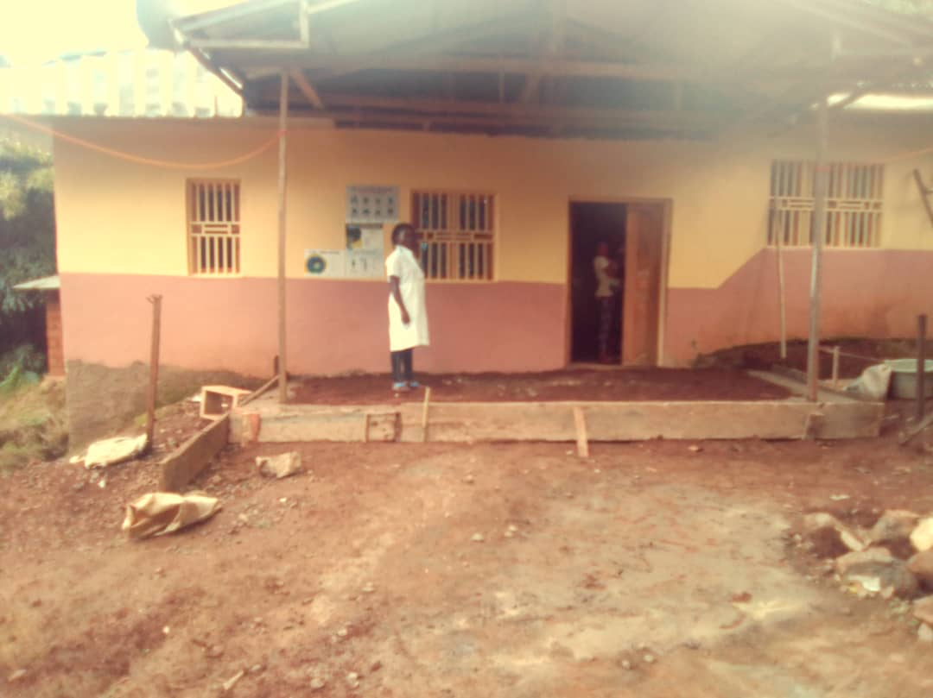

Front View of the New RECEADIT Mbam Community Health Center Building

Third Photo

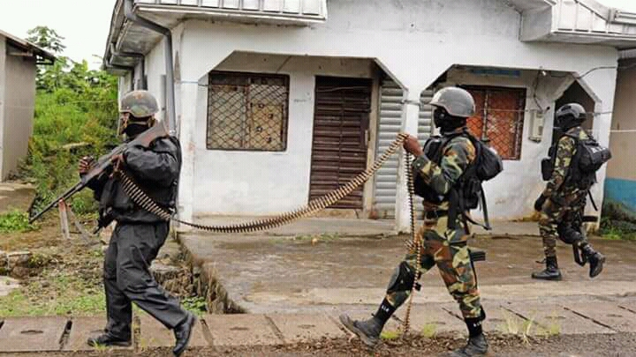

Military Invasion of the Mbam Rural Community

Fourth Photo

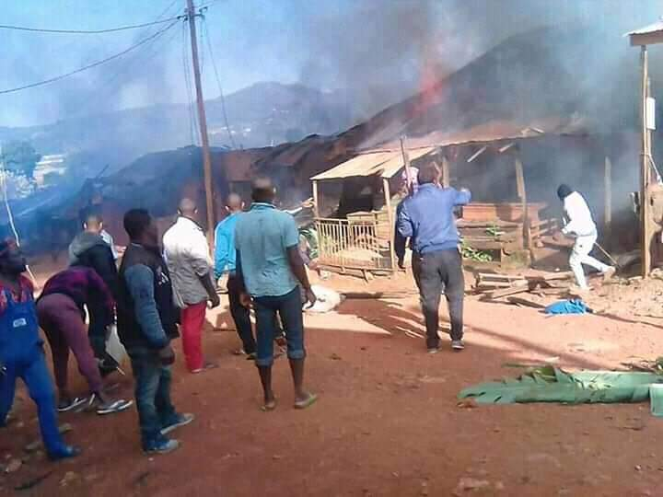

Buildings set on Fire by the Military in the Mbam Rural Community/Village

Fifth Photo

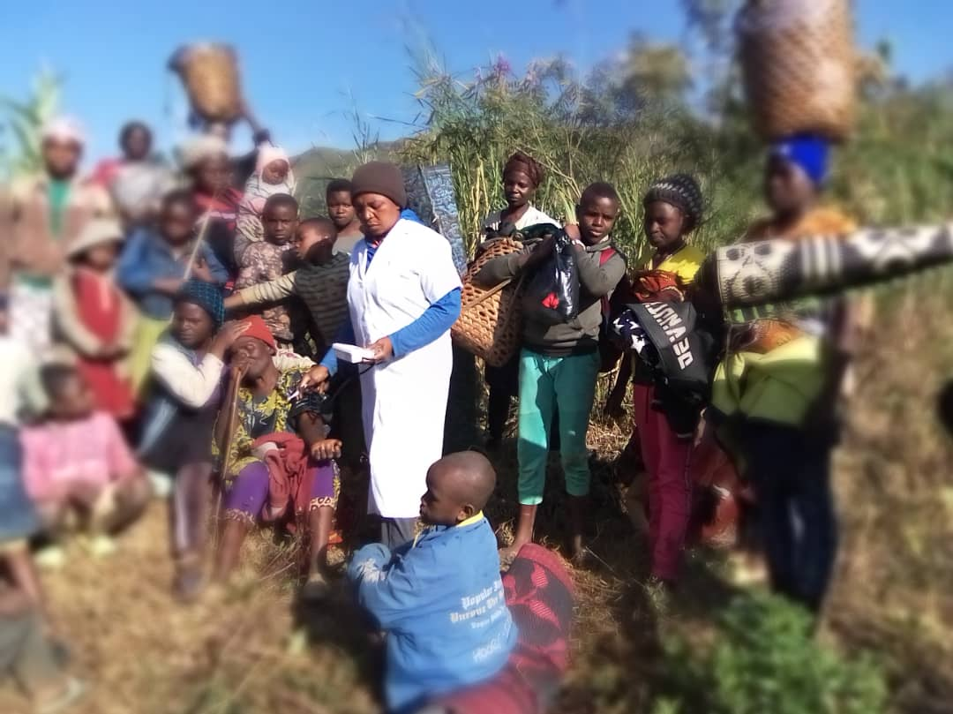

RECEADIT Nurse Attending to Internally Displaced Mbam Rural Community Members

