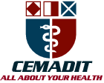
Research Center for Analytic Diagnosis and Imaging Trends (RECEADIT)
School of Health, Biomedical and Computer Sciences (SHBCS)
2020-2021 Academic Year
P.O. Box 19, Belo-Kom, Belo Sub-Division, Boyo Division, Cameroon, North-West Region,
West Africa - Tel: (237) 6 83 41 86 00 or (237) 6 77 68 99 32
CEMADIT@yahoo.com http://www.meditech-group.org

Motto: Health Care Research and Education for Services to Humanity

MEDITECH GROUP
CEMADIT
ALL ABOUT YOUR HEALTH

MEDITECH GROUP
RECEADIT
ALL ABOUT YOUR HEALTH

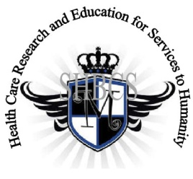

Ministry of Higher Education Ministry of Public Health Registration No. 3342 of August 31, 2011 Registration No. 4042 of August 31, 2011

GlobalGiving RECEADIT Mbam Community Health Care Project (29930)
Sixteenth Project Report of Tuesday, March 22nd, 2022
On behalf of our RECEADIT Humanitarian Team, I take this opportunity to thank you so very much for your generosity and willingness to join us and to partnership with us on our journey of serving humanity through the Guidance, the Blessings, the Love and the Grace of God Almighty.
We are glad to provide you with the following progress report and updates for our “Mbam Community Health Care Project (29930)” thanks to your generosity:
1) As we reported in our Fifteenth Project Report, our main focus now is on our upgraded building program. For this Sixteenth Project Report, we want you to know that the Building update continues, with the construction of a new building which is intended to provide shelter for the Internally Displaced People (See First and Second Illustration Photos);

2) This Sixteenth Project Report also continues to focus on our New Central Pharmacy Drug Program, facilitated by our new Bike which is instrumental in the Transportation and Distribution of Drugs/Medication and other medical Equipment to RECEADIT Clinics at Kitchu, Mbam, Muteff, and Ngemsibo Remote, Rural Communities (See Third and Fourth Illustration Photos);

3) The increase in malaria cases resulting from the onset of the Raining Season and the continued threat posed by Covid-19, has resulted in an increase in our Home and Community Visits, undertaken by our female and male nurses within the Mbam remote, rural Community in particular (See Fifth, Sixth, Seventh and Eighth Illustration Photos); and

4) Even though we have an Organized, Medical Training Program for all our RECEADIT workers and a New One Year Medical Training Program (See Ninth Illustration Photo) , we must point out here again, with lots of regrets and disappointment, that: a) the intensified war keeps interrupting the program ; and b) our School of Health, Biomedical and Computer Sciences (SHBCS), as well as all other schools in this part of the country, have not been operational since October 2016 due to the serious, ongoing political crisis and war in Cameroon.

We will continue to provide you with monthly reports and updates of our other projects, activities, accomplishments, and challenges.
We hope that you will continue with us on this our journey of serving humanity through the Guidance, the Blessings, the Love and the Grace of God Almighty, a journey which has taken us to this “Mbam Community Health Care Project” through our new link: https://goto.gg/29930

Jilly M. Ngwainmbi, RECEADIT Project Leader

Illustration Photos

First Photo

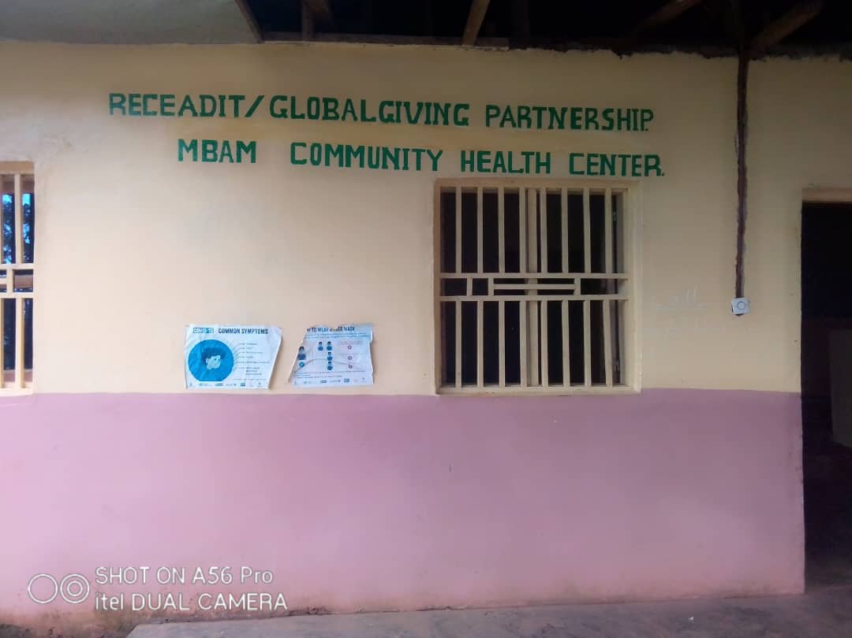

RECEADIT/GlobalGiving Partnership, Mbam Community Health Center

Second Photo

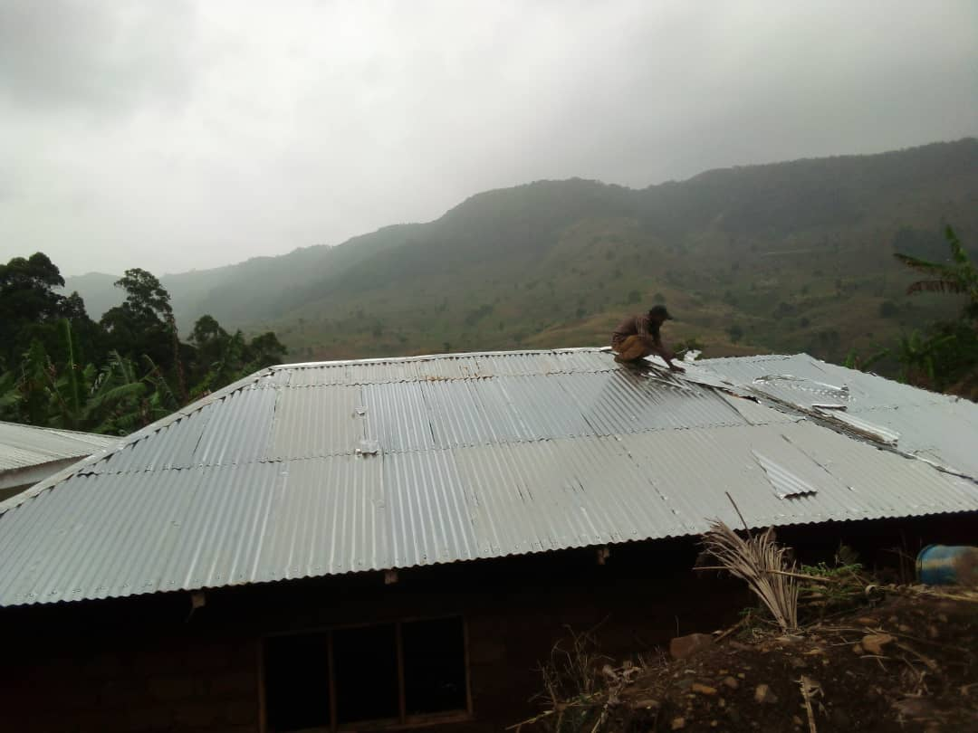

New Building Under Construction to be Used as a Shelter for the Internally Displaced People

Third Photo
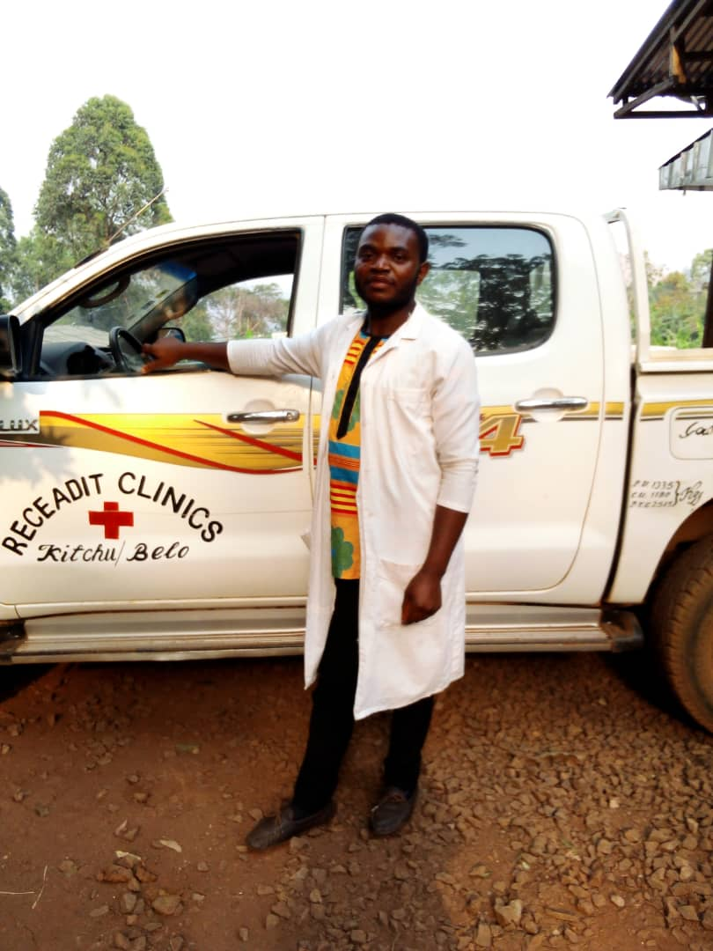

RECEADIT Nurse Ready to Leave Bamenda with Pharmacy Drugs to Mbam

Fourth Photo

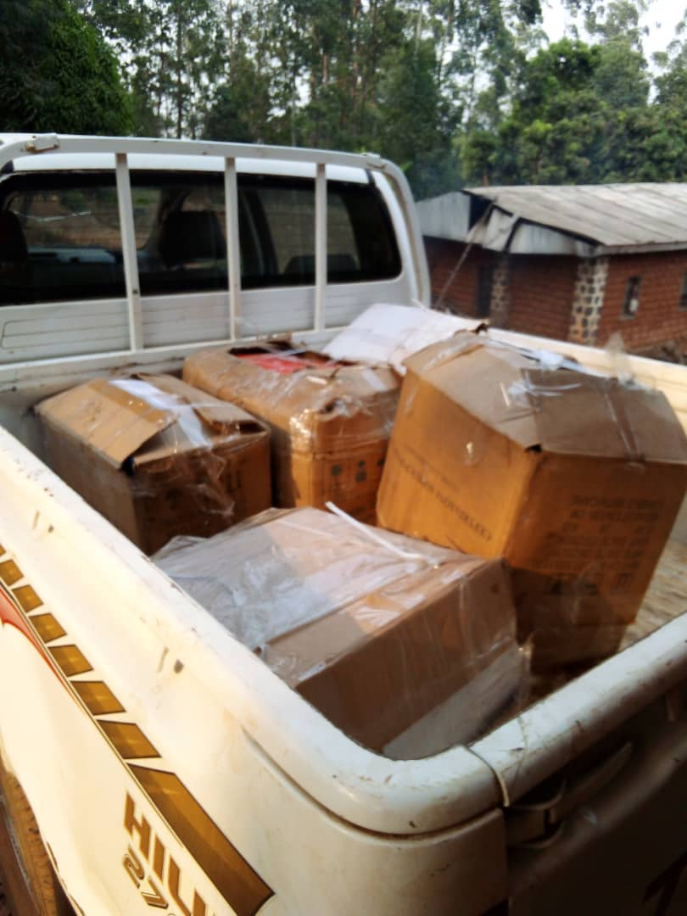

RECEADIT Truck Arrives Mbam with Pharmacy Drugs

Fifth Photo

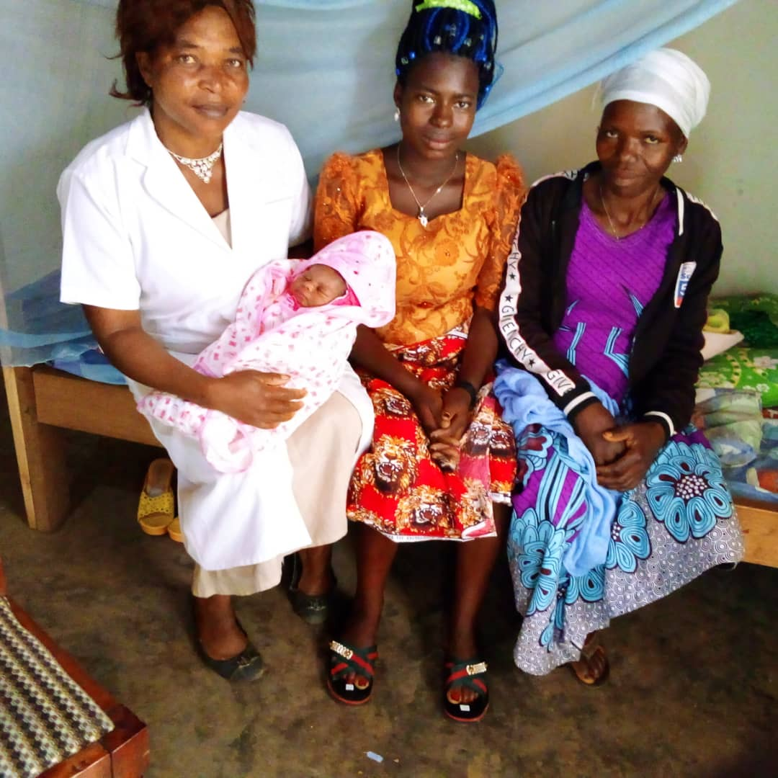

RECEADIT Female Nurse with a newborn, the mother and Grandmother on her RECEADIT Home Visits Program

Sixth Photo

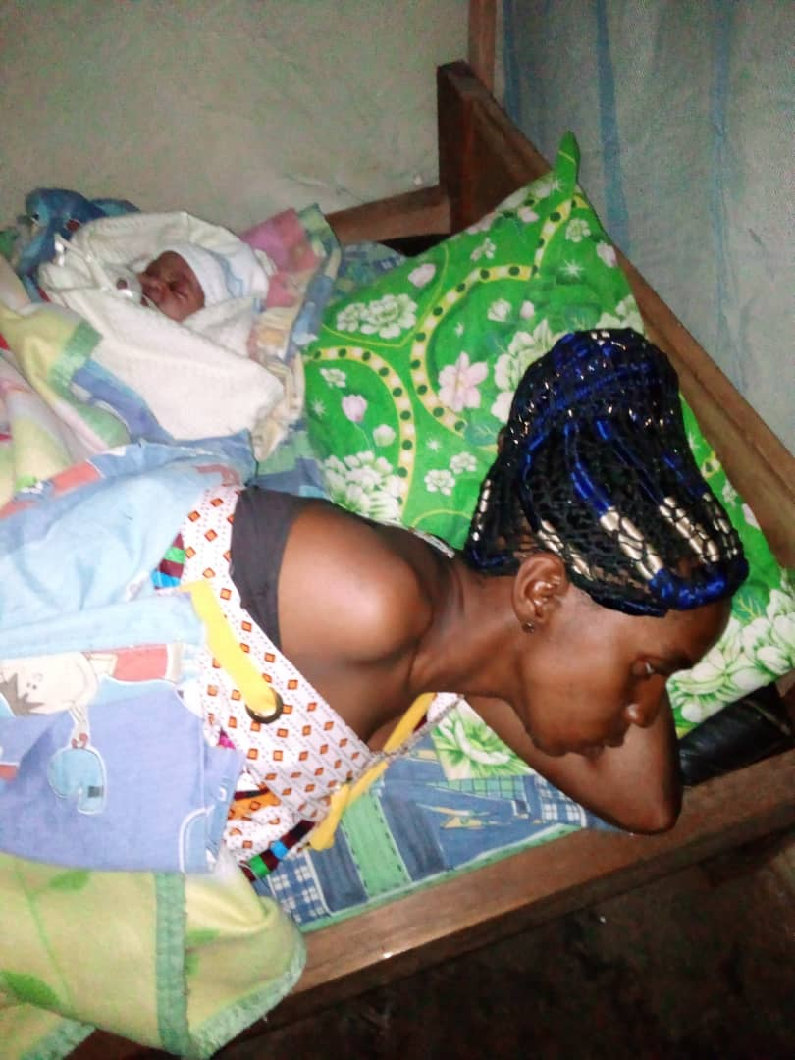

RECEDIT Home Visits Program: A Mother and her Newborn at their Home

Seventh Photo

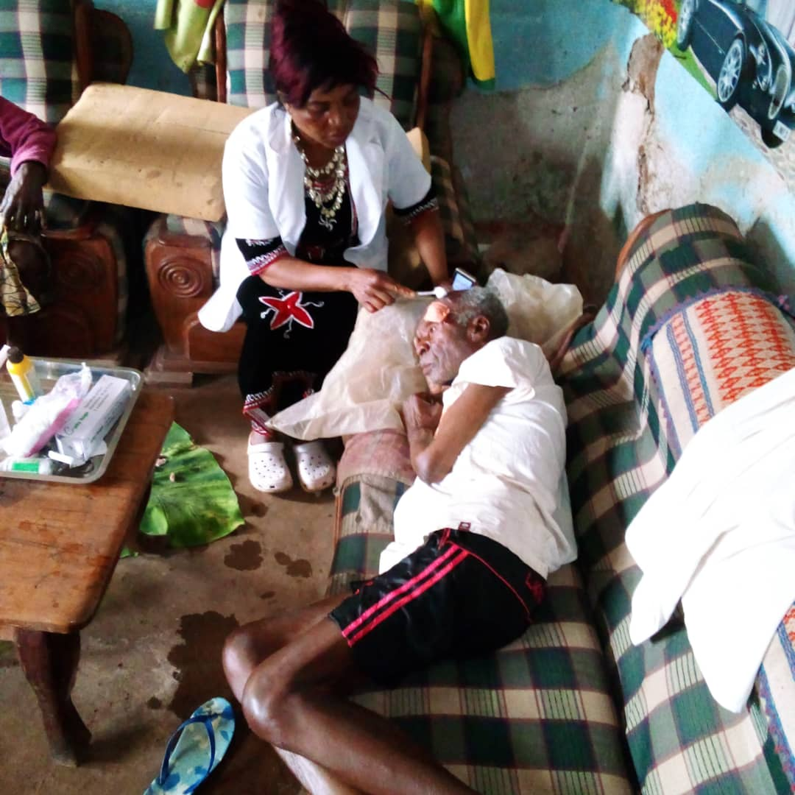

RECEADIT Female Nurse Attending to an elderly patient at his home on our RECEADIT Home Visits Program

Eighth Photo

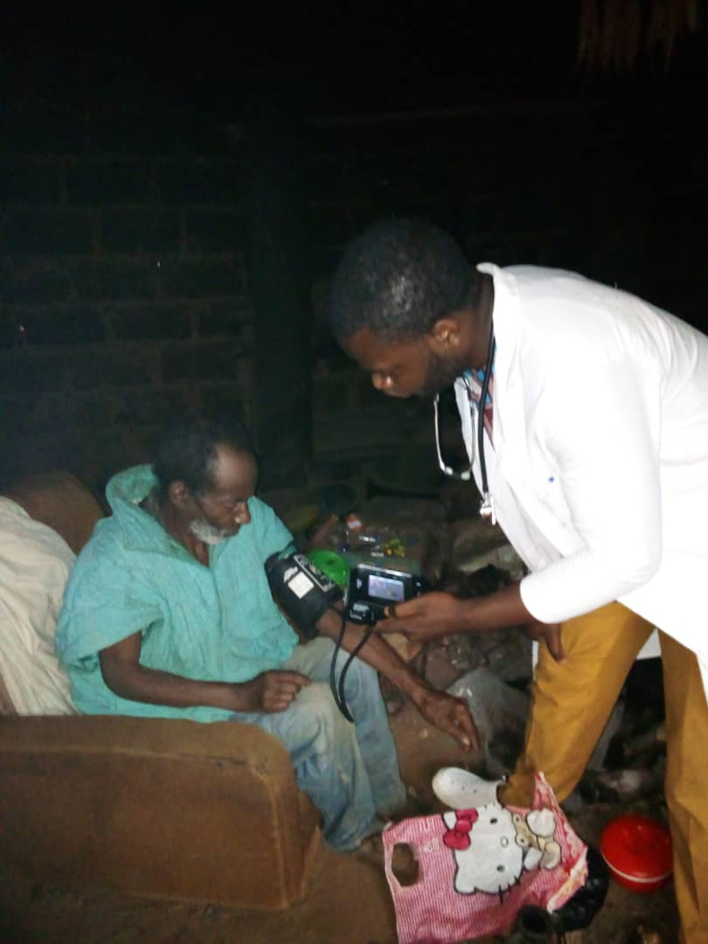

RECEADIT male Nurse Attending to an elderly patient at his home on our RECEADIT Home Visits Program

Ninth Photo

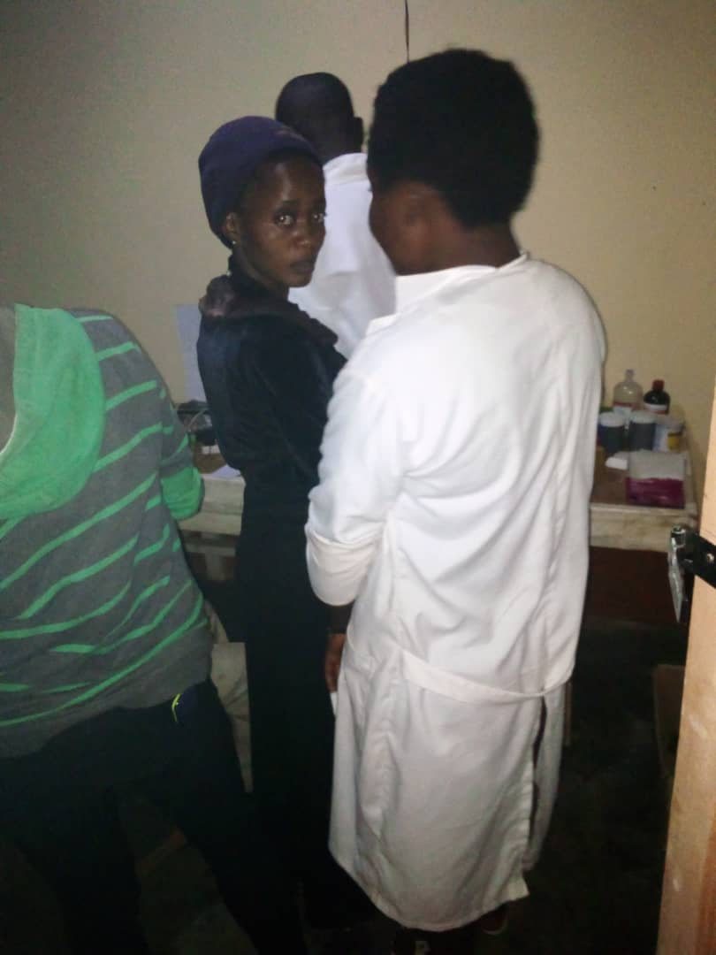

RECEADIT Laboratory Technicians Attending to patients in the RECEADIT Laboratory Training Unit at Mbam Clinic

