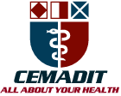
Research Center for Analytic Diagnosis and Imaging Trends (RECEADIT)
School of Health, Biomedical and Computer Sciences (SHBCS)
2022-2023 Academic Year
P.O. Box 19, Belo-Kom, Belo Sub-Division, Boyo Division, Cameroon, North-West Region,
Africa - Tel: + 1(910) 261-7785 or +237 6 52 49 78 82 or + (237) 6 77 68 99 32
cemadit@yahoo.com http://www.meditech-group.org
RECEADIT-CEMADIT Clinic Authorisation no/A/MINSANTE/SG/DOSTS/SDOS/SFSP
Motto: Health Care Research and Education for Services to Humanity

Motto: Health Care Research and Education for Services to Humanity

MEDITECH GROUP
CEMADIT
ALL ABOUT YOUR HEALTH

MEDITECH GROUP
RECEADIT
ALL ABOUT YOUR HEALTH

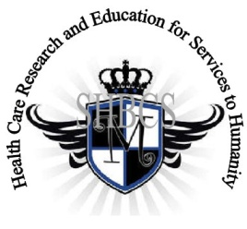

Ministry of Higher Education Ministry of Public Health Registration No. 3342 of August 31, 2011 Registration No. 4042 of August 31, 2011

GlobalGiving RECEADIT Mbam Community Health Care Project (29930)
Twentieth Project Report of Saturday, August 5, 2023
On behalf of our RECEADIT Humanitarian Team, I take this opportunity to thank you so, so very much for your generosity and willingness to join us and to partnership with us on our journey of serving humanity through the Guidance, the Blessings, the Love and the Grace of God Almighty.
We are glad to provide you with the following progress report and updates for our “Mbam Community Health Care Project (29930)” thanks to your generosity:

1) For this Twentieth Project Report, our main focus is again on our RECEADIT/GlobalGiving Partnership, Mbam Community Health Center (See First and Second Illustration Photos) and our RECEADIT workers’ determination to remain at their respective Clinics and provide needed Medical Services to Our Internally Displaced Fellow Human Beings and those whose villages have been burnt down (See Third, Fourth, Fifth, Sixth and Seventh Illustration Photos). The Report concentrates on the following:

a) Drug supplies to RECEADIT Clinics, which has been truly challenging and practically impossible due to the lock down. Our RECEADIT Workers have to walk many miles to: i) the city of Bamenda to purchase needed essential drugs for the RECEADIT Central Pharmacy at Kitchu; ii) Babunguh; iii) Kitchu; and Fundong to get basic necessities and food items and then walk back to their respective Clinics (See Eighth, Ninth, Tenth, Eleventh, Twelfth, and Thirteenth Illustration Photos);

b) Providing Lodging and Accommodation for some Internally Displaced People whose villages have been burnt down and who were able to walk to the Clinics because our six Clinic bikes were all locked up in safe locations due to the lock down (See Fourteenth, Fifteenth, Sixteenth, Seventeenth, Eighteenth, Nineteenth and Twentieth Illustration Photos);

c) Community Medical Assistance through our Home Visits Program, which was basically discontinued and stopped due to the lockdown. However, a few Home visits were conducted within the Muteff and Ngemsibo remote, rural Communities by our female nurses of our Muteff and Ngemsibo Clinics (See Twenty First, Twenty Second, Twenty Third, Twenty Fourth, Twenty Fifth and Twenty Sixth Illustration Photos); and

d) Vaccination of Children within the Bassamba, Kitchu, Mbam, Muteff and Ngemsibo remote, rural Communities where Our RECEADIT Clinics are located. We are so thankful to and very proud of our two female medical workers who walked many miles despite the Lock Down, got vaccines on Thursday, July 27, 2023 and got Nineteen (19) children vaccinated successfully on Friday, July 28, 2023 at Our RECEADIT- GlobalGiving Partnership Community Health Center at Ngemsibo. Our three nurses at Our RECEADIT-Globalgiving Partnership Community Health Clinic at Our RECEADIT’s CEMADIT Clinic Annex at Bassamba successfully vaccinated ten (10) children (See Twenty Seventh, Twenty Eighth and Twenty Ninth Illustration Photos);

2) Again, as we reported in our Seventeenth Project Report, although we have an Organized, Medical Training Program for all our RECEADIT workers and a New One Year Medical Training Program, we must point out here once more, with lots of regrets and disappointment, that: a) the intensified war keeps interrupting the program; and b) our School of Health, Biomedical and Computer Sciences (SHBCS), as well as all other schools in this part of the country, have not been operational since October 2016 due to the serious, ongoing political crisis and war in Cameroon.

We will continue to provide you with monthly reports and updates of our other projects, activities, accomplishments, and challenges.
We hope that you will continue with us on this our journey of serving humanity through the Guidance, the Blessings, the Love and the Grace of God Almighty, a journey which has taken us to this “Mbam Community Health Care Project” through our new link: https://goto.gg/29930

Jilly M. Ngwainmbi, RECEADIT Project Leader

Illustration Photos

First Illustration Photo

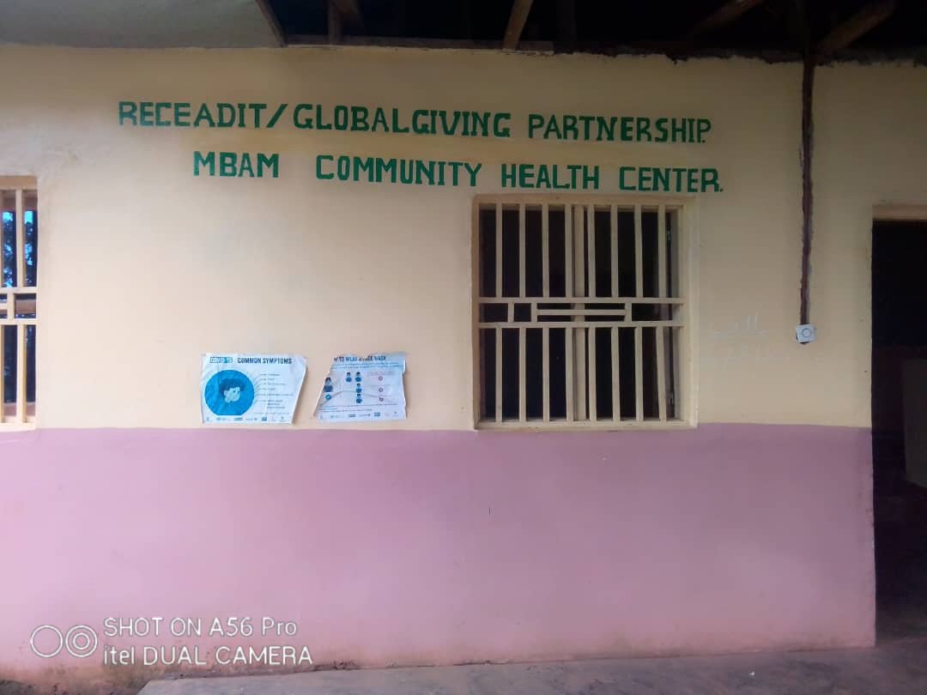

RECEADIT/GlobalGiving Partnership, Mbam Community Health Center

Second Illustration Photo

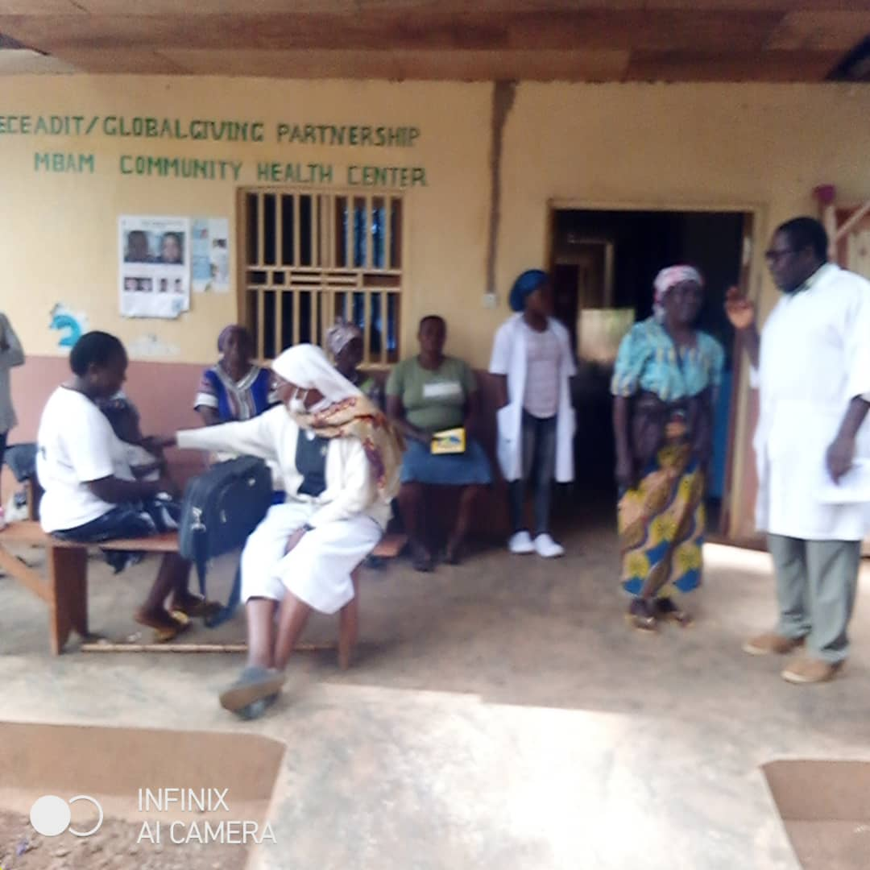

RECEADIT/Njinikom General Hospital Partnership Medical Team attending to patients at our RECEADIT/GlobalGiving Partnership, Mbam Community Health Center

Third Illustration Photo

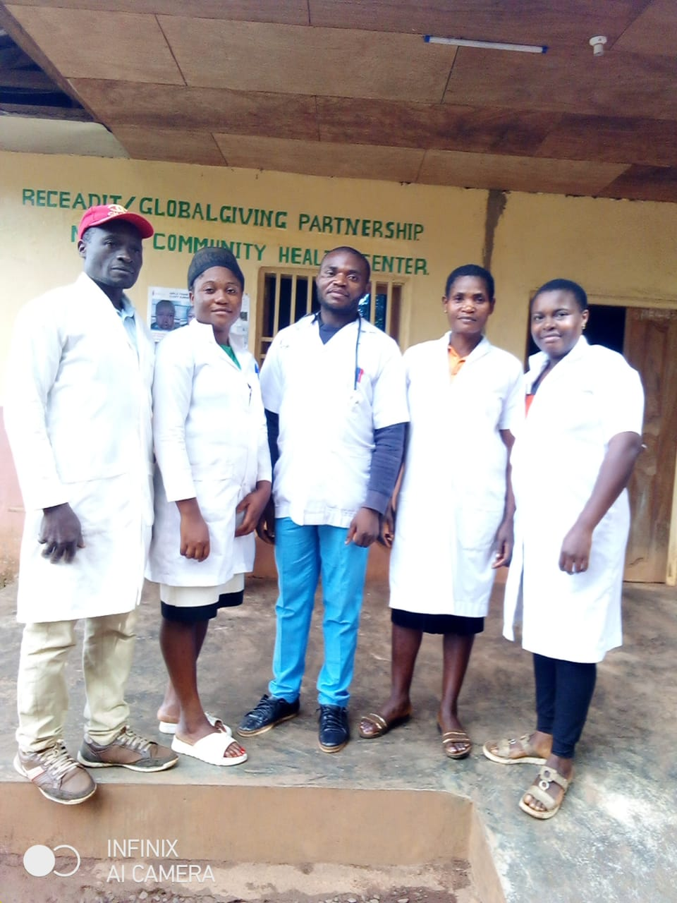

RECEADIT Medical Team Ready and waiting for patients at our RECEADIT/GlobalGiving Partnership, Mbam Community Health Center Despite the Extended Lock Down

Fourth Illustration Photo

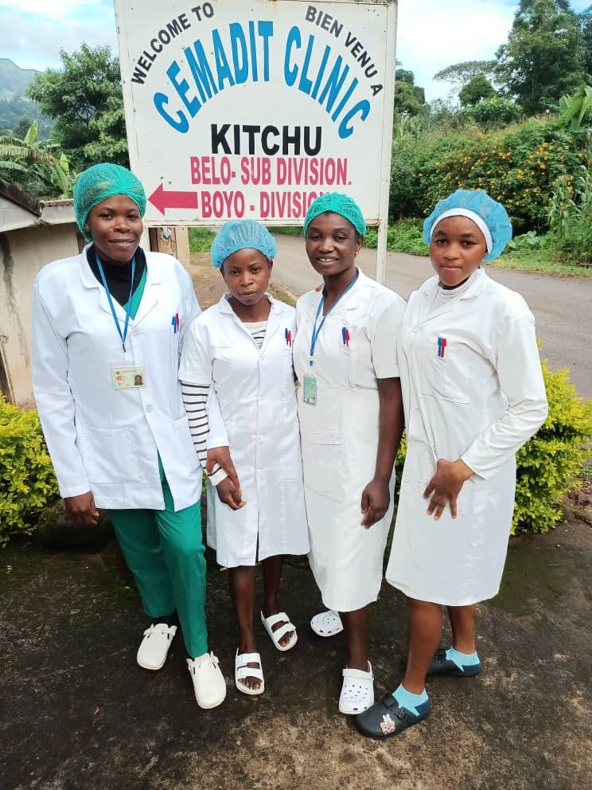

RECEADIT Medical Team Ready and waiting for patients at our RECEADIT/GlobalGiving Partnership, Kitchu Community Health Center Despite the Extended Lock Down

Fifth Illustration Photo

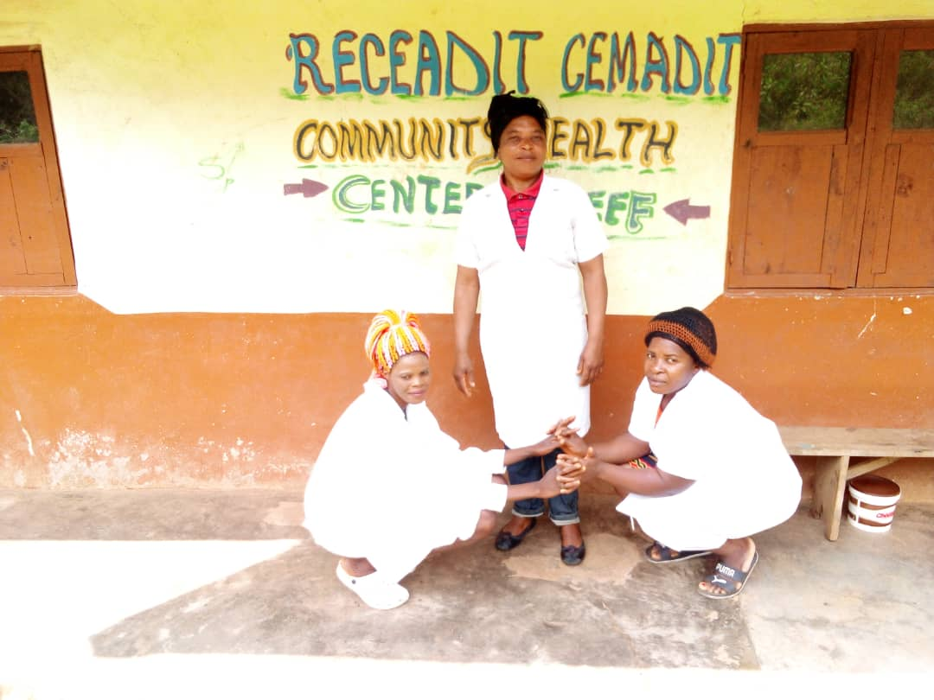
RECEADIT Medical Team Ready and waiting for patients at our RECEADIT/GlobalGiving Partnership, Muteff Community Health Center Despite the Extended Lock Down

Sixth Illustration Photo

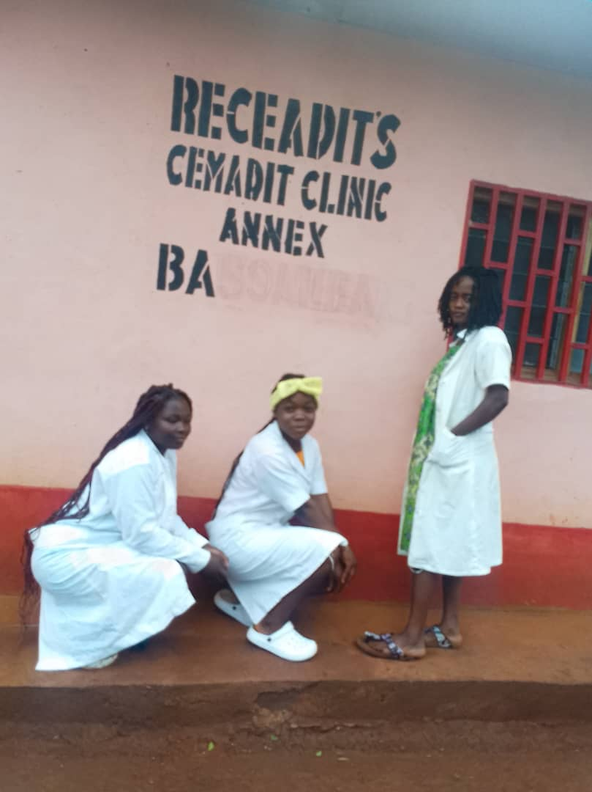

RECEADIT Medical Team Ready and waiting for patients at our RECEADIT/GlobalGiving Partnership, RECEADIT’s CEMADIT Clinic Annex at Bassamba Community Despite the Extended Lock Down

Seventh Illustration Photo
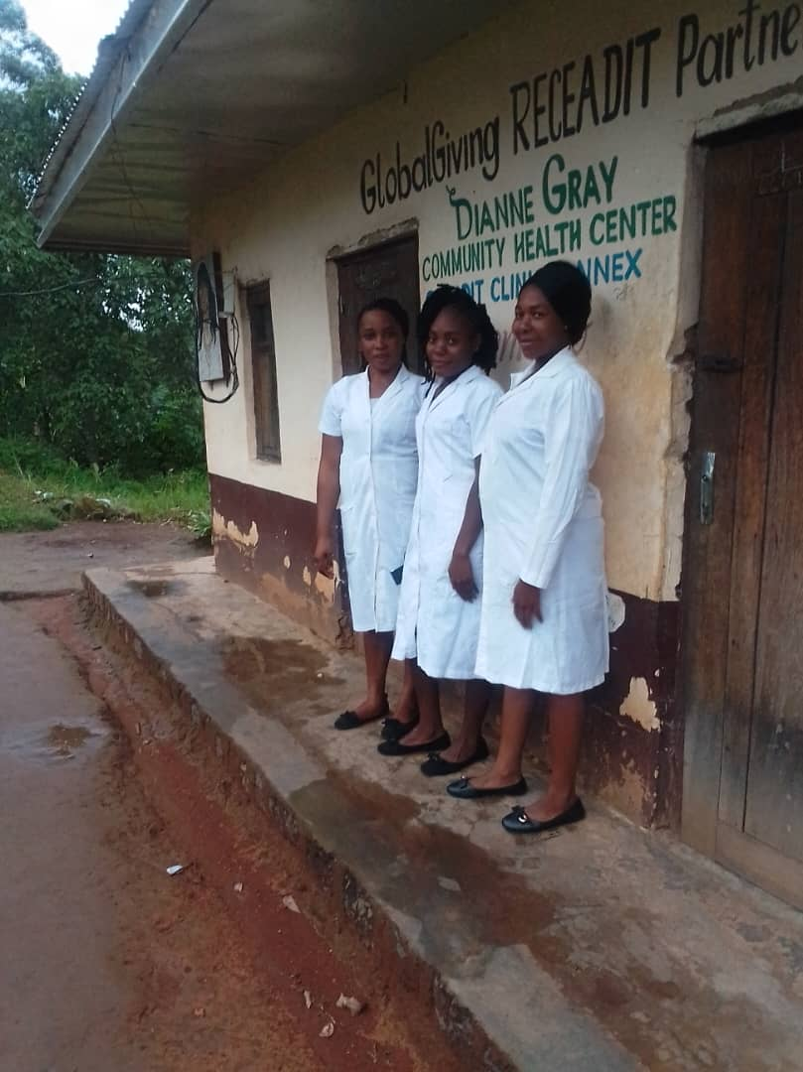

RECEADIT Medical Team Ready and waiting for patients at Our RECEADIT/GlobalGiving Partnership, Ngemsibo Community Health Center Despite the Extended Lock Down

Eighth Illustration Photo

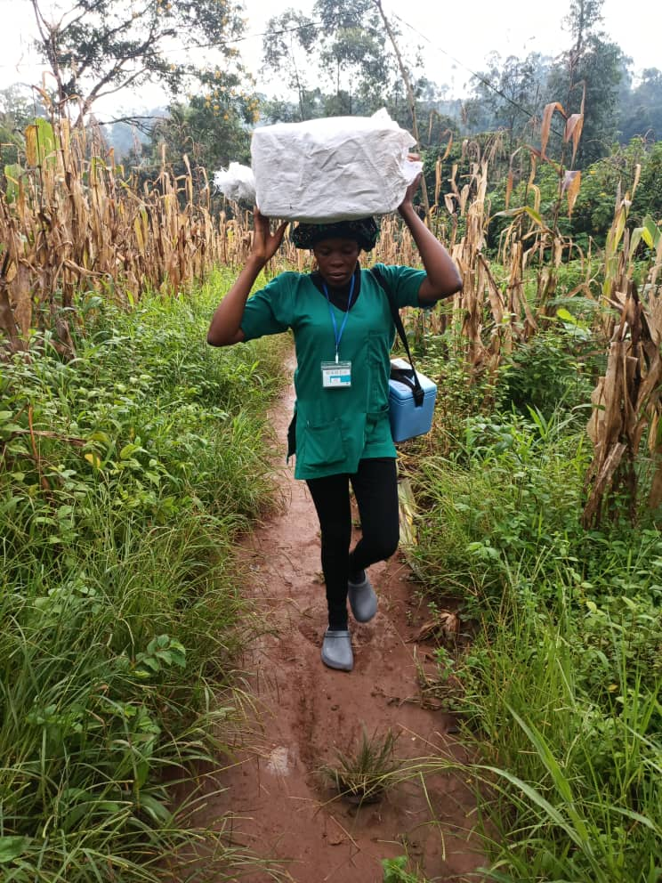

Our RECEADIT Female Nurse Who Walked Many Miles to the City of Bamenda to Purchase Needed Essential Drugs, Basic Necessities and Food Items and Walked Back to her Clinic at Kitchu

Ninth Illustration Photo

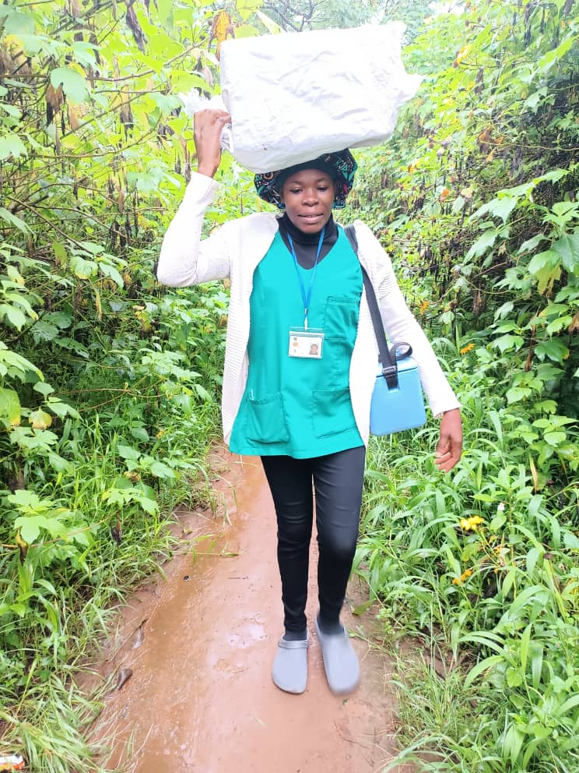

Our RECEADIT Female Nurse Who Walked Many Miles to the City of Bamenda to Purchase Needed Essential Drugs, Basic Necessities and Food Items and Walked Back to her Clinic at Kitchu

Tenth Illustration Photo

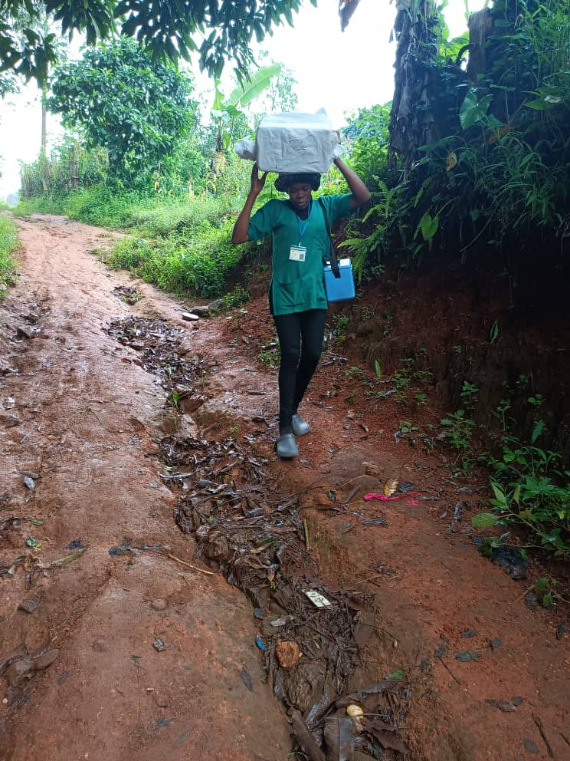

Our RECEADIT Female Nurse Who Walked Many Miles to deliver Vaccines and Needed Essential Drugs, Basic Necessities and Food Items to Our RECEADIT-Globalgiving Partnership Community Health Center at Ngemsibo.

Eleventh Illustration Photo

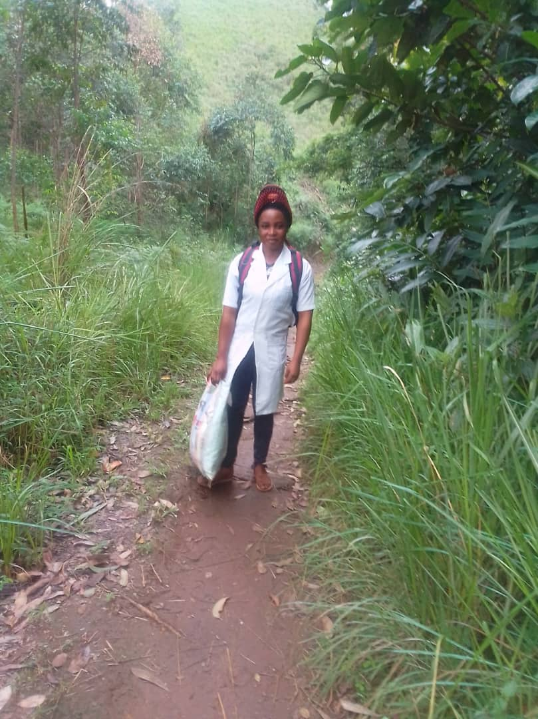

Our RECEADIT Female Nurse Who Walked Many Miles to Babunguh to Purchase Essential Drugs and Food Items for Our RECEADIT-Globalgiving Partnership Community Health Center at Ngemsibo.

Twelfth Illustration Photo

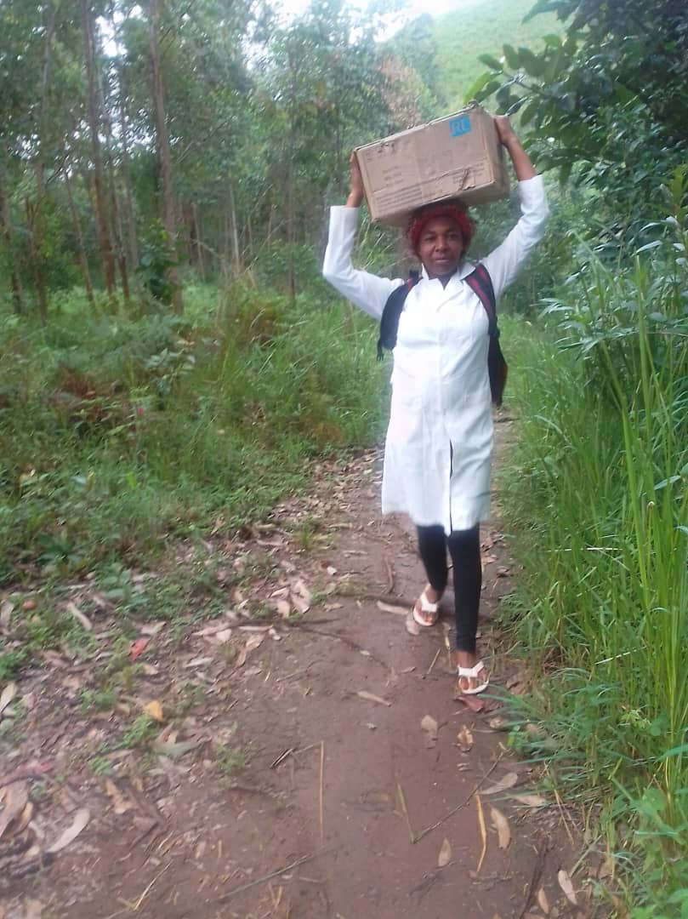

Our RECEADIT Female Nurse Who Walked Many Miles to get Needed Essential Drugs and Basic Necessities from Our RECEADIT Central Pharmacy at Kitchu to Our RECEADIT-Globalgiving Partnership Community Health Center at Ngemsibo.

Thirteenth Illustration Photo

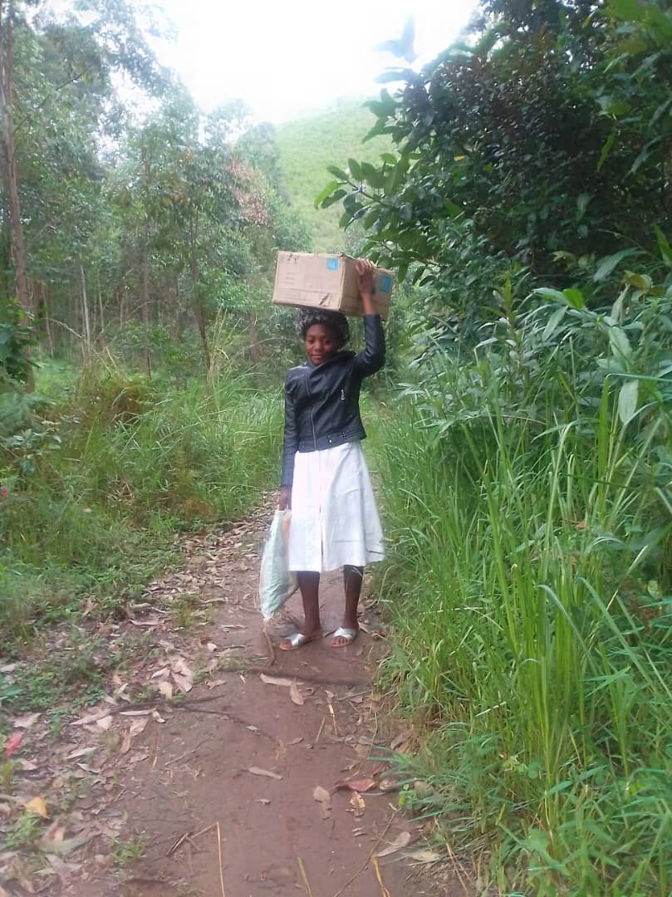

Our RECEADIT Female Nurse Who Walked Many Miles to Babunguh to Purchase Essential Drugs and Basic Necessities for Our RECEADIT-Globalgiving Partnership Community Health Center at Ngemsibo.

Fourteenth Illustration Photo

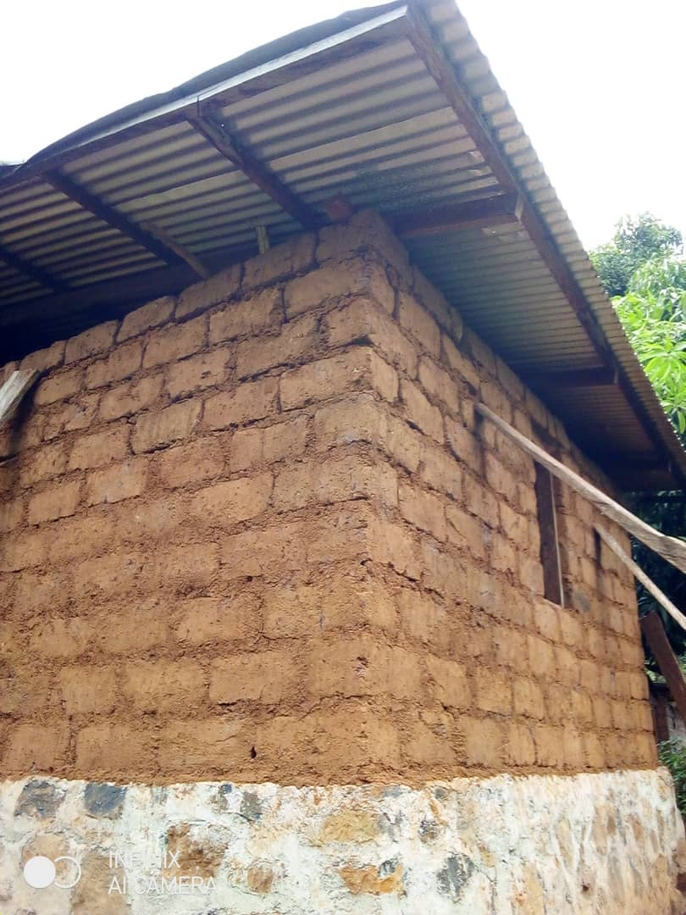

RECEADIT New Building under Construction for the provision of Accommodation and shelter for Our Internally Displaced at our RECEADIT/GlobalGiving Partnership, Mbam Community Health Center.

Fifteenth Illustration Photo

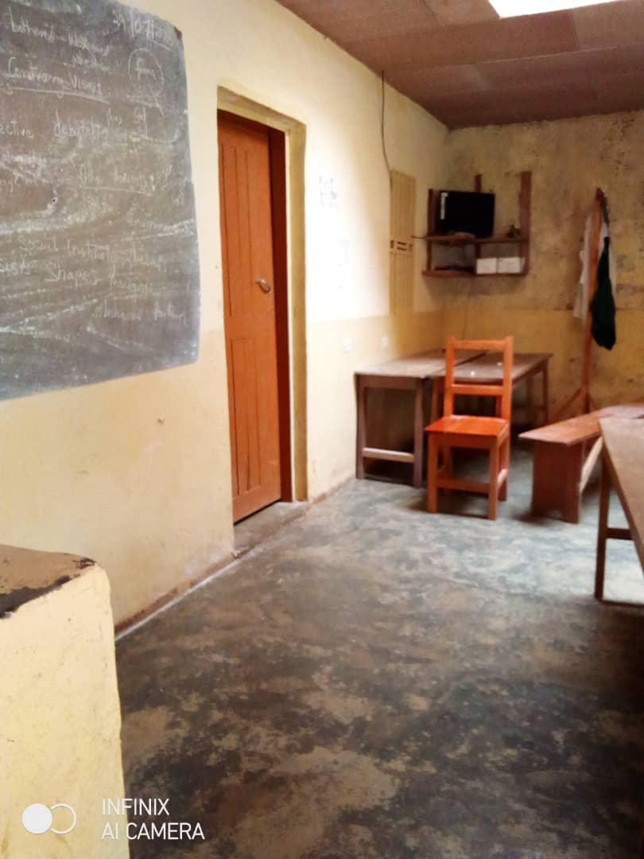

One Room in the RECEADIT New Building under Construction already occupied by Four of Our Internally Displaced Fellow Human Beings at our RECEADIT/GlobalGiving Partnership, Mbam Community Health Center.

Sixteenth Illustration Photo

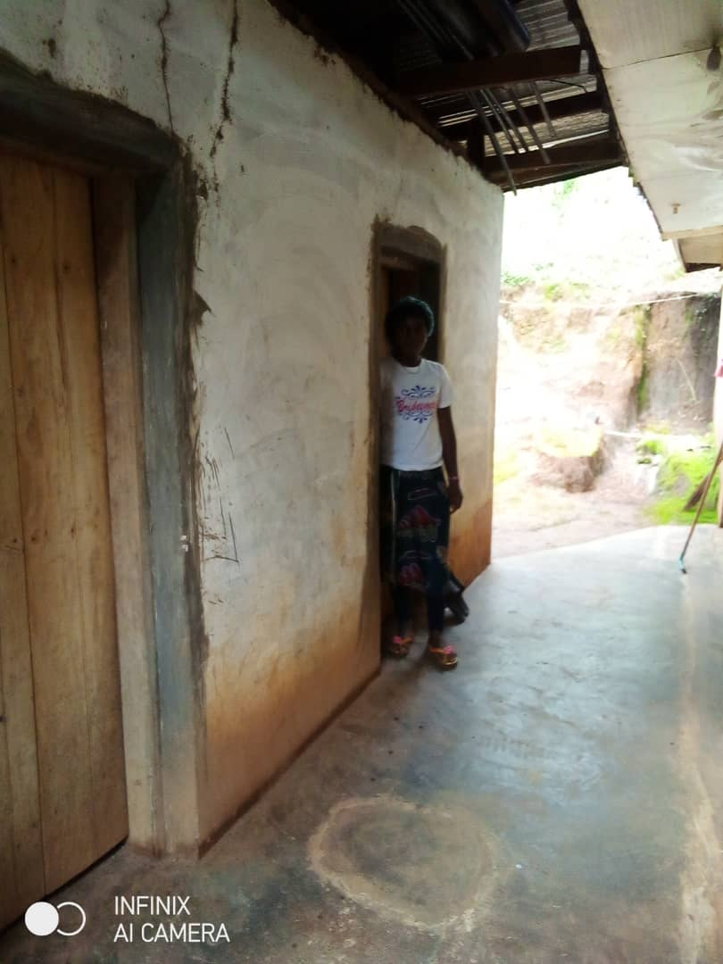

Two Completed Rooms in the RECEADIT New Building under Construction already occupied by Six of Our Internally Displaced Fellow Human Beings at our RECEADIT/GlobalGiving Partnership, Mbam Community Health Center.

Seventeenth Illustration Photo

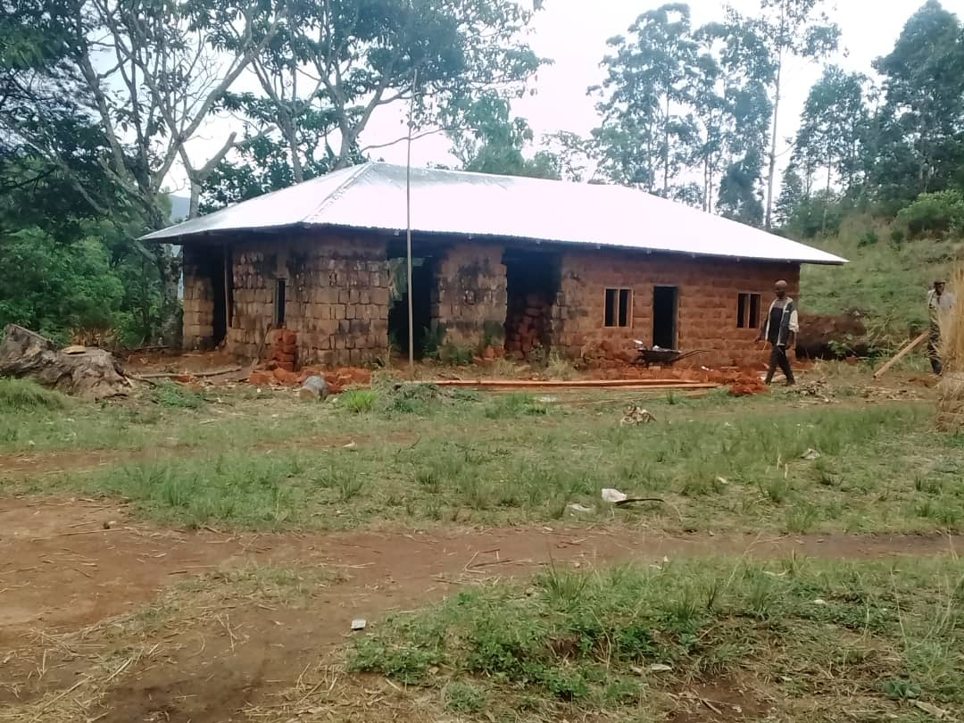

RECEADIT New Building under Construction for the provision of Accommodation and shelter for Our Internally Displaced Fellow Human Beings at our RECEADIT/GlobalGiving Partnership, Ngemsibo Community Health Center.

Eighteenth Illustration Photo

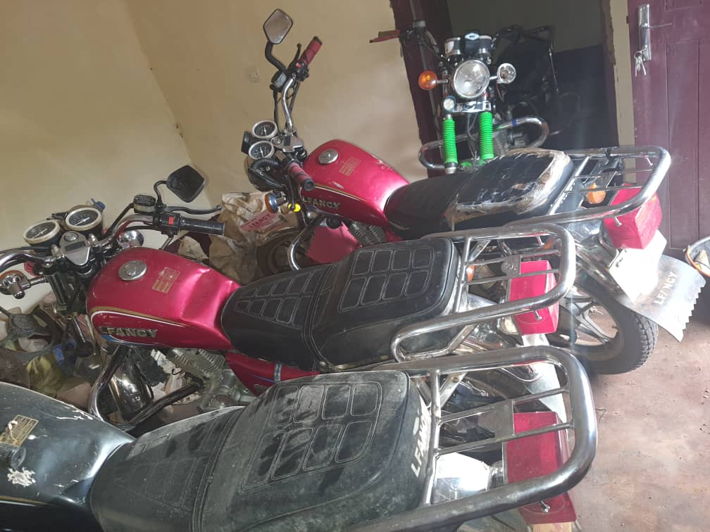

Our RECEADIT Four Bikes locked up in a secured location during the Lock down of over Two months now

Nineteenth Illustration Photo

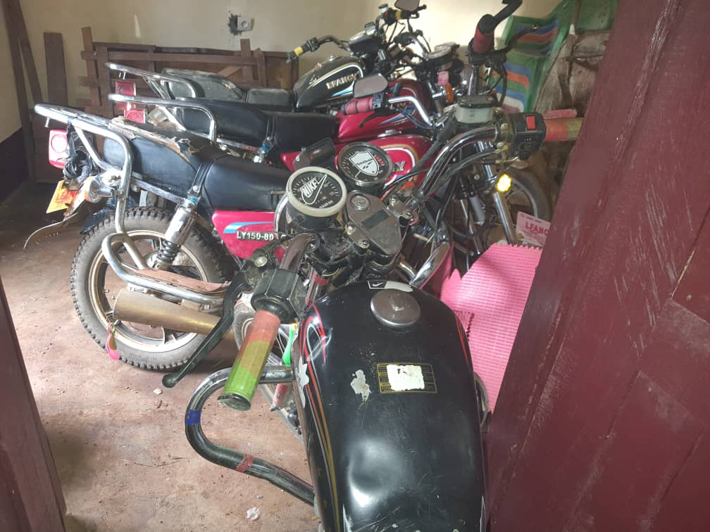

Our RECEADIT Four Bikes locked up in a secured location during the Lock down of over Two months now

Twentieth Illustration Photo

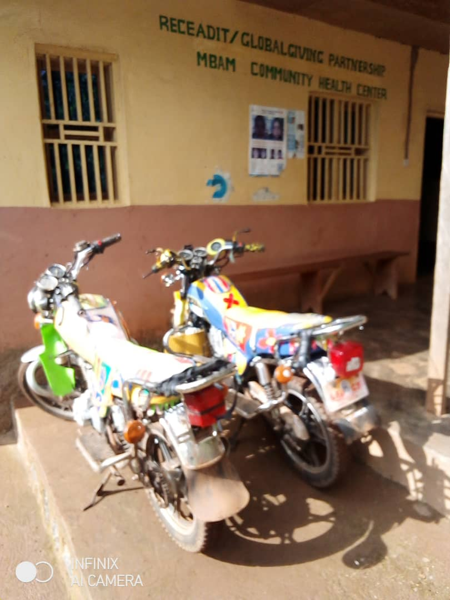

Our RECEADIT Two Bikes safely locked up at Our RECEADIT-Globalgiving Partnership Community Health Center at Mbam during the Lock down of over Two months now

Twenty First Illustration Photo

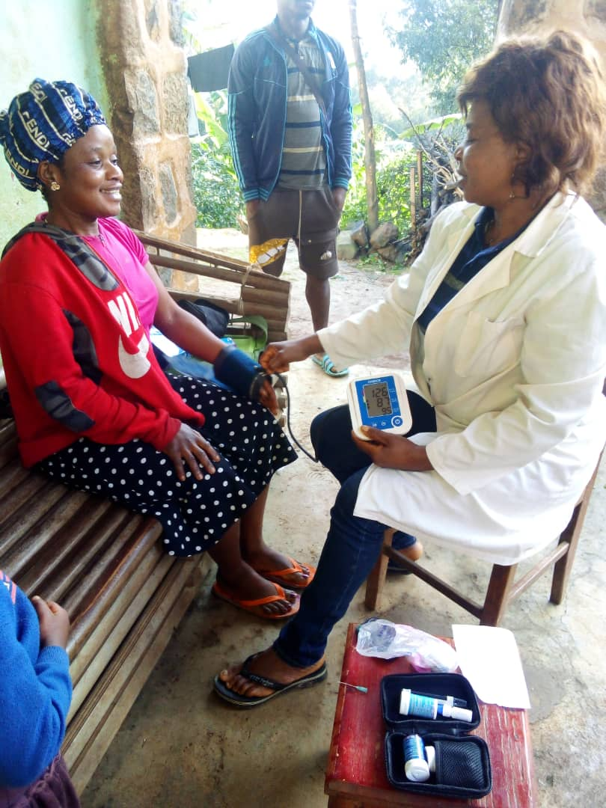

Our Determined and Committed Female nurse of our RECEADIT-Partnership Community Health Center at Muteff out in the Muteff Community for her Home Visits.

Twenty Second Illustration Photo

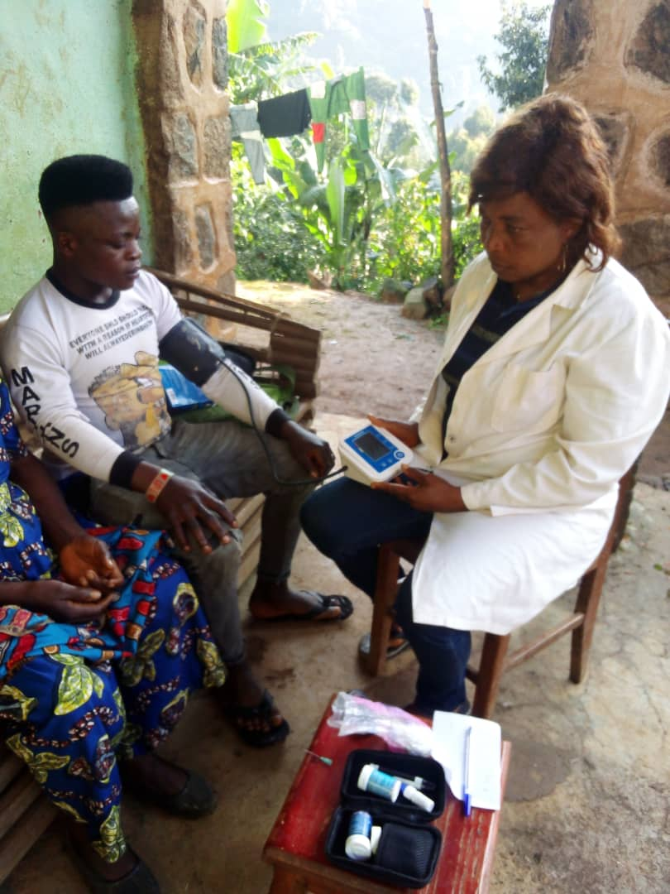

Our Determined and Committed Female nurse of our RECEADIT-Partnership Community Health Center at Muteff out in the Muteff Community for her Home Visits.

Twenty Third Illustration Photo

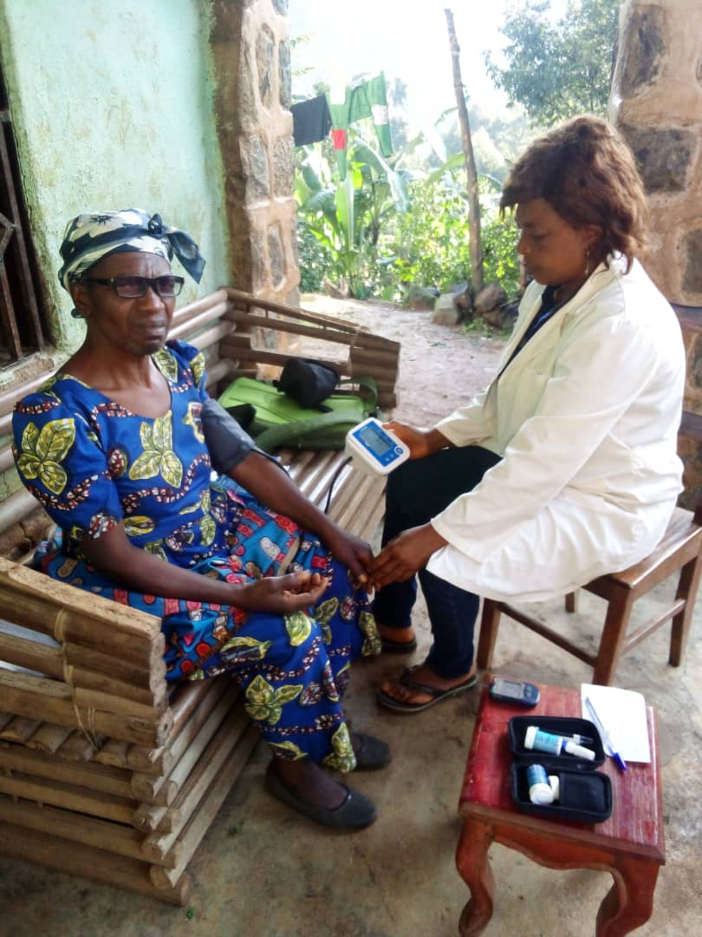

Our Determined and Committed Female nurse of our RECEADIT-Partnership Community Health Center at Muteff out in the Muteff Community for her Home Visits.

Twenty Fourth Illustration Photo

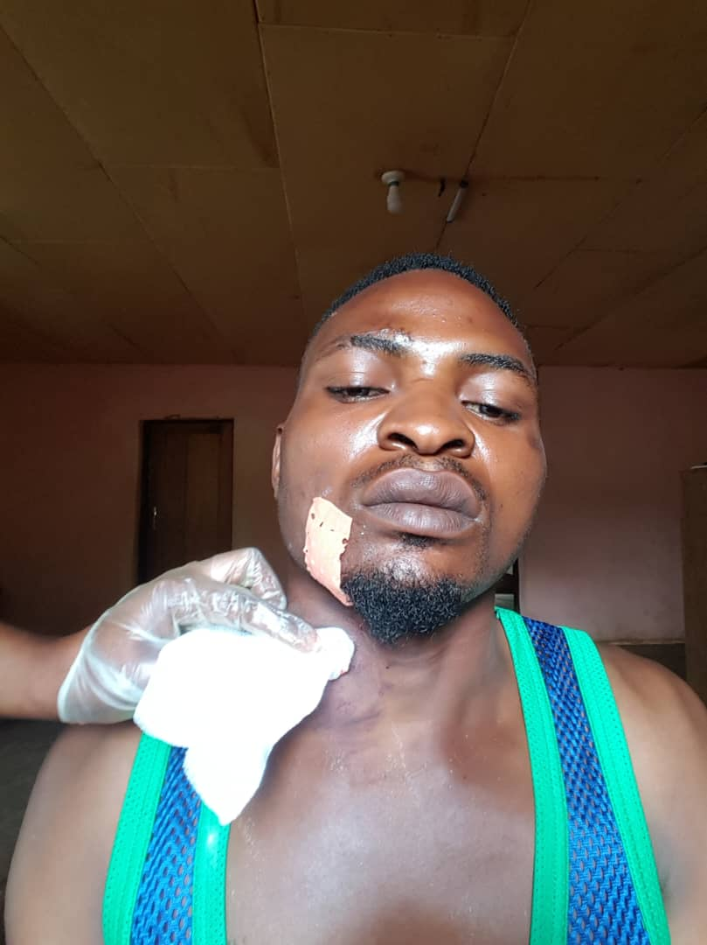
Our Determined and Committed Female nurse of our RECEADIT-Partnership Community Health Center at Ngemsibo out in the Ngemsibo Community for her Home Visits.

Twenty Fifth Illustration Photo

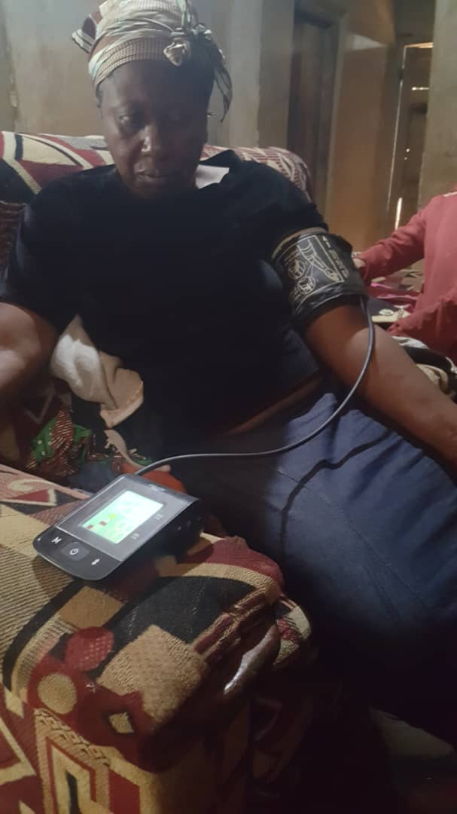

Our Determined and Committed Female nurse of our RECEADIT-Partnership Community Health Center at Ngemsibo out in the Ngemsibo Community for her Home Visits.

Twenty Sixth Illustration Photo

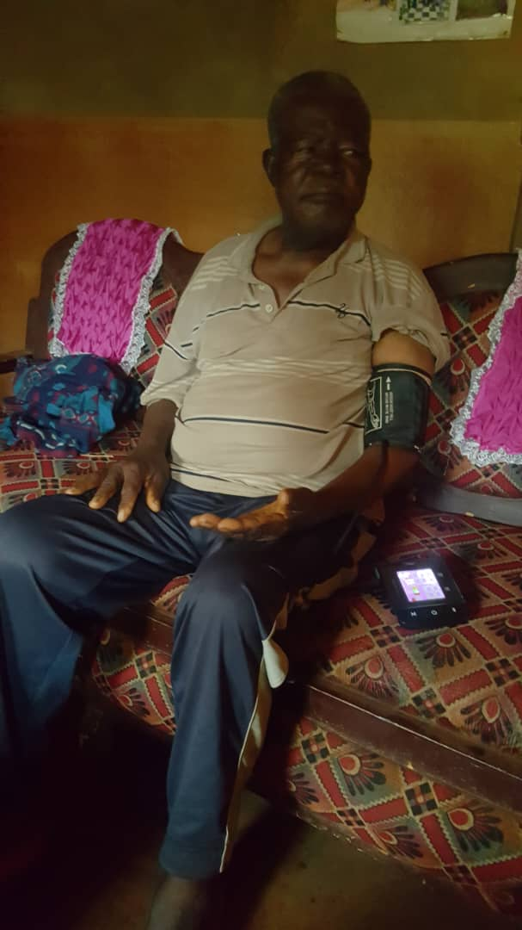

Our Determined and Committed Female nurse of our RECEADIT-Partnership Community Health Center at Ngemsibo out in the Ngemsibo Community for her Home Visits.

Twenty Seventh Illustration Photo

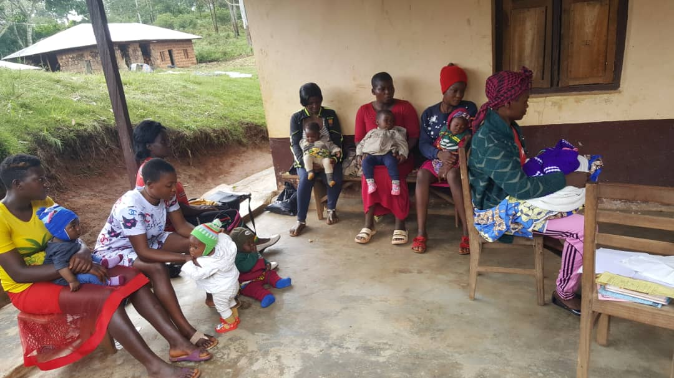

Mothers and their Children waiting for Vaccination at Our RECEADIT-Globalgiving Partnership Community Health Clinic at Ngemsibo

Twenty Eighth Illustration Photo

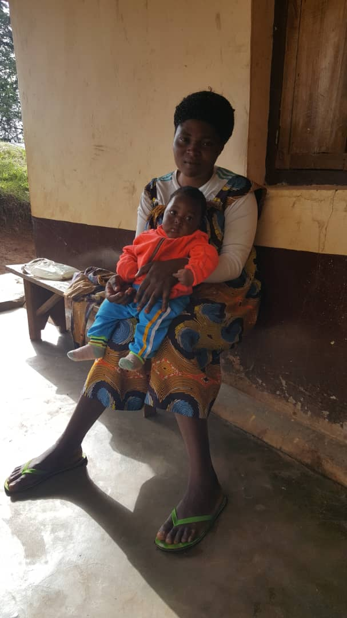

A Mother and her Child waiting for Vaccination at Our RECEADIT-Globalgiving Partnership Community Health Clinic at Ngemsibo.

Twenty Ninth Illustration Photo

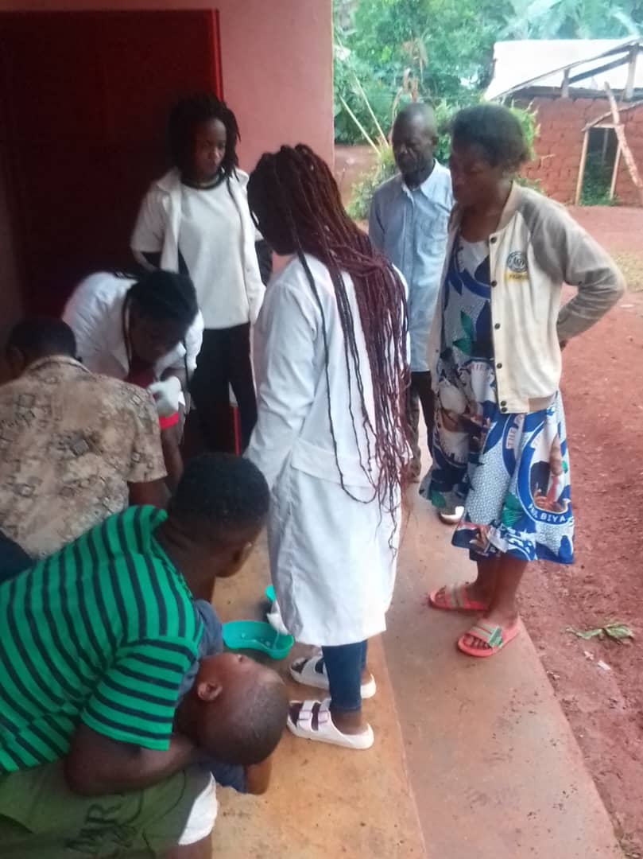

Our Determined and Committed Female nurses of our RECEADIT-Partnership Community Health Clinic at Bassamba Vaccinating children.

