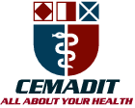
Research Center for Analytic Diagnosis and Imaging Trends (RECEADIT)
School of Health, Biomedical and Computer Sciences (SHBCS)
2021-2022 Academic Year
P.O. Box 19, Belo-Kom, Belo Sub-Division, Boyo Division, Cameroon, North-West Region,
Africa - Tel: + 1(910) 261-7785 or +237 6 52 49 78 82 or + (237) 6 77 68 99 32
cemadit@yahoo.com http://www.meditech-group.org
RECEADIT-CEMADIT Clinic Authorisation no/A/MINSANTE/SG/DOSTS/SDOS/SFSP
Motto: Health Care Research and Education for Services to Humanity

Motto: Health Care Research and Education for Services to Humanity

MEDITECH GROUP
CEMADIT
ALL ABOUT YOUR HEALTH

MEDITECH GROUP
RECEADIT
ALL ABOUT YOUR HEALTH

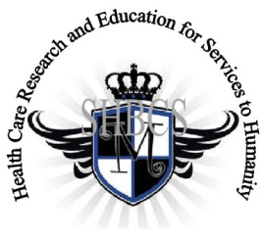

Ministry of Higher Education Ministry of Public Health Registration No. 3342 of August 31, 2011 Registration No. 4042 of August 31, 2011

GlobalGiving RECEADIT Mbam Community Health Care Project (29930)
Eighteenth Project Report of Saturday, December 17^{th,} 2022
On behalf of our RECEADIT Humanitarian Team, I take this opportunity to thank you so very much for your generosity and willingness to join us and to partnership with us on our journey of serving humanity through the Guidance, the Blessings, the Love and the Grace of God Almighty.
We are glad to provide you with the following progress report and updates for our “Mbam Community Health Care Project (29930)” thanks to your generosity:

1) For this Eighteenth Project Report, our main focus is on our RECEADIT/GlobalGiving Partnership, Mbam Community Health Center (See First Illustration Photo) and our Central Pharmacy Drug Program, concentrating on the following: a) Drug supplies to RECEADIT Clinics; b) Medical Home Visits; and c) Vaccination within the Kitchu, Mbam, Muteff and Ngemsibo remote, rural Communities where our RECEDIT Clinics are located (See First Illustration Photos). In order to achieve these, we have purchased two new bikes (See Second and Third Illustration Photos);

2) The increased threat posed by Covid-19 and malaria in the English Speaking part of Cameroon, where our RECEADIT Clinics are located, has resulted in the increase in our RECEADIT Medical Team’s increased vaccination outreach trips to Kitchu, Mbam, Muteff, and Ngemsibo communities within which our RECEADIT Clinics are located (See Fourth, Fifth, Sixth, Seventh and Eighth Illustration Photos);

3) As we reported in our Seventeenth Project Report, the increase in malaria cases, resulting from the onset of the Rainy Season and now the Dry Season and the continued threat posed by Covid-19, have also resulted in a continued increase in our RECEADIT Medical Team’s Home and Community Visits within the Kitchu, Mbam, Muteff and Ngemsibo remote, rural Communities where our RECEADIT Health Clinics are located (See Ninth, Tenth, Eleventh, Twelfth, Thirteenth, and Fourteenth Illustration Photos); and

4) Again, as we reported in our Seventeenth Project Report, though we have an Organized, Medical Training Program for all our RECEADIT workers and a New One Year Medical Training Program, we must point out here once more, with lots of regrets and disappointment, that: a) the intensified war keeps interrupting the program ; and b) our School of Health, Biomedical and Computer Sciences (SHBCS), as well as all other schools in this part of the country, have not been operational since October 2016 due to the serious, ongoing political crisis and war in Cameroon.

We will continue to provide you with monthly reports and updates of our other projects, activities, accomplishments, and challenges.
We hope that you will continue with us on this our journey of serving humanity through the Guidance, the Blessings, the Love and the Grace of God Almighty, a journey which has taken us to this “Mbam Community Health Care Project” through our new link: https://goto.gg/29930

Jilly M. Ngwainmbi, RECEADIT Project Leader

Illustration Photos

First Illustration Photo

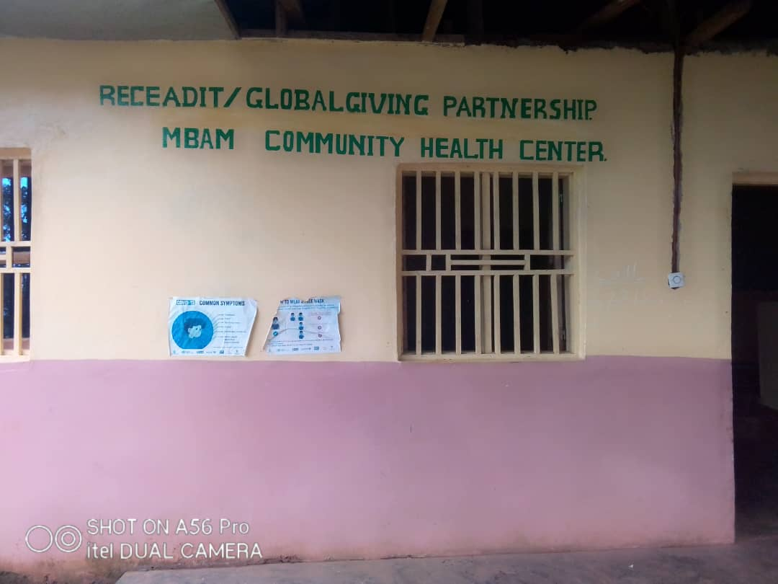

RECEADIT/GlobalGiving Partnership, Mbam Community Health Center

Second Illustration Photo

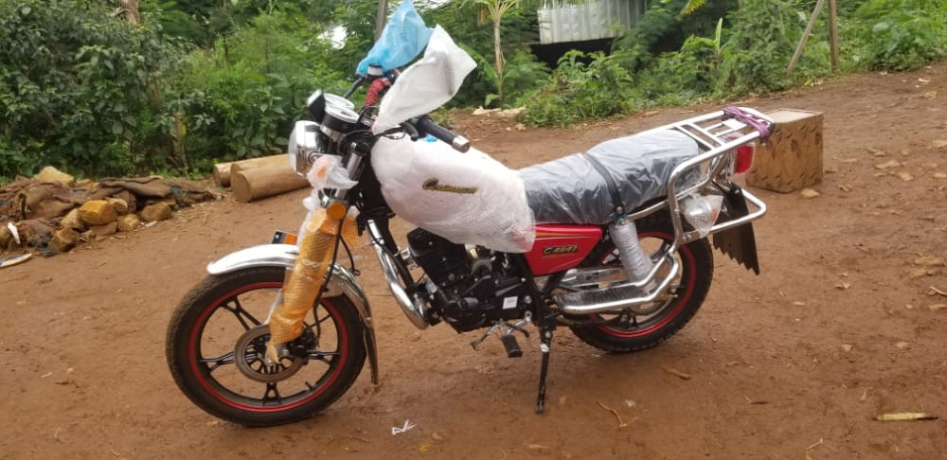

New RECEADIT Bike for our RECEADIT/GlobalGiving Partnership, Mbam and Muteff Community Health Centers

Third Illustration Photo

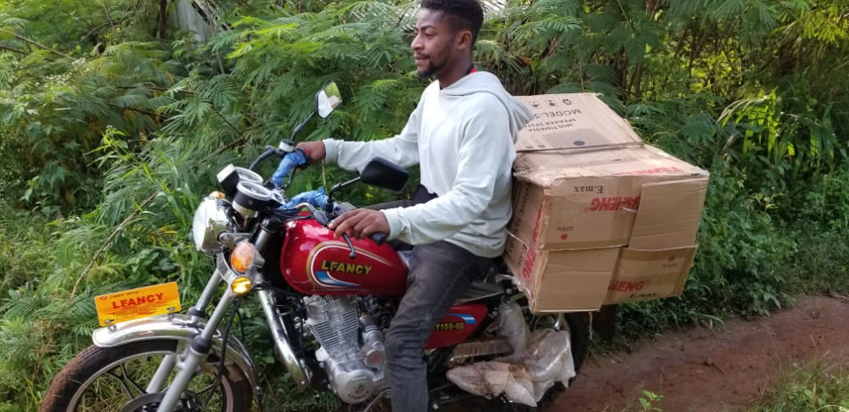

New RECEADIT Bike Transporting Drug Supplies to our RECEADIT/GlobalGiving Partnership, Muteff Community Health Center

Fourth Illustration Photo

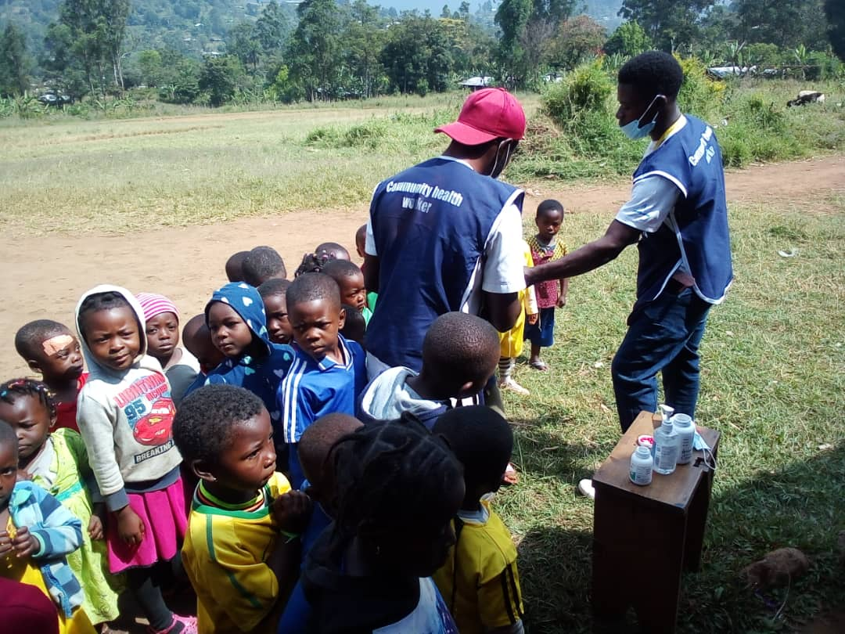

RECEADIT Medical Vaccination Team vaccinating children at the Kitchu rural community where our RECEDIT Clinic is located.

Fifth Illustration Photo

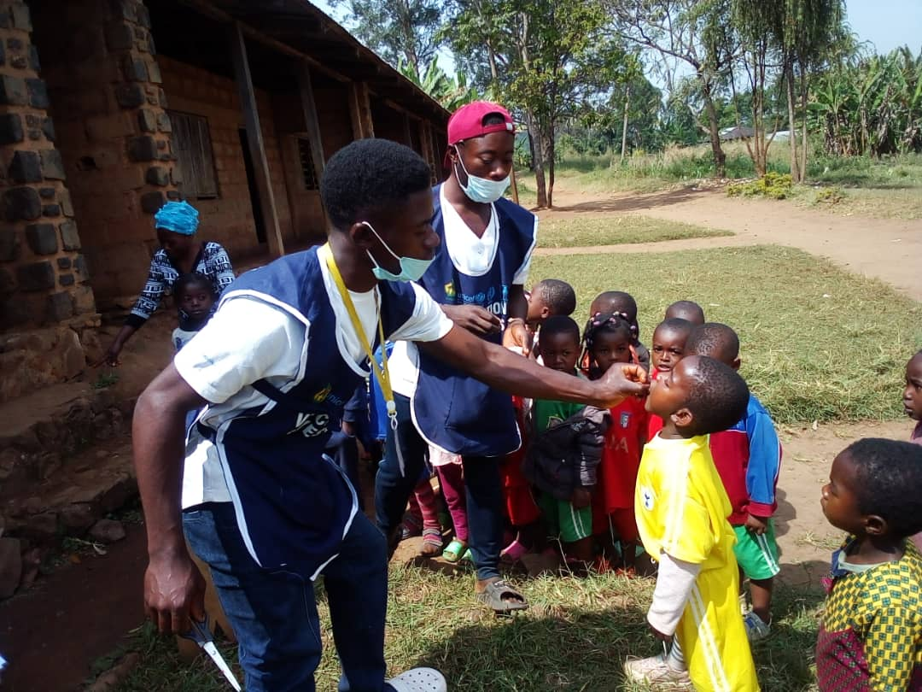

RECEADIT Medical Vaccination Team vaccinating children at a School in Kitchu rural community where our RECEDIT Clinic is located.

Sixth Illustration Photo

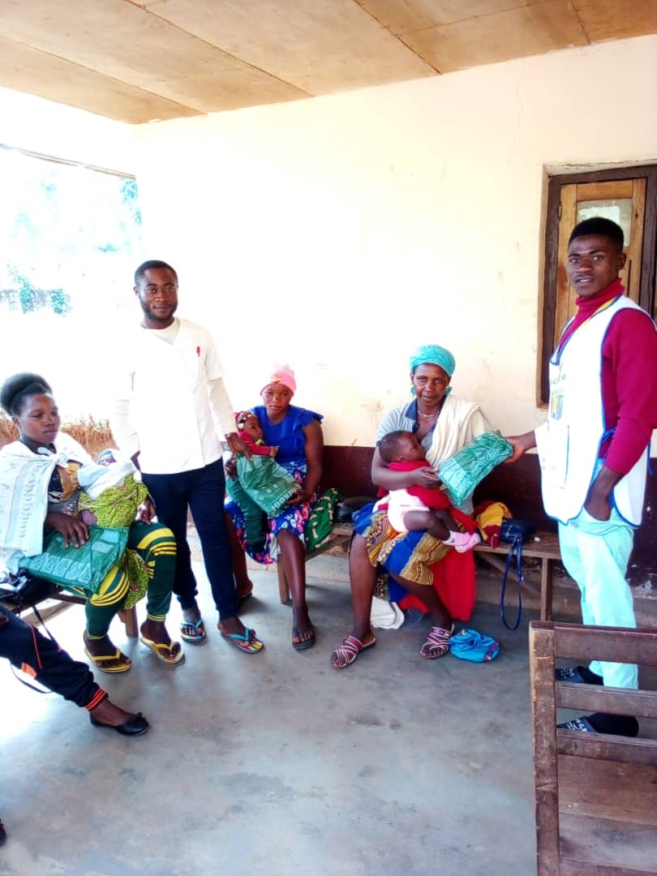
RECEADIT Medical Vaccination Team at our RECEADIT/GlobalGiving Partnership, Ngemsibo Community Health Center
getting ready to start vaccinating children.

Seventh Illustration Photo

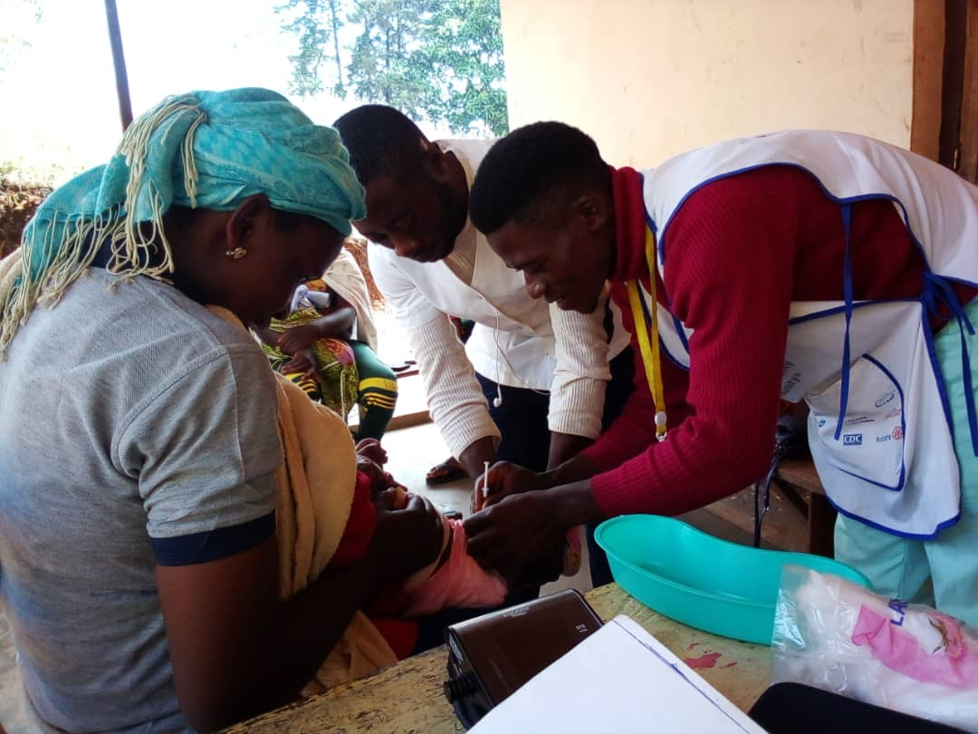

RECEADIT Medical Vaccination Team at our RECEADIT/GlobalGiving Partnership, Ngemsibo Community Health Center
vaccinating children.

Eighth Illustration Photo

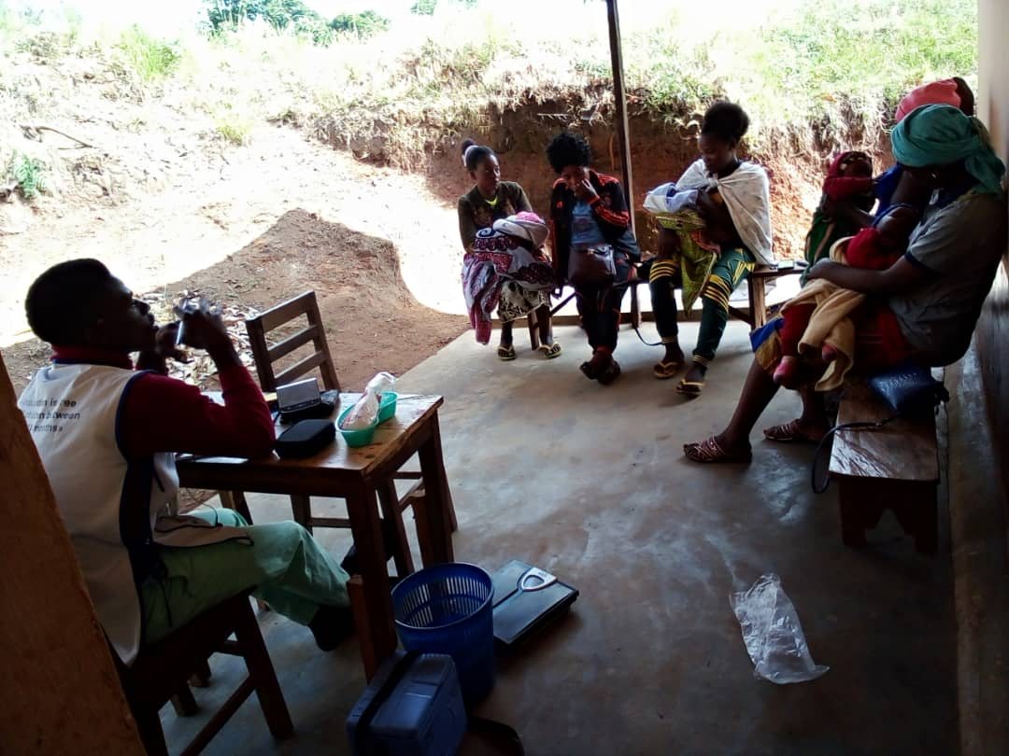

RECEADIT Medical Vaccination Team at our RECEADIT/GlobalGiving Partnership, Ngemsibo Community Health Center
vaccinating children.

Ninth Illustration Photo

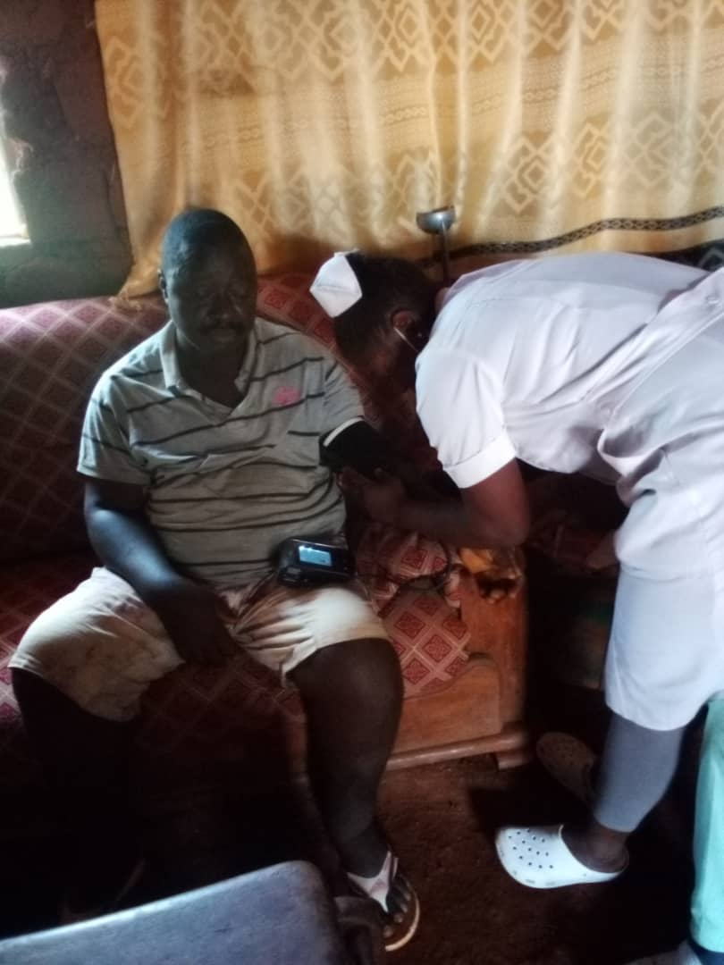
Female Nurse of our RECEADIT Medical Team on her Home Visits within the Kitchu Community where our RECEADIT Clinic is located

Tenth Illustration Photo

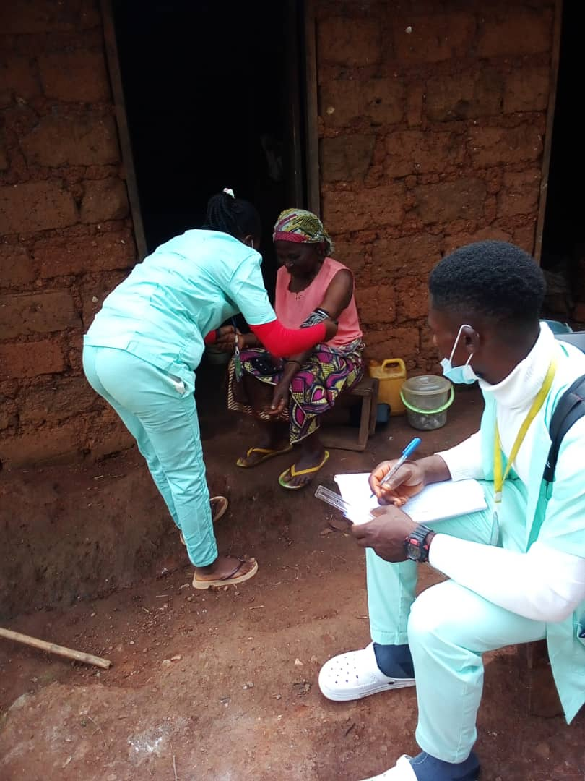

Female Nurse and Male nurse of our RECEADIT Medical Team on their Home Visits within the Kitchu Community where our RECEADIT Clinic is located

Eleventh Illustration Photo

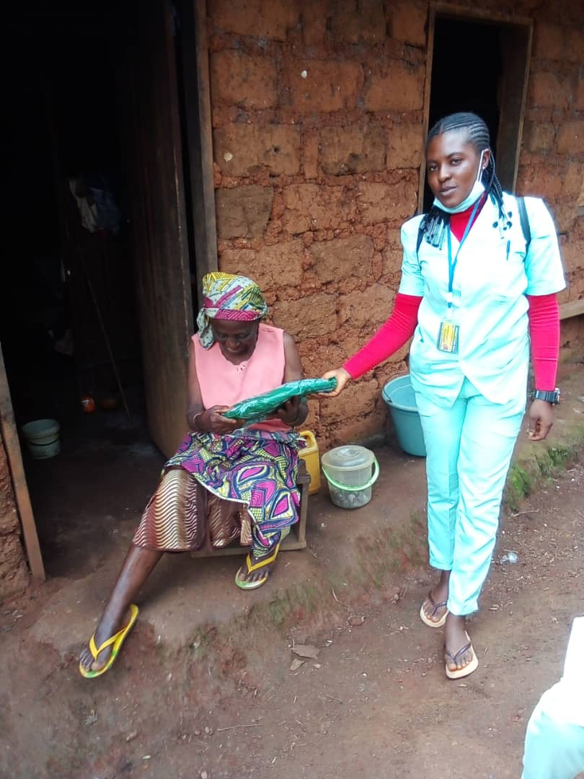

Female Nurse of our RECEADIT Medical Team on her Home Visits within the Kitchu Community where our RECEADIT Clinic is located

Twelfth Illustration Photo

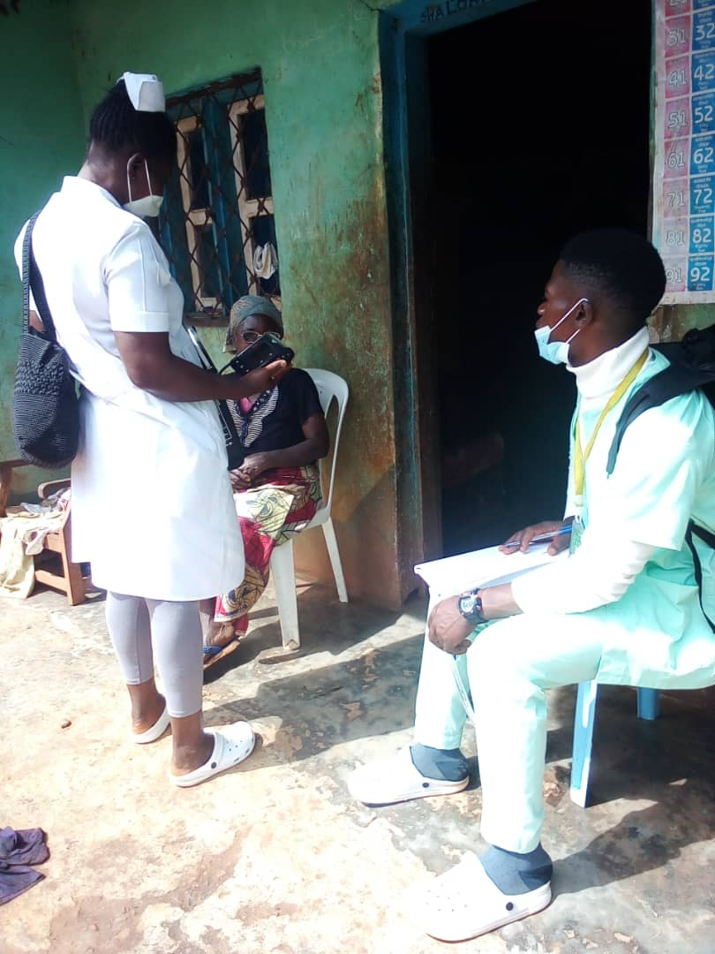
Female Nurse and Male Nurse of our RECEADIT Medical Team on their Home Visits within the Kitchu Community where our RECEADIT Clinic is located

Thirteenth Illustration Photo

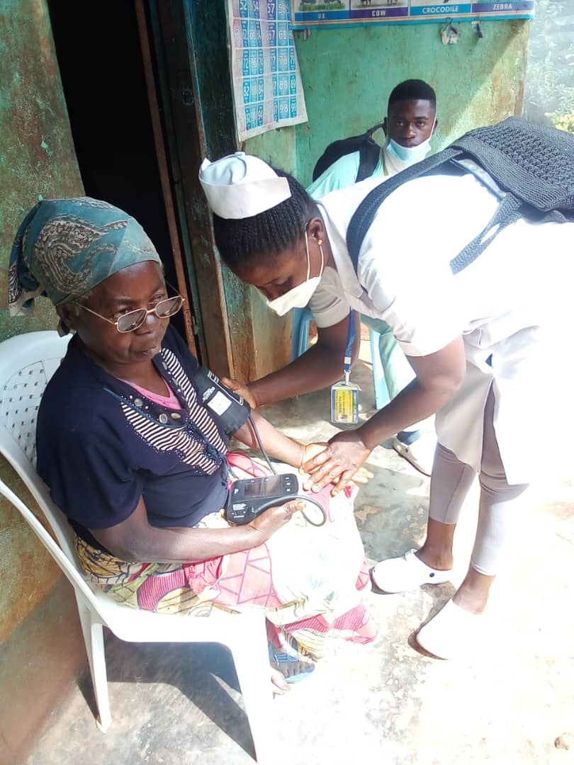
Female Nurse and Male Nurse of our RECEADIT Medical Team on their Home Visits at Njinikem, a nearby Community to Kitchu where our RECEADIT Clinic is located

Fourteenth Illustration Photo

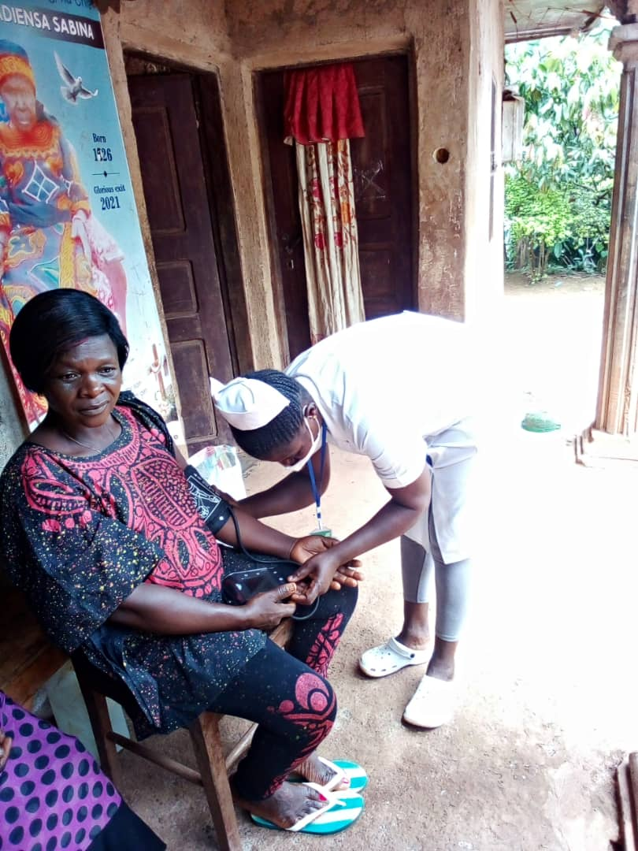

Female Nurse of our RECEADIT Medical Team on her Home Visits at Njinikejem, a nearby Community to Kitchu where our RECEADIT Clinic is located

