***Research Center for Analytic Diagnosis and Imaging Trends (RECEADIT)***

***School of Health, Biomedical and Computer Sciences (SHBCS)***

***2022-2023 Academic Year***

P.O. Box 19, Belo-Kom, Belo Sub-Division, Boyo Division, Cameroon, North-West Region,

Africa - Tel: + 1(910) 261-7785 or +237 6 52 49 78 82 or + (237) 6 77 68 99 32

[cemadit@yahoo.com](mailto:cemadit@yahoo.com) <http://www.meditech-group.org>

**RECEADIT-CEMADIT Clinic Authorisation no/A/MINSANTE/SG/DOSTS/SDOS/SFSP**

***Motto: Health Care Research and Education for Services to Humanity***

***Motto: Health Care Research and Education for Services to Humanity***

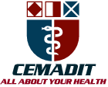

***MEDITECH GROUP***

***CEMADIT***

***ALL ABOUT YOUR HEALTH***



***MEDITECH GROUP***

***RECEADIT***

***ALL ABOUT YOUR HEALTH***

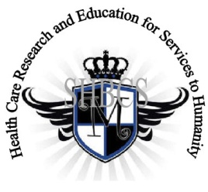

**Ministry of Higher Education Ministry of Public Health Registration No. 3342 of** **August 31, 2011 Registration No. 4042 of August 31, 2011**

# GlobalGiving RECEADIT Mbam Community Health Care Project (29930)

**Nineteenth Project Report of Sunday, April 9th, 2023**

On behalf of our RECEADIT Humanitarian Team, I take this opportunity to thank you so, so very much for your generosity and willingness to join us and to partnership with us on our journey of serving humanity through the Guidance, the Blessings, the Love and the Grace of God Almighty.  
  
We are glad to provide you with the following progress report and updates for our “Mbam Community Health Care Project (29930)” thanks to your generosity:

1) For this Nineteenth Project Report, our main focus is on our **RECEADIT/GlobalGiving Partnership, Mbam Community Health Center (**See First and Second Illustration Photos) and our RECEADIT’s efforts to provide general assistance to the Internally Displaced People, concentrating on the following: a) Drug supplies to RECEADIT Clinics; b) Providing Lodging and Accommodation; c) Community Medical Assistance through our Home Visits Program; and d) Vaccination within the Bassamba, Kitchu, Mbam, Muteff and Ngemsibo remote, rural Communities where our RECEDIT Clinics are located (See All Illustration Photos). In order to achieve these, we now have six RECEADIT bikes (See Fourteenth, Fifteenth, Sixteenth, Seventeenth, Eighteenth, Nineteenth, Twentieth and Twenty First Illustration Photos);

2) Again, we want to point out and emphasize that the increased threat posed by Covid-19 and malaria in the English Speaking part of Cameroon, where our RECEADIT Clinics are located, has resulted in the increase in our RECEADIT Medical Team’s increased vaccination outreach trips to Kitchu, Mbam, Muteff, and Ngemsibo communities within which our RECEADIT Clinics are located (See Second, Twenty Second, Twenty third, Twenty Fourth, Twenty Fifth, Twenty Sixth, Twenty Seventh, Twenty Eighth, and Twenty ninth Illustration Photos);

3) The suffering of the Internally Displaced People, especially the elderly, children and expecting mothers, resulting from malaria and the continued threat posed by Covid-19, have led to the following RECEADIT actions: a) Construction of accommodation facilities; b) Providing furnished sleeping rooms; c) Providing food; and d) increasing Home and Community Visits within the Bassamba, Kitchu, Mbam, Muteff and Ngemsibo remote, rural Communities where our RECEADIT Health Clinics are located (See Third through Twentieth Illustration Photos); and

4) Again, as we reported in our Seventeenth Project Report, although we have an Organized, Medical Training Program for all our RECEADIT workers and a New One Year Medical Training Program, we must point out here once more, with lots of regrets and disappointment, that: a) the intensified war keeps interrupting the program; and b) our School of Health, Biomedical and Computer Sciences (SHBCS), as well as all other schools in this part of the country, have not been operational since October 2016 due to the serious, ongoing political crisis and war in Cameroon.

We will continue to provide you with monthly reports and updates of our other projects, activities, accomplishments, and challenges.

We hope that you will continue with us on this our journey of serving humanity through the Guidance, the Blessings, the Love and the Grace of God Almighty, a journey which has taken us to this “Mbam Community Health Care Project” through our new link: [**https://goto.gg/29930**](https://goto.gg/29930)

Jilly M. Ngwainmbi, RECEADIT Project Leader

**Illustration Photos**

**First Illustration Photo**

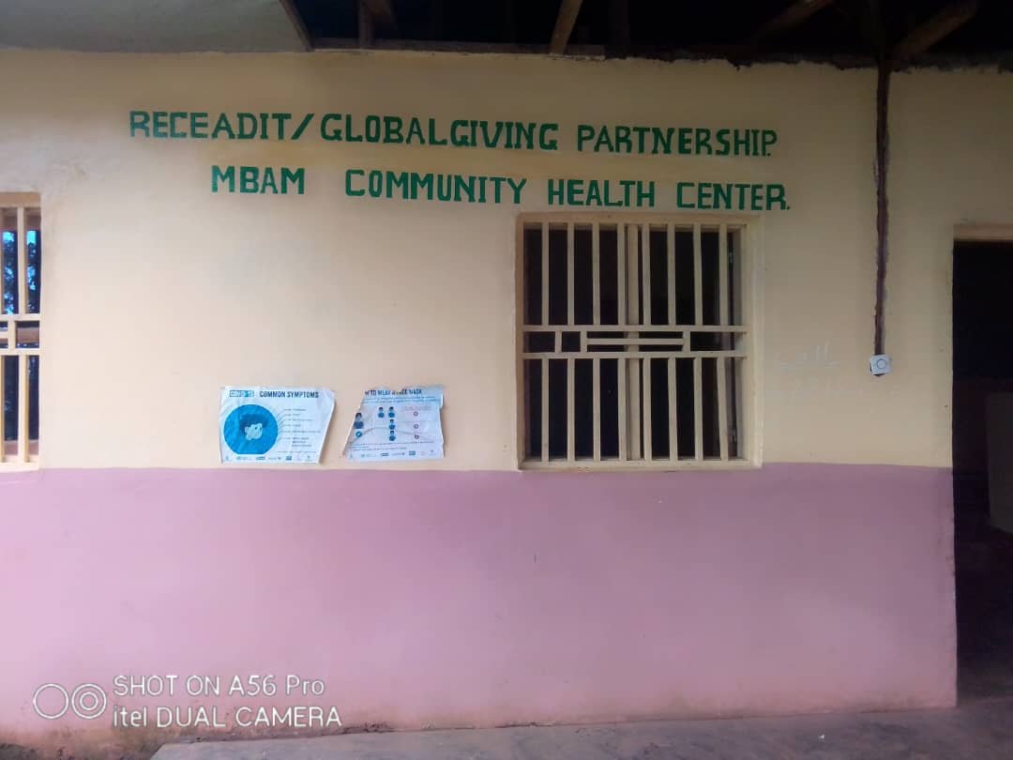

**RECEADIT/GlobalGiving Partnership, Mbam Community Health Center**

**Second Illustration Photo**

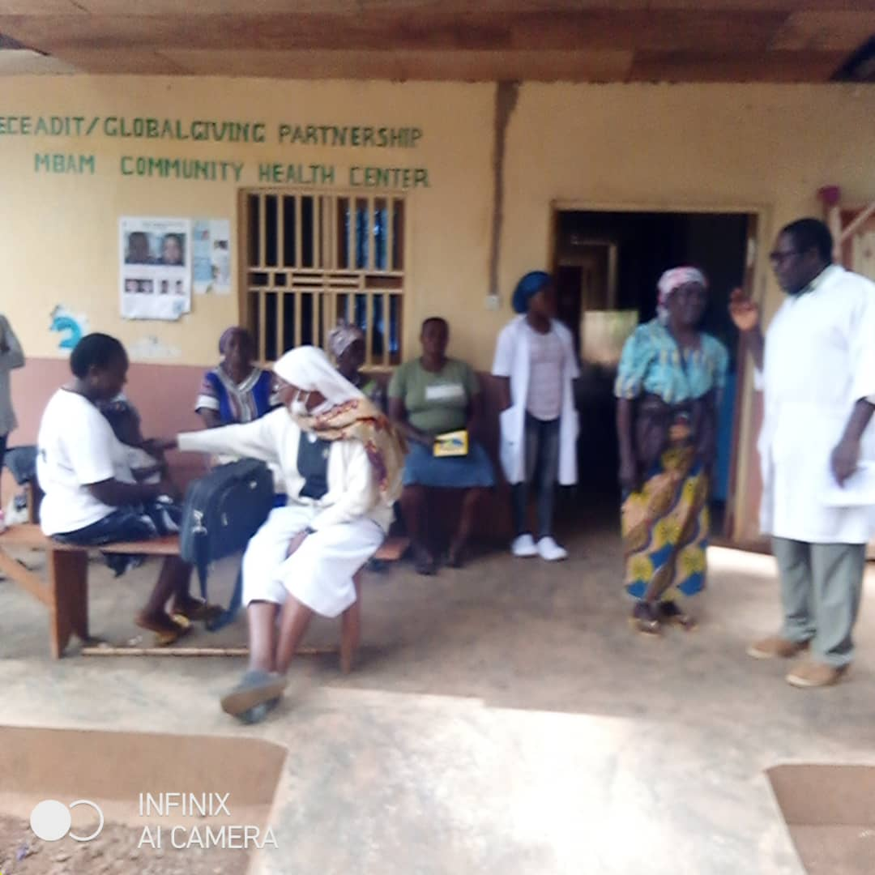

**RECEADIT/Njinikom General Hospital Partnership Medical Team attending to patients at our RECEADIT/GlobalGiving Partnership, Mbam Community Health Center**

**Third Illustration Photo**

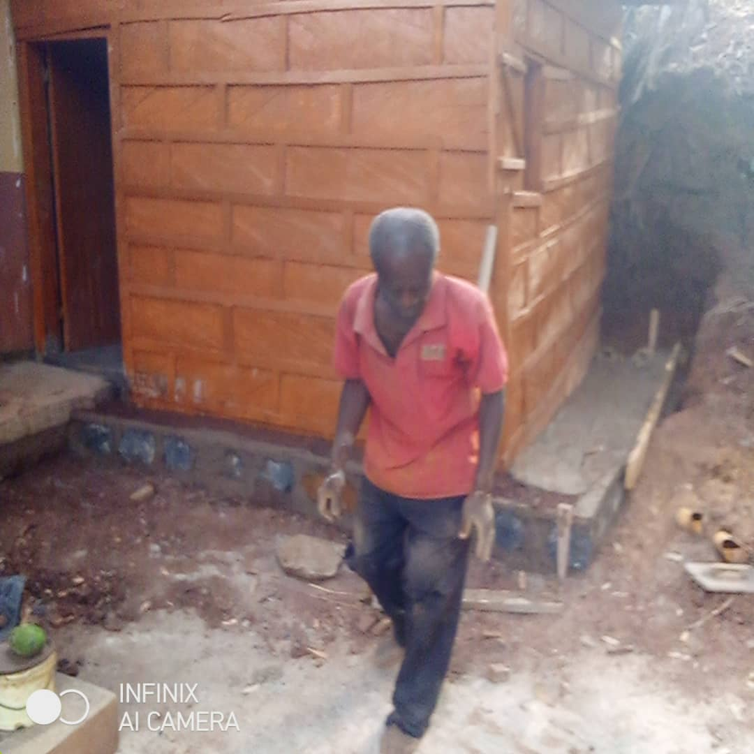

**Construction of a Clinic Canteen at our RECEADIT/GlobalGiving Partnership, Mbam Community Health Center**

**Fourth Illustration Photo**

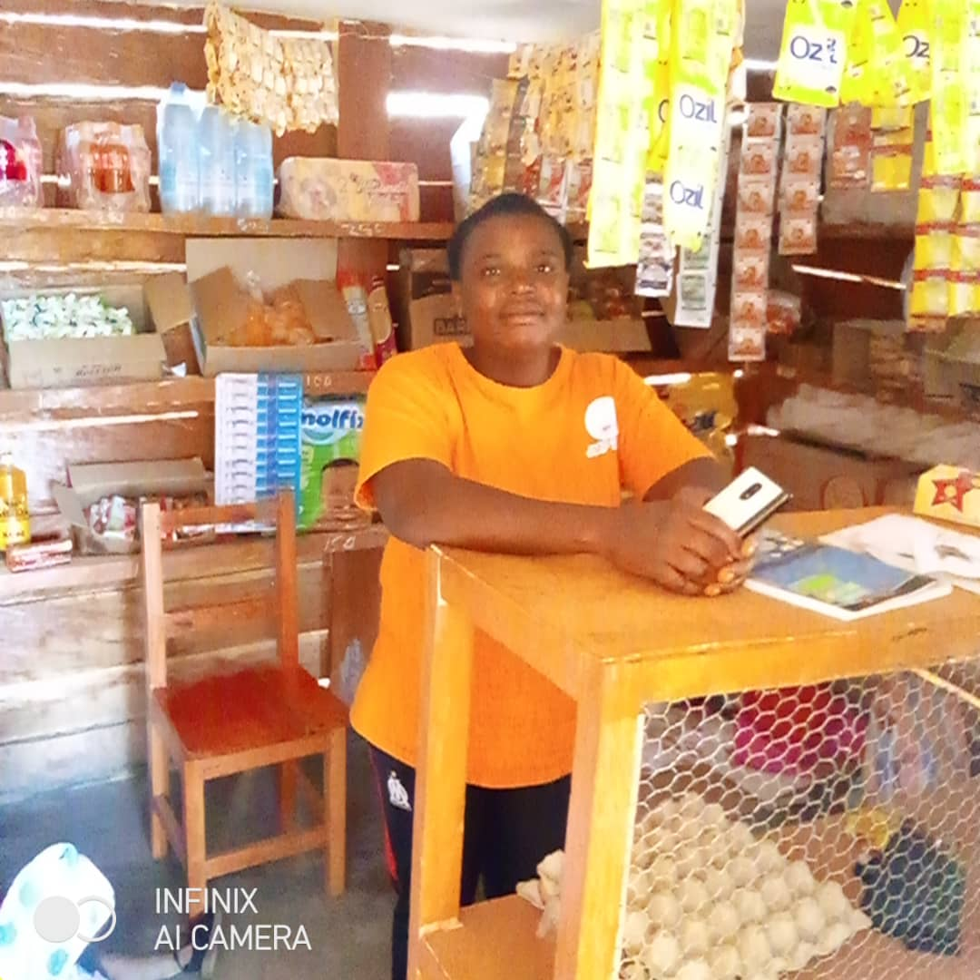

**Completed Clinic Canteen at our RECEADIT/GlobalGiving Partnership, Mbam Community Health Center, which has provided wonderful job opportunities for our community members.**

**Fifth Illustration Photo**

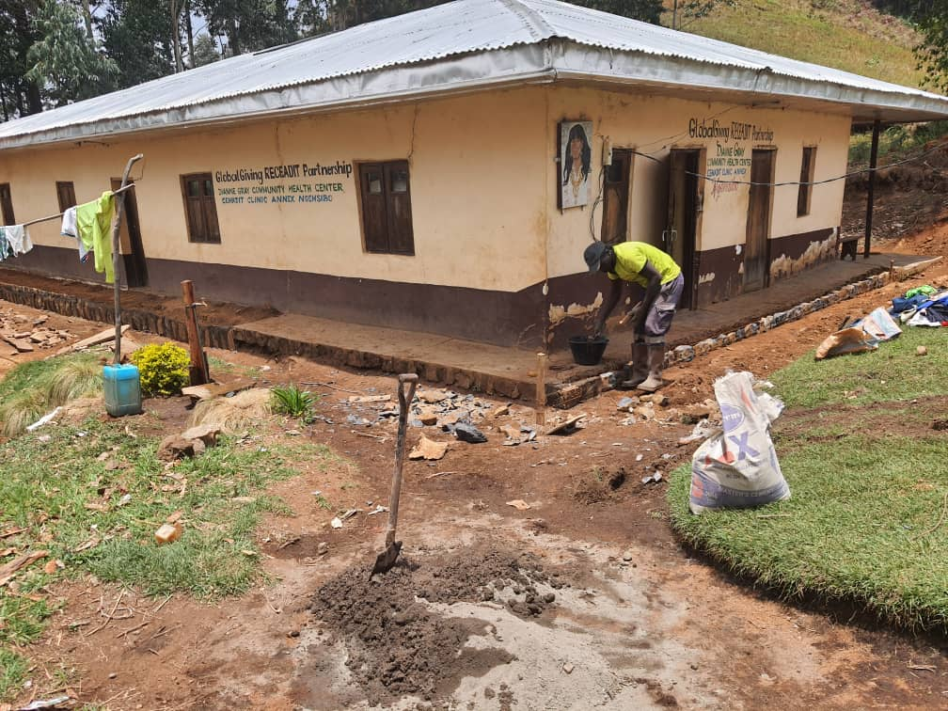

**Minor Building Repairs at our RECEADIT/GlobalGiving Partnership, Ngemsibo Community Health Center**

**Sixth Illustration Photo**

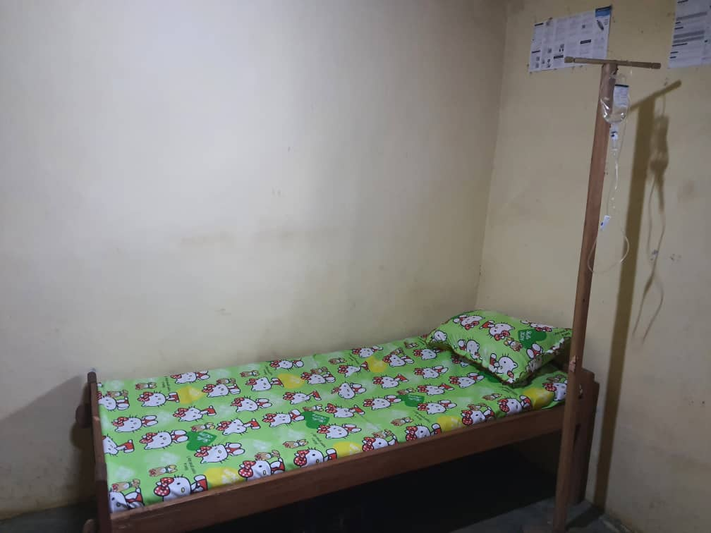

**Room and Bed for the accommodation of the Internally Displaced People at Ngemsibo where Our RECEADIT/GlobalGiving Partnership Community Health Center is located**

**Seventh Illustration Photo**

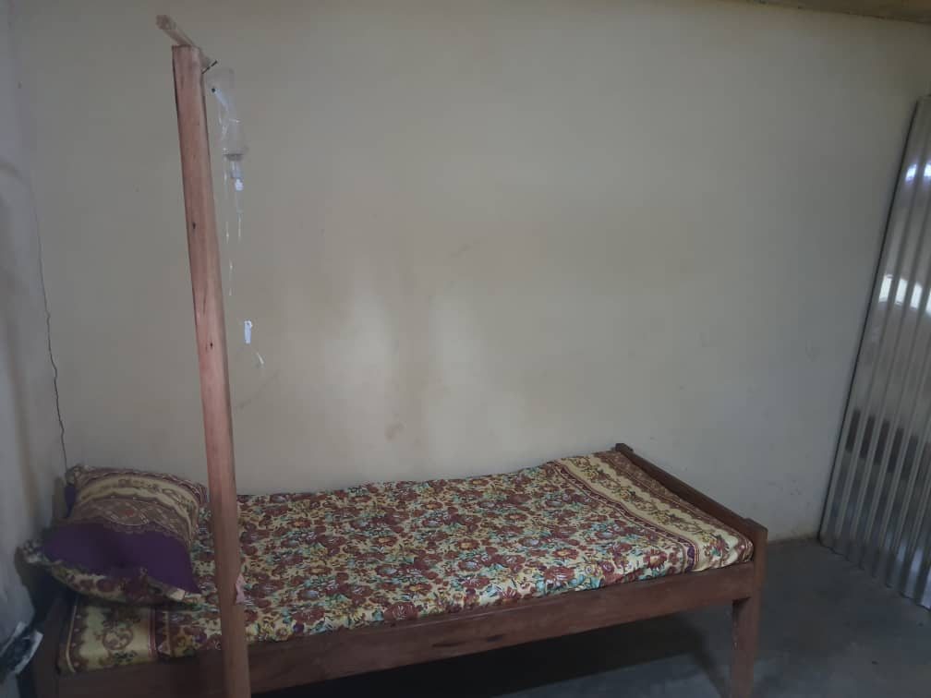

**Room and Bed for the accommodation of the Internally Displaced People at Ngemsibo where Our RECEADIT/GlobalGiving Partnership Community Health Center is located**

**Eighth Illustration Photo**

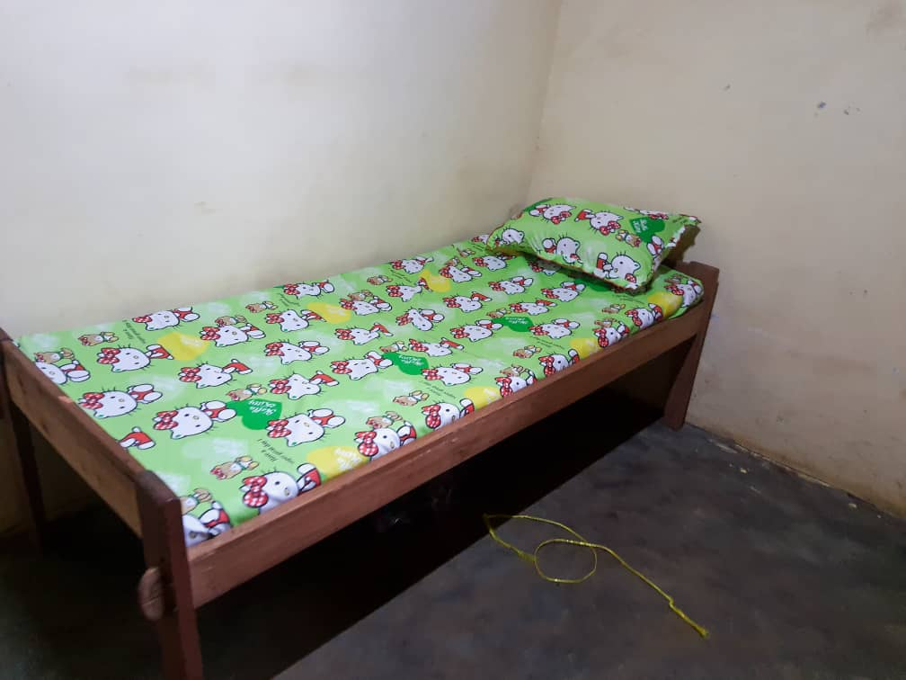

**Room and Bed for the accommodation of the Internally Displaced People at Ngemsibo where Our RECEADIT/GlobalGiving Partnership Community Health Center is located**

**Ninth Illustration Photo**

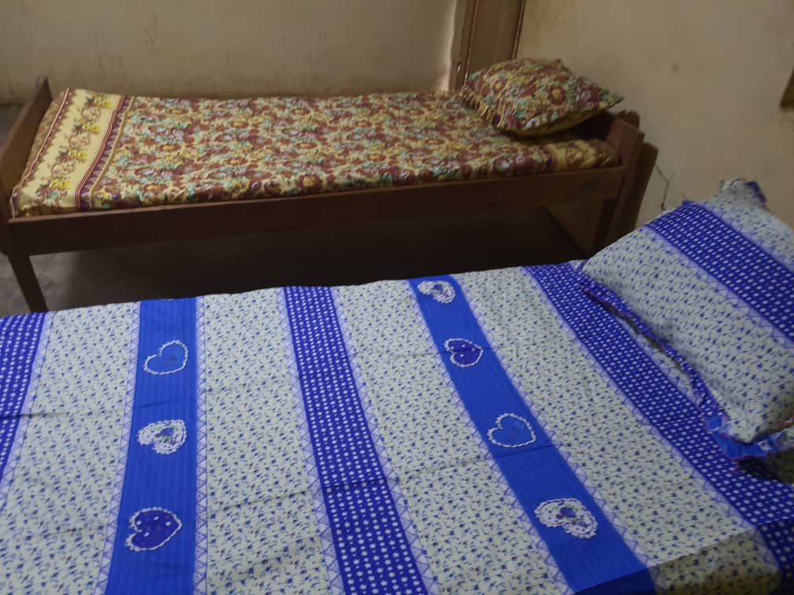

**Room and Bed for the accommodation of the Internally Displaced People at Ngemsibo where Our RECEADIT/GlobalGiving Partnership Community Health Center is located**

**Tenth Illustration Photo**

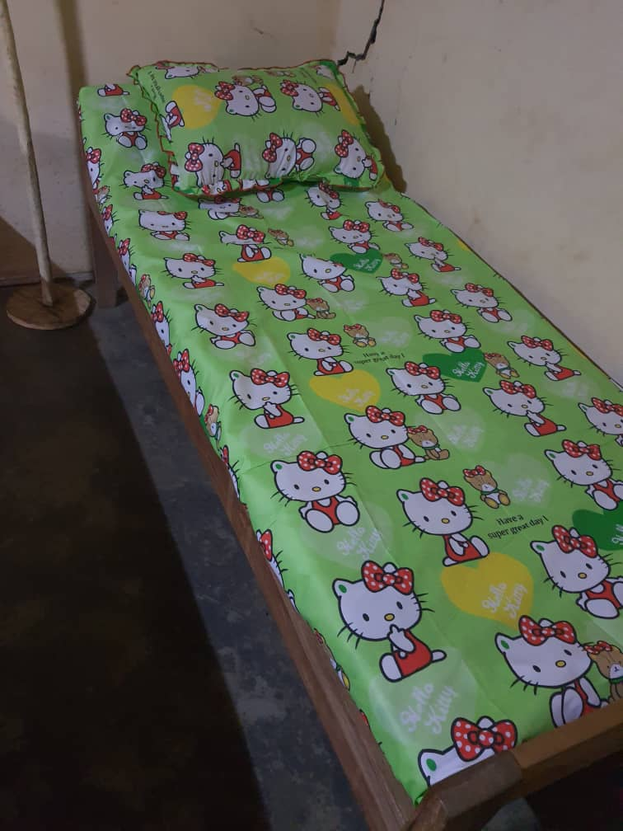

**Room and Bed for the accommodation of the Internally Displaced People at Ngemsibo where Our RECEADIT/GlobalGiving Partnership Community Health Center is located**

**Eleventh Illustration Photo**

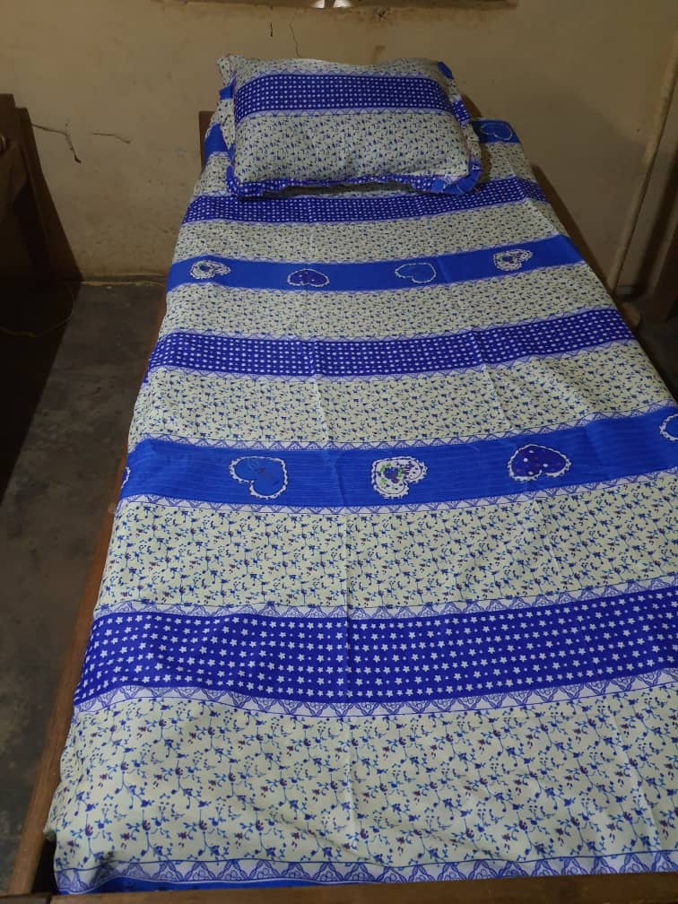

**Room and Bed for the accommodation of the Internally Displaced People at Ngemsibo where Our RECEADIT/GlobalGiving Partnership Community Health Center is located**

**Twelfth Illustration Photo**

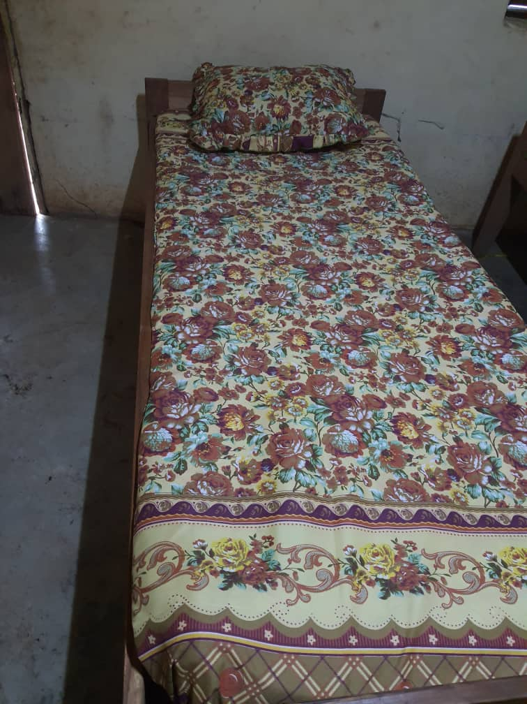

**Room and Bed for the accommodation of the Internally Displaced People at Ngemsibo where Our RECEADIT/GlobalGiving Partnership Community Health Center is located**

**Thirteenth Illustration Photo**

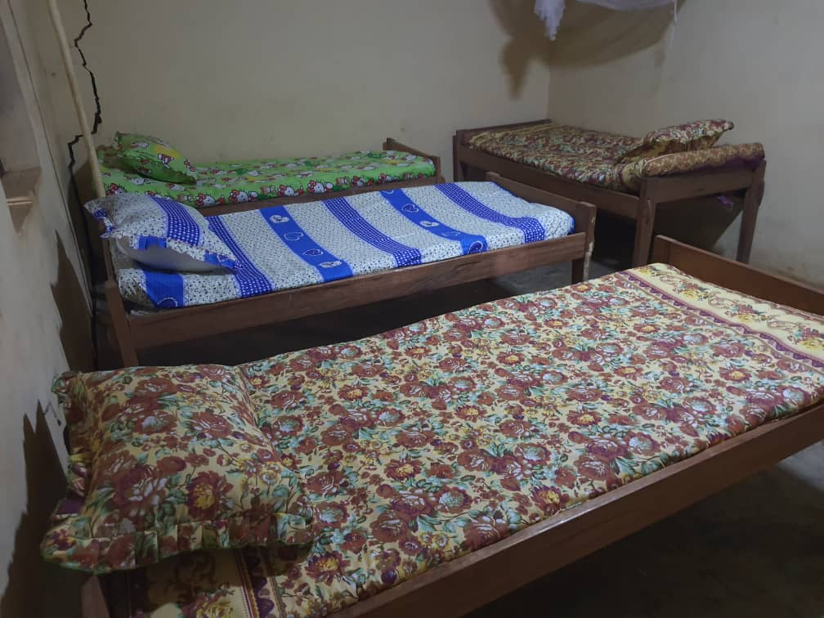

**Room and Bed for the accommodation of the Internally Displaced People at Ngemsibo where Our RECEADIT/GlobalGiving Partnership Community Health Center is located**

**Fourteenth Illustration Photo**

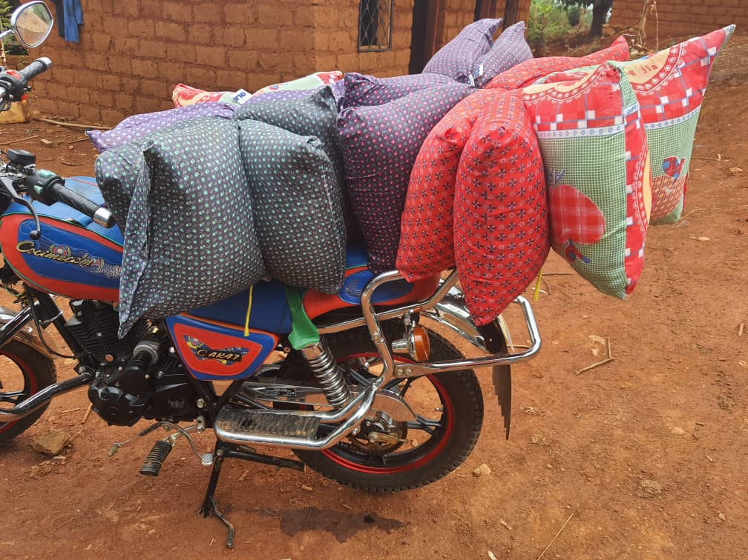

**New RECEADIT Bike Transporting pillows for the accommodation of Internally Displaced People at our RECEADIT/GlobalGiving Partnership, Muteff Community Health Center**

**Fifteenth Illustration Photo**

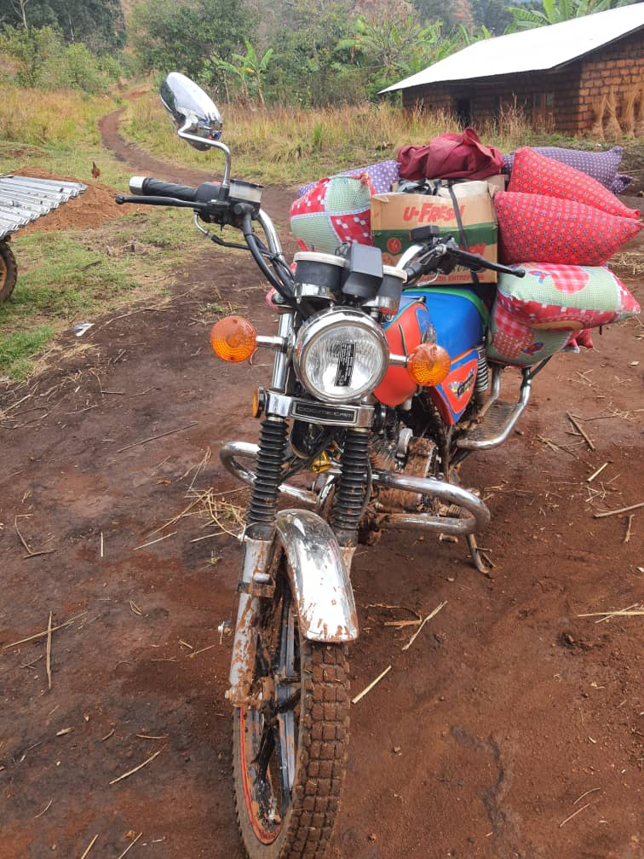

**One of the New RECEADIT Bikes Transporting pillows for the accommodation of Internally Displaced People at our RECEADIT/GlobalGiving Partnership, Muteff Community Health Center**

**Sixteenth Illustration Photo**



**One of the New RECEADIT Bikes Transporting pillows for the accommodation of Internally Displaced People at our RECEADIT/GlobalGiving Partnership, Muteff Community Health Center**

**Seventeenth Illustration Photo**

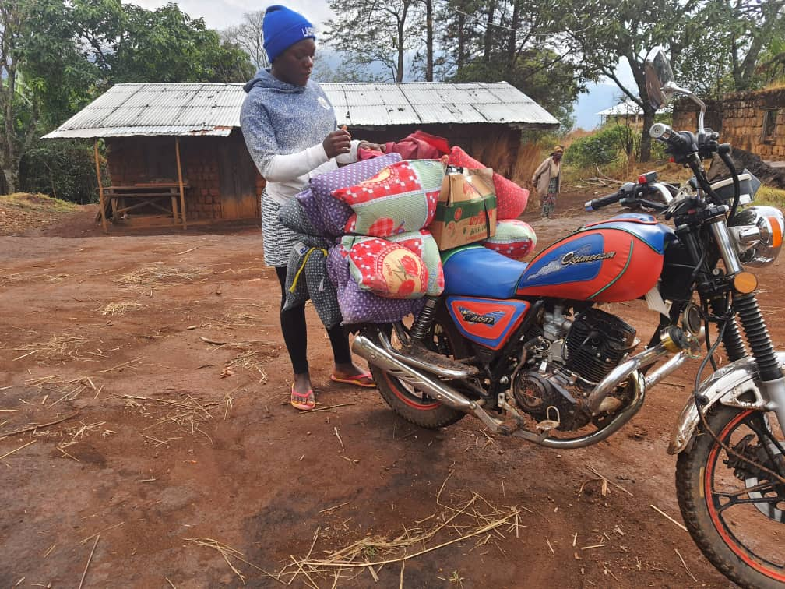

**One of the New RECEADIT Bikes Transporting pillows for the accommodation of Internally Displaced People at our RECEADIT/GlobalGiving Partnership, Ngemsibo Community Health Center**

**Eighteenth Illustration Photo**

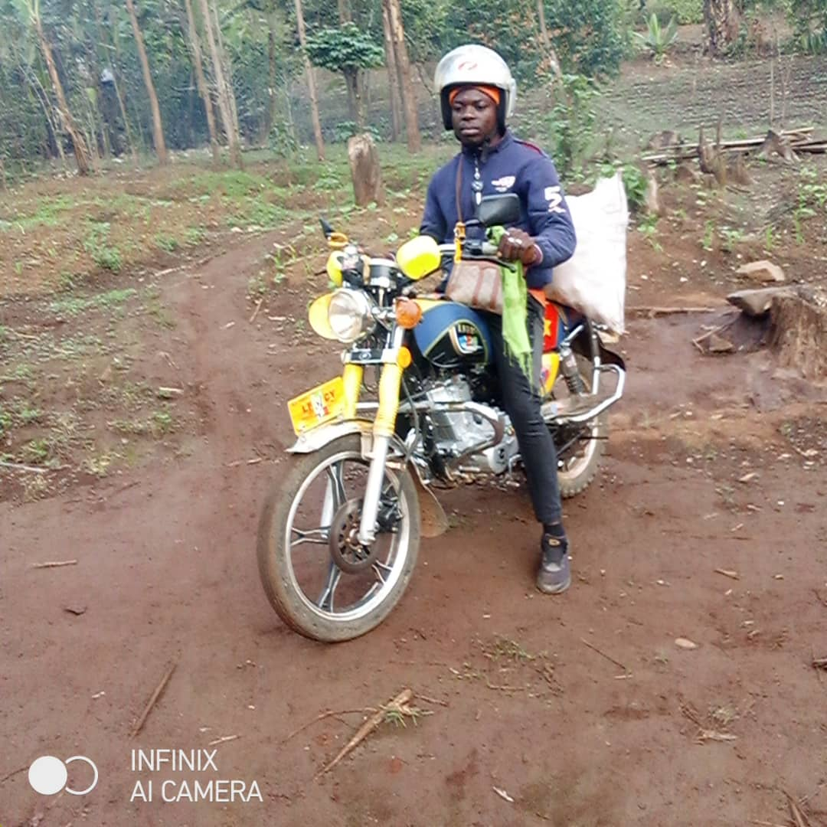

**New RECEADIT Bike Transporting food items for Internally Displaced People at our RECEADIT/GlobalGiving Partnership, Muteff Community Health Center**

**Nineteenth Illustration Photo**

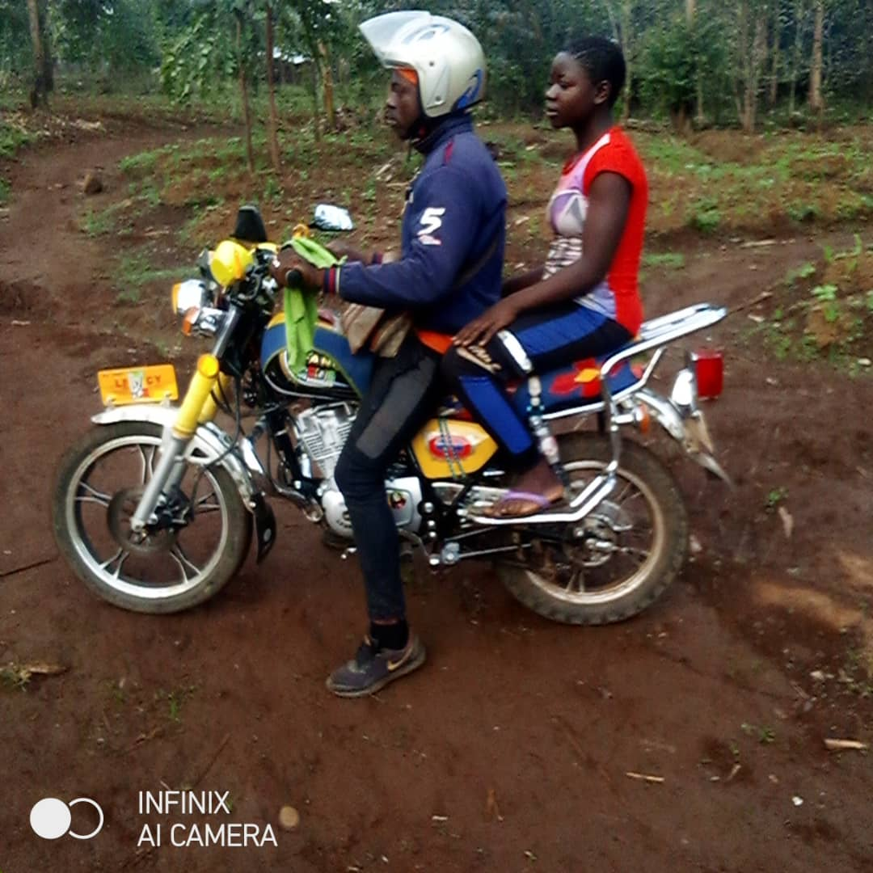

**New RECEADIT Bike Transporting an Internally Displaced Person to our RECEADIT/GlobalGiving Partnership, Muteff Community Health Center**

**Twentieth Illustration Photo**

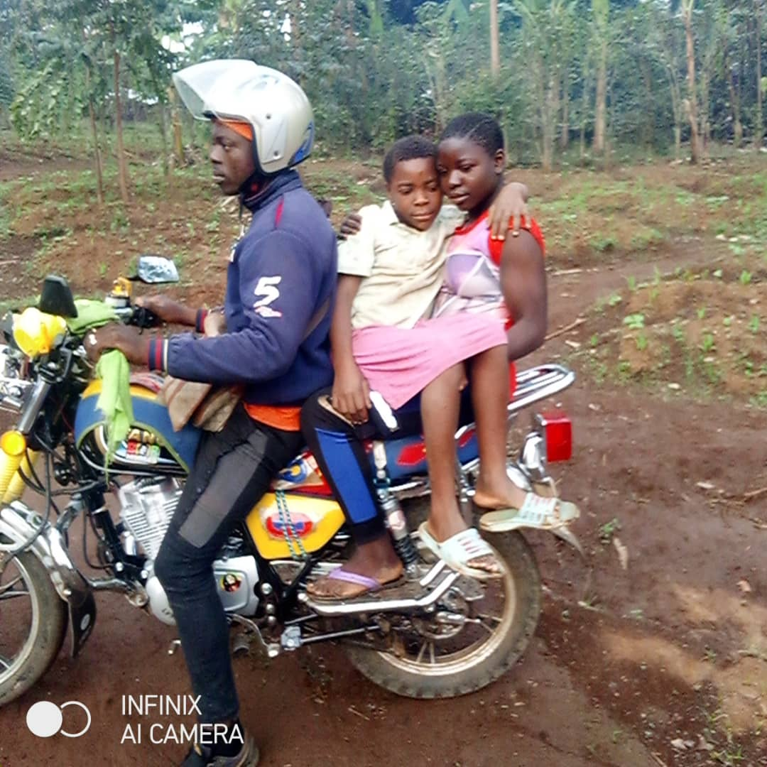

**New RECEADIT Bike Transporting two Internally Displaced Persons to our RECEADIT/GlobalGiving Partnership, Muteff Community Health Center**

**Twenty First Illustration Photo**

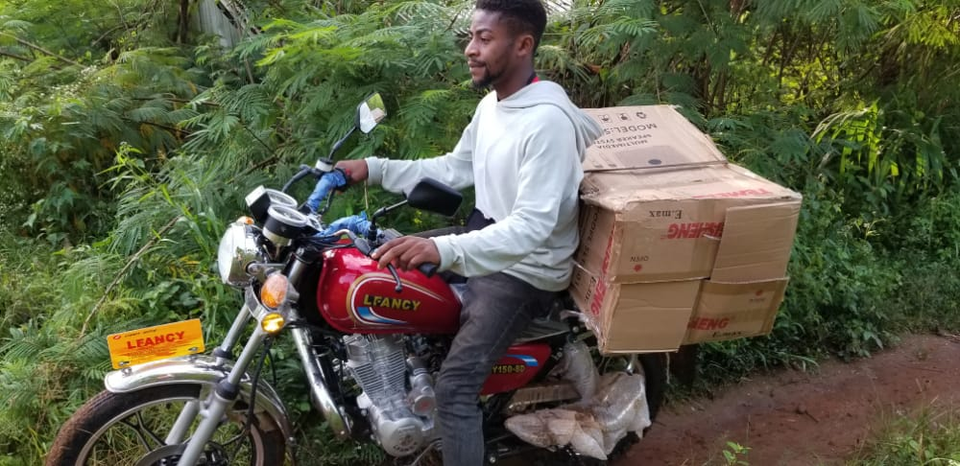

**New RECEADIT Bike Transporting Drug Supplies to our RECEADIT/GlobalGiving Partnership, Muteff Community Health Center**

**Twenty Second Illustration Photo**

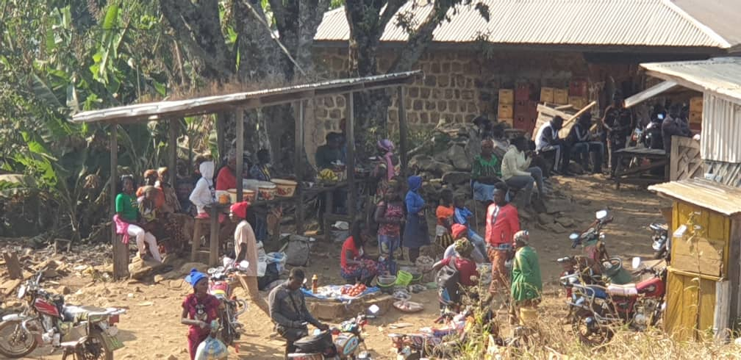

**Internally Displaced People waiting for medical assistance at Muteff, remote rural community where Our RECEADIT-GlobalGiving Partnership Community Health Center is located**

**Twenty Third Illustration Photo**

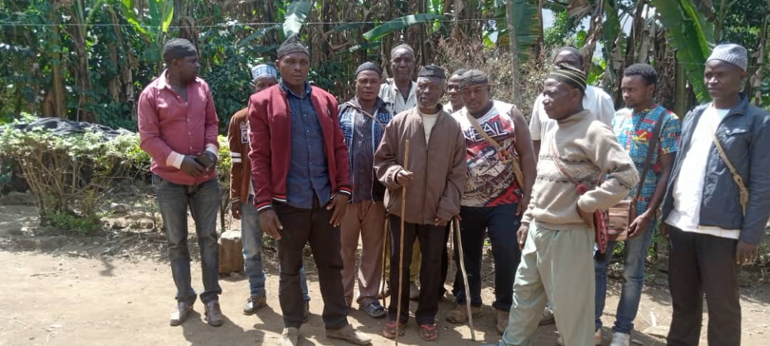

**Community members waiting for medical assistance at Muteff, remote rural community where Our RECEADIT/GlobalGiving Partnership Community Health Center is located**

**Twenty Fourth Illustration Photo**

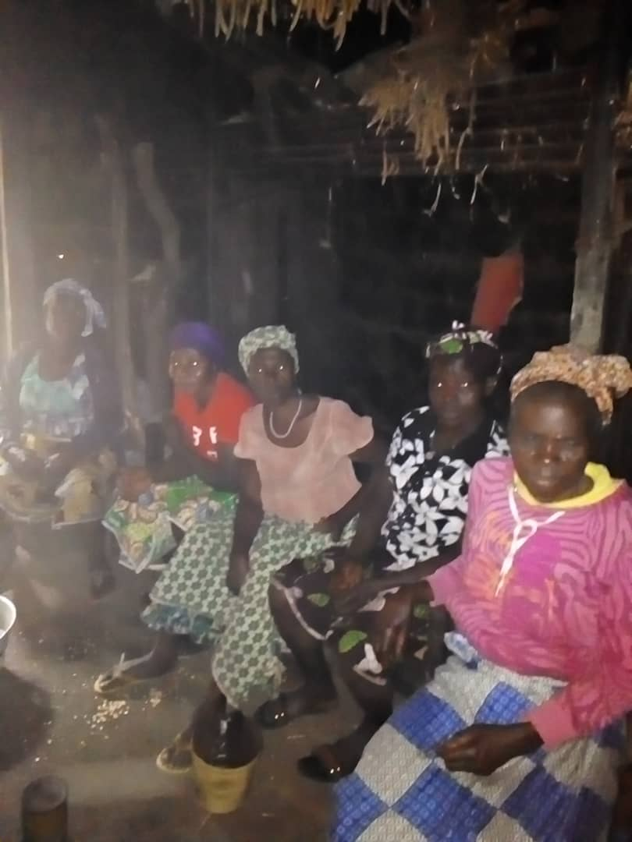

**Community members waiting for medical assistance at Muteff, remote rural community where Our RECEADIT/GlobalGiving Partnership Community Health Center is located**

**Twenty Fifth Illustration Photo**

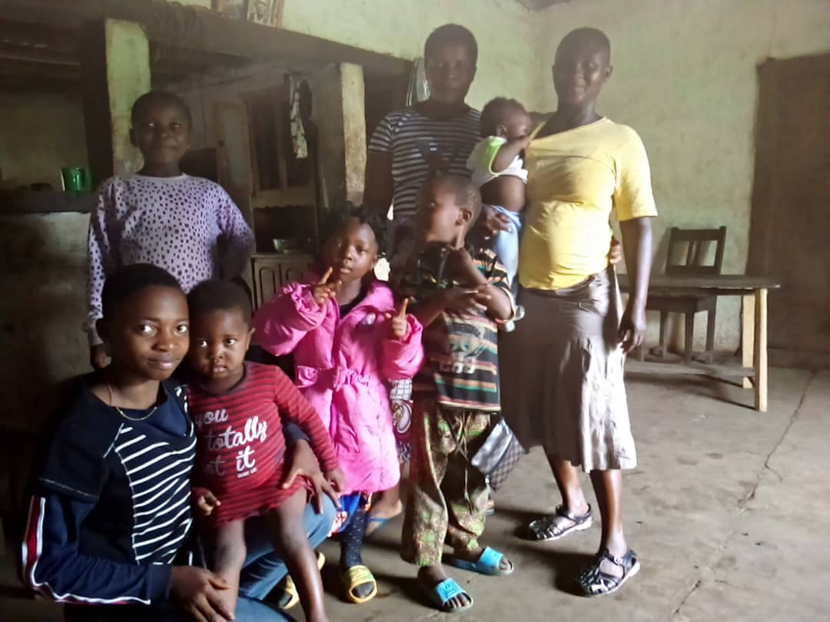

**Community members waiting for medical assistance at Muteff, remote rural community where Our RECEADIT/GlobalGiving Partnership Community Health Center is located**

**Twenty Sixth Illustration Photo**

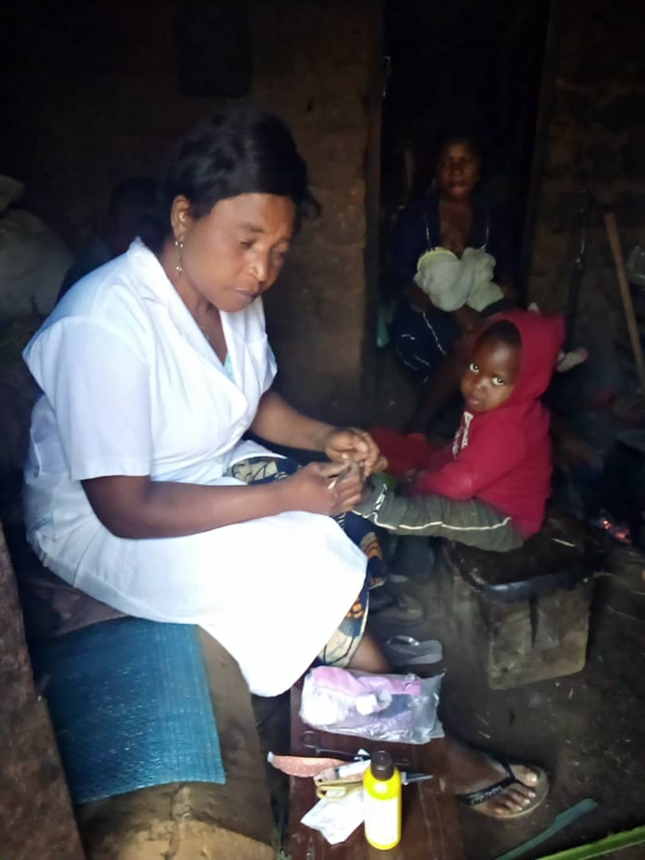

**RECEADIT Female nurse attending to children at home during her Home Visits Program at Muteff, remote rural community where Our RECEADIT/GlobalGiving Partnership Community Health Center is located**

**Twenty Seventh Illustration Photo**

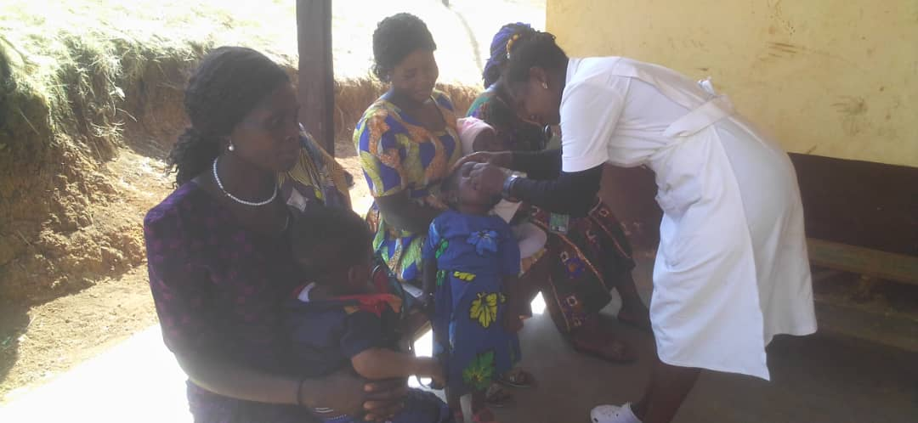

**RECEADIT Children’s Vaccination at Ngemsibo, remote rural community where Our RECEADIT/GlobalGiving Partnership Community Health Center is located**

**Twenty Eighth Illustration Photo**

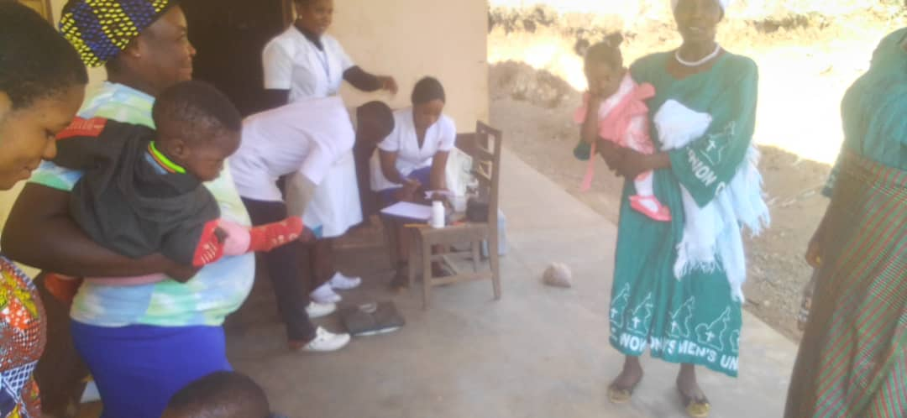

**RECEADIT Children’s Vaccination at Ngemsibo, remote rural community where Our RECEADIT/GlobalGiving Partnership Community Health Center is located**

**Twenty Ninth Illustration Photo**

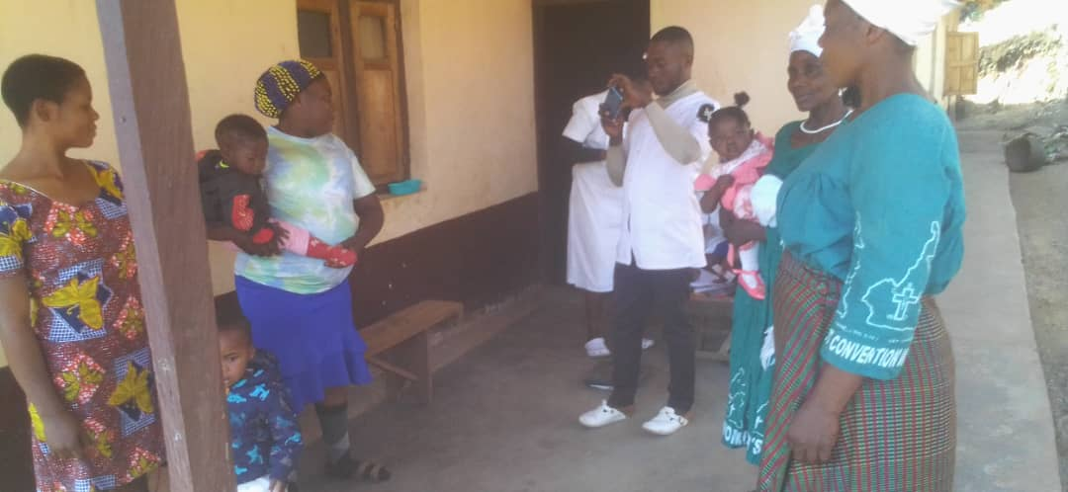

**RECEADIT Children’s Vaccination at Ngemsibo, remote rural community where Our RECEADIT/GlobalGiving Partnership Community Health Center is located**