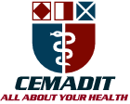
Research Center for Analytic Diagnosis and Imaging Trends (RECEADIT)
School of Health, Biomedical and Computer Sciences (SHBCS)
2017-2018 Academic Year
P.O. Box 19, Belo-Kom, Belo Sub-Division, Boyo Division, Cameroon, North-West Region,
West Africa - Tel: (237) 6 83 41 86 00 or (237) 6 77 68 99 32
CEMADIT@yahoo.com http://www.meditech-group.org

Motto: Health Care Research and Education for Services to Humanity

MEDITECH GROUP
CEMADIT
ALL ABOUT YOUR HEALTH

MEDITECH GROUP
RECEADIT
ALL ABOUT YOUR HEALTH

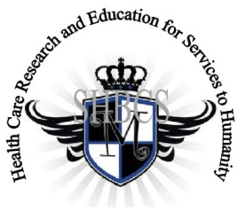

Ministry of Higher Education Ministry of Public Health Registration No. 3342 of August 31, 2011 Registration No. 4042 of August 31, 2011

GlobalGiving RECEADIT Mbam Community Health Care Project (29930)
Ninth Project Report of Sunday, December 8th, 2019
On behalf of our RECEADIT Humanitarian Team, I take this opportunity to thank you so very much for your generosity and willingness to join us and to partnership with us in our journey of serving humanity through the Guidance, the Blessings, the Love and the Grace of God Almighty.
We are glad to provide you with the following progress report and updates for our “Mbam Community Health Care Project (29930)” thanks to your generosity:
1) As we reported in our eighth Project Report of September 9th, 2019, the builders had stopped all construction work on the New Clinic Building (See First; Second; and Third Illustration Photos) due to the intensified, ongoing war, aimed at eliminating young males 12 to 32 years old. The situation has not changed. It is still simply impossible to continue with the construction work, especially because of lack of building materials and more importantly, the risk of losing human lives;

2) Since the eighth Project Report, we have not been able to do any more construction work due to lack building material. The intensified war has made it extremely dangerous to continue with any construction work. Building materials are scarce and extremely expensive; and

3) For this ninth Report, our Community Health Care Workers, who are all female graduates of our School of Health, Biomedical and Computer Sciences (SHBCS), have, at least, kept the Clinic open for emergency cases (See Fourth Illustration Photo). They have not been able to continue with their Home Visits. We must point out here again, with lots of regrets and disappointment, that our School of Health, Biomedical and Computer Sciences (SHBCS), as well as all other schools in this part of the country, have not been operational since October 2016 due to the serious, ongoing political crisis and war in Cameroon.

We will continue to provide you with monthly reports and updates of our other projects, activities, accomplishments, and challenges.
We hope that you will continue with us on this our journey of serving humanity through the Guidance, the Blessings, the Love and the Grace of God Almighty, a journey which has taken us to this “Mbam Community Health Care Project” through our new link: https://goto.gg/29930

Jilly M. Ngwainmbi, RECEADIT Project Leader

Illustration Photos

First Photo
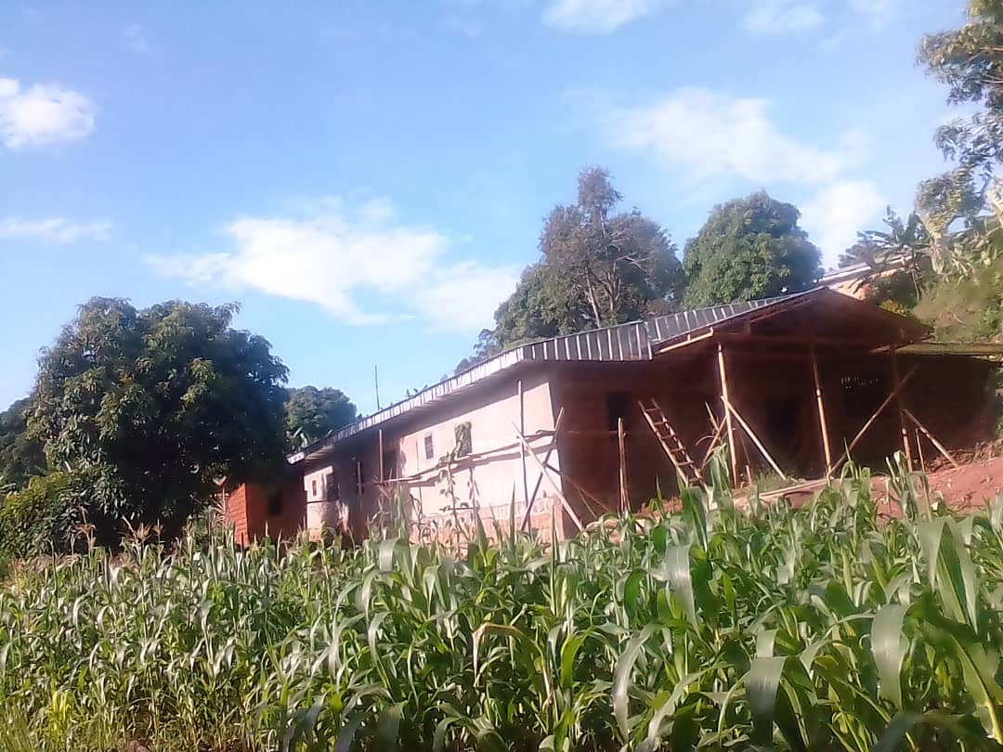
Completed First Floor: Front View

Second Photo
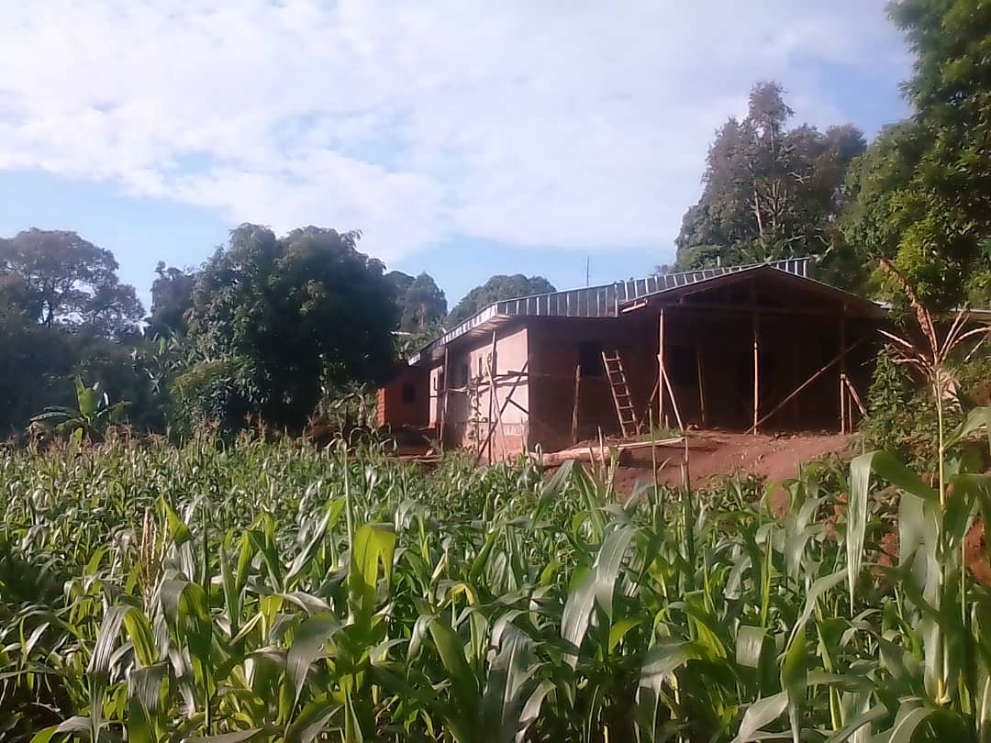
Completed First Floor: Front View

Third Photo
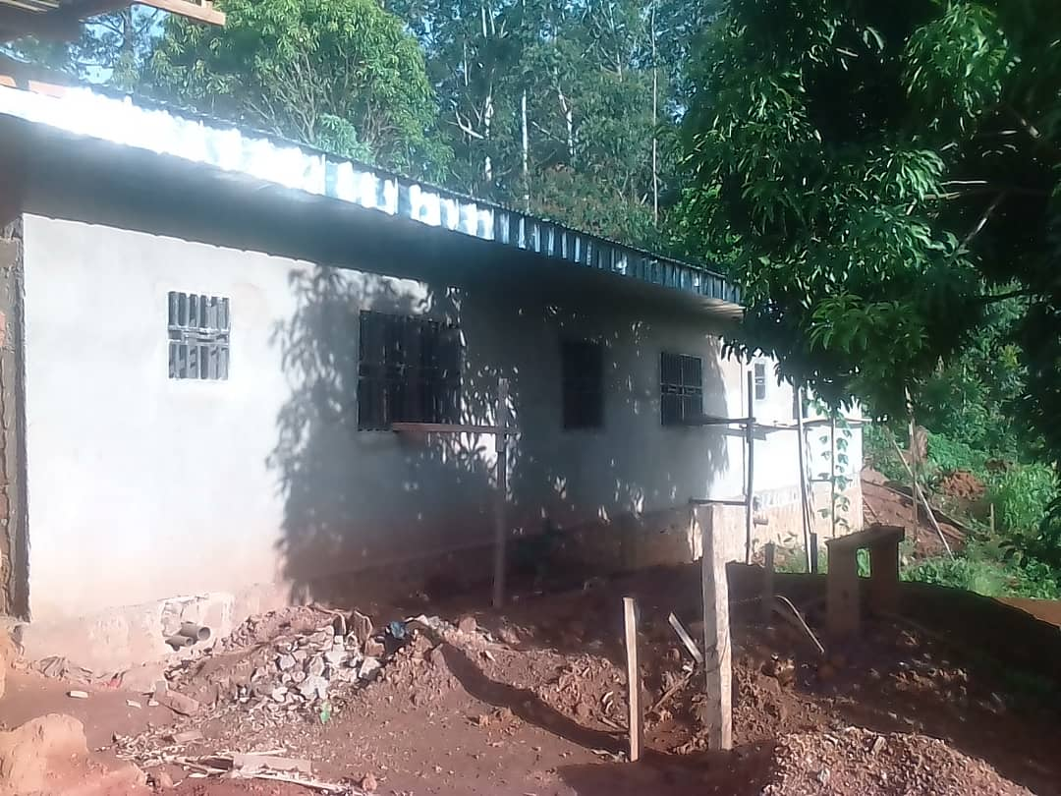
Completed First Floor: Rear View

Fourth Photo
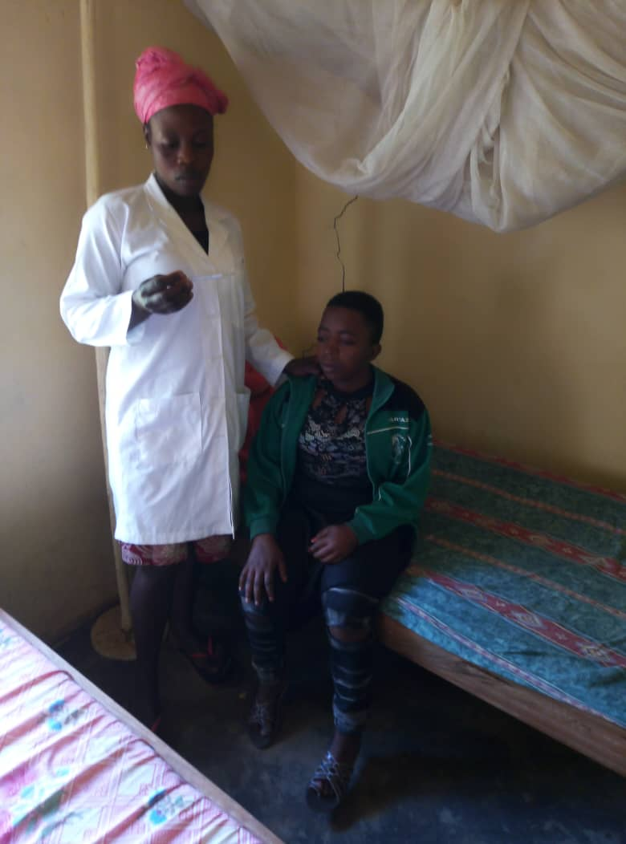
Female Nurse Attending to a Patient at the Clinic

