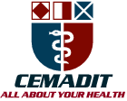
Research Center for Analytic Diagnosis and Imaging Trends (RECEADIT)
School of Health, Biomedical and Computer Sciences (SHBCS)
2020-2021 Academic Year
P.O. Box 19, Belo-Kom, Belo Sub-Division, Boyo Division, Cameroon, North-West Region,
West Africa - Tel: (237) 6 83 41 86 00 or (237) 6 77 68 99 32
CEMADIT@yahoo.com http://www.meditech-group.org

Motto: Health Care Research and Education for Services to Humanity

MEDITECH GROUP
CEMADIT
ALL ABOUT YOUR HEALTH

MEDITECH GROUP
RECEADIT
ALL ABOUT YOUR HEALTH

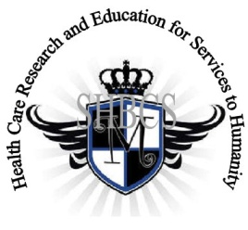

Ministry of Higher Education Ministry of Public Health Registration No. 3342 of August 31, 2011 Registration No. 4042 of August 31, 2011

GlobalGiving RECEADIT Mbam Community Health Care Project (29930)
Fourteenth Project Report of Tuesday, July 27th, 2021
On behalf of our RECEADIT Humanitarian Team, I take this opportunity to thank you so very much for your generosity and willingness to join us and to partnership with us on our journey of serving humanity through the Guidance, the Blessings, the Love and the Grace of God Almighty.
We are glad to provide you with the following progress report and updates for our “Mbam Community Health Care Project (29930)” thanks to your generosity:
1) As we reported in our Thirteenth Project Report of Friday, February 26, 2021, we moved into the New Clinic Building on Tuesday, September 1st, 2020. Now we have students of our Organized, Medical Training Program for all our RECEADIT workers and those of the New One Year Medical Training Program taking classes in the New Building (See First and Second Illustration Photos);

2) For this Fourteenth Project Report, our main focus is on our Home Visits Program, which involves Health Care Workers, who are mainly female graduates of our School of Health, Biomedical and Computer Sciences (SHBCS), going out into the Mbam Community and attending to community members at their homes (See Third, Fourth, and Fifth Illustration Photo);

3) This Fourteenth Project Report also focuses on Community Visits, undertaken by Dr. Nsom Marcel and selected RECEADIT workers, designed to attend to the Internally Displaced People within the Kitchu, Mbam, Muteff, and Ngemsibo rural Communities (See Sixth, Seventh, and Eighth Photo);

Even though we have started an Organized, Medical Training Program for all our RECEADIT workers and a New One Year Medical Training Program, we must point out here again, with lots of regrets and disappointment, that our School of Health, Biomedical and Computer Sciences (SHBCS), as well as all other schools in this part of the country, have not been operational since October 2016 due to the serious, ongoing political crisis and war in Cameroon.

We will continue to provide you with monthly reports and updates of our other projects, activities, accomplishments, and challenges.
We hope that you will continue with us on this our journey of serving humanity through the Guidance, the Blessings, the Love and the Grace of God Almighty, a journey which has taken us to this “Mbam Community Health Care Project” through our new link: https://goto.gg/29930

Jilly M. Ngwainmbi, RECEADIT Project Leader

Illustration Photos

First Photo

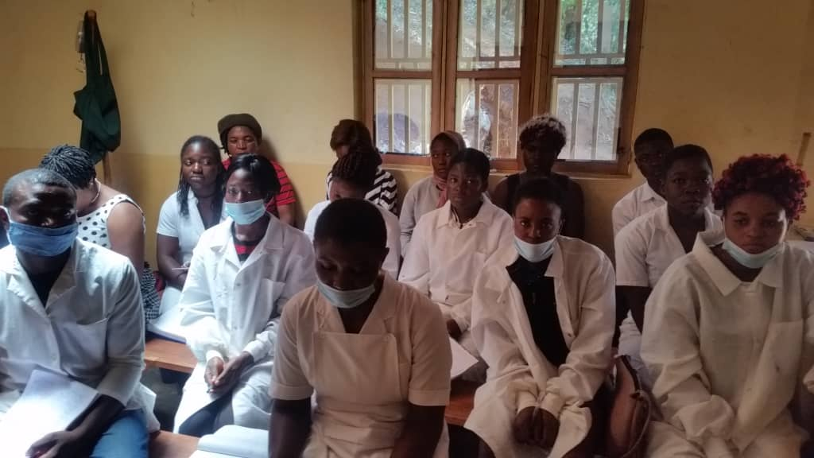
Students in the Organized, Medical Training Program for all our RECEADIT workers at the New RECEADIT Community Health Center at Mbam

Second Photo

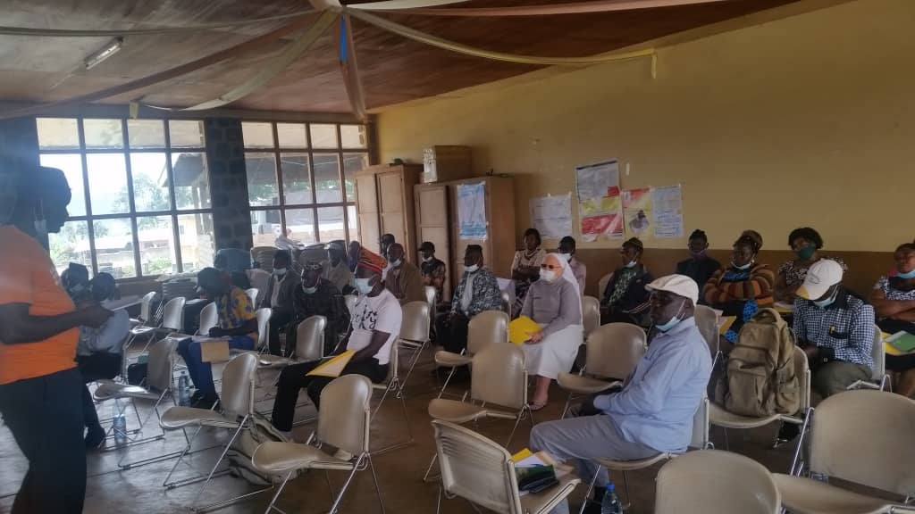

Students in the New One Year Medical Training Program at the New RECEADIT Community Health Center at Mbam

Third Photo

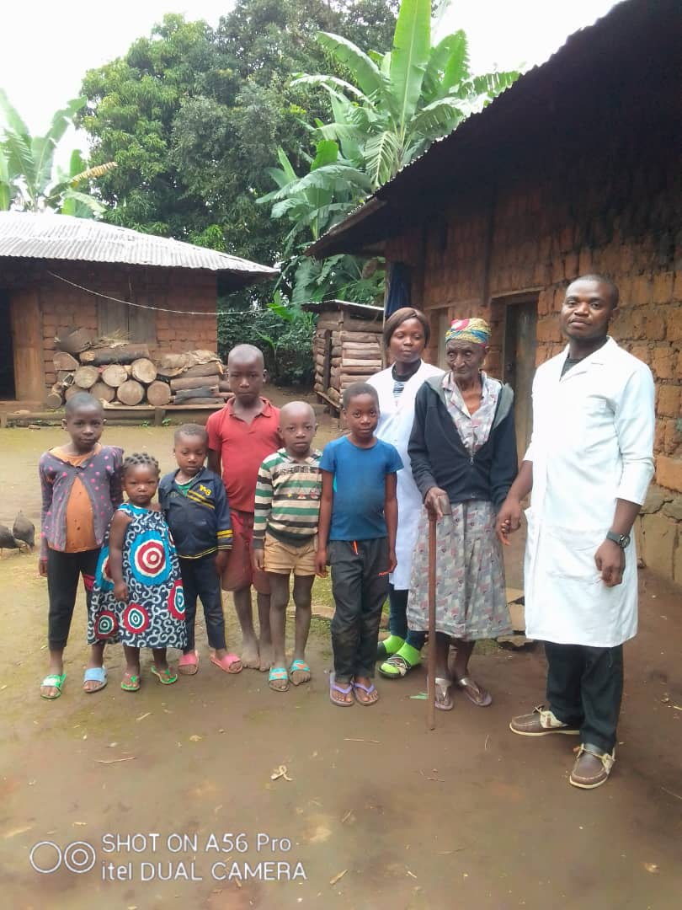

Workers’ Home Visit Program: RECEADIT Female and Male Nurse Workers attending to Community Members at their Homes in Mbam

Fourth Photo

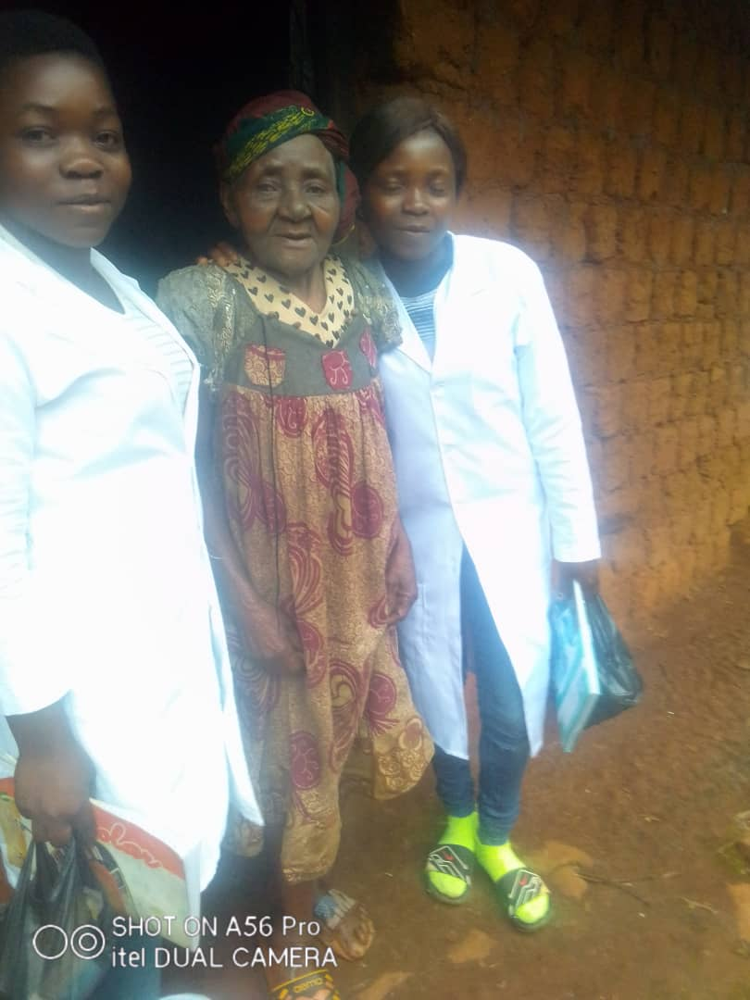

Workers’ Home Visit Program: RECEADIT Female Nurse Workers attending to a Community Member at her Home in Mbam

Fifth Photo

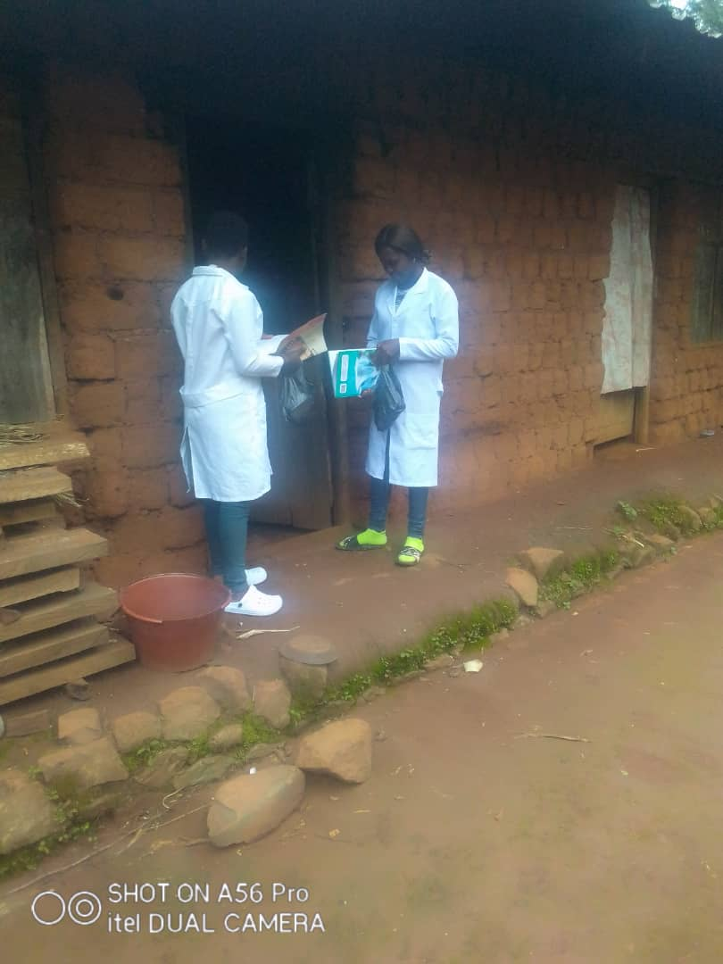

Workers’ Home Visit Program: RECEADIT Female Nurse Workers attending to Community Members at their Homes in Mbam

Sixth Photo

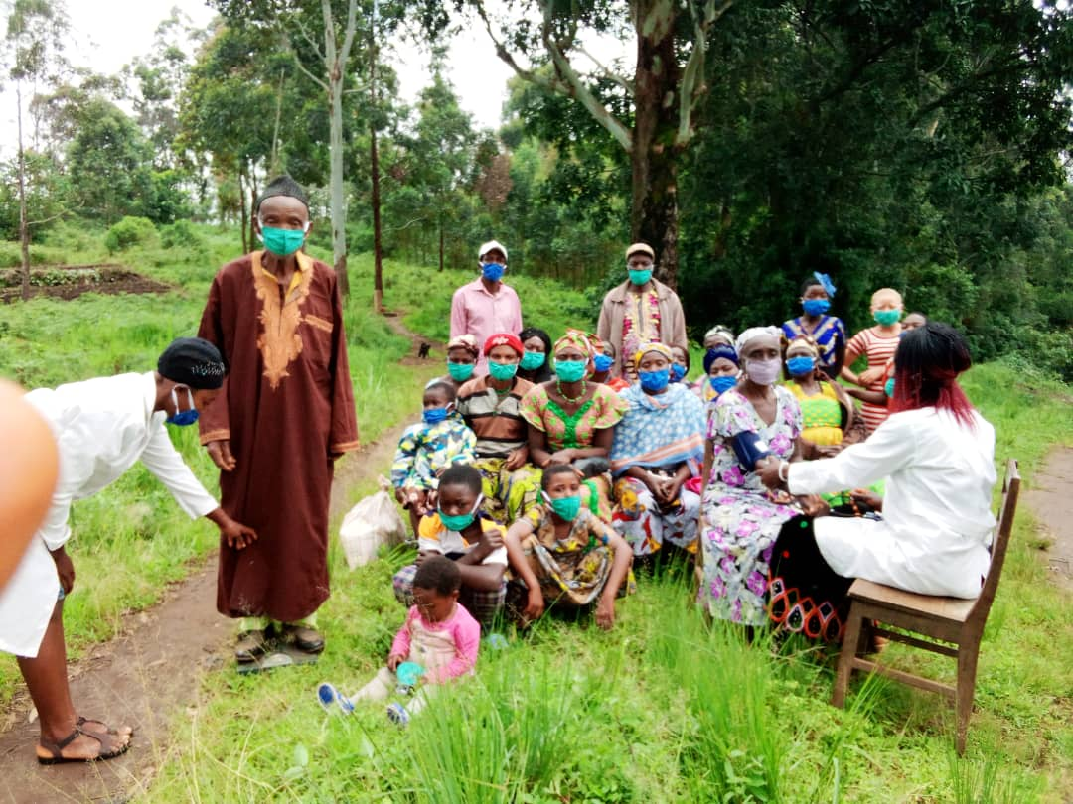

RECEADIT Female Nurse Workers Attending to the Internally Displaced People Within the Ngemsibo Rural Community

Seventh Photo

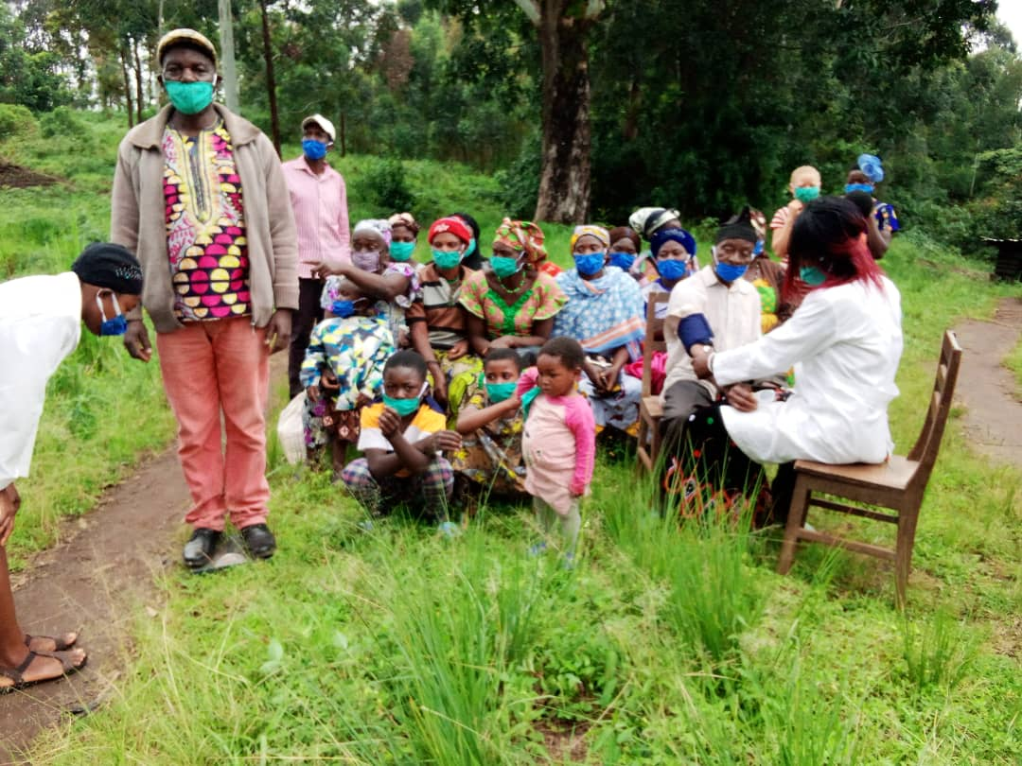

RECEADIT Female Nurse Workers Attending to the Internally Displaced People Within the Ngemsibo Rural Community

Eighth Photo Below: RECEADIT Medical Workers Attending to the Internally Displaced People Within the Ngemsibo Rural Community

