Research Center for Analytic Diagnosis and Imaging Trends (RECEADIT)
School of Health, Biomedical and Computer Sciences (SHBCS)
2020-2021 Academic Year
P.O. Box 19, Belo-Kom, Belo Sub-Division, Boyo Division, Cameroon, North-West Region,
West Africa - Tel: (237) 6 83 41 86 00 or (237) 6 77 68 99 32
CEMADIT@yahoo.com http://www.meditech-group.org

Motto: Health Care Research and Education for Services to Humanity

MEDITECH GROUP
CEMADIT
ALL ABOUT YOUR HEALTH

MEDITECH GROUP
RECEADIT
ALL ABOUT YOUR HEALTH

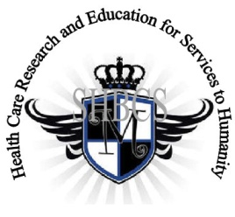

Ministry of Higher Education Ministry of Public Health Registration No. 3342 of August 31, 2011 Registration No. 4042 of August 31, 2011

GlobalGiving RECEADIT Mbam Community Health Care Project (29930)
Fifteenth Project Report of Tuesday, November 23rd, 2021
On behalf of our RECEADIT Humanitarian Team, I take this opportunity to thank you so very much for your generosity and willingness to join us and to partnership with us on our journey of serving humanity through the Guidance, the Blessings, the Love and the Grace of God Almighty.
We are glad to provide you with the following progress report and updates for our “Mbam Community Health Care Project (29930)” thanks to your generosity:
1) As we reported in our Fourteenth Project Report of Tuesday, 27th, 2021, we moved into the New Clinic Building on Tuesday, September 1st, 2020. We regret to share with you the fact that Our Organized, Medical Training Program for all our RECEADIT workers and those of the New One Year Medical Training Program has been interrupted by the intensified war (See First Photo).

2) For this Fifteenth Project Report, our main focus is on our upgraded building program, which involves Solar installation, toilet upgrade inside the Building, and the construction of a new toilet outside, behind the Building (See Second, Third, Fourth, Fifth, and Sixth Illustration Photos);

3) This Fifteenth Project Report also focuses on Community Visits, undertaken by female nurses within the Mbam remote, rural Community in particular (See Eighth Photo);

4) We are glad to report that RECEADIT has purchased a new Bike for the Transportation and Distribution of Drugs/Medication and other medical Equipment to RECEADIT Clinics at Kitchu, Mbam, Muteff, and Ngemsibo Remote, Rural Communities; and

5) Even though we have an Organized, Medical Training Program for all our RECEADIT workers and a New One Year Medical Training Program, we must point out here again, with lots of regrets and disappointment, that: a) the intensified war keeps interrupting the program ; and b) our School of Health, Biomedical and Computer Sciences (SHBCS), as well as all other schools in this part of the country, have not been operational since October 2016 due to the serious, ongoing political crisis and war in Cameroon.

We will continue to provide you with monthly reports and updates of our other projects, activities, accomplishments, and challenges.
We hope that you will continue with us on this our journey of serving humanity through the Guidance, the Blessings, the Love and the Grace of God Almighty, a journey which has taken us to this “Mbam Community Health Care Project” through our new link: https://goto.gg/29930

Jilly M. Ngwainmbi, RECEADIT Project Leader

Illustration Photos

First Photo

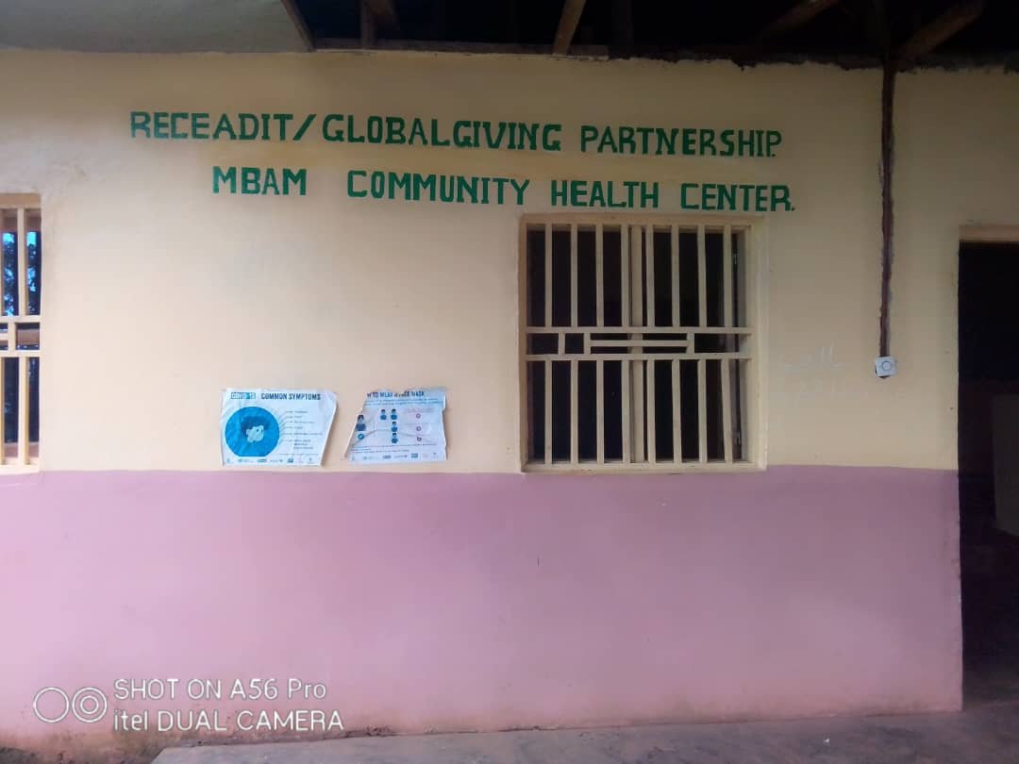

RECEADIT/GlobalGiving Partnership, Mbam Community Health Center

Second Photo

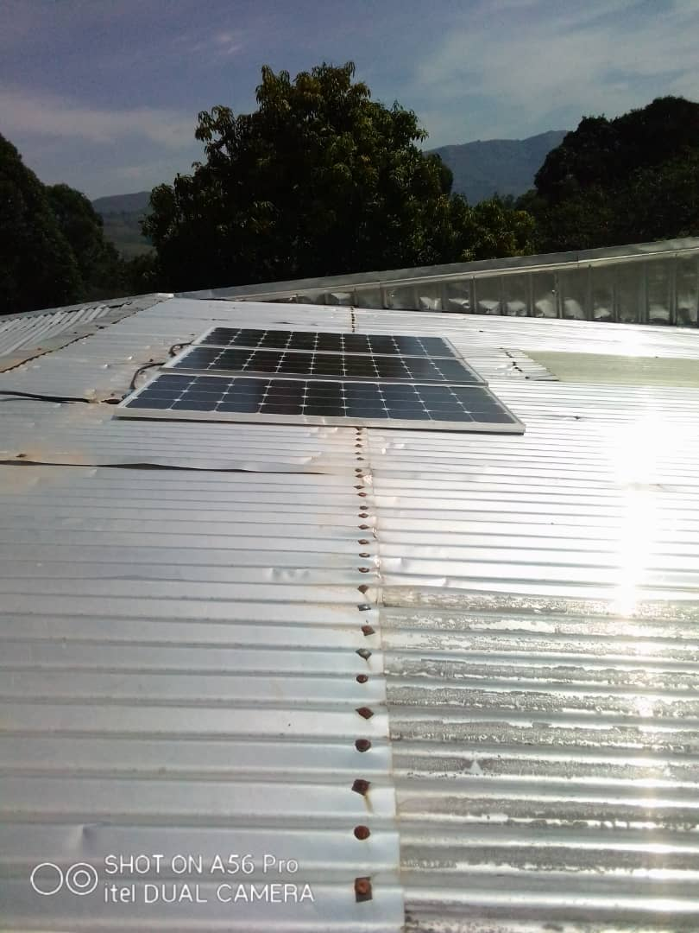

Recently Installed Solar System at RECEADIT Mbam Community Health Center

Third Photo

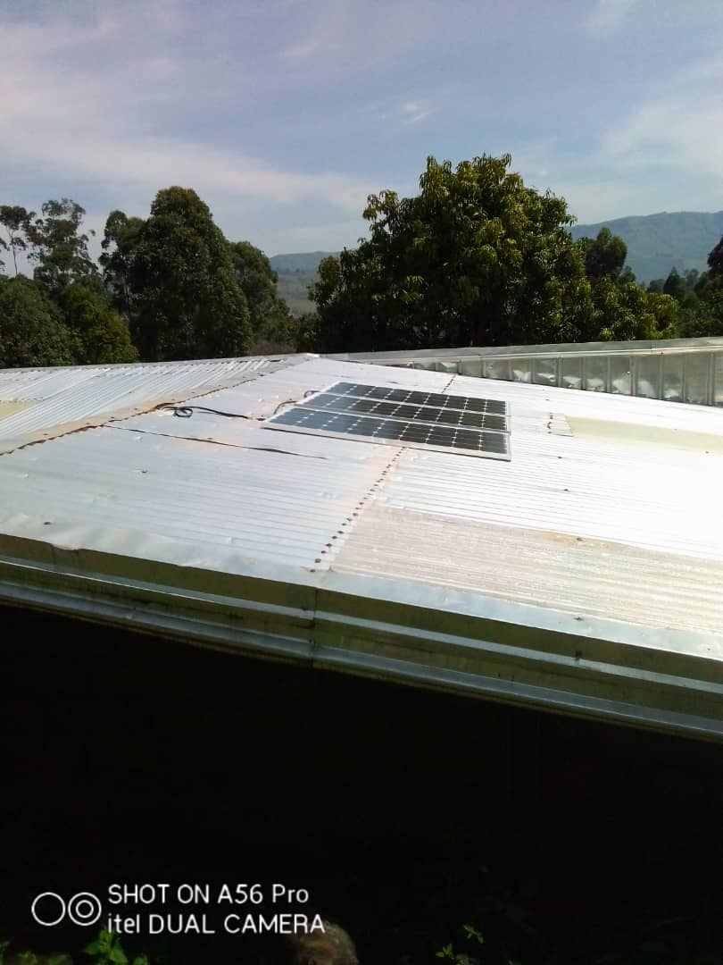

Recently Installed Solar System at RECEADIT Mbam Community Health Center

Fourth Photo

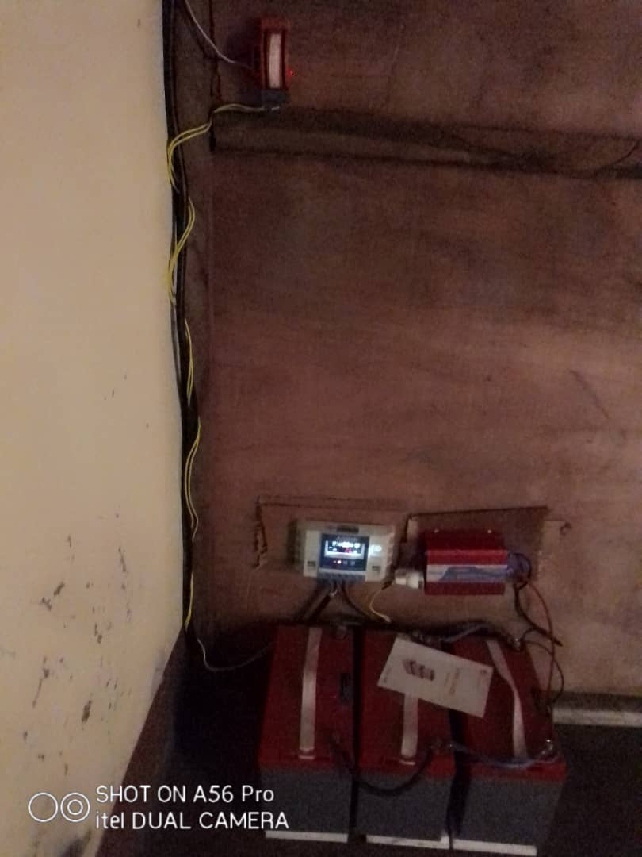

Control Room of the Recently Installed Solar System at RECEADIT Mbam Community Health Center

Fifth Photo

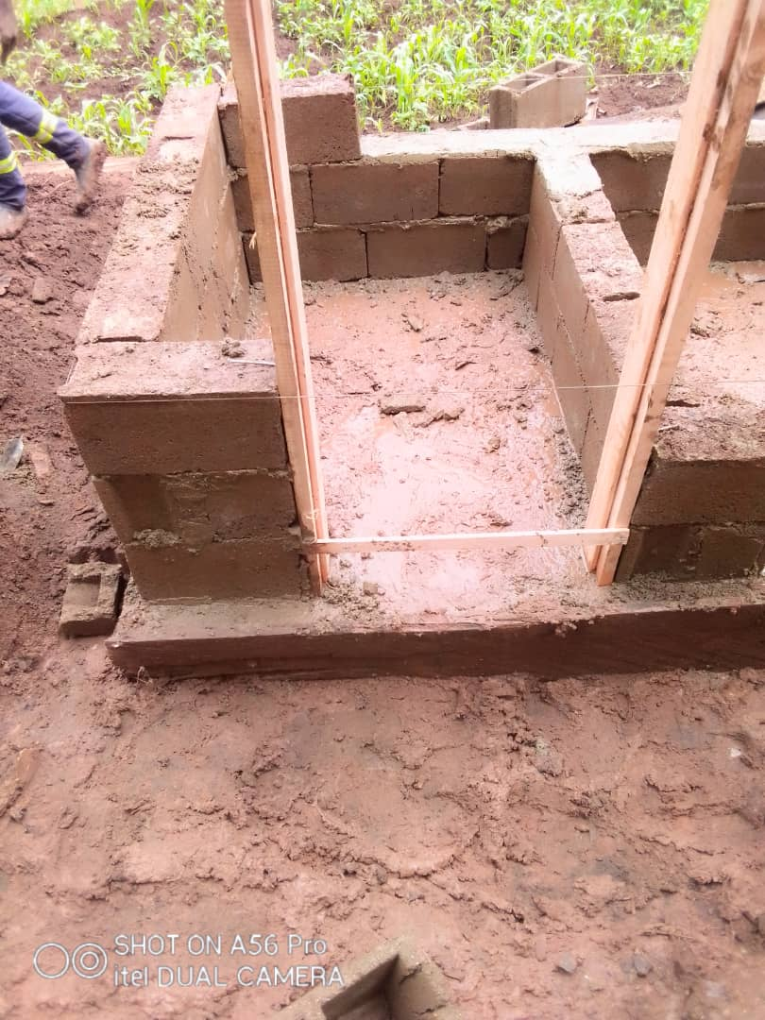

Construction of external Toilet at RECEADIT Mbam Community Health Center

Sixth Photo

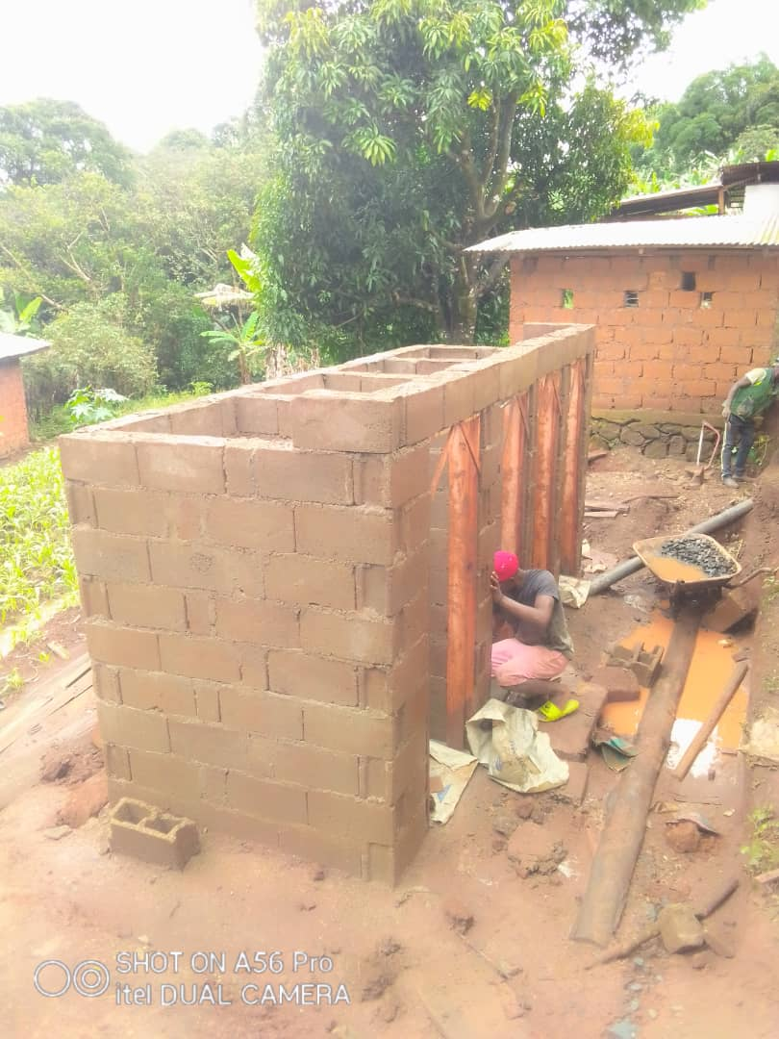

Construction of external Toilet at RECEADIT Mbam Community Health Center

Seventh Photo

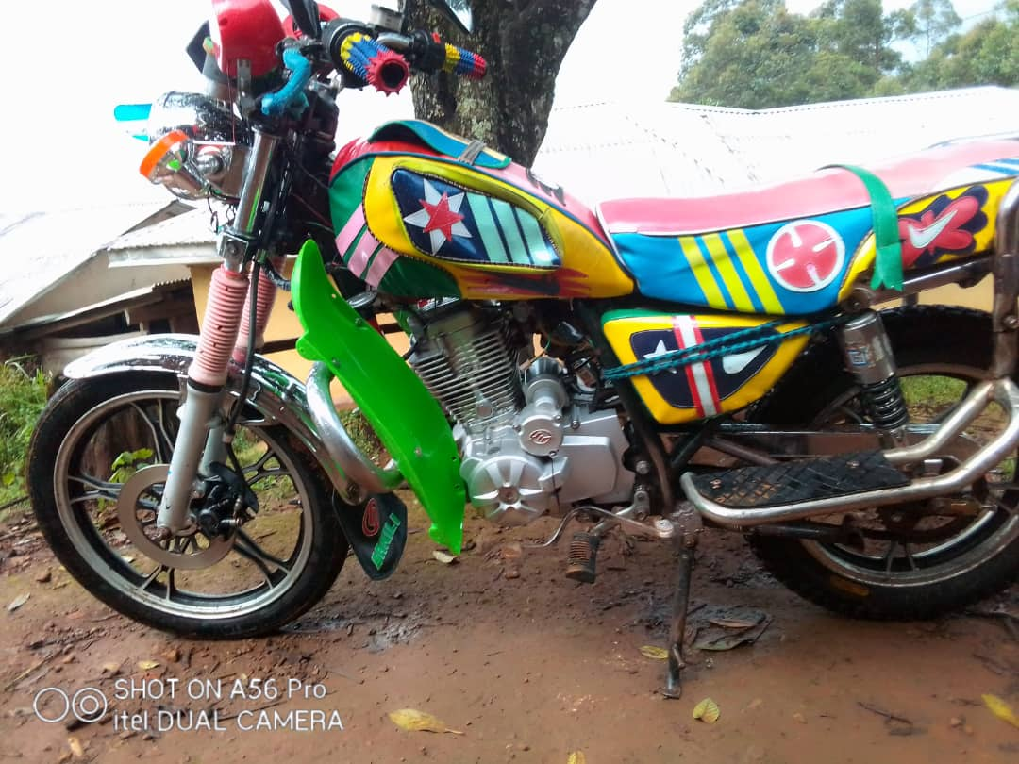

New RECEADIT Bike for the Transportation and Distribution of Drugs/Medication and other medical Equipment to RECEADIT Clinics at Kitchu, Mbam, Muteff, and Ngemsibo Remote, Rural Communities.

Eighth Photo

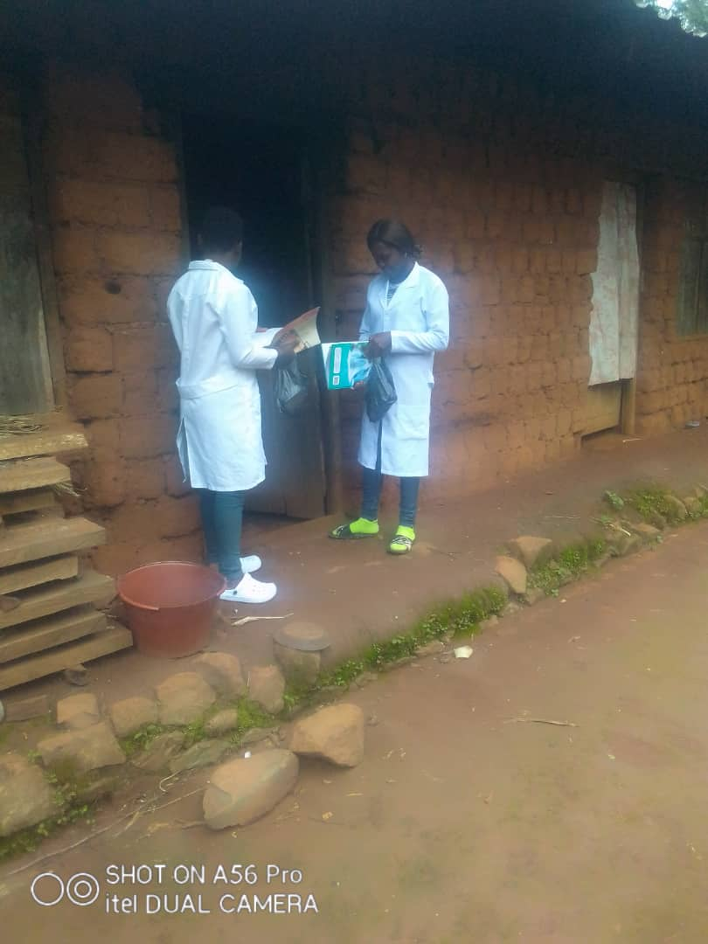

Workers’ Home Visit Program: RECEADIT Female Nurse Workers attending to Community Members at their Homes in Mbam

