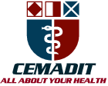
Research Center for Analytic Diagnosis and Imaging Trends (RECEADIT)
School of Health, Biomedical and Computer Sciences (SHBCS)
2019-2020 Academic Year
P.O. Box 19, Belo-Kom, Belo Sub-Division, Boyo Division, Cameroon, North-West Region,
West Africa - Tel: (237) 6 83 41 86 00 or (237) 6 77 68 99 32
CEMADIT@yahoo.com http://www.meditech-group.org

Motto: Health Care Research and Education for Services to Humanity

MEDITECH GROUP
CEMADIT
ALL ABOUT YOUR HEALTH

MEDITECH GROUP
RECEADIT
ALL ABOUT YOUR HEALTH

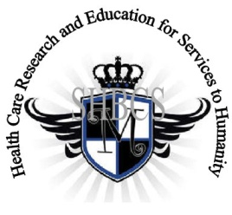

Ministry of Higher Education Ministry of Public Health Registration No. 3342 of August 31, 2011 Registration No. 4042 of August 31, 2011

GlobalGiving RECEADIT Mbam Community Health Care Project (29930)
Eleventh Project Report of Saturday, July 4th, 2020
On behalf of our RECEADIT Humanitarian Team, I take this opportunity to thank you so very much for your generosity and willingness to join us and to partnership with us in our journey of serving humanity through the Guidance, the Blessings, the Love and the Grace of God Almighty.
We are glad to provide you with the following progress report and updates for our “Mbam Community Health Care Project (29930)” thanks to your generosity:
1) As we reported in our Tenth Project Report of Sunday, March 7th, 2020, the builders had stopped all construction work on the New Clinic Building (See First; Second; and Third Illustration Photos) due to the intensified, ongoing war, aimed at eliminating young males 12 to 32 years old. The situation still has not changed. It is still simply impossible to continue with the construction work, especially because of lack of building materials and more importantly, the risk of losing human lives;

2) However, since the Tenth Project Report, the builders have used the ten bags of cement which we purchased, as reported in our Tenth Project Report, to finish the plastering work inside the new building; and

3) For this Eleventh Project Report, our Community Health Care Workers, who are mainly female graduates of our School of Health, Biomedical and Computer Sciences (SHBCS), have, at least, continued to keep the Clinic open for emergency cases. We were able to find and hire one male nurse who is assisting the female nurses, especially with the distribution of face masks (See Fourth, Fifth, and Sixth Illustration Photos). The nurses still have not been able to continue with their Home Visits. We must point out here again, with lots of regrets and disappointment, that our School of Health, Biomedical and Computer Sciences (SHBCS), as well as all other schools in this part of the country, have not been operational since October 2016 due to the serious, ongoing political crisis and war in Cameroon.

We will continue to provide you with monthly reports and updates of our other projects, activities, accomplishments, and challenges.
We hope that you will continue with us on this our journey of serving humanity through the Guidance, the Blessings, the Love and the Grace of God Almighty, a journey which has taken us to this “MbamCommunity Health Care Project” through our new link: https://goto.gg/29930

Jilly M. Ngwainmbi, RECEADIT Project Leader

Illustration Photos

First Photo
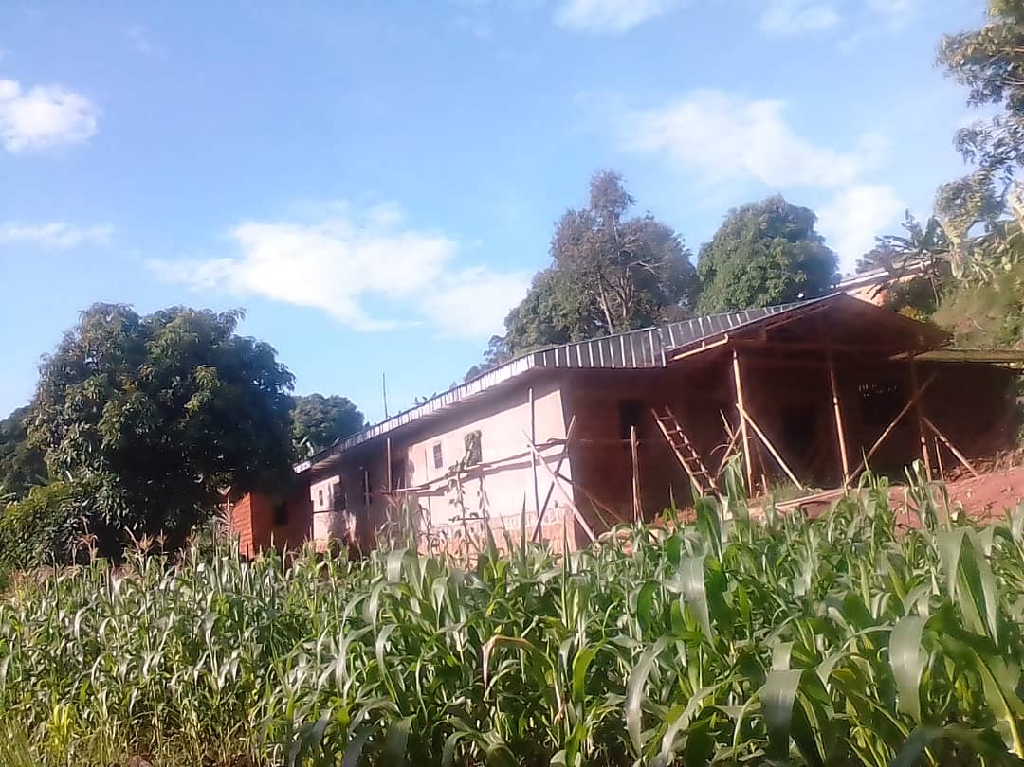
Completed First Floor: Front View

Second Photo
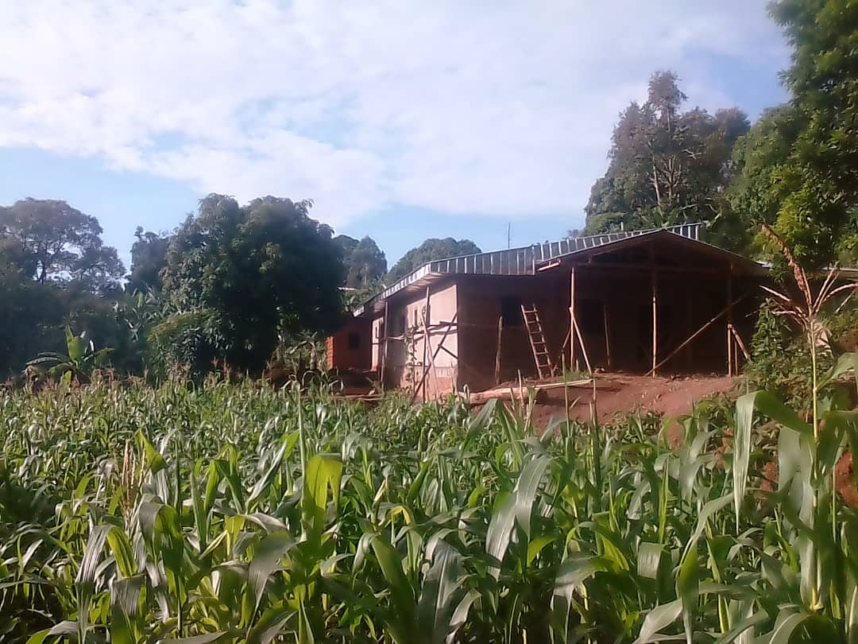
Completed First Floor: Front View

Third Photo
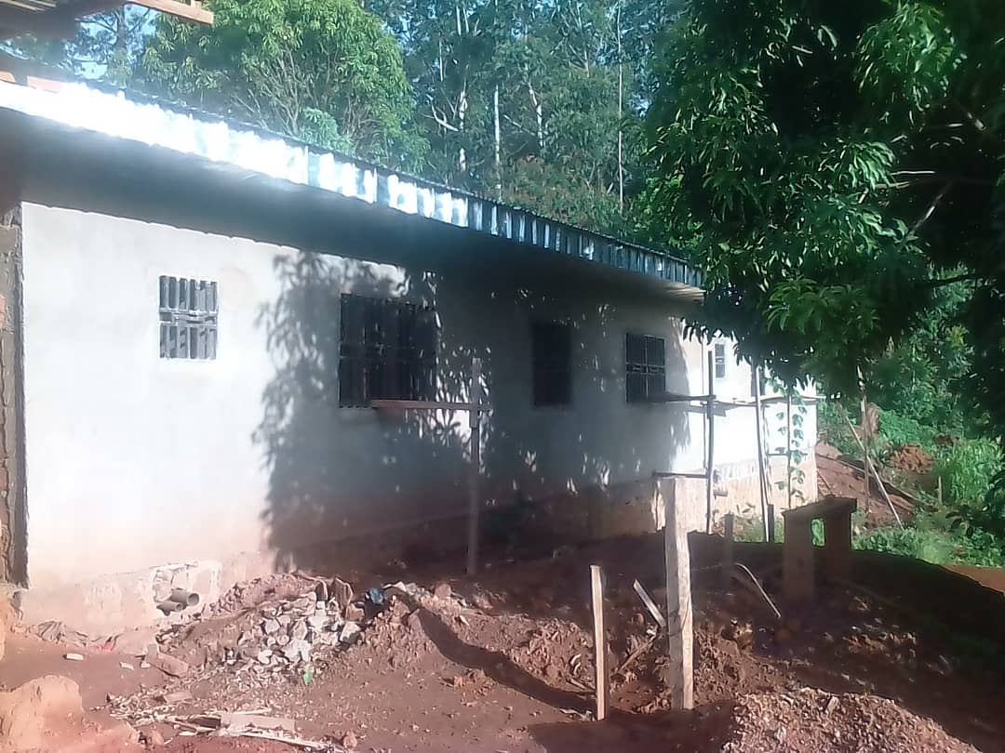
Completed First Floor: Rear View

Fourth Photo
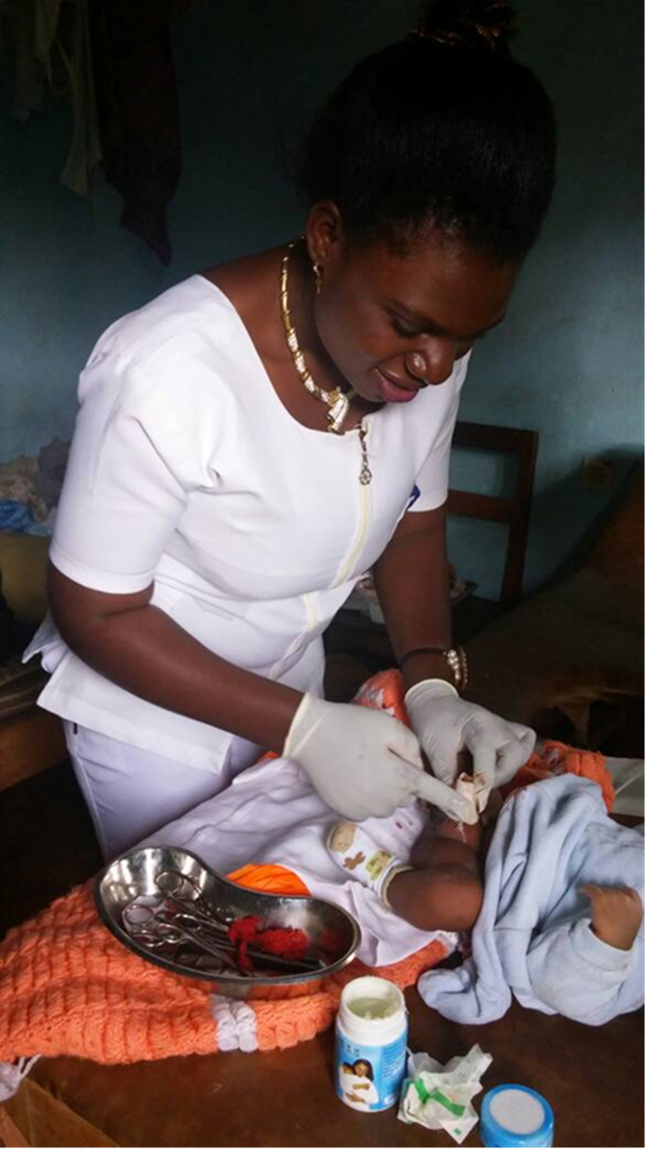
Female Nurse Attending to a New-Born Baby at our RECEADIT
Rental Health Facility at Mbam

Fifth Photo
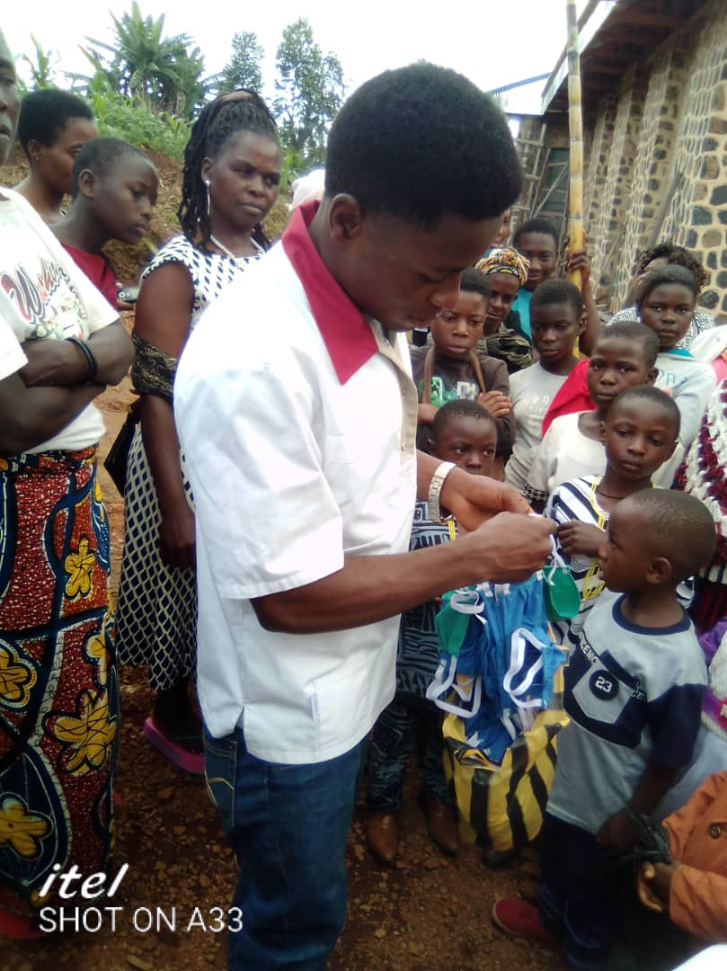

New Male Nurse Distributing Face Masks to Mbam Community Memebers

Sixth Photo

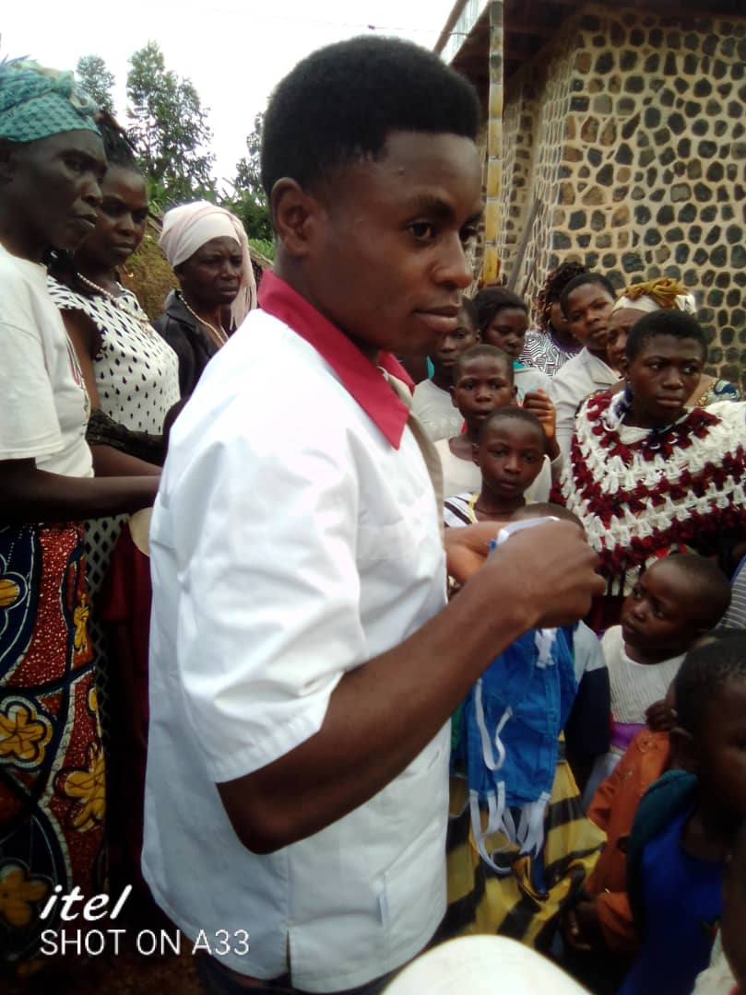

New Male Nurse Distributing Face Masks to Mbam Community Memebers

