Screenshots and Pictures
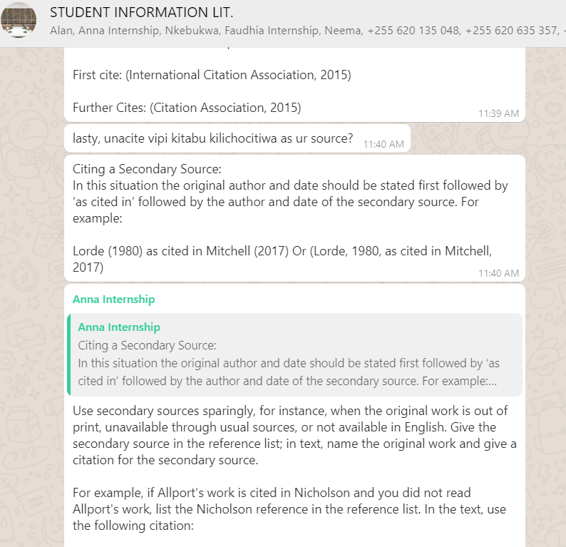
A sample of an interaction on the WhatsApp group

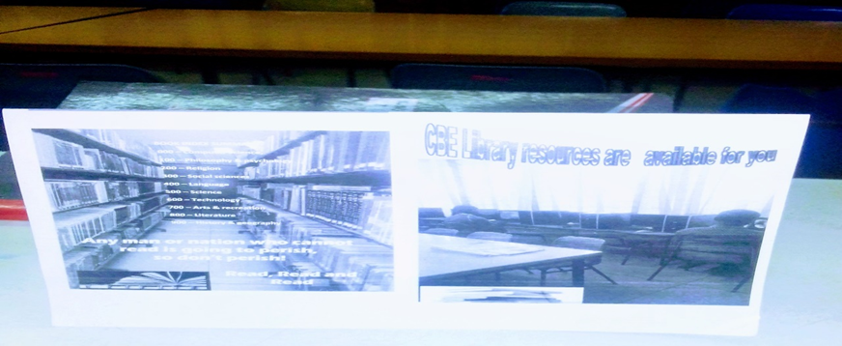
A brochure showing how books are arranged on shelves and a section of the library
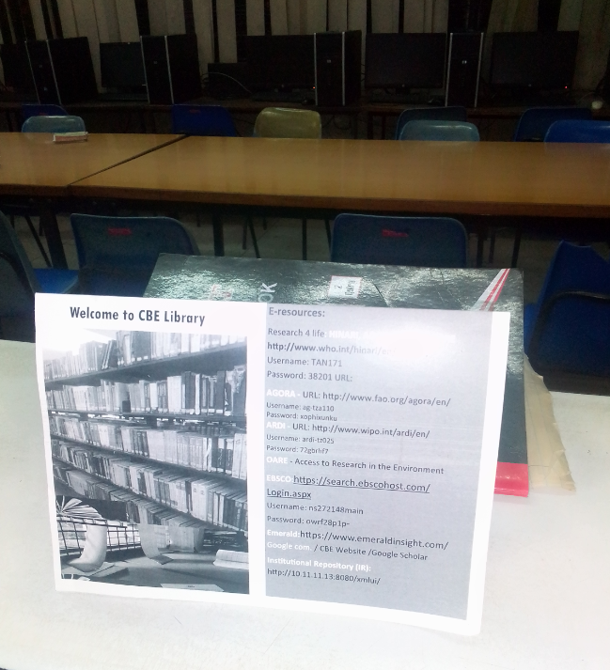
Another brochure she created showing online databases

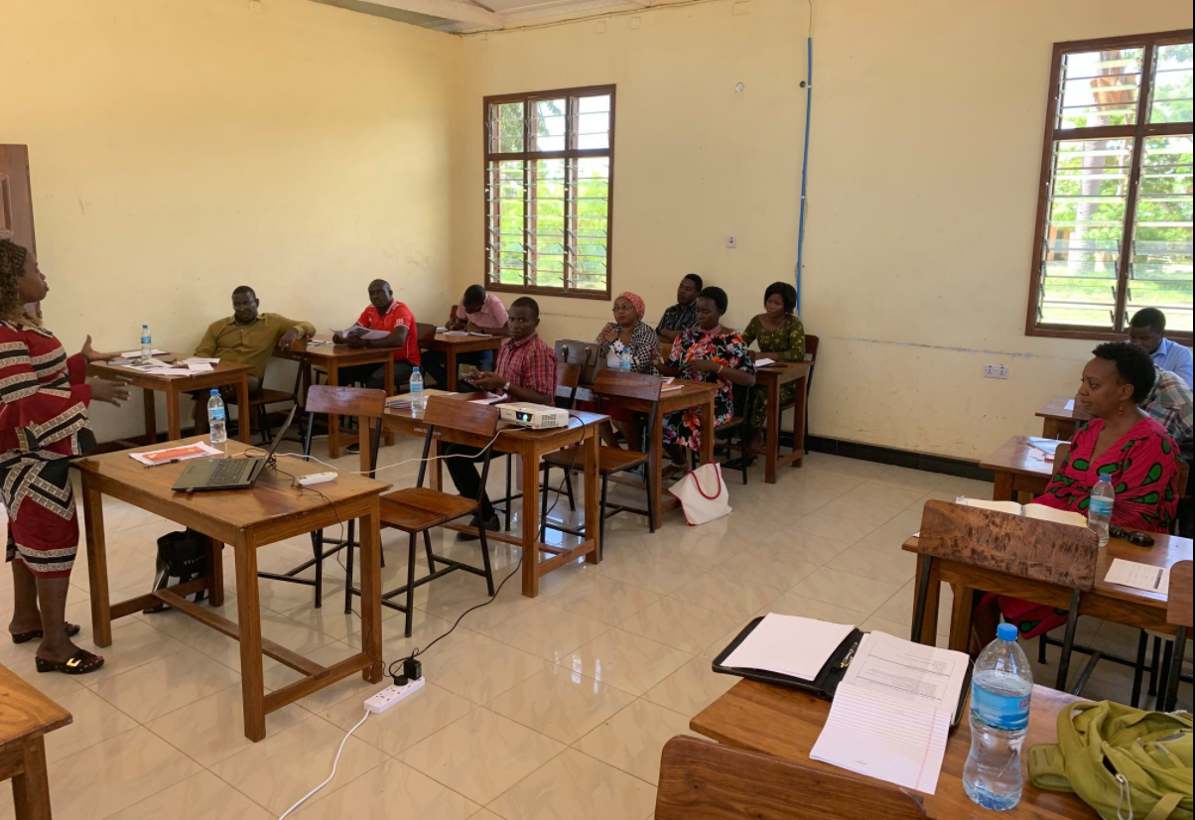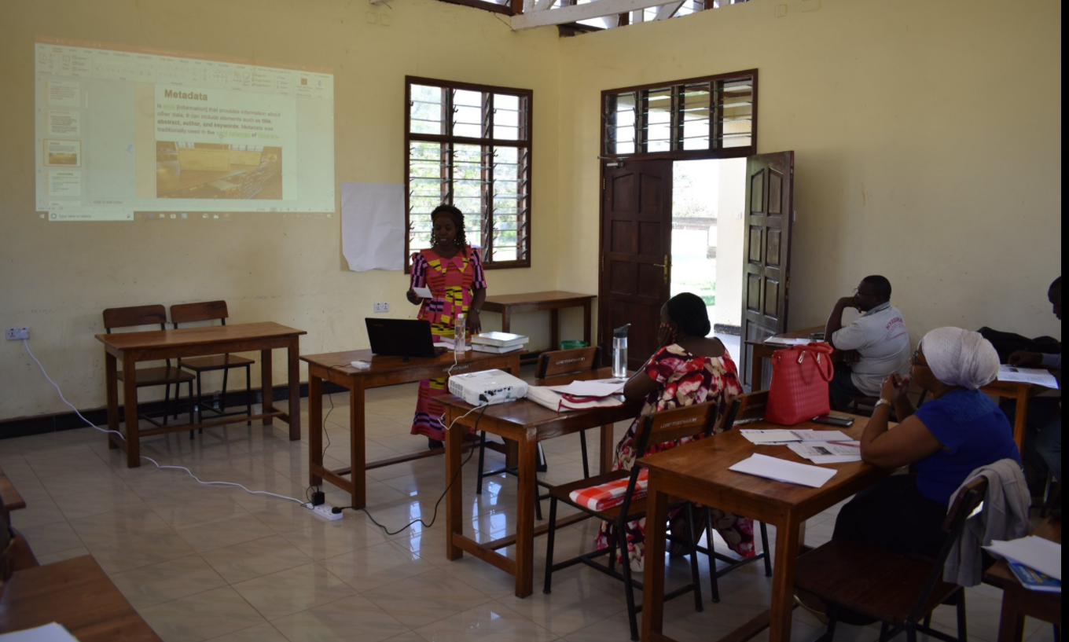
Training users on how to access information electronically

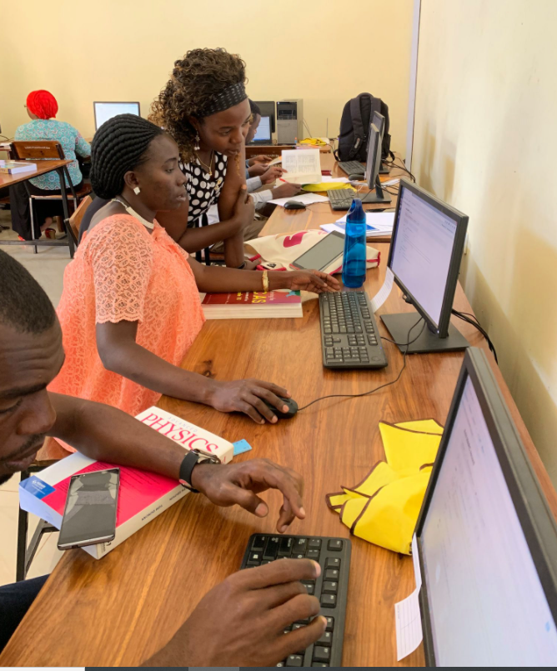
Training other librarians on how to access information electronically

