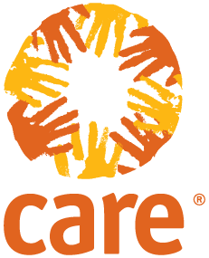

CARE Proposal

Hurricane Irma Emergency Response Fund

Initial Funding Goal: $15 Million

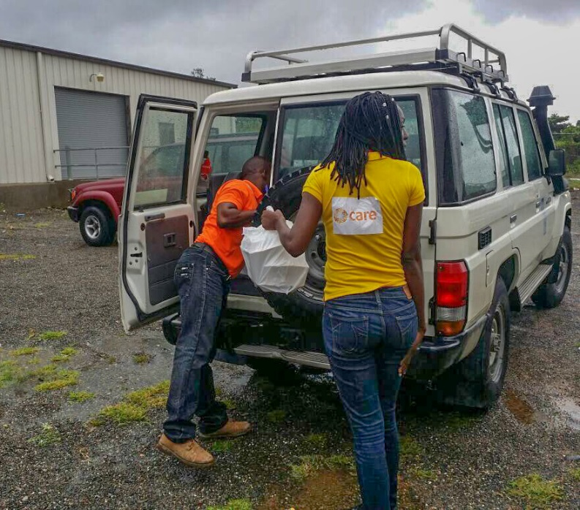

Executive Summary

The extent of destruction left behind by Hurricane Irma – the strongest storm ever recorded in the Atlantic – is only beginning to become clear. Damage is particularly severe in several Caribbean islands as well as the Florida Keys. CARE’s teams on the ground in Haiti and Cuba are concerned about potential secondary effects of the storm, including large-scale population displacement and the threat of waterborne diseases including cholera. In the medium term, major recovery efforts will be needed to address destruction of housing and livelihoods, including agriculture. Thanks to CARE’s long-standing presence in Haiti and Cuba, we are well situated to work with authorities in those countries to support the humanitarian response. We’re also assessing other areas where we could lend expertise and support as needed.

“We knew Irma would be bad. Virtually the entire island has been impacted,” said Richard Paterson, CARE’s country representative in Cuba. “Right now, we’re reaching out to local partners to get a sense of how hard this hurricane hit. We’re particularly worried about those communities along the northern coast in the central provinces – we fear some of these areas have been left in ruins.”

CARE has established the **Hurricane Irma Emergency Response Fund**, with a $15 million initial goal to support our humanitarian response and work with partners to provide immediate relief and longer-term rehabilitation in the most affected areas. Your gift will help us address the needs of the most vulnerable families.[1]

CARE’s Capacity and Response

**CUBA**

Officials have reported significant flooding and waves up to 16 feet in coastal villages in the east of Cuba. Many of those communities were still under three or four feet of water at last report. As many as 1 million people were evacuated ahead of the storm, which also hit the capital city of Havana, with greater force than was anticipated. Power remains out across the island.

While official figures and hard data on damages or numbers of people affected are not yet available, initial reports indicate that the provinces of Camaguey, Ciego de Avila, Sancti Spiritus and Villa Clara have been most severely affected by strong winds, heavy rains and huge storm surges. There are smaller pockets in other provinces that also have been devastated.

CARE is in contact with partners and government officials in many of the affected provinces to ascertain the extent of the damage. With help from partner organizations, we are conducting quick assessments on the ground. As people return to their homes, immediate needs include the restoration of electricity and water supply; food, water and hygiene supplies; roofing and basic household goods. We are particularly concerned about the impact of Hurricane Irma on communities that are still recovering from the effects of Hurricane Matthew last year.

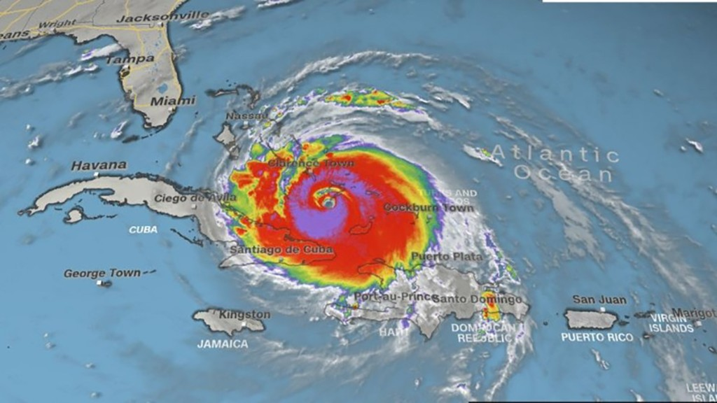

*Winds and heavy rain spawned by Irma affected much of Haiti and Cuba.*

When responding to natural disasters in Cuba, CARE has traditionally provided assistance in water, sanitation and hygiene (WASH) and shelter. CARE has been active in Cuba for more than two decades, with programming focused on food, WASH, disaster risk reduction, humanitarian assistance and gender equality. CARE’s emergency team and partners are experienced in responding to hurricanes and actively prepare for these disasters as part of emergency planning. In Cuba, CARE responded to Hurricane Sandy (2012) and Hurricane Matthew (2016), focusing on women-headed households, families with members who are handicapped and the elderly. Similar to those responses, we plan to focus initially on the provision of basic non-food items (mattresses, sheets and towels) and water and sanitation (water purification, tanks and pails, soap, etc.), then shift to assist communities and families reconstruct their homes (roofing and construction materials).

WASH: Disruption of safe water supplies and sanitation are typical in the aftermath of a hurricane, raising the specter of waterborne disease. CARE has identified hygiene kits as a key element of our response in Cuba. As materials for these kits cannot be procured in country, we are sourcing the materials internationally and initial supplies are ready to ship.

Shelter: Due to the rudimentary nature of houses in rural and poorer sections of urban areas, hurricanes have the potential to cause major damage to buildings – particularly roofs – and affect available shelter for families. Basic assistance for home reconstruction will urgently need to be sourced and distributed to ensure safe and secure homes for affected populations. CARE’s initial response strategy includes roofing kits (roofing sheets, support structures, fasteners and tools) as well as hygiene necessities and basic household items. Because it can take three weeks or more to import shelter relief items that cannot be sourced in Cuba, CARE began reaching out immediately to suppliers to commence procurement.

In planning our medium-term response, CARE expects to focus on helping survivors recover their livelihoods, including agriculture. CARE’s priority for our response is the most vulnerable people, in particular women-headed households, ensuring women have equal access to and ability to use the materials provided, with specialized support if needed. Priority areas for our response may include Gibara in Holguin Province; Nuevitas and Esmeraldas in Camagüey Province; and Caibarien and Corralillo in Villa Clara Province.

**HAITI**

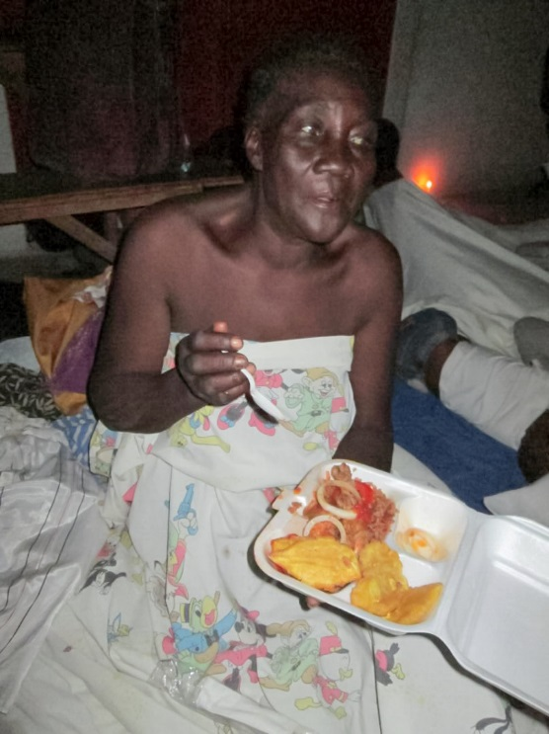While Haiti did not face a direct hit from Irma, heavy rains and winds across the country resulted in flooding, trees falling and damage to agriculture and infrastructure. The most affected areas were the North-West and North-East departments. More than 10,000 people were evacuated to 59 temporary shelters in six departments throughout the country. As the situation begins to normalize, CARE is working with mayors and the Directorate for Civil Protection (DPC) to encourage people to return home rather than stay in the shelters.

In both the North-West and North-East departments, CARE has distributed hundreds of hot meals and safe drinking water in shelters. We are coordinating with Haitian government agencies and the U.N. as we assess the impact and ramp up our response. We plan to work with the DPC to distribute materials such as tarps, hygiene kits, and water treatment tablets to affected people once they have returned home.

CARE has worked in Haiti for more than 50 years, both on long-term development projects and in response to frequent natural disasters.

Conclusion

CARE needs the resources to respond quickly when an emergency happens, insuring we reach the most vulnerable, particularly women and children. CARE’s emergency response teams specialize in helping people prepare for disasters; providing food, water, shelter and health care after a disaster strikes; and helping communities recover after the emergency has passed. When a natural disaster like Hurricane Irma occurs, CARE needs immediate, flexible funding to allow us to mount a comprehensive and timely response and work in partnership with civil society organizations. Thank you for considering a donation to the Hurricane Irma Emergency Response Fund to support these lifesaving efforts in areas devastated by the natural disaster.

*September 12, 2017*

1. In order to effectively manage the current emergency response and continue to be able to deploy resources for other emergencies, CARE will reserve 20 percent of donations to the Hurricane Irma Emergency Response Fund to cover technical support, administration and emergency preparedness expenses, including the rapid deployment of staff to emergencies such as this one.