CARE AND DEVELOPMENT CENTRE (CADEC)

23 OROEKPO ROAD, MILE 4, RUMUEME, PORT-HARCOURT, RIVERS STATE,
NIGERIA

E-mail: vcarenigngo@yahoo.com
Twitter handle: @cadec@virtuouscare
Face book: https://www.facebook.com/cadecngo
G.S.M: 08032650025

CONCEPT NOTE

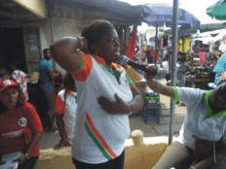
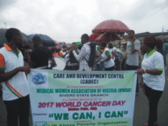
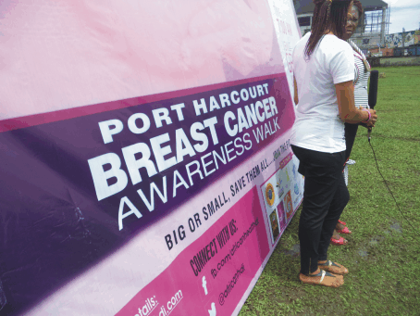

- Project Title : Campaign for Cancer Control (C3)
- Project location: (Choba, Rumuokoro, D-line, Aggrey, Town, and Diobu) Obio/Akpor and Port-Harcourt City Local Government Areas of Rivers State, Nigeria
- Specific problem to be solved: Recent data provided by smaller population-based and hospital-based registries suggests that cancer incidence is increasing in the country. In view of this problem, CADEC shall be promoting initiatives to help halt the death rate accruing as a result of cancer related diseases, promote early diagnosis and early presentation for prompt medical treatment,
- Project duration: This initiative shall last for a period of 12 months.
- Project goal: Reduced rate of cancer related deaths among target population in Rivers State by 25% by year 2019.
- Project objectives: Increase cancer awareness among rural men and women in target communities of target Local Government Areas by 25% by year 2019.
- Promote culture of early detection among target population
- To advocate for policy and practice changes to enhance awareness, screening, and care for cancer patients in Rivers State.
- Project activities: Baseline survey: CADEC shall utilize quantitative method of structured questionnaires, administered to further empirically ascertain target beneficiaries knowledge trends. The baseline will also help to determine indicator level targets. A sample size of 100 target community members is envisaged.
- Social Mobilization /Awareness creation: The team shall key into the cluster communities’ social events; like women group meetings, community market days, religious program, cultural festivities etc. to disseminate cancer information, distribute IEC materials, and as well make referrals to diagnostic and cancer focused health facilities. These forums shall equally be used to advocate for change in believe systems and myths.
- Screening and referrals: The project shall promote rapid response screening for cervical cancer at the facilities level, utilizing visual inspection with acetic acid, and referral to other partnering facilities for pap smear, clinical breast examination/mammogram, and prostate cancer screening/PSA for men prostate levels. Equally, CADEC shall facilitate community-facility referral linkages for an effective referral services.
- Networking and partnership with various cancer diagnostic canters/hospitals and state agencies/Rivers State Primary Health Care Management Board (RSPHMCB). CADEC shall strengthen her existing relationship with the agencies for effective project implementation.
- Selection and Training of 12 community volunteers as Inter Personal Communicators (IPCs) and 12 Primary Health Workers on ;
- Cancer prevention and control
- Visual Inspection with Ascetic Acid for rapid response cervical cancer screening..
CADEC will conduct the 2-day intensive training to develop the capacities of the IPCs and facilities focal persons to efficiently integrate cancer control and prevention in their routine facility schedules. IPCs shall extend awareness creation at their communities, with the knowledge gained through the training. This will create a multiplier effect of behavioral change to the cluster communities.
- Advocacy to relevant stakeholders: CADEC shall hold meetings with policy makers on the need for state agencies/government to strengthen the efficiency of cancer facilities in the state government hospitals.
- Commemoration of the World Cancer Day and Breast Cancer Week. CADEC shall partner with other cancer intervention stakeholders to commemorate the above activities, through outreach programs and street walk to market squares/ religious places were further awareness shall be made and screening facilitated in partnership with our stakeholders like the Medical Women Association of Nigeria (MWAN), Rivers State Branch, Africa Health and Development Initiative (AHDI) and the Rivers State Ministry of Health (RSMH) See samples of partnership letters attached.
- Support for breast surgeries: The project shall financially support a maximum of 6 indigent women diagnosed with breast cancer to undergo breast surgeries/chemotherapy, and as well linked up with cancer survivor support groups.
- Key stakeholders:
- Target community members: They are the direct project beneficiaries
- State agencies (Rivers State Primary Health Care Management Board, Rivers State Ministry of Health, and University of Port-Harcourt Teaching Hospital): Tasked with primary responsibility of primary and tertiary health care in the state. They shall play both technical support and monitoring of project implementation
- Primary Health Care Facilities: Play the role of health facility focal contacts.
- Private health facilities: Play the role of supply end, by providing subsidized cancer care services and diagnosis.
Project targets: Awareness creation: 100,000 persons (Excluding media coverage).
Referrals for various screening:
- Breast cancer……………………………………………150
- Cervical cancer………………………………………….150
- Prostate cancer …………………………………………..50
- Vaccination against cervical cancer …………………… 50
- Project sustainability plan: 12 IPCs shall be nominated from existing community structures, and trained to continue with knowledge gained after project close out while 12 community health workers are trained to Integrate cancer primary prevention into Primary Health Care delivery services. CADEC shall equally integrate cancer intervention programs in our Malaria Elimination Programs, Women Empowerment Initiatives and HIV/AIDS interventions,
- List of similar project executed, amount and sources of fund: Community Campaign for Cancer Control (C4)

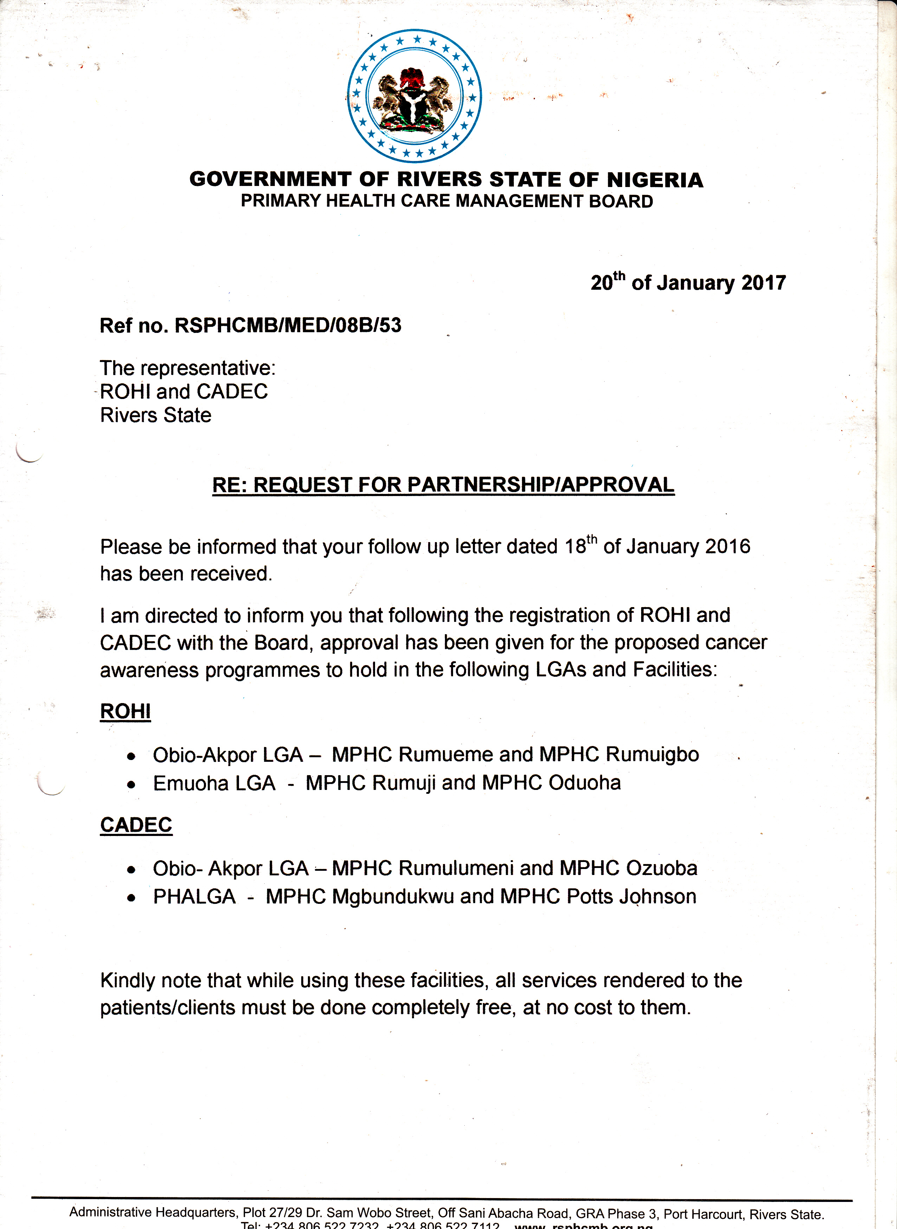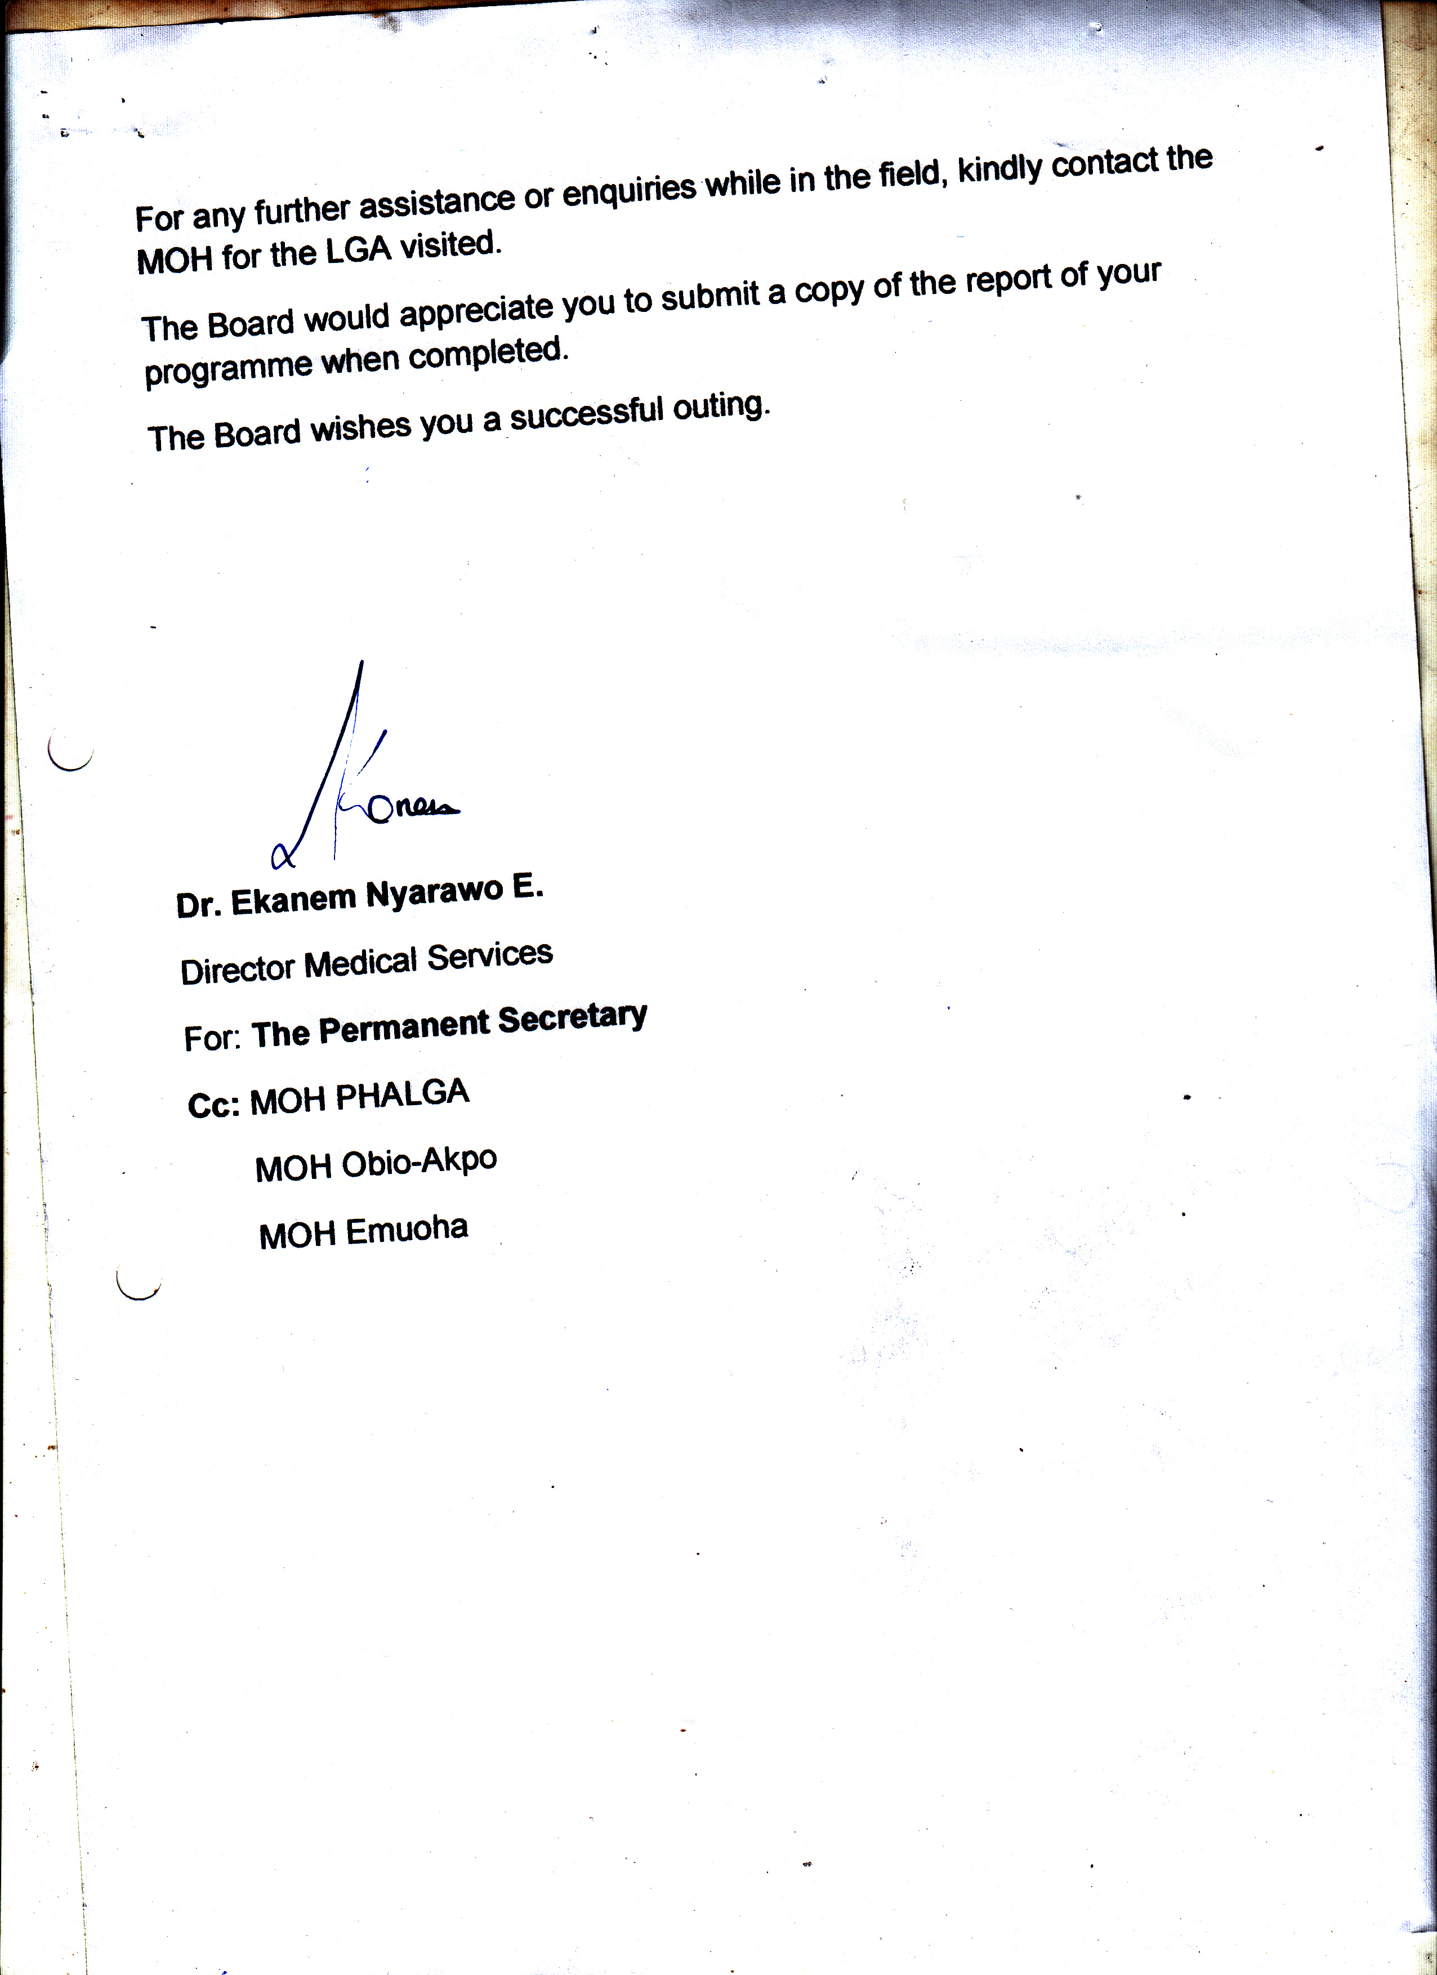

 | BREAKDOWN OF PROJECT BUDGET - CADEC
S/N | ACTIVITIES | FREQ. | UNITS | UNIT COST | TOTAL COST | SUB TOTAL
 | PROJECT DIRECT COST :
1 | Baseline Survey |  |  |  |  | CADEC will employ the services of the M&E officer and 1 2 selected community volunteers to conduct the baseline survey across the 6 communities in Obio/Akpor AND Port-Harcourt city LG.AS for a maximum period of 4 days
 | :Stipends for community participants | 4.00 | 12.00 | 2,500.00 | 120,000.00
 | Sub total cost |  |  |  | 120,000.00 | 120,000.00
2.00 | Community mobilization and Awareness creations |  |  |  |  | CADEC is optimistic of receiving a minimum of 50 community members per community for the sensitization.
 | Town crier fees | 1.00 | 6.00 | 3,000.00 | 18,000.00
 | Snacks for community participants | 4.00 | 50.00 | 500.00 | 100,000.00
 | Digital banners | 1.00 | 9.00 | 8,000.00 | 72,000.00
 | Outreaches :
 | Renting of Public address sytem | 4.00 | 12.00 | 10,000.00 | 480,000.00
 | Video coverages | 4.00 | 12.00 | 15,000.00 | 720,000.00
 | Volunteers stipends | 8.00 | 12.00 | 41,000.00 | 3,936,000.00
 | Dance bands | 1.00 | 12.00 | 25,000.00 | 300,000.00
 | Snacks for volunteers | 4.00 | 12.00 | 500.00 | 24,000.00
 | Prodiction of IEC materials | 1.00 | 10,000.00 | 55.00 | 550,000.00
 | Radio jingles :
 | Prodcution of jingle | 1.00 | 1.00 | 60,000.00 | 60,000.00
 | Weekly radio jingle airtime/slots | 8.00 | 60.00 | 6,500.00 | 3,120,000.00
 | Sub total cost for |  |  |  | 6,200,000.00 | 6,200,000.00
3.00 | Strengthening of Community Health system through training of 12 community volunteers as (IPCs) and 12 Primary Health Workers |  |  |  | `` | A 2 day non residential training. This shall comprise of 12 community volunteers, 12 Health Workers, 2 Government agencies representative, and 2 CADEC staff.
 | Training center | 2.00 | 1.00 | 80,000.00 | 160,000.00
 | Training/writing materials | 1.00 | 24.00 | 500.00 | 12,000.00
 | Tea break and lunchs for participants | 2.00 | 28.00 | 3,500.00 | 196,000.00 | Tea break -1000, Lunchs- 2000= 3000 x 2days x 28 persons.
 | Digital banners | 1.00 | 1.00 | 8,000.00 | 8,000.00
 | Transport refunds to participants | 2.00 | 28.00 | 5,000.00 | 280,000.00
 | Sub total |  |  |  | 656,000.00 | 656,000.00
4.00 | Volunteers and PHC Focal Persons engagements :
 | Stipends for IPCs | 10.00 | 12.00 | 4,000.00 | 480,000.00 | IPC monthly stipends : 4000 x 10 IPCs x 12 months = 480
 | Stipends for PHC focal Persons | 10.00 | 12.00 | 4,000.00 | 480,000.00 | Focal Persons monthly stipends : 4000 x 10 IPCs x 12 months = 480
 | Sub total |  |  |  | 960,000.00 | 960,000.00
5.00 | Integration of Cancer primary prevention into Primary Health Care delivery services |  |  |  |  | This is to support the health facilities to diligently carry out the cancer integration processes into their routine health schedules by providing free V.I.A free of charge for community beneficiaries at their facilities.
 | Provision of consumables for V.I.A :
 | Provision of hospital equipments for 5 PHCs | 1.00 | 5.00 | 50,000.00 | 250,000.00
 | Liters of Acetic Acid | 4.00 | 3.00 | 15,000.00 | 180,000.00
 | Packet of Examination Gloves | 4.00 | 2.00 | 2,500.00 | 20,000.00
 | Disinfectant | 4.00 | 1.00 | 2,000.00 | 8,000.00
 | Packets of Cotton Wool | 4.00 | 1.00 | 2,500.00 | 10,000.00
 | Provision of Cusco Vaginal Speculum (Re-usable) | 4.00 | 120.00 | 2,500.00 | 1,200,000.00
 | Sub total |  |  |  | 1,668,000.00 | 1,668,000.00
6.00 | Commeomoration of World Cancer Day : February
 | Production of T-Shirts/advocacy T-Shirts and cap | 1.00 | 50.00 | 1,300.00 | 65,000.00
 | Production of digital banners | 1.00 | 1.00 | 6,000.00 | 6,000.00
 | Refreshments for volunteers | 1.00 | 15.00 | 500.00 | 7,500.00
 | Volunteers stipends | 1.00 | 15.00 | 4,000.00 | 60,000.00
 | Public Address system | 1.00 | 1.00 | 10,000.00 | 10,000.00
 | Video coverage | 1.00 | 1.00 | 20,000.00 | 20,000.00
 | Sub total |  |  |  | 168,500.00 | 168,500.00
7.00 | Commemoration of Breast Cancer Awareness Week : October
 | Production of T-Shirts/advocacy T-Shirts and cap | 1.00 | 50.00 | 1,600.00 | 80,000.00
 | Production of digital banners | 1.00 | 1.00 | 6,000.00 | 6,000.00
 | Volunteers stipends | 1.00 | 15.00 | 4,000.00 | 60,000.00
 | Refreshments for volunteers | 1.00 | 15.00 | 500.00 | 7,500.00
 | Public Address system | 1.00 | 1.00 | 10,000.00 | 10,000.00
 | Video coverage | 1.00 | 1.00 | 20,000.00 | 20,000.00
 | Sub total |  |  |  | 183,500.00 | 183,500.00
 | /Breast cancer surgery support | 1.00 | 6.00 | 100,000.00 | 600,000.00 | We anticipate a minimum of 6 extreme cases of indigent women with full-blown breast cancer victims, thus provision to support them through surgical operation, if opted for.
 | Sub total cost |  |  |  | 600,000.00 | 600,000.00
9.00 | Transportations
 | Project staff ' transportations to project communities |  |  |  |  | Transportation for project team community entry visits, routine visits to the community for both programme monitoring and other issues= N6000 x 3times a week x 12 months
 | Transportation for staff | 12.00 | 12.00 | 6,000.00 | 864,000.00
 | Sub total cost |  |  |  | 864,000.00 | 864,000.00
13.00 | Monitoring and Evaluation
 | Dono'r M and E activities
 | Production of M and E tools :
 | Referral Booklets | 1.00 | 20.00 | 1,500.00 | 30,000.00
 | Referral refister | 1.00 | 12.00 | 1,200.00 | 14,400.00
 | Service Registers | 1.00 | 12.00 | 1,200.00 | 14,400.00
 | Sub total |  |  |  | 58,800.00 | 58,800.00
 | TOTAL PROJECT DIRECT COST: |  |  |  |  | 11,478,800.00
 | T.Y Danjuma staff monitoring visit budget/cost |  |  |  |  | 573,940.00
 | PROJECT TOTAL COST : |  |  |  |  | 12,052,740.00
1.00 | INSTITUTIONAL SUPPORT :
 | Bank fees/charges | 1.00 | 12.00 | 2,000.00 | 24,000.00
 | Couriers | 1.00 | 12.00 | 5,000.00 | 60,000.00
 | Communication rates | 1.00 | 12.00 | 5,000.00 | 60,000.00
 | Stationaries | 1.00 | 12.00 | 5,000.00 | 60,000.00
 | Fueling of generator for alternative power | 1.00 | 12.00 | 4,000.00 | 48,000.00
 | Sub-total |  |  |  | 144,000.00 | 144,000.00
2.00 | Personnels Cost :
 | Project Manager | 1.00 | 12.00 | 65,000.00 | 780,000.00
 | Finance Officer | 1.00 | 12.00 | 45,000.00 | 540,000.00
 | M and E Officer | 1.00 | 12.00 | 45,000.00 | 540,000.00
 | Sub total |  |  |  | 1,860,000.00 | 1,860,000.00
 | TOTAL INSTITUTIONAL SUPPORT |  |  |  |  | 2,004,000.00
 | TOTAL PROJECT COST IN NAIRA |  |  |  |  | 13,424,000.00
 | TOTAL PROJECT COST IN USD |  |  |  |  | 44,013.11

