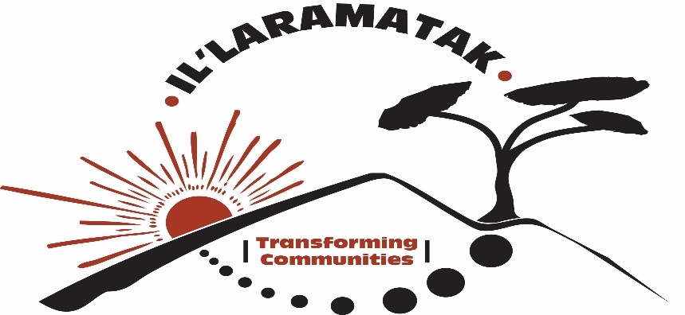

INTRODUCTION AND HISTORY
The Arid and Semi-Arid Lands (ASALs) make up more than 40% of the earth’s surface and are home to 35% of its population. Indigenous peoples in East Africa comprise pastoralists, hunter-gatherers and minority fisher folk communities. Pastoralist and minority fisher folk communities are found in arid and semi-arid areas while hunter-gatherers are found in forest areas. In Kenya, the ASALs occupy 89% of the country and are home to about 14 million people and approximately 80% of the national livestock herd. The pastoralists in Kenya include the Maasai, Rendile, Samburu, Borana, Pokot and Turkana, among others, while the fisher folk include the Elmolo and Ilchemps among others.

Il’laramatak Community Concerns (ICC), is a registered Non-Governmental Organization (NGO), founded in September 2011, to address human rights and development concerns of indigenous pastoralists, who are part of the minority communities in Kenya, with special focus on women and girls. ICC believes and recognizes that pastoralist communities in the arid and semi-arid lands of Kenya have much to offer to the country, and ICC would like to look at these groups differently, recognizing their strengths and the resources they have, and understanding what makes them distinct. By doing so, ICC hopes to reduce injustices meted against them, support their contribution to national development, and that they are treated and benefit accordingly in the spirit and commitment of the Kenyan Constitution 2010.

ICC actions in working with pastoralist women and girls is based on the fact that we believe they are the change agents that will transform our communities through rejecting all forms of discrimination, defending their human rights and the rights of their communities.

VISION for Il’laramatak Community Concerns
Il’laramatak Community Concerns envisions a society where pastoralist communities live free from any form of discrimination, interact and integrate with other communities with respect while appreciating their unique contribution to development at all levels; locally, nationally and Internationally.

MISSION for Il’laramatak Community Concerns
ICC’s mission is to support pastoralist communities, particularly women and girls in Kenya, empowering them to transform their lives through improved education, justice empowerment and socio-economic development. ICC maintains this mission by providing information, opportunities and mentorship for them to transcend socio-cultural barriers to progress in their communities.

ICC Thematic Areas
- Putting recourses in the hands of pastoralist women
- Protecting and keeping pastoralist children in school
- Pastoralists adaptation to extreme whether
- Pastoralists engagement in leadership and governance
- Sustainability option

ICC Specific Objectives
- To expose women to possible and diverse sources of livelihoods while protecting their rights to ownership of natural resources
- To transform the lives of pastoralist children through education while preserving positive cultural aspects
- To support traditional knowledge and practices that enhance pastoralists resilience to extreme whether effects
- To support pastoralist communities and their county governments to realize full benefits of devolution
- To enhance the sustainability of the organization to realize its long term vision

- Protecting and keeping pastoralists girls in school.
Theme: Education not Mutilation
Lack of formal education has been the biggest reason and excuse to pastoralists’ marginalization. Levels of illiteracy are high and it is even worse among girls and women. ICC contributes to increase in enrolment, retention and transition from primary to college among pastoralists’ children and especially girls. It does these through role-modeling and goal-setting, annual youth camps and role models school visits children are inspired to dream beyond the household jobs they’ve seen for women in their village. They understand that education is the ticket to a better future and that future is in their hands.
This way ICC discourages early/forced marriages as well as retrogressive cultural practices such as FGM. To advance this course ICC founded and now hosts a network of organizations working on children issues in the entire Kajiado County.

Kajiado County Children’s Stakeholders Network (KACCSNET) is a network of more than Thirty (30) non-governmental organizations, Faith Based Organizations, Community Based Organizations working together with the National and County Government to ensure effective coordination and implementation of child focused activities for greater results in addressing issues affecting children in Kajiado County.
As a network, KACCSNET has enhanced effective interventions by improving coordination, partnerships and teamwork for organizations working to ensure children and especially girls are protected and remain in school. The network has widened scope of impact and has made the otherwise challenging tasks of protecting children interesting and successful.
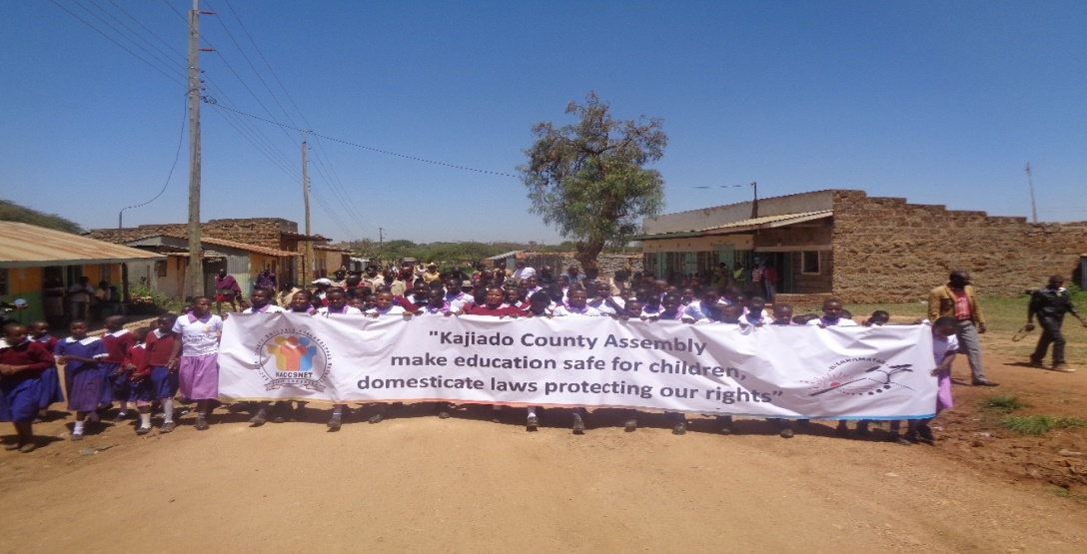

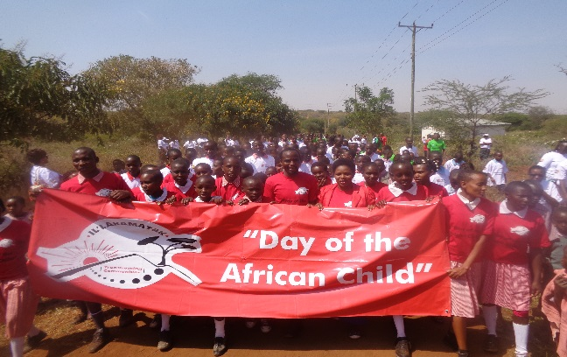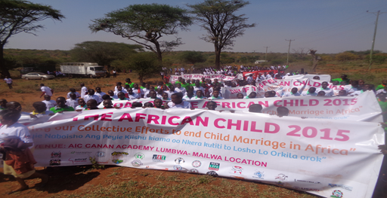

This network is now working with the county government especially the ministry of Gender and ICT to spearhead the domestication of the Female Genital Mutilation (FGM) Act of 2011 to suit Kajiado County context and build ownership, hence implementation realization with less ado.
ICC uses an approach called transformative leadership for girls to help them focus on high level goals and aspirations different from traditional and cultural lifestyle. A high proportion of girls from the Maasai community drop out of school early and do not complete their education. ICC postulates that keeping girls in school, and developing their leadership capabilities, will provide protection and safety to become independent and economically active members of their communities.

ICC’s strategy to support education and transformative leadership for girls includes:
- Leadership and mentorship holiday camps for girls, following the ICC Girls’ Transformative Leadership curriculum.
- Financial support to girls from poor families to stay in school while meeting their pressing material needs
- Strong relationship developed with households/families, the whole community and school administration around the learning and living environment for girls
- Goal setting for the girls aimed at breaking the cycle of poverty and illiteracy giving a voice to the voiceless
- Formation of Girls Transformation Clubs in schools to foster self-esteem, ambition and networking among girls to form a generation of young women leaders who understand and fight for their rights
- Foster and encouraging peer learning through the exchange programs

- Putting resources in the hands of women.
Theme: Supporting livelihoods and Economic empowerment for women.

ICC empowers women as central pillars that hold and support families by putting resources in their hands. It does this through formation and registration of self-help groups, training, and linkage to financial institutions as well as establishment of small businesses. This would result into women being able to provide more than two meals a day to their families, acquisition of household assets, improvement of housing conditions, and increasingly earning respect and voice at community level.

ICC empowers women to own and seek control of natural resources and assets such as land.

ICC strategy to support livelihoods includes;
- Pilot drip irrigation farms for pastoralist women in Inkinye village in Kajiado and Lekiji in Laikipia North. These are five to ten acres of land each set aside for food production and income generation for the communities.
- Bead work branding which makes use of perfected traditional skills to make unique products that attract a diverse local and international markets
- Livestock fattening and selling during the drought seasons for profit making
- Introduction of dairy goats in the pilot farms

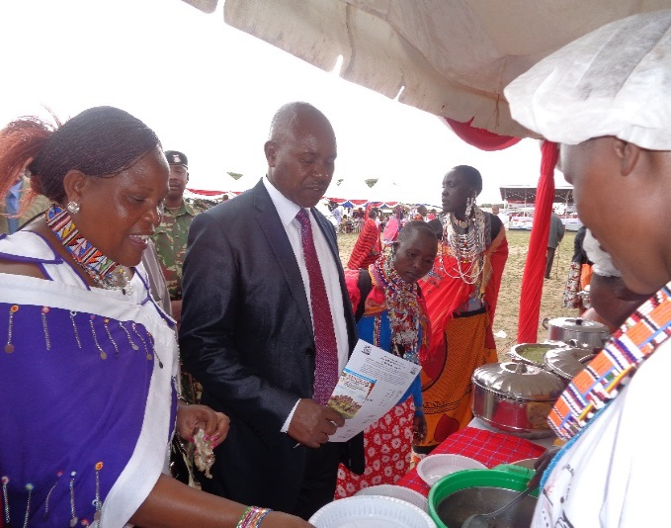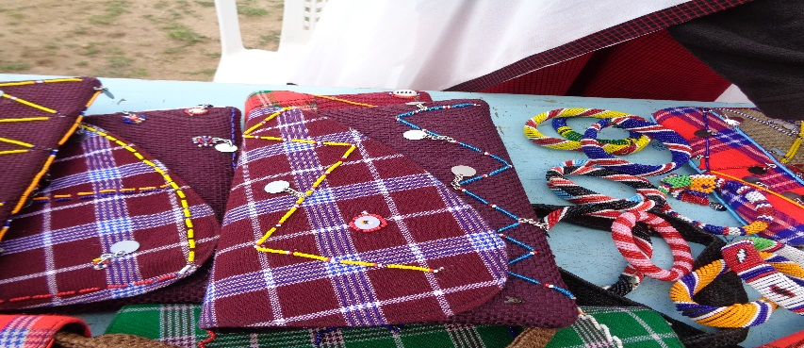

Kajiado County Governor having a look at different women products during an exhibition.

Inkinye Kiret Community Farm

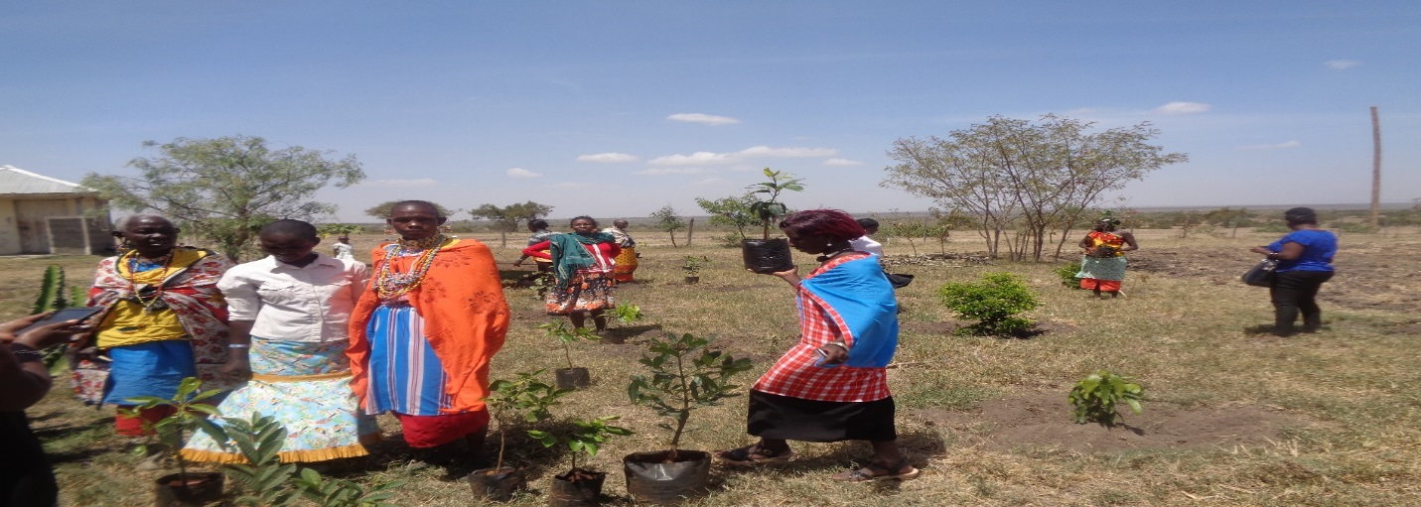

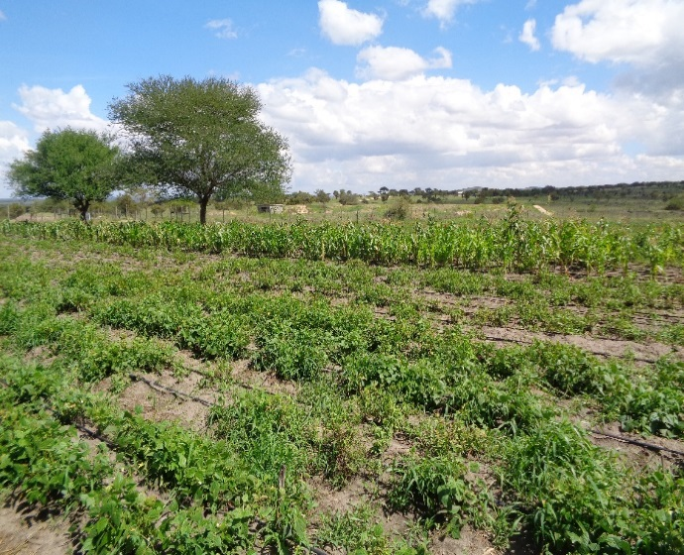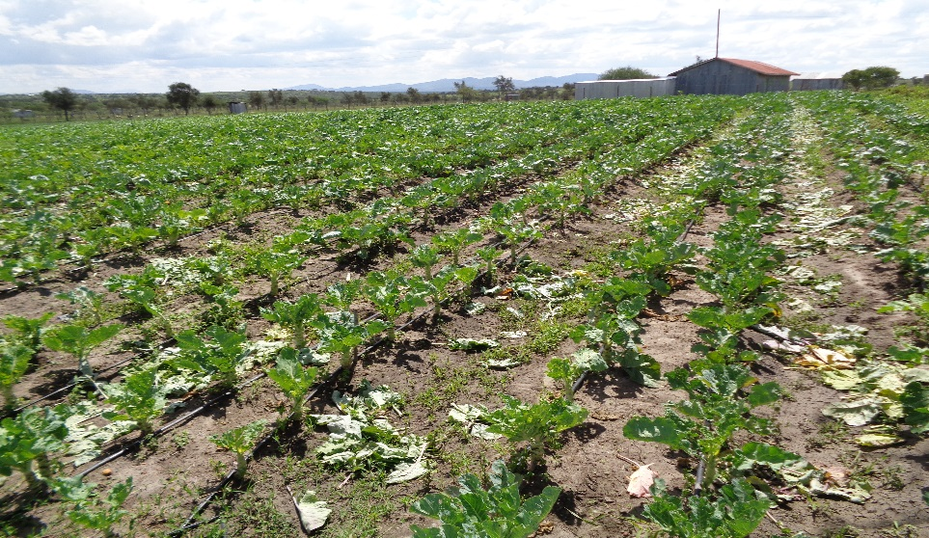

LEKIJI COMMUNITY FARM

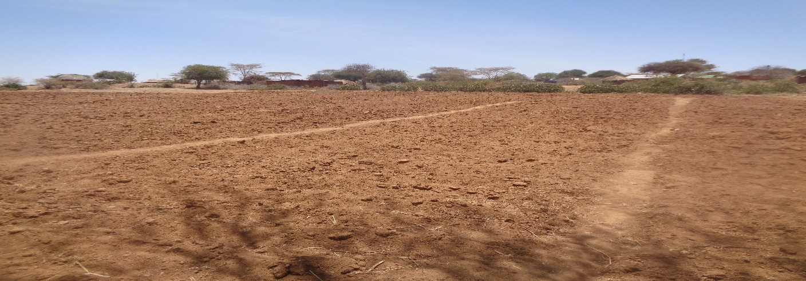

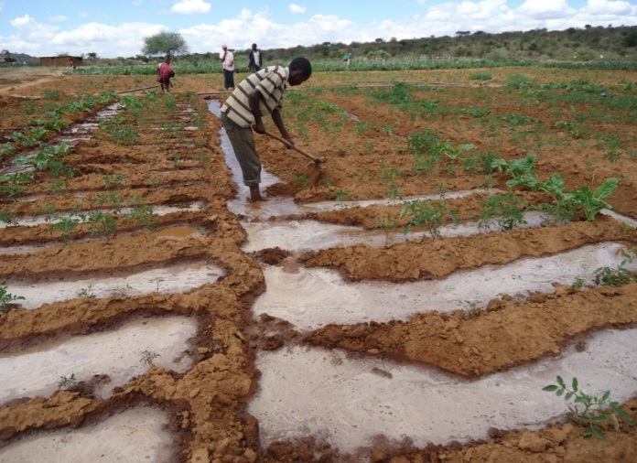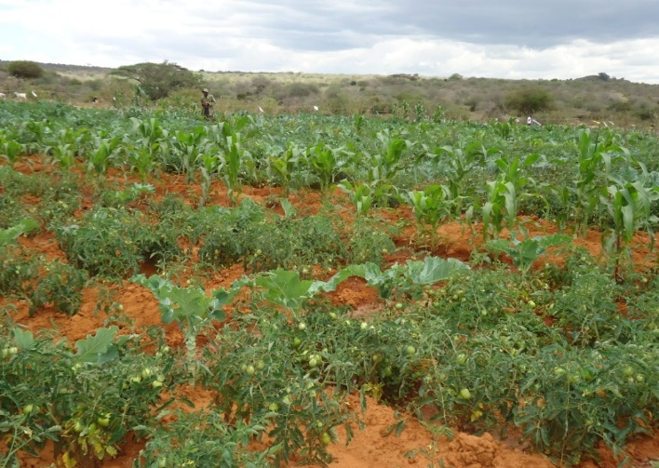

- Adaptation to extreme weather.

Theme: Building resilience using modern and Indigenous knowledge systems
In the advent of growing concerns on climate change effects, ICC works to support modern and traditional practices of climate change adaptation that enhance resilience to drought and other shocks. ICC documents indigenous traditional knowledge systems and practices, and link them to modern science in search of new dynamic and creative ways of increasing resilience. Community platforms such as community conversations and sensitization on new thinking and innovations would be used to launch discussions that would ensure community priorities are integrated in solutions to their own problems.

ICC is promoting green energy utilization such as solar lamps, solar cooking etc. and promotes conservation of forests and other natural resources through conservation by utilization of energy saving jikos, use of kilns, tree planting and controlled charcoal making.

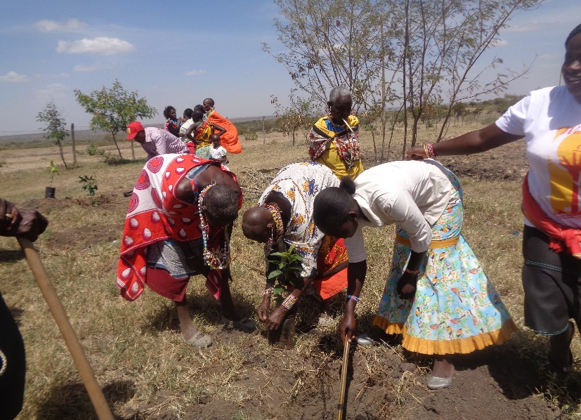

- Pastoralists’ engagement in Governance and peace building
Theme: Ensuring Justice for all through gender equality, fairness and inclusive leadership
Pastoralist landscapes are characterized by resource-based conflicts, cattle rustling, and inadequate participation in Governance. ICC inspires and trains pastoralist to realize their basic rights as granted by the Kenyan constitution and equip them with knowledge and skills for claiming these rights through civic education. ICC ensures women are included and are at the center of participation in elective political leadership. Women then are actively engaged in decision making on their future destiny as citizens at village, County and National levels.

In Kenya, women participation in political leadership is significantly low and is even worst among pastoralist communities where illiteracy and cultural practices inhibit women’s quest for representation. ICC believes that there is need to strengthen participation of women in political processes and decision making so as to adequately address their issues at all levels. ICC has been a member of TUVUKE steering committee at national and community level seeking to enhance women participation as voters and would-be leaders.

ICC uses community forums to train on and conduct civic education in the community in order to facilitate dialogue, problem identification and planning for solutions.
- Policy engagement.

Theme: Advocacy at all levels – International, Regional, National, County and Community.

In the past, pastoralist communities have suffered historical injustices, inequalities and marginalization as a result of biased policy choices made by consecutive post-independence governments in Kenya. This has persisted to date with no improvements whatsoever. Despite the fact that Kenya is a signatory to many International human rights conventions and has ratified some of them, institutionalization has been hampered by low political will and relative inertia to implement. ICC sees that engaging in policy advocacy at local, national, regional and International levels is key to causation of change towards better lives for pastoralists, especially women and girls. It is the only way to bring out the issues of pastoralists to the public domain and to agitate for action at all levels.

Community advocacy
At the community level, ICC advocates for change of attitude towards women in leadership and education. ICC facilitates the formation of Girls Transformation Clubs in schools to foster self-esteem, ambition and networking to form a generation of young women leaders who understand and fight for their rights. The girls are as well involved in goal-setting for school girls aimed at long-term visioning and breaking the cycle of poverty and illiteracy giving a voice to the voiceless. ICC fosters and encourages peer learning through exchange programs between community schools under its area of coverage among pastoralists

County Advocacy
At the County level, ICC advocates for gender sensitive resource budgeting and allocation e.g. targeting a percentage or number of bursaries for needy students from Northern Kenya and other arid lands, particularly girls who wish to pursue tertiary and university education through County and CDF education grants. ICC influences the development of gender-sensitive legislation at County level to ensure equity and representation of women and girls issues.

National advocacy:
At the National level, ICC is championing formal education of the pastoralist girls in the country, aimed at increasing the enrolment, retention and completion of education for the girls in the pastoralist communities. ICC advocates for the enactment and enforcement of Acts directly affecting pastoralist communities, women and girls e.g. FGM Act, Community Land Act among others.
ICC promotes representation and participation of pastoralist women in national leadership positions and advocates for gender sensitive education policies for pastoralist communities
ICC is involved in advocacy for the enactment of constitutional articles that directly impact on pastoralists to improve their conditions, such as article 204 on equalization fund among others. It advocates for the enactment of pastoralist-friendly education and land policies in the country in favor of especially nomadic pastoralist, with special emphasis to women and girls. ICC has been elected as the Executive Committee at the National NGO council, representing pastoralist and minority groups in the country. ICC is the chair of the girl-child network and is taking the lead in advocating for the rights of children.

Regional advocacy:
ICC in the region advocates for International human rights instruments to be included in the regional legislations and promotes domestication and institutionalization of the AU protocols relevant to pastoralist peoples, with special emphasis to women and girls.
ICC is a member of IPACC- Indigenous People of Africa Coordinating Committee and has been elected as a gender representative for the African Region

International advocacy:
At the International level ICC provides recommendations to the UN on pastoralists issues for implementation by member states and advocates for the implementation of international human rights conventions such as the UNDRIP and other protocols in African member states

ICC attends the UN permanent forum on indigenous issues which is the only platform that addresses indigenous people issues.

- ICC going forward: Il’laramatak Academy (Primary school, handy crafts complex)
Theme: Sustaining the vision and mission of ICC.
ICC plans to become a more focused sustainable organization in keeping with the passion and desire of its founder, through venturing into business that will sustain its dream and mission by engaging a profit making wing that supports the charitable role in serving the poorest in the target community. The fact that funding arrangements often change strategy and/or partnership within three to five years makes steady funding commitments for long term projects a challenge.
An example is the sponsorship program for girls rescued from early/forced marriage and female genital mutilation. Currently ICC is supporting over 75 girls at ILbisil Primary School and various secondary schools through Ford Foundation and private donors, but getting continued funding on school fees is a big challenge. This has informed ICC decision to initiate steps towards establishing an academy complex to include a private primary school and a handy-crafts complex.
It is envisaged that this profit-making business will generate funds in the future to shoulder the costs of supporting education for girls from poor families and those suffering from FGM stigma, rescue from early/forced marriages etc. ICC will institute a system where able parents from well-to-do families will pay school fees for their children and the profits accrued from the school as a business used to support rescued girls. This school which will be based in Kajiado becomes ICC’s long-term plan to continue supporting rescued girls and possible replication in other ASAL Counties of Kenya with similar challenges.

