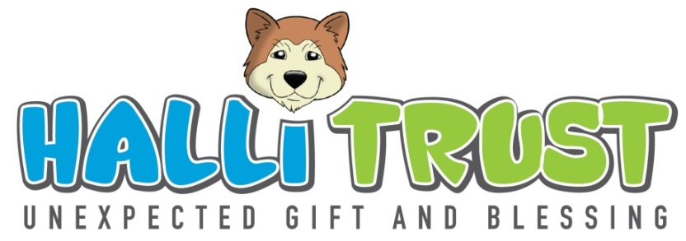
Halli Club & Halli Leaders Club

The Halli Club is for children between the ages of 8 and 10 years old. The club consists of about 100 children in both Smartie Town and Nomzamo where gatherings take place.

The Halli Leaders Club is for the 11 year old children who showed leadership skills and attended every gathering during their last year in the Halli Club.
The leaders will be part of the Halli Leaders Club until the age of 18 years.

Aim
We want to use both these Clubs as a platform to teach children basic life skills and leadership skills.
In the Halli Leaders Club we aim to develop young leaders and aim to give them guidance to adulthood and the responsibilities of life. We want to focus on leadership, career advice, spiritual growth and work ethic.

Vision
Our vision is to ensure that we invested in children who want to go out and not just to be the CHANGE but to be leaders, work hard and make a difference. We want children who are prepared to be forerunners for their generation.

Mission
We get together monthly on a Friday afternoon from 2h30 to 3h30 with the Halli Leaders and 3h30 – 5h30 with the Halli Club.
We are looking for children who want to learn and be prepared to be future leaders.

