PROJECT PROPOSAL
FOR

IMPROVING ACCESS TO QUALITY BASIC EDUCATION FOR GIRL CHILDREN and CHILDREN WITH SPECIAL NEEDS

Submitted
To
Global Giving

Submitted
By
Nari Nidhi

Plot No – 11, Laxmi Nivas, Panchvati Colony, Majhouli Khetal, PO- Khabra,
Muzaffarpur-843146 Bihar, INDIA
Mob: 9430013517, 8651183313

e-mail: narinidhi.muz@gmail.com narinidhi_mzp@rediffmail.com

To,
The Director,
Global Giving

Subject: improving access to quality basic education for girl children and children with special needs
Dear Sir,
We, on behalf of the Nari Nidhi, would like to submit the enclosed project proposal entitled as above for your kind consideration and necessary action.

Ours is a non-political, non-profitable & secular voluntary organization working in the field of awareness, health, education, training and skill development, women and child welfare activities etc. in Bihar for SC/ST/OBC Women and Child, other backward and under privileged people for their upliftment above the poverty line and to ameliorate their standard of social and economic lives.

It will be highly appreciated if the concerned authorities be kind enough to provide suitable arrangements for implementing this project by our N.G.O. so that we can cover more and more population.

Hope you would be kind enough to give due consideration of above facts and for the needful at your earliest for implementing the project.

Thanking you
Yours Faithfully

Ms. Asha Choudhary
(Secretary)

Organization Profile

Registered Office Address | NARI NIDHI
Registered Office Address | AT | Ram Pratap Bhawan
Registered Office Address | Village | North of Kathpool, Mandiri
Registered Office Address | PO | GPO Patna
Registered Office Address | District | Patna
Registered Office Address | State | Bihar
Registered Office Address | PIN Code | 800001
Registered Office Address | Email | Narinidhi_mzp@rediffmail.com narinidhi.muz@gmail.com
Administrative Office Address | Village | Plot No- 11, Laxmi Niwas, Panchvati Colony, Majhoulia Khetal
Administrative Office Address | P.O. | Khabra
Administrative Office Address | District | Muzaffarpur
Administrative Office Address | PIN Code | 843146
Administrative Office Address | State | Bihar
Administrative Office Address | Mobile No. | 91- 9430013517, 8651183313
Administrative Office Address | Email | Narinidhi_mzp@rediffmail.com narinidhi.muz@gmail.com
SECRETARY | Mrs. Asha Choudhary  Secretary  Contact Mobile No. 91- 9430013517  Email- narinidhi_mzp@rediffmail.com narinidhi.muz@gmail.com

LEGAL STATUS
S.No. | Particulars | Registration No. | Date
1 | Registered under Societies Registration Act XXI,1860 | 826 | 30.03.1993
2 | Registration under Foreign Contribution  (Regulation) Act, 1976 | 031170200 | 15.05.2001
3 | Income Tax & Other Registration
3 | -Under Section 12A | 84/2007-08,2100-03 | 14.12.2007
3 | -Under Section 80G | 804/07-08,2104-07 | 14.12.2007
3 | -Permanent Account No. (PAN) | AAATN6641A
3 | -Tax Deduction Account No. (TAN) | PTNN01178C
4 | Registration No. of NITI AAYOG NGO  Portal Unique ID | BR/2016/0097008
Goal | All our efforts will enhance the capabilities of vulnerable people, especially women and children, to better control their lives.
Vision | We see a world where vulnerable people live a better life in a better community. NARI NIDHI commits to this by being an innovator in development, valued by all.
Mission | Nari Nidhi’s mission is to serve “Vulnerable individuals and families to achieve sustainable improvements in their livelihood, education, health and sanitation status”. We pursue our mission with both excellence and compassion because the people whom we serve deserve nothing less.

BASIC DATA
Name of Proposed Project | (DISHA)
State | Bihar
District | Muzaffarpur
Project Location | 06 Urban and semi urban Slums of Muzaffarpur district
Project Duration | One year
Grant Amount Requested | INR 2586000.00 (Dollar 45101.00)

PROJECT PURPOSE:
With the experience gained in the past 36 months we focused to work on Children with special needs and their families tend to be overlooked and stigmatized. Mostly these are the children who are not regular to classes due to various reasons. Like irregular attendance, caste discrimination, burden of household work, low income families, health problems, stigma of backwardness, physical disabled. Nari Nidhi will ensure that every child with special needs, irrespective of the kind, category and degree of disability, is provided education in an appropriate environment. The thrust of Nari Nidhi will be on providing integrated and inclusive education to all children with special needs in general schools. It will also support a wide range of approaches, options and strategies for education of children with special needs. This includes education through learning, special schools, model remedial teaching, part time classes and community based rehabilitations (CBR) and cooperative programmes.

GOAL:
The proposed project “DISHA” is targeting to provide educational requirements of 300 dropout and Nonschool going SNE children’s especially girls through running 06 Remedial Education Centers in 06 Urban and semi urban Slums communities of Mushari Block under Muzaffarpur District of Bihar State in India.

Expected Key Performance Indicators:
- Enrolment of children with special needs in mainstream schools increased by about 300 by end of the project,
- Academic performance of about 300 girl children with special needs in key subjects improved by end of the project,
- Children with special needs advancing from lower to upper grades increased by 30% by end of the project.
- Children with special needs well equipped with supporting devices and appliances.
- The outcome of the project will be an increased number of children with special needs in target community receiving quality basic education through new approaches that include inclusive methods of education.

Objective;
- Strengthen Quality of education primary level and promote the concept of joyful learning among 6-14 aged girl children through remedial education.
- Improve enrolment and retention of girl children through bridge school and supplementary education like Remedial Education Centres (RECs).
- Mainstreaming of girl children with disability
- To enhance the basic skills of school dropouts.
- To stimulate the girl children to join mainstream schools.
The Project Target Group:
Targeted beneficiaries of the proposed project would be children out of school due to poverty, child labor, migration, etc The total number of students to be reached is 300 Girls (aged 6 -14 years) in 06 centers . The total number of teachers to be trained is 06 non-formal school teachers.
As mentioned already Nari Nidhi’s specific target audiences are the women and children. Nari Nidhi has gone through a good amount of literature and reports on the same and understands that in an area as this, girl children are the most vulnerable and badly affected group. Every community looks upon its girl children for a better and a safer tomorrow. Today’s children are tomorrow’s future and the future at slums looks bleak looking at the economic, social and health backwardness of the children there. Hence Nari Nidhi envisions for a better future for its children. Then of course slums looks at the well being of the entire community by sensitizing them and educating them on some important social and health issues that require urgent attention. In its quest to reach out to whomever it can, and it will work with special focus on girl children from poor families having any physical disabilities as priority.

About the project area:
These are the urban slums in the heart of Muzaffarpur city namely Gandhinagar, Aghoria Bazar, Akharaghat, Imlichatti and Majhoulia. The women are the main earning members of the family in these slums. Gandhinagar comprises of hawkers and vendors originally migrated from Gujarat and Hindu by religion. These women hawkers practice the trade of exchanging steel utensils with old cloths. These cloths are then darned, washed, ironed and sold to the poor people. The inhabitants of Aghoria Bazar are in the business of broom making. They even sell it in market. They have a very low profit in this business. Muslims mostly inhabit Majhoulia. People are extremely poor and backward. They do all labor and in return get a very low income. Akharaghat slum comes under the bank of river Gandak and community inhabited by economically weaker section of society. Scheduled casts are more in number with untouchability steel prevailing. In all these slums the young boys and girls in the age group 6-14yrs either do the household chores or help their parents in their business. Thus they remain illiterate or attain a very low level of education. The ambience is very unhealthy with drains overflowing and garbage dumped around the shanty settlements.

Key Strategies:
Nari Nidhi envisages the following are the broad strategies of project to promote quality education in Slums.
- Promotion of 5 remedial education centers to around 300 needy girl children with quality education and joyful learning to retention them in main stream education.
- Learning Centre decoration and preparation of teaching and learning materials along with children.
- To support the development of classrooms for children with disabilities within regular schools.
- Provision of Devices, Appliances and calipers for the children with disability.
- Arrangement of excursion/exposure visit of children like Science exhibition, Zoo, Historical places, cinema and park.
- Provision of supplementary nutritious food to reduce malnourishment
Key activities:

1. Remedial Education (RE):-
The first step to planning the child's learning in a Remedial Centre, starts with assessing his/her level of learning/ grasping ,and diagnosing the problems that interfere with certain concepts, or in connecting different ideas, etc across various disciplines. Once this is identified, appropriate remedies for overcoming these difficulties are identified in accordance with the child's learning style. Teacher volunteers will train on the process of identifying the various learning disabilities, and helping individual children learn better. Simple remedies for the improvement of classroom dynamics go a long way in helping children learn better.
The classroom processes are child centered. Use of appropriate and adequate activities to allow children to learn at their own pace while emphasizing progression through the curriculum. The teacher to work as a facilitator in the multi-level teaching-learning process. To make the learning effective, use of appropriate learning material (textbooks, workbooks, activity cards or sheets, multi-grade kits). Continuous and comprehensive evaluation of learners to assess the ability of children before they get mainstreamed and also the quality of education provided in the centers.

2. Strengthening Girl Child Education:

50% of girl children in slums get dropped out after 8-9th Standard and 70% after 10th standard. Going to High school remains a dream for large number of girl children because of economic problem, taboos attached with girl child education. Nari Nidhi - DISHA project is working in addressing this issue and noticed high dropout of girl children after completing 10th standard. This is where we are working with families and individual girls to go for higher education by counseling and integrating them with the facilities available in the area.

3. Excursion of children to Historical places/zoo/scientific exhibitions:

Engaging children in the activities like childhood exchange programmes will build self esteem and help develop social skills as well as help their overall growth. It will act as forum for children from two or more neighboring villages to gather together, at one location and participate in cultural and sport activities, and also enhance their cultural and intellectual skills. These activities help in build self esteem and help develop social skills as well as their overall growth.
This activity will support children in terms of positive impact on social behavioral and effective communication among children in bridge and remedial education centers. Hence Nari Nidhi plans 02 exposure visit programmes during project period and the activity will also support other children who are in lower grade in the schools and also other dropout children.

4. Provision of supplementary nutritious feeding:
The supplementary nutritious feeding activity which is key intervention for nutritional support to poor children will indeed brought many children into center and assures their retention at center. However, it will be conducted with the due seriousness it deserves. A different food recipe will be provided on each of the six days in a week in each month.
4. Support with appliances to the children with special needs with the consultation of expert, Red Cross society and district/State level disable rehabilitation centers. This activity will support children in terms of positive impact on social behavioral and effective communication.

Activity Details:
S. No. | Activity | Targeted Number | Objectively variable indicators | Time line | Source of verification
1 | Establishing and starting Functioning of Remedial Education centers | 06 | Enrollment register and functioning of centers | 1st Month | List and location of centers
2 | Purchase of teaching and learning Materials | 30 | No of learning materials | 2nd Month | Stock and distribution register
3 | Exposure visit of children | 02 | More than 300 numbers of children from poor families would get involved in exchange programme and reduce the school dropouts | 2nd Month onward | Participants list, Report and photo
4 | Procurement of disability devices/appliances | 30 | children will equipped with disability devices and appliances | 3rd Month on wards | Beneficiaries list, distribution register and photographs

Planned Target and Expected outcome in Project location in the 2nd Year
Annual Expected Outcome during Project intervention | Target to be achieved
Remedial Education for school dropouts, slow learners and children with learning difficulties | 300
Provide children with 5 note books and a pen ( Joy of Giving Programme) | 300
Children below 6 enrolled in schools due to project intervention otherwise they would have not enrolled on right age through enrolment campaign. | 300
Children participated in sports and cultural programmes through children’s learning exchange programme or picnics or neighbor childhood exchange programmes. | 300
Children with disability will equipped with Calipers, devices and appliances | 31

Monitoring and Evaluation
The project once implemented will be regularly monitored and documented by Nari Nidhi in the form of periodical progress report with quantities and qualitative achievement analysis for sharing with concerned project stakeholders and beneficiaries. A careful monitoring plan will form part of the project implementation. This will be accompanied by intensive presence of the project staff in field. Nari Nidhi will organize an evaluation for official review at the end of the project. Nari Nidhi looks forward to working with communities to provide access to quality education for vulnerable girl children. Nari Nidhi has been implementing Non Formal Education Project since 2014 with the financial support of various partner organizations and succeeded in joining more than 1200 girl children in mainstream school and improved the quality of education and motivated confidence and self esteem in the minds of children.

SUSTAINABILITY
As far as project sustainability is concerned, the beneficiaries shall serve as role models and shall be advocates for education for girl children in their community. A well educated new generation shall lead to demand generation among the community members for increased access to quality education and subsequently shall ensure community ownership driven sustainability of the project. After the completion of the project, the center along with the resources shall be utilized to continue the process. The quality teaching imparted during the course of the project may attract financial grants from other sources and shall consequently lead to institutional sustainability.

Budget 2017 - 2018
S. NO. | Component | Cost INR/Month | Unit | Amount in INR | Amount in Dollar
1 | Honorarium of One Project Coordinator | 20000 | 12 | 240000 | 6000
2 | Establishment of remedial School Education Centre Black Board, Water Jug, and Glasses, chalk, Duster, Teaching Books, Benches, Table and Chairs | 50000 | 6 | 250000 | 4167
3 | volunteers fees for 6 teachers/ @Rs.6000 per month for all the 12 months | 36000 | 12 | 432000 | 7200
4 | Rent of remedial centre @Rs. 5000X6 Center x12 month | 30000 | 12 | 360000 | 6000
5 | Learning and teaching materials and work books (Student performance measuring books) | 30000 | 6 | 180000 | 3000
6 | Nutritious Supplementary food @ Rs. 10000 pm X 6 centre*12 month | 60000 | 12 | 720000 | 12000
7 | Organizing "Educational information fair Education fair/rally etc. | 30000 | 2 | 60000 | 1000
8 | Exposure Visit for all student | 30000 | 2 | 60000 | 1000
9 | Program Travel for Monitoring purposes | 6000 | 12 | 72000 | 1200
10 | Provision for disability assistive devices |  |  | 200000 | 3334
 | Audit Fee | 12000 | 1 | 12000 | 200
 | GRAND TOTAL |  |  | 2586000.00 | 45101.00

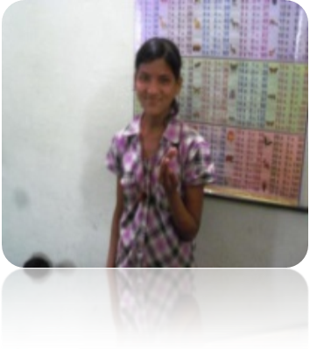
Indu Kumari
REC Student
REC Majhoulia
Age: 12 year
Father: Mr. Ashok Kumar
Mother: Ms. Kangana Devi
Our teacher loves us very much. We can learn our lesson easily. Because she teaches us well.

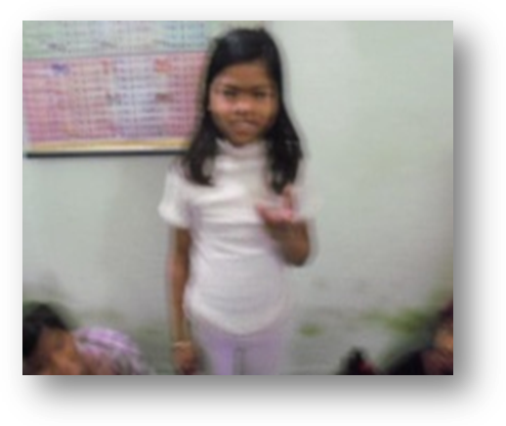

Anjali Kumari
REC student
REC Aghoria Bazar
Age: 10 year
Father: Mr. Jayshankar Mahtoo
Mother: Ms: Anita Devi
There is no school in our locality. We have got the scope to study for establishing REC center. We feel well to read in this center. Our teacher is nice. We can dance and sing here.

Pinki learns to learn!
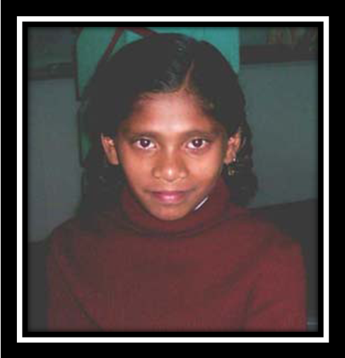
Pinki is an 11 year old bubbly girl with moderate to severe CP. But this wasn't the case initially. When our field workers identified her, Pinki had no mobility and was in a lying down position all the time. Our teacher admits her at RE centre and tie- up with district disability rehabilitation centre Muzaffarpur. After regular therapy, her mobility has improved and she was able to go to school. The rehabilitation team then started working with her using AAC (Augmentative Alternate Communication Chart) and her communication improved tremendously. The communication methodology was taught to her parents, friends and teachers. With this, her learning improved largely. She is now in Std. III at her nearby school. She is taking once a week to the RE centres at Majhoulia where she essentially gets to interact socially. With all these developments, Pinki is a motivated and happy child. She is also one of the most regular students at our centre.

Success Story:- 2
Name: Jyoti Kumari
Age: 14 years
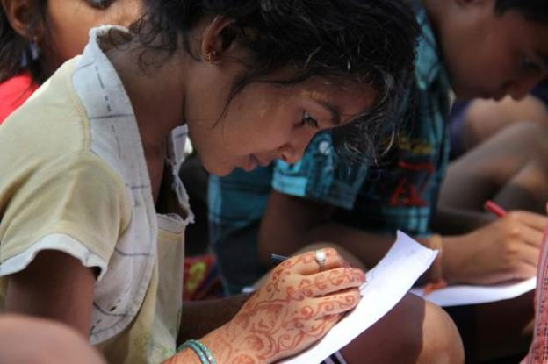
Jyoti Kumari was a school drop-out. Jyoti is currently studying in class-V at Radha Devi Middle School. Her father Manoj Pandit is a daily wage earner with monthly income of around Rs 2000.She has 2 brothers and 1 sister. She had dropped out of school due to financial difficulties. Nari Nidhi had started project – Improving access to basic education for children with special needs where a Remedial Education centre was established in the Akharaghat slum. Jyoti joined the RE centre where she studied for 3 hours daily .Seeing her dedication and commitment, the centre teacher gave her coaching even after the classes were over. Jyoti is a brilliant student who was given admission in the higher class -5 after clearing merit test. Now she is in class- 5th and is a role model for her community members. Her parents are proud of her and no longer stop her from studying.

PICTURE ZONE

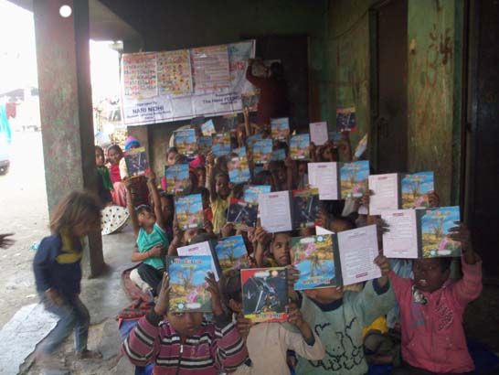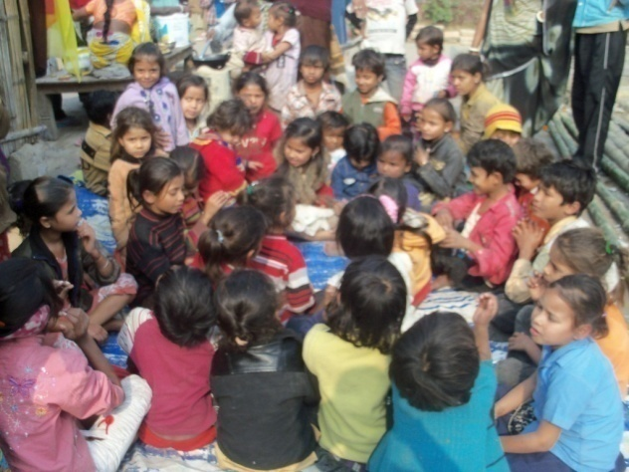
Joy full learning Participated in children club meeting
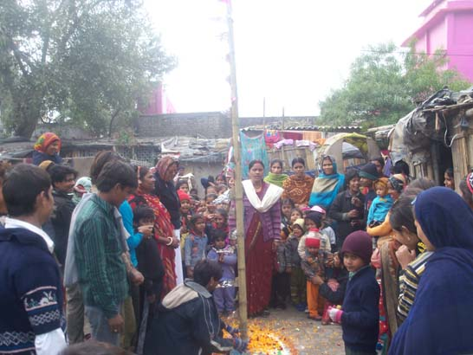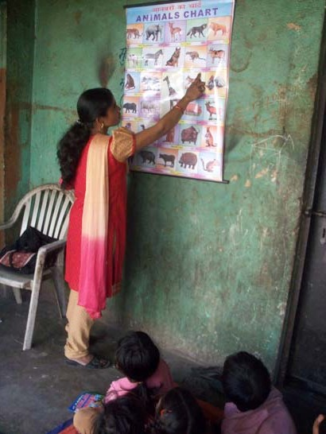

Republic day celebration Class room activity

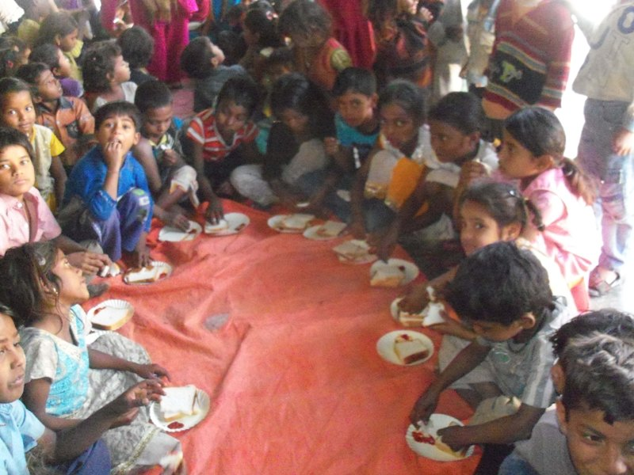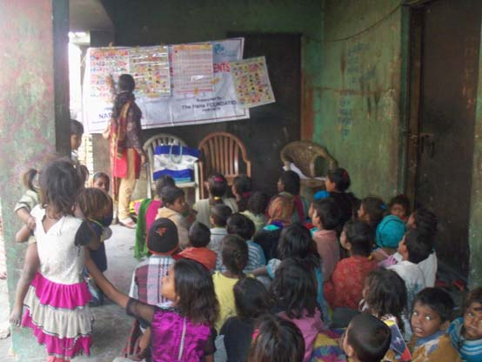

Supplementary nutrition feeding Class room activity

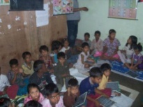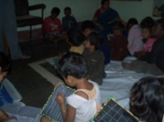
Class room activity Class room activity
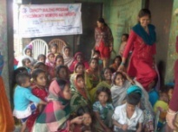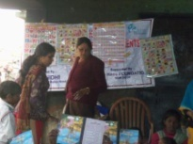

Pupil, Parents and teacher meeting Distribution of learning materials

EXPOSURE TRIP OF STUDENTS TO VAISHALI

