Thank you for supporting ICARE’s Community Work
Kind people are rare and we, at ICARE are glad to know you
The magnitude of the problem of blindness in the developing world is staggering. Most developing countries are now challenged with a huge backlog of blinded citizens. India has perhaps the largest blind and potentially blind population in the world.

2018
ICARE
ICARE Eye Hospital, Noida
6/7/2018

Problem Statement
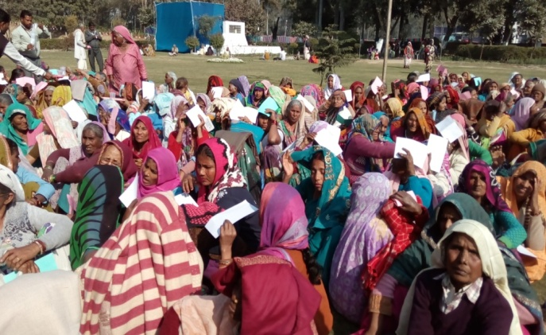
India, with 29 states and seven union territories, has a combined population of a little more than one billion and represents about one-sixth of the world's population. India has more blind people than any other country in the world. Of the 45 million blind people worldwide, Indian citizens number 12 million, 1 million of whom are children. India carries a significant proportion of the world's blindness and visual impairment, with nearly 6.7 million blind people.

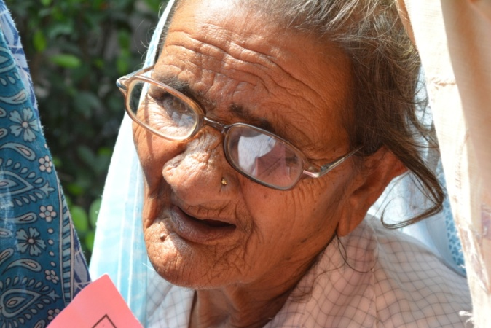
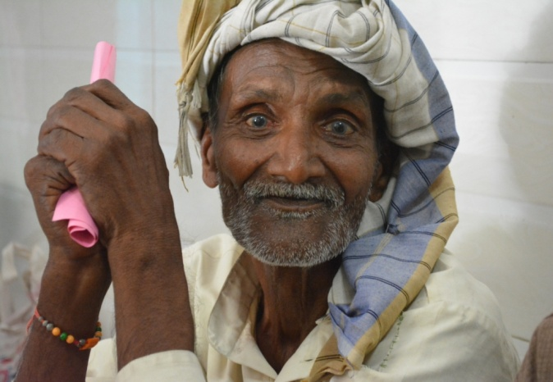
Considering the fact that almost 70 percent of blindness is curable, these numbers speak volumes for the poor infrastructure and facilities available in the eye care sector in the county, leading to a very large un-served population. The loss of productivity, as a result, is huge for India – the cost of blindness in the county equals US$ 3 billion annually. The situation in North India in general and Uttar Pradesh in particular is even more dismal. The state has a 1.15 percent prevalence of blindness. A closer look at the causes for this high rate of blindness - cataract (73 percent); refractive errors (9 percent); glaucoma (8 percent); corneal opacity (1 percent); surgical complications (2 percent); others (8 percent) – clearly indicates that with adequate eye care facilities and infrastructure this blindness is preventable and curable and will add considerable amount of GDP to the country, by restoring vision of preventable blindness of the country.

To address this huge gap in ophthalmic services for the poor, Ishwar Charitable Trust (ICT) was established in 1982 by Dr. Sushil Choudhry in the name of his Late. Mother Smt. Ishwar Choudhry. ICARE Eye Hospital was established in 1993 in Noida under the ICT for providing free of cost eye care services to rural/urban underprivileged communities in the National Capital Region (NCR).

Types of Blindness
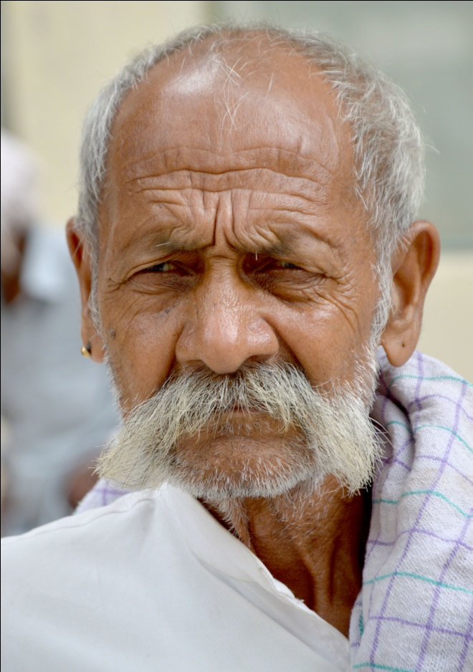
Economic Blindness: Inability of a person to count fingers from a distance of 6 meters of 20 feet technical definition.
Social Blindness: Vision 3/60 or diminution of filed of vision to 10 degree
Absolute blindness: No perception of light
Manifest Blindness: Vision of 1/60 to just perception of light
Curable Blindness: The stage of blindness where the damage is reversible by prompt management e.g. cataract
Preventable blindness: The loss of blindness that could have been completely prevented by intuitions of effective preventive or prophylactic measures e.g. exophthalmia, trachoma and glaucoma
Barriers prevent both women and men from receiving surgery and they are often more problematic for women. They include:
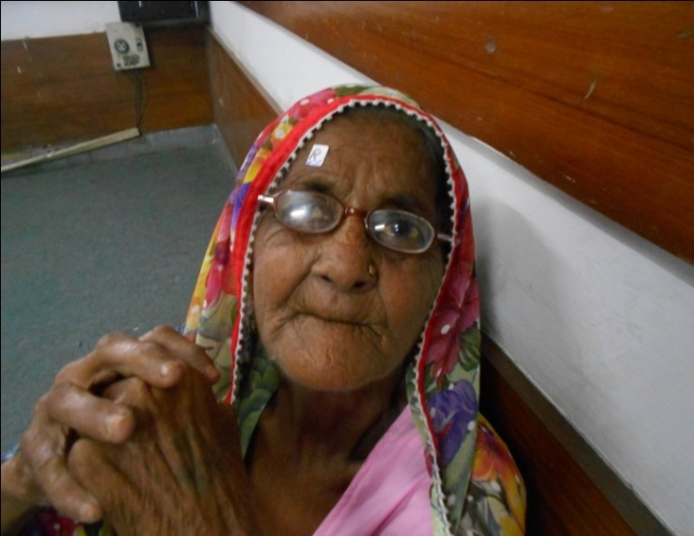
- Cost of surgery: Women often have less access to family financial resources to pay for eye care or transportation to reach services.
- Inability to travel to a surgical facility: Have fewer options for travel than men. Older women may require assistance, which poor families cannot provide.
- Differences in the perceived value of surgery: Cataract is often viewed as an inevitable consequence of ageing and women are less likely to have social support in a family to seek care.
- Lack of access to information and resources: Female literacy is often lower than male, especially among the elderly. Women are less likely to know about the possibility of treatment for eye disease or where to go to receive it.

Case studies
Patient Name – Asgar Husain
Father Name - Bashir Ahmad
Age -60 years
MRD No- C041517
Operated Eye – Right eye Cataract with IOL
Village- Chandpur, Bijnore, Uttar Pradesh

Asgar and his family lives in village Chandpur, Bijnore, Uttar Pradesh .He has a joint family with brothers staying together and working as farmers. The source of income only comes from irrigation. Asgar was complaining of low vision and went to the mukhiya’s house for help. The mukhiya guided him to visit ICARE organized eye camp which happens weekly in their village. Asgar went to the eye camp where the doctor diagnosed him and found him suffering through cataract which needed urgent attention. Asgar told the counsellor, to which the counsellor told him that the surgery would be done free of cost and need not to pay anything. Asgar was brought to the base hospital in ICARE’s ambulance for the further treatment. After a comprehensive eye checkup, a surgery was performed on his right eye to remove the cataract with Intraocular lens implant successfully. Asgar rejoined his work after the surgery and now is a happy person.

Patient Name: Chander Wati
Husband name - Dal Singh
Age : 65
MRD : C044709
Operated Eye – Right eye Cataract with IOL
Address : Village Veerpur, Bulandshahr, UP
Chander Wati Singh is 65 year woman Village Veerpur, Bulandshahr, UP. She got a paralytic attack a year back, while recovering from the attack she complaint of low vision to his children. Her eldest daughter-in –law took her to ICARE organised eye camp which happened in the village. The team at the camp diagnosed cataract in her right eye, counsellor assured that the treatment will happen free of cost. Chanderwati, was happy to hear that the surgery would be free, as she knew that her son could not afford the treatment cost due to poverty. She underwent a detailed check up followed by surgery. Her vision got restored, she is very happy as she can be an useful member of the family.

