Phoolwati regained sight and hope to live her dreams again
Name of Patient : Phoolwati
Husband’s name: Pooran
Age: 65
Gender: Female
MRD # C042356
Address – Village Ransida, Ujina, district Mewat of Haryana, India

Phoolwati is a 65-year-old woman who lives in village Ransida located in Ujina, district Mewat of Haryana, India. She lives with her husband and their extended family.

She works as a daily wage worker along with her husband in a factory and her son works as a carpenter. Together as a family they could afford most things they needed, and they were living a happy life. Then one day, Phoolwati started to have blurred vision in both her eyes. She had no idea what was happening. After some time, she was unable to see things in the distance, and her vision was only getting worse.

Phoolwati began to fear for herself and deteriorating vision problem. She worried that she would eventually become a burden to her family. Her family also felt helpless. They had no idea how to help Phoolwati, and they started to fear for her as well.

But then a wonderful thing happened – Phoolwati heard of ICARE’s organising an eye in their village from one of the fellow villager. On 7th March’18 at the eye camp organized by ICARE, Phoolwati was the first person standing in the queue to get her eye examined; it didn’t take long for the doctor to diagnose Phoolwati with bilateral cataract. After some counseling about cataracts and the required treatment, she was still worried about the cost.

But the counsellor assured her that the treatment would be free! And all thanks to the incredible generosity of GlobalGiving!

This news was like a dream come true to Phoolwati! And when she discussed undergoing treatment with her family, they were so happy that they lent her their wholehearted support!. After his family’s approval, she boarded the ICARE’s ambulance for reaching the base hospital for her treatment. On examination, presence cataract was found in both the yes but left eye was more matured than the right eye. She was operated for cataract with IOL in her right eye on 8th March’18 from 1/60 her vision improved to 6/12 with no complications.

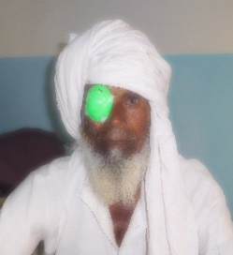
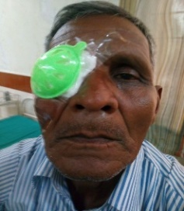
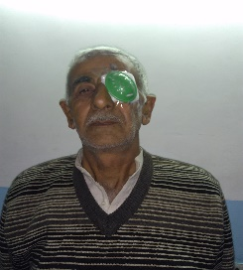
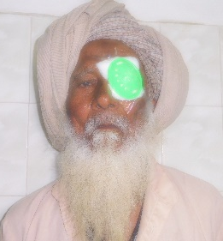
PHOTOGRAPHS OF THE BENEFICIARIES

DURGA PRASAD (1) ABDUL (2) SHERU (3) KHURSHID (4) SHAMSUDEEN (5) HOM SINGH (6) HARSAIYA (7)
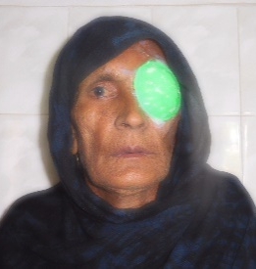
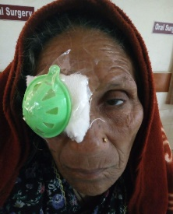
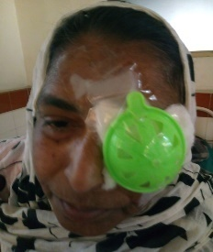
FEMIDA (8) SHARDA RAM (9) HASAN MOHD (10) ANAT RAM (11) ANWARI (12) NOOR JAHA (13) SARBARI (14)
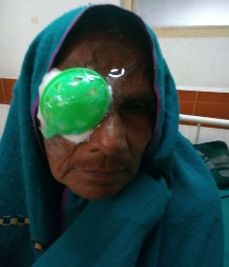
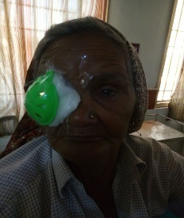
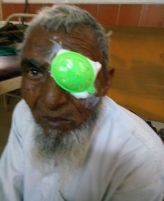
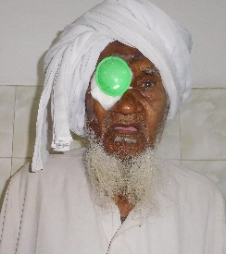
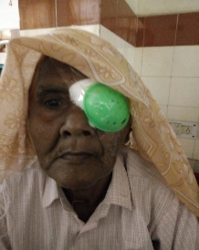
NANAK (15) HOTI LAL (16) AMNA (17) NOORI (18) PHOOL WATI (19) PARMO (20) SAHIDAN (21)
RAZAQ (22) MEHRU (23) HAMIDA (24) DEEN MOHD (25) KHURSHID (26) RISAL (27) SAHMUDI (28)
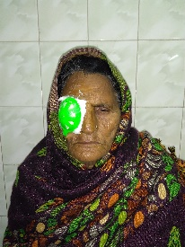
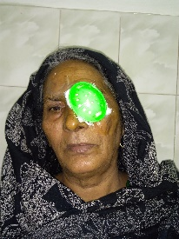
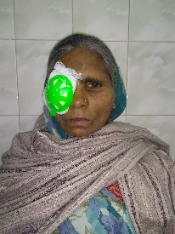
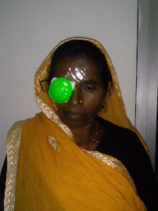

HAMIDI (29) HAZRA (30) CHANDER WATI (31)KOKA (32)

LIST OF PATIENTS OPERATED FOR CATARACT SURGERY
AT
ICARE EYE HOSPITAL & POSTGRADUATE INSTITUTE
S.NO | MRD No. | Patient Name | Age (Yrs) | Gender | Address of Patient | Date of Registration of Patient | Date of Surgery | Type of Eye Surgery (L/R/Misc.) | Pre- Operative | Post-Operative
1 | C042248 | DURGA PRASAD S/O BASU DEV | 50 | M | BHIKAMPURA, BADALPUR | 27.02.2018 | 01.03.2018 | RE SICS + PCIOL | FCCF | 6/18
2 | C042268 | ABDUL S/O SUMER | 55 | M | 15B, VILL-CHILLA, UJINA | 28.02.2018 | 01.03.2018 | RE PHACO + PCIOL | 4/60 | 6/18
3 | C042269 | SHERU S/O HIMMAT | 65 | M | 28-BICHONDYA, UJINA | 28.02.2018 | 01.03.2018 | LE SICS + PCIOL | 6/60 | 6/12
4 | C042270 | KHURSHID S/O RAMJAN | 62 | M | SHAJADPUR, UJINA | 28.02.2018 | 01.03.2018 | LE PHACO + PCIOL | 5/60 | 6/18
5 | C042271 | SHAMSUDEEN S/O IDDU | 57 | M | KHILLAKA, PALWAL, UJINA | 28.02.2018 | 01.03.2018 | RE SICS + PCIOL | 1/60 | 6/9
6 | C042274 | HOM SINGH S/O BANSHI SINGH | 60 | M | NAHARI, UP,ANUPSHAHR | 28.02.2018 | 01.03.2018 | LE SICS + PCIOL | 2/60 | 3/60
7 | C042275 | HARSAIYA S/O PATTAN | 65 | M | AATNI, BULANDSHAHR,ANUPSHAHR | 28.02.2018 | 01.03.2018 | RE SICS + PCIOL | 3/60 | 6/12
8 | C042276 | FEMIDA W/O HABIB | 60 | F | JHAGIRABAD,ANUPSHAHR | 28.02.2018 | 01.03.2018 | LE SICS + PCIOL | PL+PR | 6/12
9 | C042288 | SHARDA RAM S/O HARPAT | 60 | M | DABHUVA, SOHNA,HARIYANA | 05.03.2018 | 06.03.2018 | LE PHACO + PCIOL | 5/60 | 6/24
10 | C042289 | HASAN MOHD S/O TAJ MOHD | 65 | M | CHAHLKA, HARIYANA | 05.03.2018 | 07.03.2018 | LE SICS + PCIOL | FCCF | 6/12
11 | C042290 | ANAT RAM S/O DURGA | 66 | M | NAGLI, GURGAON, HARYANA | 05.03.2018 | 06.03.2018 | RE PHACO + PCIOL | 6/60 | 6/12
12 | C042292 | ANWARI W/O FAIYAZUDEEN | 40 | F | RUSTAMPUR, CHANDPUR, BIJNOR | 05.03.2018 | 06.03.2018 | RE SICS + PCIOL | FCCF | 6/12
13 | C042296 | NOOR JAHA W/O ABDUL HAFIZ | 60 | F | PIPALI,CHANDPUR, BIJNOR | 05.03.2018 | 06.03.2018 | LE SICS + PCIOL | 1/60 | 6/36
14 | C042297 | SARBARI W/O MOHD UMAR | 60 | F | PIPALI,CHANDPUR, BIJNOR | 05.03.2018 | 06.03.2018 | LE PHACO + PCIOL | 6/36 | 6/18
15 | C042299 | NANAK S/O GANGA RAM | 60 | M | AKHTIYARPUR,CHANDPUR, BIJNOR | 05.03.2018 | 06.03.2018 | LE SICS + PCIOL | HM | 6/18
16 | C042049 | HOTI LAL S/O GHAN SHAYAM DAS | 65 | M | ANUPSHAHR, UTTAR PRADESH | 06.03.2018 | 07.03.2018 | LE PHACO TRAB + PCIOL | 3/60 | 6/12
17 | C042354 | AMNA W/O FAZRU | 60 | F | TAI, HARYANA | 07.03.2018 | 08.03.2018 | RE PHACO + PCIOL | 6/60 | 6/12
18 | C042355 | NOORI W/O MOHD UMAR | 65 | F | BHIMA,HARYANA | 07.03.2018 | 08.03.2018 | LE SICS + PCIOL | FCCF | 6/24
19 | C042356 | PHOOL WATI W/O POORAN | 65 | F | RANSIDA,HARYANA | 07.03.2018 | 08.03.2018 | RE SICS + PCIOL | 1/60 | 6/12
20 | C042357 | PARMO W/O TIKAM | 62 | F | NAUGAVU, ALWAR,HARYANA | 07.03.2018 | 08.03.2018 | LE PHACO + PCIOL | 5/60 | 6/18
21 | C042358 | SAHIDAN W/O BASSIR | 60 | F | MALAI,HARYANA | 07.03.2018 | 08.03.2018 | RE PHACO + PCIOL | 6/60 | 6/12
22 | C042359 | RAZAQ W/O MUNSHI | 60 | F | TEKLI,HARYANA | 07.03.2018 | 08.03.2018 | RE SICS + PCIOL | 5/60 | 6/9
23 | C042360 | MEHRU S/O ISHAB | 65 | M | GAUVALOA, ALWAR,HARYANA | 07.03.2018 | 08.03.2018 | RE SICS + PCIOL | 2/60 | 6/9
24 | C042362 | HAMIDA W/O FAJRU | 60 | F | GHTMIKA,HARYANA | 07.03.2018 | 08.03.2018 | RE SICS + PCIOL | HM | 6/12
25 | C042363 | DEEN MOHD S/O SUBRATI | 60 | M | MALAU, NUH | 07.03.2018 | 08.03.2018 | RE PHACO + PCIOL | 6/60 | 6/60
26 | C042364 | KHURSHID S/O RAHIM SHA | 60 | M | CHAISA, PALWAL,HARYANA | 07.03.2018 | 08.03.2018 | LE SICS + PCIOL | 3/60 | 6/9
27 | C042366 | RISAL S/O UMRAO | 80 | M | UMRI, NUH,HARYANA | 07.03.2018 | 08.03.2018 | LE SICS + PCIOL | 4/60 | 6/9
28 | C042369 | SAHMUDI W/O NOOR MOHD | 60 | F | TAI, NUH,HARYANA | 07.03.2018 | 08.03.2018 | LE SICS + PCIOL | 2/60 | 6/18
29 | C042371 | HAMIDI W/O SAHJAD | 60 | F | TAI, NUH,HARYANA | 07.03.2018 | 08.03.2018 | RE SICS + PCIOL | 3/60 | 6/12
30 | C042372 | HAZRA W/O NAWAB | 60 | F | HATIN, PALWAL,HARYANA | 07.03.2018 | 08.03.2018 | LE SICS + PCIOL | FCCF | 6/18
31 | C042374 | CHANDER WATI W/O KISHAN LAL | 70 | F | BHOBRA, AMROHA,ANUPSHAHR | 07.03.2018 | 08.03.2018 | RE SICS + PCIOL | PL+PR | 6/24
32 | C042375 | KOKA W/O BADAM SINGH | 70 | F | KORAKA, BADUL,ANUPSHAHR | 07.03.2018 | 08.03.2018 | RE SICS + PCIOL | 6/60 | 6/36

