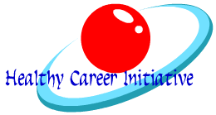
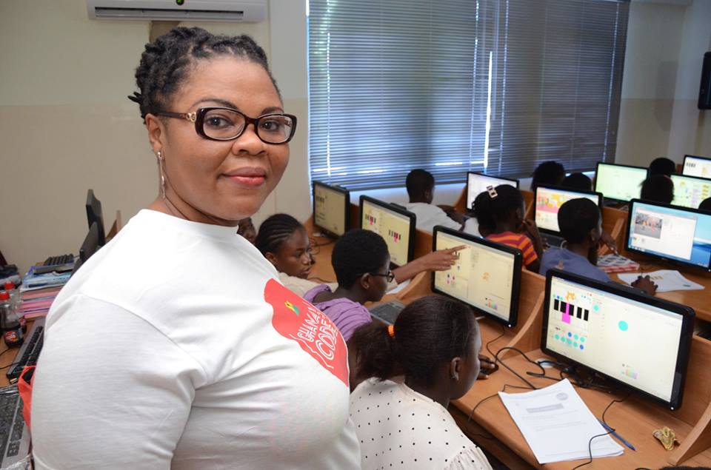
Ghana Code Club! Empowering the future generation with the right skill set to create technology!
Project Plan
Ernestina Edem Appiah
Founder &CEO Healthy Career Initiative
www.ghanacodeclub.org
www.facebook.com/ghanacodeclub
www.twitter/com/ghanacodeclub

Project Abstract
The Healthy Career Initiative, in Accra, Ghana is seeking funding to establish training center(s) and also expand our after school coding club network. Our objective is to equip school children with basic programming skills so that they can create awesome projects in technology. Our goal is that by the end of each academic year, at least a 20,000 students may have undergone the training process and then hopefully, they will patronize other digital making activities as they proceed in life so that, those who wouldn’t be able to continue to tertiary institutions may still end up with skill set for the workforce. The Ghana Code Club concept is based on the advocacies going on worldwide about why children must be empowered with digital skills at an early age. We need Funding in the amount of $100,000 to purchase hardware devices and distribute to participating schools and also to establish our training center and equip it with devices making it possible for us to reach out to more children nationwide. Program will be sustained through fundraising. We intend to raise these funds in bits to tackle each problem at a time.

Statement of Need

There’s the need for such a digital making fun club in Ghana because technology is reinventing the world meanwhile the Ghana Kids are not exposed to any digital making activities. Knowing that digital skill set is going to be a requirement in future work force, action to empower children now with digital skills is a must. Yes, it is our responsibility to equip future generations with the skill set they need to thrive in the 21st century workforce. Tomorrow’s analysts, social entrepreneurs, developers, architects, designers, engineers, virtual teachers, etc. need our help today to accelerate and nurture economic development in the fastest growing continent in the world.

In order to prevent the digital divide from becoming a digital skills divide and to improve Africa’s position in the globally competitive knowledge economy, we need to join forces and make high-level ICT teaching a number one priority within the African education systems. Not only will it allow companies in Africa to find the best local candidates for the thousands of qualified jobs they are currently struggling to fill, but ICT learning is also one of the most powerful ways to develop the collaboration, self-regulation and critical thinking skills young women and men need to sustain a successful career. Everyone, from governments and educational institutions all the way to NGOs and corporations - has a role to play to make it happen.

Program Description

The HCI is giving the opportunity for every child in Ghana School to try their hands on coding. Coding has become a language for the future and every child deserves to become fluent. We have designed a step by step project guide in 3 different computer languages that will help equip the child with enough skill set. The project guide gives teachers and even students the greatest flexibility in understanding the coding concepts better.
Our projects will be supervised by our volunteer network or trained ICT teachers at each center. At the end of each academic year, members of the code clubs will be able to create websites, create interactive stories, and make their own games. The languages used are the Scratch language, HTML+CSS and Python language. Each language is to be taught in a term or 3 months. The software used can be downloaded and used offline that suits us perfectly due to lack of internet services in about 99% of schools in Ghana. All the teachers need to do is to follow our instructions, install the software and take our training courses online to be able to supervise children.

Scratch Software (Language 1)

With Scratch, you can program your own interactive stories, games, and animations — and share your creations with others in the online community.
Scratch helps young people learn to think creatively, reason systematically, and work collaboratively — essential skills for life in the 21st century. Scratch is a project of the Lifelong Kindergarten Group at the MIT Media Lab. It is provided free of charge.

HTML + CSS (language 2)

The HTML and CSS are used for web development. Close to everything we see on the internet are is a combination of HTML, CSS and Javascript. Even some apps on iOS and android are made with them. Web browser is a universal app that everyone has. HTML, CSS and Javascript are the language of the web and the web browsers. Moreover, HTML, CSS and Javascript are open source meaning they don’t require any pluggin to run them. Very perfect for kids to learn about web development.

Python (Language 3)

Python is a widely used, general purpose, text-based programming language.
References

http://scratch.mit.edu
http://cs-first.com
http://codeacademy.com

Goals & Objectives

Our goal is to inspire a lot of children to build and share their ideas, learning along the way. We want children to leave Ghana Code Club inspired to pursue technology, whether that’s in their spare time, in school or as a career.

We want them to gain skills that are useful to them - not only learning to program, but also learning about computational thinking, problem solving, planning, designing and collaboration
OBJECTIVES:
•Provide free training sessions for volunteers or teachers to teach children between the ages of 8-18 to code for free in Ghana.
•Empower and equip children with free tuition on basic programming skills as a healthy career choice for the 21st Century.
•Create after school fun clubs in basic schools and provide free project materials and a volunteer framework
•Empower future entrepreneurs, innovators, critical thinkers and problem solvers in Ghana
•Establish Computer Labs all over Ghana to serve as training centers and an after school coding club for the less privileged children.
Budget
Our budget includes funds for the purchase of hardware which includes complete set of Arduino and raspberry pi’s to be distributed to participation schools, computer sets & accessories, printouts, development of project guide, training materials, projectors, printers, photocopiers, scanners and rent for a computer lab.
Item | Price(USD) | Quantity | Total
Raspberry Pi | $45 | 100 | $4500
Computer & accessories | $800 | 50 | $40,000
Color Laser Printer | $800 | 3 | $1500
Scanner | $300 | 1 | $300
Photocopier | $1200 | 1 | $1200
Furniture(tables & chairs) | $150 | 50 | $7500
Projector & accessories | $1200 | 1 | $1200
Air conditioner | $2000 | 1 | $2000
Office space rent | $4000 | 5 | $20,000
Promotional materials | $20 | 5000 | $10,000
Video training production cost | $3000 | 1 | $3000
Back office development | $2000 | 1 | $2000
Miscellaneous | $6800 | 1 | $6800
Total |  |  | $100,000

Evaluation
There would be coding competitions each year organized to determine the performance of each child.
Staff and Organizational Information
- Ernestina Appiah, Founder and CEO of Healthy Career Initiative, has an in-depth knowledge in computer science. She graduated from Code Academy USA and has extensive experience working and serving clients globally online. She has a passion to create fun activities for school children through learning to code and was responsible for implementing the successful pilot test program in 10 centers during Africa Code Week Celebrations in 2015 where she was the ambassador from Ghana. She is proficient with learning technology, including computer hardware and software.
- Peter Aforo, Program coordinator and trainer is a software engineer. Peter has been the head of Learning and Development unit at Accra Institute of Technology. He has also been the IT Manager at AGAMS Holdings. Peter studied and graduated with BSC Computer Science from the Valley View University.
- Alberta Obeng is an IT Consultant at Vivacom Ltd, and will be responsible for coordinating participation with classroom teachers. She holds a masters degree in computer science
- Shadrach Agyiri is a consultant at the University of Ghana Legon. He holds a BSC in computer science and works with 2 children

