PROJECT PROPOSAL COVER SHEET

Project Title: Provide the Electricity Water Color for the 4 Girls Schools (1.GG MAIN PRIMARY SCHOOL THARO SHAH ,2.Dharti Public School Village Gul Mohammad Shar ,3-GPS Gul Solangi. Dharti Public Schools Village Akber Machi Uc Mubhat Dero) Dist Naushero Feroze Sindh Pakistan
Applicant
Name of Organization: DHARTI DEVELOPMENT FOUNDATION (DDF).
Registration No SK/1641 OF 2008-2009
PCP Registration No: PCP/2013/286
NTN : 4140619-2
Mailing Address: Near Bahiria Collage Sial Abad Road Mehrabpur District Noushero Feroze Sindh Pakistan
Physical Address: Same
Telephone: 0331-3674499--0300-3514216
Fax: _______E-Mail: dhartifkhp@yahoo.com, dhartifkhp@gmail.com
Principal Officer: AINI TAHIR RAJPUT ( Chairmen)
(Name and Position)
Project Contact: _Jinsar Hussain ( Chief Executive)
(Name and Position)
Project
Road TO JANNAH SGP Thematic Area: Water
Proposed Starting Date: 25 December , 2017
Proposed Project Duration: 2 Months. 25 December , 2017 to 25 February -2018
Finances
Total SGP Request: [local currency] 186000 (1682.)
Total from Other Sources: [Local currency] 0/= (£ 0)
Total project cost : [Local currency] 186000 (1682)
Exchange Rate : 107 PKR

Section A.

1.0 PROJECT PROPOSAL OUTLINE AND CONTENT

1.1 Project Summary (1 page)
The projects strive at providing safe drinking Cold water to 4 Schools of Dist Nausheo Feroze at this time the heat is day by increase specially in the Dist Naushero feroze temperature is very high maximum daily base 48 to 52 temperature schools is run in this heat so heat alternative is cold water so Dharti Development foundation asses the Dist Naushero Feroze 4 Schools is select this school run daily base and student strength is daily base increase but due to shortage of safe drinking water many problem is create in the schools Dharti Development foundation with the support of Road to Jannah the installation of water cooler in those
GG Main Sindhi Primary School Tharo Shah SEMIOS Code-416010306 This school in the city of tharo shah in this schools total 250 girls is enrolled and 16 teachers daily base 230 to 240 girls is regular attend the class at this time temperature in Sindh is very high so need of cold water to children
Dharti Public School Gul Mohammad Shar (SEMES CODENEWSAS004) THIS Schools in village Gul Mohammad Shar in this schools 265 Total children 125 Boys and150 girls is register daily base 180 to 200 boys & girls attend the schools this school is elementary in this school run 1 to 5 class at this time 7 teacher . daily base
GPS GUL Solangi (SEMES CODE-41605007) this school is in the village GUL Solangi at this time in this school 281 boys children is read the education daily base 140 to 200 children is come to school at this time 6 teacher is run the school . in this school water facility is available but this water is not cold due to high temperate in area so need of cold water
Dharti Public School Village Akber Macahi UC Mubhat Dero) This school is run Dharti Development foundation free of cost at this time 221 boys and girls is enrollee daily base 190 to 200 children come to school. Village akber machi is very poor village and this village no any govt. school and all the Govt. school is 2 kilometer away from the village so in this village not gate the primary education so Dharti Development foundation start this schools at this time 221 children benefited

Dharti Development foundation is request to Global Giving For electric water coolar at this time very need of this schools and electricity is available in this schools

1.2 Organizational Background and Capacity to implement the project (1 page)
DDF is established non-profit, no religious and social organization 2008 and registered under the Societies Act 1860, since 2009. And Dharti Development foundation is PCP Certified organization PCP NO PCP/2013/286With a strategic vision of promoting Peace and inter faith harmony among the various communities of Sindh, DDF is working in Sindh districts on various development initiatives in order to assist the communities in Health, Education, Women rights awareness, women skill development, Fighting Poverty, Agricultural Development, Enterprise rural development program, Water Sanitation, Health and Hygiene (WASH) and leadership development.
DDF has a vast institutional expertise and experience, extensive grass roots linkages and community presence in various Areas of Sindh namely Tando Muhammad khan, Khairpur Mirs Khuda bux Soomro, Mirpurkhas, Sanghar and Naushero Feroz.
Dharti Development Foundation was formed by some social activists of District Khairpur Mirs &Naushero Feroz who came together by a common objective of promoting development in under-developed areas. Dharti is a local Sindhi language word which means earth. So the organization basically envisions to work for development of earth and its inhabitants including the environment. Local funding support was initial support through which the organization started different small initiatives for its constituents. With active and participatory social mobilization approaches, Dharti has made its inroads within the communities it wanted to work. Together with these communities, the organization has also set up its program priorities, which include fighting Education, poverty, water & sanitation, human development and agricultural development. The targets groups of Dharti include the poorest of the poor communities in primarily in the districts of , Naushero Feroz and Khairpur Mirs. It works with a holistic development approach in its target areas. However, Dharti does want to extend its work to other areas.
The15 member’s general body elects the board of directors/executives which currently stands at 9 people in strength; of the organization consist of mainly young enthusiast and professionals who are full of zest for community development through their activities
In the last 6 years since its registration, the organization have implemented projects in the areas of human rights, child rights, women empowerment and equity, rehabilitation and disaster recovery, Health and education, Water and Sanitation as well as education and community empowerment. Few of the projects that we have implemented in the recent past are given below,
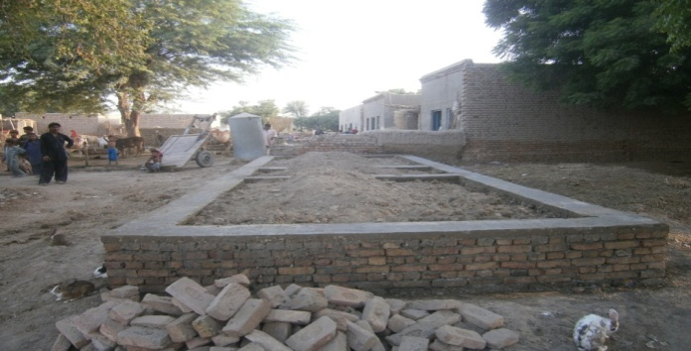
Supervision of Low Cost Housing @ Dist. Naushero Feroze
Dharti Development foundation is worked on the Supervision of low Cost Housing in Dist Naushero Feroze and Khairpur Mirs with the Coloration of PEACE, and Shah Latif Rural Development Organization , Dharti Development Foundation has provided the following service to SBBHC Karachi on its Low Cost Housing Units.
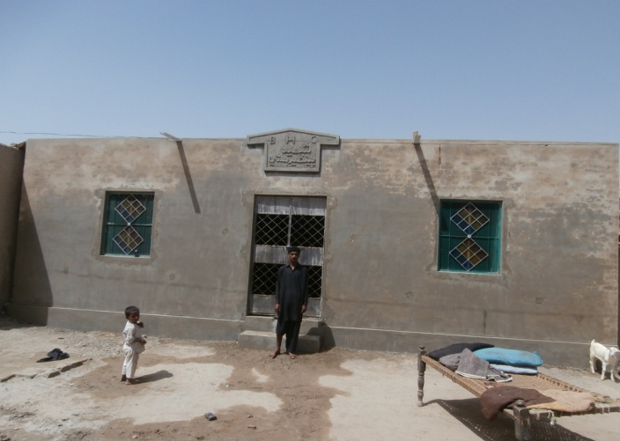
- Social Mobilization of the Community.
- Training of local peoples as masons and skilled persons.
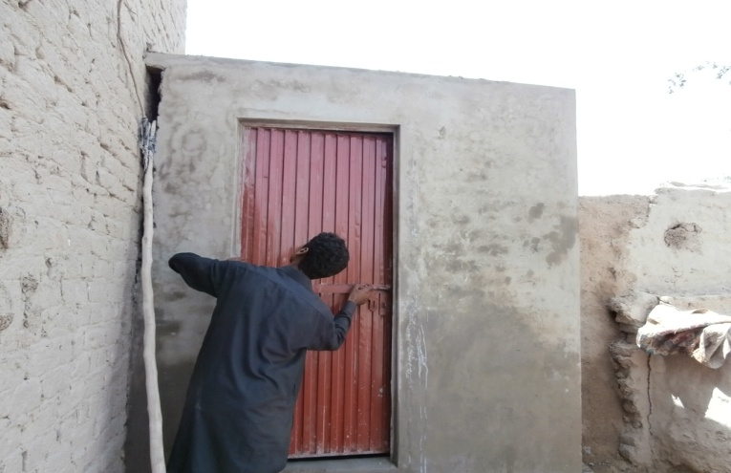
- Disbursements of the funds to the beneficiaries.
- Technical Assistance to the beneficiaries for construction of Low Cost Housing Units.

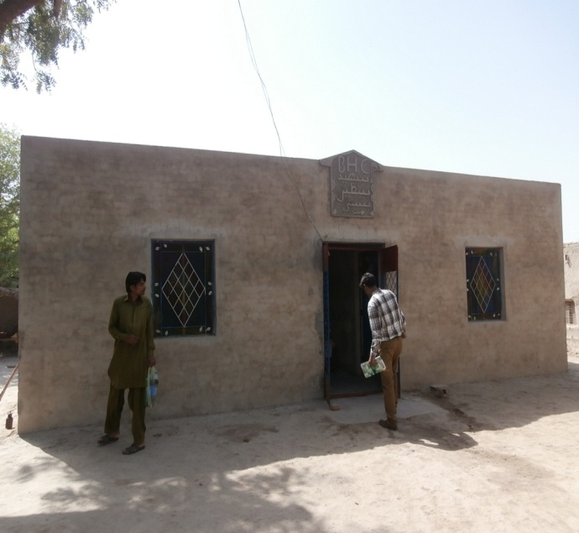
at this time Dharti Development foundation is complete 81 House and Feasibility 56 house Dharti Development foundation is conduct feasibility and over all supervision of the work and DDF team is work on the House is very good Quality

Adopt School Project Construction of the Building of the Three Govt. School at Dist Naushero Feroze With the Support of Muslim Charity UK.

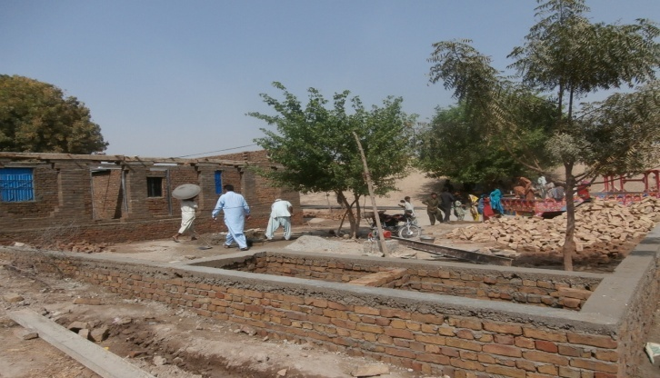
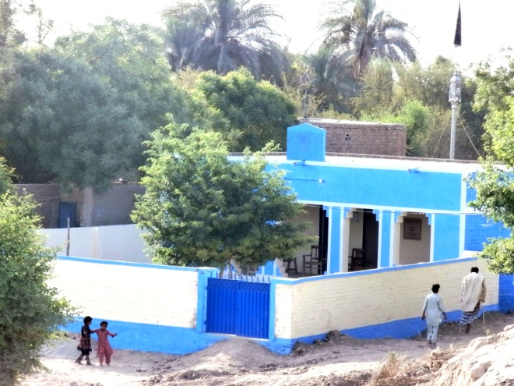
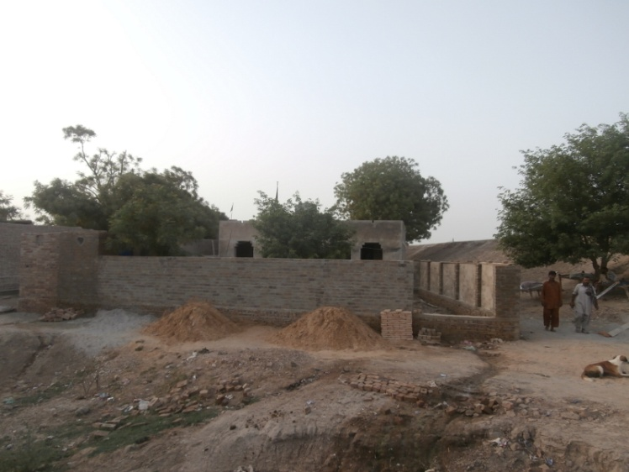
Dharti Development foundation is working on Different Sectors and Specially Focus for the Development of the poorest community of the sin dh Province so DDF is see the Education Missing Facility of the Govt. School many schools is not Drinking water facility and many Schools is not Furniture and 35 school is not Building in Dist Naushero Feroze these school is run very Best and Children enrolment is above 100 and children is read in open sky so Dharti Development foundation with the Support of the Muslim Charity Uk Construction of the Three school Building in Dist Naushero Feroze AT this time one School Building work is complete at GPS MIX Budhal khan Gopang P/O Dhabero UC abad Taluka Kandiaro in this school building is two room 14 by 16 and one warinda 7 feet 150 feet compound wall two Wash room For boys and Girls separate Electricity fitting and all color project is running construction work is complete but color of school is process

- Monitoring of the 45 BASIC Schools with the Support of BECS Govt of Pakistan
Dharti Development foundation working the Basic Education Community Schools BECS Govt. of Pakistan. In this project DDF supervise the 45 schools monthly base and increase the enrolment of the children
- Safe Drinking Water Installed the 45 Hand pump in the Two village of the UC kotari Kabeer
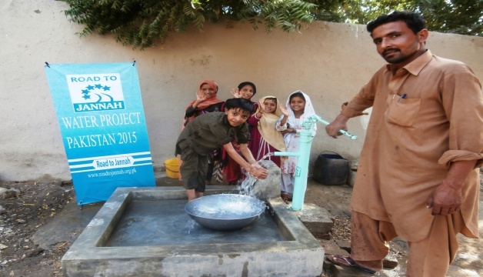
Dharti Development Foundation is working with the international Donor Organization ROAD TO JINNAH UK for the safe drinking water installed the 10 Hand pump in the two village of the Uc Kotari Kabeer in this project 25 families and 180 population is benefited this project Duration is one month Start on the 1 September end is 1 October
- Safe Drinking Water Installed the 300 Hand pumps in Govt Schools and Houses With The Support of Muslim Charity in 2014-2015
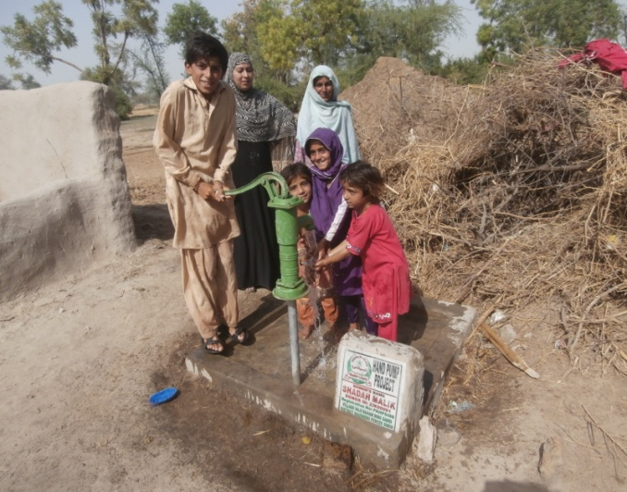
Dharti Development Foundation with the support of Muslim Charity has initiated its project to 300 Installed the Hand pump in Govt. Schools and Poorest houses Holds of Taluka Kandiaro Bhiria .Mehrabpur ,Schools and House Hold Masjid , and Public places Hand pump is installed in Dist Naushero Feroze Sindh. DDF has initiated its activities on WASH to make possible utmost access of Potable water for drinking and essential domestic use of households by installation of new hand pumps,. During the Year 2014 and 2015 Dharti Development Foundation with the support of Muslim Charity UK installed the 300 hand pump and at this time thousands community is benefited from this hand pumps
- At this time 575 houses 3363 population is asses the safe Drinking water for near their houses
- 47 villages of Taluka kandiaro asses the safe Drinking water
- Specially women is very happy and benefited from the hand pump and asses safe drinking water
- 70 Govt. Schools of Taluka Kandiaro asses the safe Drinking water facilities in theirs near asses
- 9160 student male and female is benefited from the hand pump
- Increase the enrolment of the Govt. Schools

- Intergraded Education Learning Program IELP
Dharti Development foundation has worked in River Indus area during flood in the year 2010. DDF has provided Health and Shelter facilities to vulnerable communities. During that time DDF has also conducted survey of village Haji Muharam Sargani, Piral Sargani, Soomar Mullah, and found no provision of education in the area, there were only male government schools while people were reluctant to send their girl children to boys schools. DDF mobilised people in the villages and agreed to send their girl children to schools if DDF could provide special Girls Schools. So DDF processed application in the bid of Sindh Education Foundation in IELP program, while these were given to individuals rather than an organization. So DDF applied through its General body member Mr. Waheed Ali and opened three girls’ schools. During start of schools, there were 172 girls students in class KG, and 102 were in second school village haji Muhram Ali Sargani. The agreement of schools has been done on April, 2011. DDF has its role to mobilize people to ensure maximum attendance and reduce drop out ration. And time to time training of teachers.
Village Piryal Sargani Code 60680
Village Piryal Sargani Student Strength year wise
Year | Boys |  |  | Girls |  |  | Total
 | KG | ONE | TWO | KG | ONE | TWO
2011 | 0 | 0 | 0 | 172 | 0 |  | 172
2012 | 5 | 0 | 1 | 226 | 40 | 36 | 308
In village Piryal Sargani School is start with the financial support of Sindh Education foundation. School was initiated on April, 2011 from the KG grade. Building of school is on rent and have 6 rooms and one hall with big ground and latrine .Now this school hase reached to class three .School management has hired 7 teachers and one peon .there are many nearby villages and student are willing to attend school. Student is not charged any single rupees, while SEF also providing books as well. And this village
- Enterprise Rural Development Programme:
The objective of the Rural Enterprise Development Project is to improve employment opportunities and income of rural men and women, and sustainability of targeted local enterprises. Over 75 percent of the people of Sind (excluding Karachi) live in rural areas where agriculture is the primary activity. Lack of access to finance and business know-how, poor infrastructure, inadequate marketing, and poor post-harvest practices are limiting economic development and constraining on-farm and non-farm employment opportunities, thus perpetuating poverty in rural areas. The programme is self-sustainable and funded by DDF and perpetual since September, 2009
Awareness Raising Program about the Immunization and Polio
Sindh is the second most populous province in Pakistan. The PDHS 2006-2007 report estimates Sindh Infant Mortality Rate (IMR) at 81 per 1000 live births (national average is 70/1000 ), and MMR for rural Sindh stands at 320 per 100,000 live births ( national average is 260/100,000) - extremely high and fail to meet MDG 4 and 5 goals to reduce child mortality and improve maternal health respectively. An indicator to monitor progress of these MDG targets is immunization of mothers and children.
Dharti Development Foundation, established in 2008, has played an active role in increasing immunization coverage in rural areas of District Naushero Feroze, Taluka Kandiaro, in Sindh. The villages in Union Council Khan Wahan targeted by DDF are located in the riverain or ‘katcha-land’ area; this is a fertile low lying area around the River Indus and is prone to flooding in the monsoon season. It is a hostile area with high crime and violence rates, and the locals adhere to an unofficial ‘curfew’ – rarely venturing out from dusk to dawn.
- Women’s Rights awareness Sessions.
DDF have always strived for women empowerment and development one example of raising awareness about the Women Rights by the D.D.F on large scale is in 22 villages of Districts of Noushero Feroz is that of “Women Rights Awareness Raising session - which was Funded by CHIRE Pakistan “it was started in September2 011and completed in November 2011. This project was aimed to raise awareness in the people of 22 villages of District Naushero Feroze about the women basic rights in the society and taking various measurements to help achieve the main and basic rights of women of these areas of District Naushero Feroze. The total beneficiaries of this project were 678 people of 22 villages of District Naushero Feroze of Sindh. Public meetings, group discussion, debates and seminars, were held to raise awareness about the women rights in the society.

- Women Skill development Trainings.

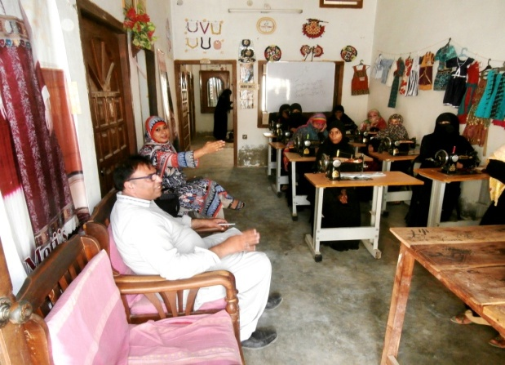
Another example of DDF project that was in respect of women welfare, rights and awareness was the Women Skill Development Program
This program is run since 2008 but at this time 2012 Dharti Development foundation is established the Women Skill Development Program for the women trained in skill development and increase the income generation at this time DDF is 250 female trained in sewing and stitching 4 Month Course in this women DDF is distribute the sewing and stitching Machine for the income generation and livelihood purpose
Accreditation & Membership
Dharti Development Foundation Friend and Partners are as follows:
- Muslim Charity UK
- ROAD TO JINNAH UK
- BASIC EDUCATION COMMUNITY SCHOOLS Govt. Of Pakistan
- Shah Latif Rural Development Organization
- SPO Sindh (Strengthening Participatory Organization
- Orangi Charitable Trust (OCT)
- Orangi Pilot Project(OPP)
- TVO (Trust for Volunteer Organization)
- Pakistan Kisan Ithad
- Action Aid Pakistan
- District Government
- Gender Water Alliances (GWA)
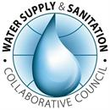
- Church World Service Pakistan /Afghanistan (CWSPA)
- Asian Rural Women's Coalition (ARWC).
- Water Supply & Sanitation Collaborative Council (WSSCC)
- SDIPK Islamabad
- HOPE 87 Islamabad
- CDP Community Program(P&DD Govt. of Sindh)
- National Humanitarian Network (NHN), Pakistan
- Pakistan Centre for Philanthropy ( PCP Certified)
- AWAL TALEEM - Education First Campaign Sindh.
- CSSP Hyderabad
- Sindh Education Foundation(SEF)
DDF‘s focus and experience area are diversified. DDF is in a vital position to explore its existing recourses for the proposed project. There are number of project based consultancy assignments that are been filed from our existing HR database during the project implementation phase. We have internal financial management controls and capacity to monitor and oversee a project of this magnitude and our project execution teams are well equipped and orientated with the geographical area of intervention. Our head office and regional offices presence in the province of intervention is also intensive

- The overall objective of the proposed project, the ultimate vision of the project.

OBJECTIVES OF THE PROJECT:

The project objectives are,

- Provider the Electricity water cooler for the cold water for children

- To increase the students retention ratio at schools by around 30% in the first year of project life by providing the missing facilities.

- To create general awareness among the masses about the importance of basic necessities availability in schools especially at girls schools for quality education and for improved retention ratio of students.
- Increase the Girls ration admission in the model schools

2.2 Projected Expenditures
Expenditure Category | Phase 1, [local currency]if applicable | Phase 2 , [local currency] if applicable | Total, [local currency]if applicable | Dolor Sterling | % Total
Electric Water Color 45 Ltire Canon (Warinity 1 year) | 120000 |  | 120000 | 1121.495327 | 1121.495327
Straplizer | 18000 |  | 18000 | 168.2242991 | 168.2242991
Tanks for Water 120 litres | 8000 |  | 8000 | 74.76635514 | 74.76635514
Pipe & Fitting | 12000 |  | 12000 | 112.1495327 | 112.1495327
Instlation of the Water Color labor | 12000 |  | 12000 | 112.1495327 | 112.1495327
Donoor Plate and Bannar | 16000 |  | 16000 | 149.5327103 | 149.5327103
 | 186000/= |  | 186000/ | 1738.317757 | 1738.317757

Exchange Rate ([local currency /£): 1 Pound PKR 155

Notes and Remarks:
Total Cost of the Capital Items budget is 1,86000 but Request from 186000

2.4 Bank Details
Provide information on any of the Organization’s bank account.
Account Name : Dharti Development Foundation
Title (current, savings, etc.): Current
Account Number : 0093002200077279
Branch/Service Centre: NBP Kandiaro Branch
Bank Name & Address: (National Bank of Pakistan NBP) Kandiaro Branch Star Chock Hospital Road Kandiaro Dist Naushero Feroze Sindh Pakistan

