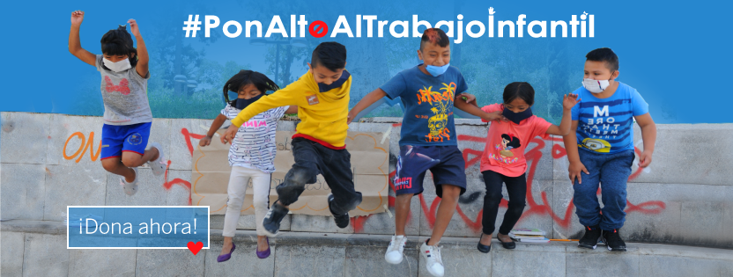

My name is Dari Yael and I am 9 years old.

I met ednica because my aunt told me, I have been attending for 1 year.

They taught me to use the computer, prevent drugs, we learned about emotions. I like ednica because we live together, we play and I like the activities.

I learned to respect, coexist and participate, if I were not here, I would be helping my mother to sell.

Together we stop child labor

During 2021, we have been very fortunate to have donors so committed and supportive of the children, adolescents, youth and families in the street who participate in our care programs in CDMX.

We are very grateful for all your help and love that you gave us this year!

It has been a year of challenges and adaptation to change, but thanks to your donation, we kept our doors open in the three community centers and we accompanied children, adolescents, young people and their families through educational and therapeutic actions, so that they acquire skills that allow them to change the street situation in which they are immersed, for a decent life project based on the exercise of their fundamental rights.
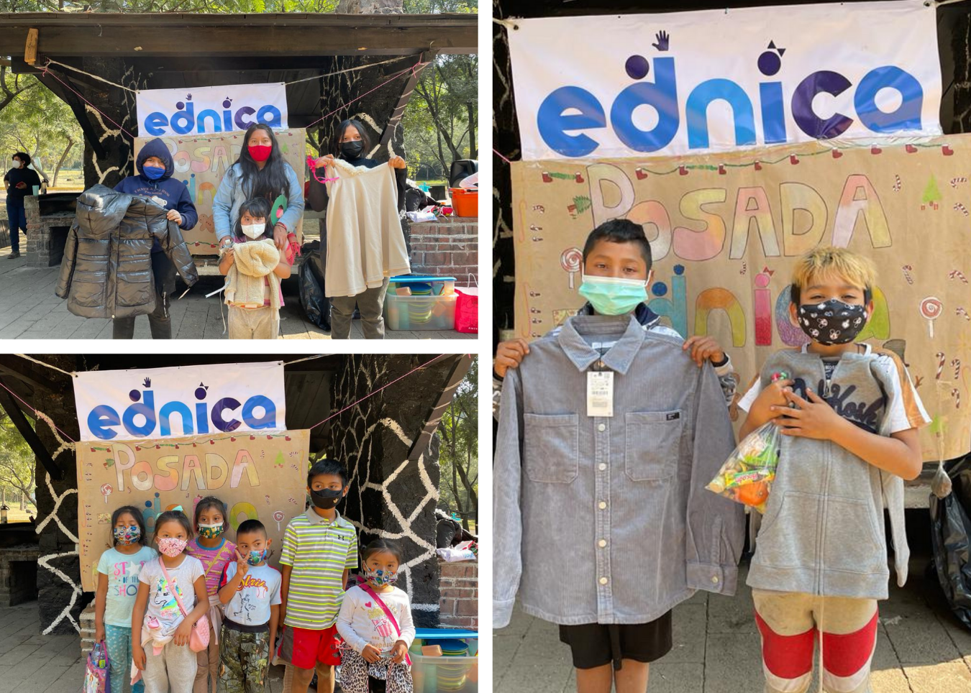

We obtained the approval of Dibujando un Mañana, A.C. and the Fundación De La Salle México, I.A.P., to implement our initiative called "Educational and technological inclusion for children and adolescent street workers", which will allow us to promote their cognitive, socio-emotional strengthening and their technological learning.

During the month of December, we held the posada in each of the community centers to celebrate “The Posadas” of 2021 with the boys, girls, young people, families and collaborators who have been part of ednica in the context of contingency health COVID-19.

A year end of many knowledge

Reading as part of life is a wide possibility of knowledge, of the development of imagination and creativity. Within ednica, we consider that the development of reading and writing skills is an important part of the intervention model for the children and adolescents with whom we work, therefore, we develop activities that stimulate these reading and writing skills. Just as we are concerned about the educational process of each one of the children and adolescents, we also recover the traditions and the right to play and recreation for them and them.

In recent months, a literary day was held in a park near the whereabouts of Indios Verdes, with children and adolescents who are part of the Morelos Community Center, where different activities related to reading, writing and writing were carried out. literary creation. In it, the following activities were developed: story micro-workshop, poetry micro-workshop, reading marathon, mobile library, storytelling, wall of verses and book exchange. The realization by children and adolescents (NNA) of literary works of this day, such as poems and stories, could be shared through the open microphone that was available to them.

Days later, in the Parque del Mestizaje and in the courtyard of the church in Candelaria the traditional posadas were held, however, this year things were different due to the measures that had to be adapted to avoid crowds and therefore, infections in the face of a health emergency. Despite these measures, each and every NNA managed to have a good time with the games they played for seasons, the food and the bonuses that were donated.

The activities to close the year were accompanied by knowledge, fun and creativity; It was possible to live together after a long time and remember the difficult path traveled during 2021, but above all, thank you for everything you learned and continue with sanitary measures to continue facing adversity.

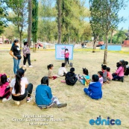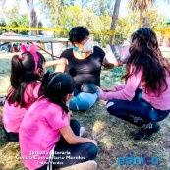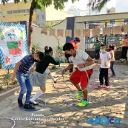

Mental health in ednica

In the last period of the year, in the Emotional Health area of ​​ednica IAP, we maintained the development of therapeutic processes for the population of girls, boys, adolescents, young people living on the streets and their families, based on the implementation of different strategies, such as individual and group psychological care, in face-to-face modalities, as well as remotely.

In this way, 16 children and adolescents who participate in the Ajusco, Morelos and Xochimilco Community Centers accessed psychological care; 8 adults responsible for the family agreed to psychological treatment; while 8 young people linked to street life accessed emotional health care services, of which 3 received individual treatment, and 5 more, accessed group care at the Morelos Community Center.

From the individual therapeutic processes, psychological evaluation procedures are developed for recently referred patients. Likewise, treatment plans are implemented based on the problem or problems diagnosed in order to promote improvements in their emotional health.

With regard to the group attention sessions for the emotional health of young people linked to street life, topics such as: follow-up on the formulation of ideas for the solution of different problems identified in the street life situation, such as the consumption of addictive substances, violence, risks to physical health, and insecurity. For this, the solution tree technique was used. Similarly, notions about the stages of change in the consumption of addictive substances were worked on, with the purpose of strengthening the ability to contemplate and visualize an action plan aimed at attention and reduction of the consumption of psychoactive substances. Finally, in the group sessions with young people linked to street life, skills for the recognition of their own emotions were reinforced, as well as for their verbal expression, in addition to skills for adapting to spaces with norms and rules. from their recognition.

To close the note, it only remains to reiterate our commitment in the area of ​​Emotional Health and in ednica IAP, to promote actions in favor of the emotional health of the target population we serve.

