Their Future Today - Overview Document

Who we are

Operating since 2005 and registered in UK and Sri Lanka in 2010, Their Future Today works to improve and educate the lives of institutionalised children and those disadvantaged through poverty. Through our programmes, we employ local carers, health professionals and teachers.  
Our holistic approach and primary aim is to give all children the right to grow up and flourish within a family as determined by the UNCRC, receive an education to improve their life chances and that of their future dependents, and end institutionalisation, which has been shown to result in the poorest outcomes for those placed there.

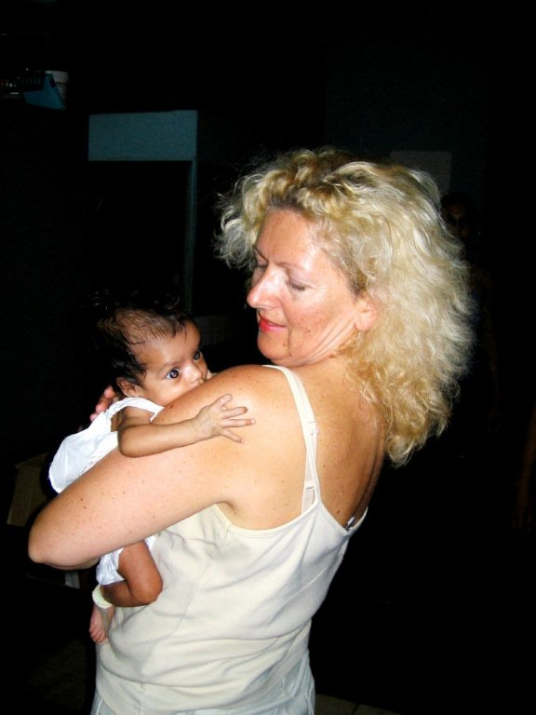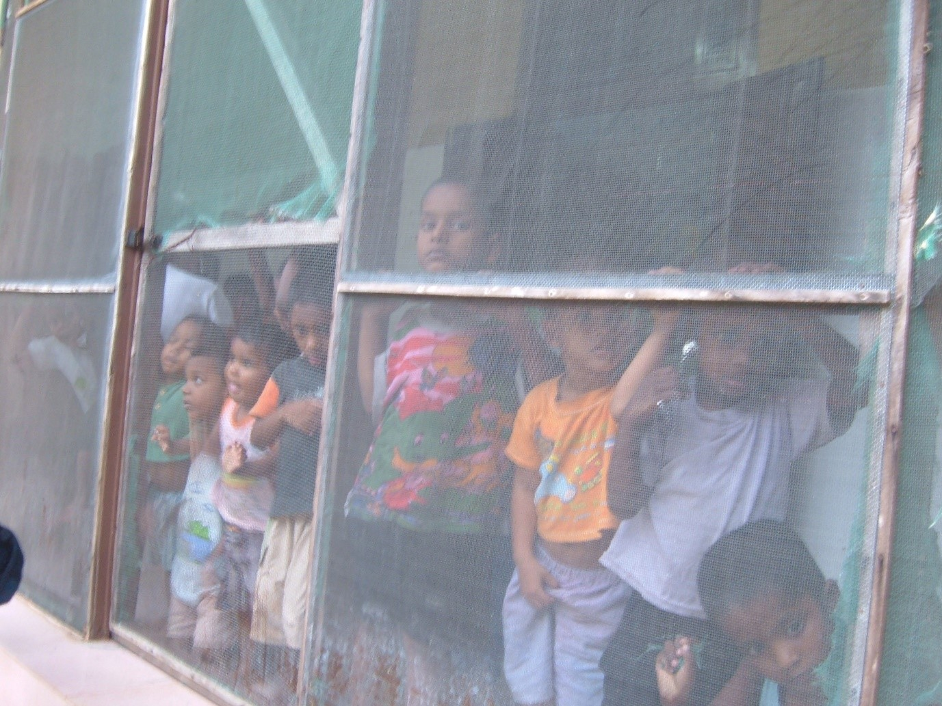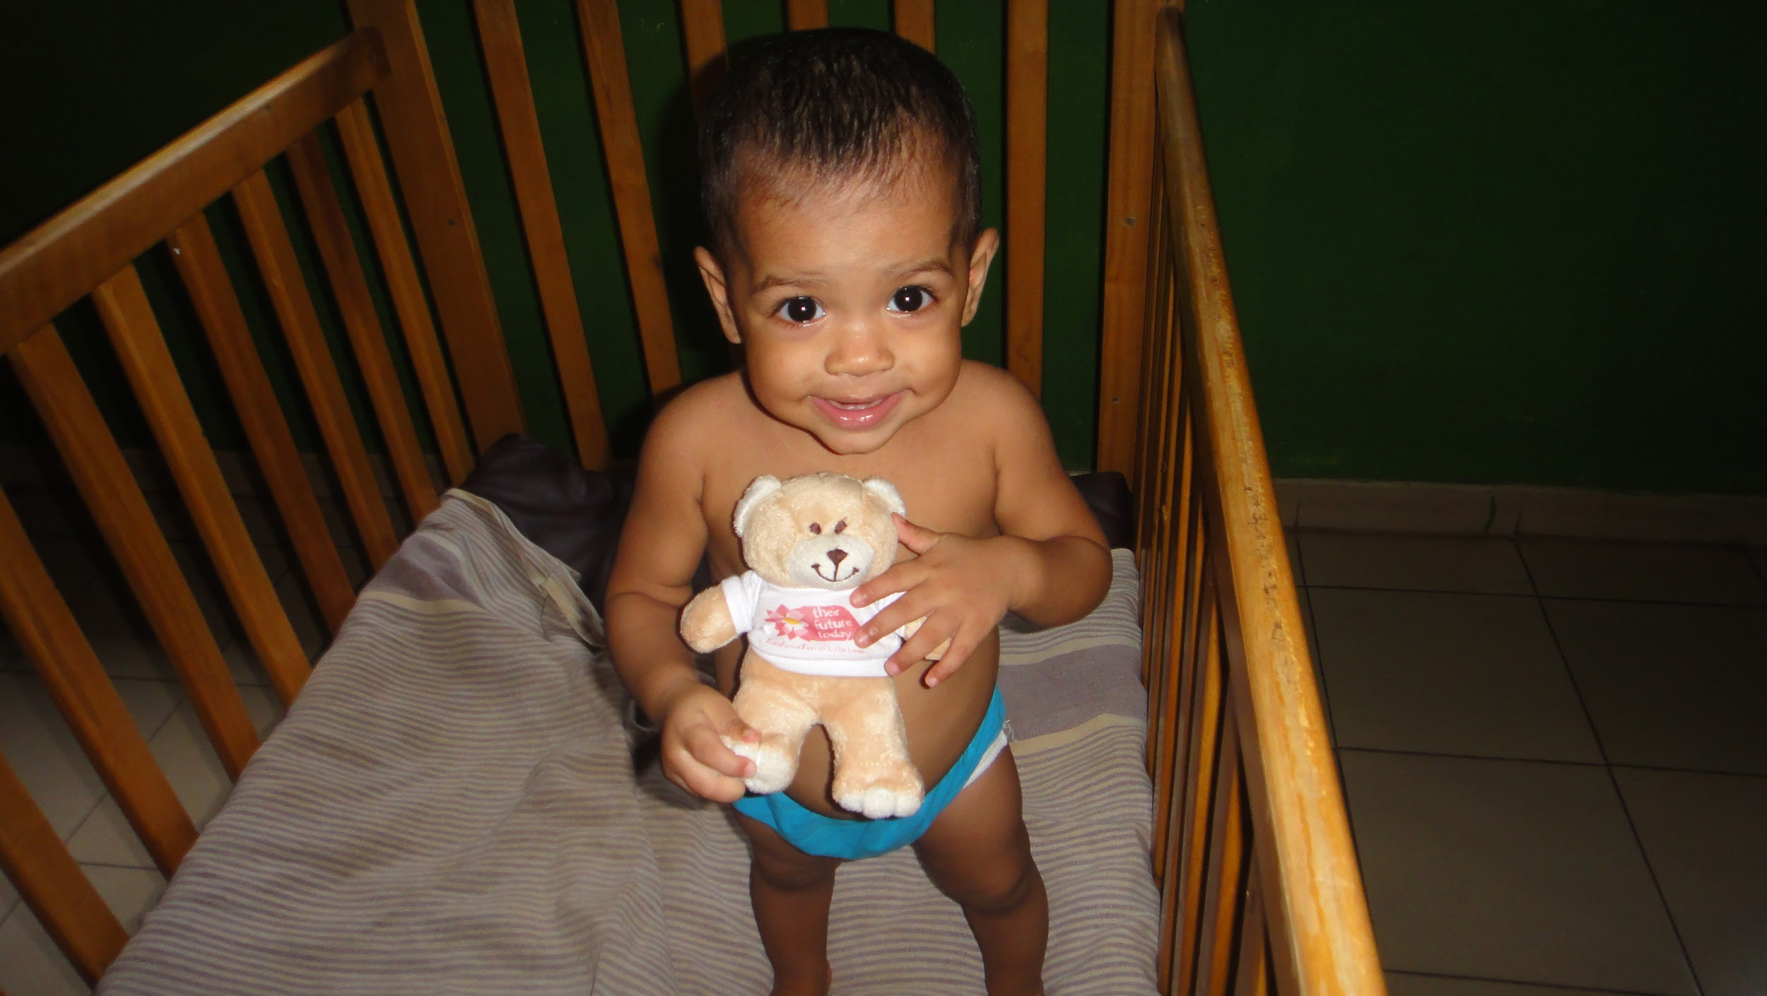

What we do

Their Future Today works to improve and develop the lives of disadvantaged children in Sri Lanka, by preventing the abandonment of children, reuniting children into their families, providing education in rural areas and transforming institutions.   
  
These goals are achieved though many activities including; providing housing, freshwater, and support to the reunited or supported family until they are able to reach self sufficiency; giving school books to children in rural areas; offering families with no funds an education for their young children at our Pre-school. To raise standards within institutions; we train housemothers and government workers in hygiene and childcare; organise activity days; provide supplies of baby milk, medicines, nappies, computers and sports equipment to the institutions. We also facilitate vocational training of sewing and computer skills for older children, which includes the supply of sewing machines and computers.

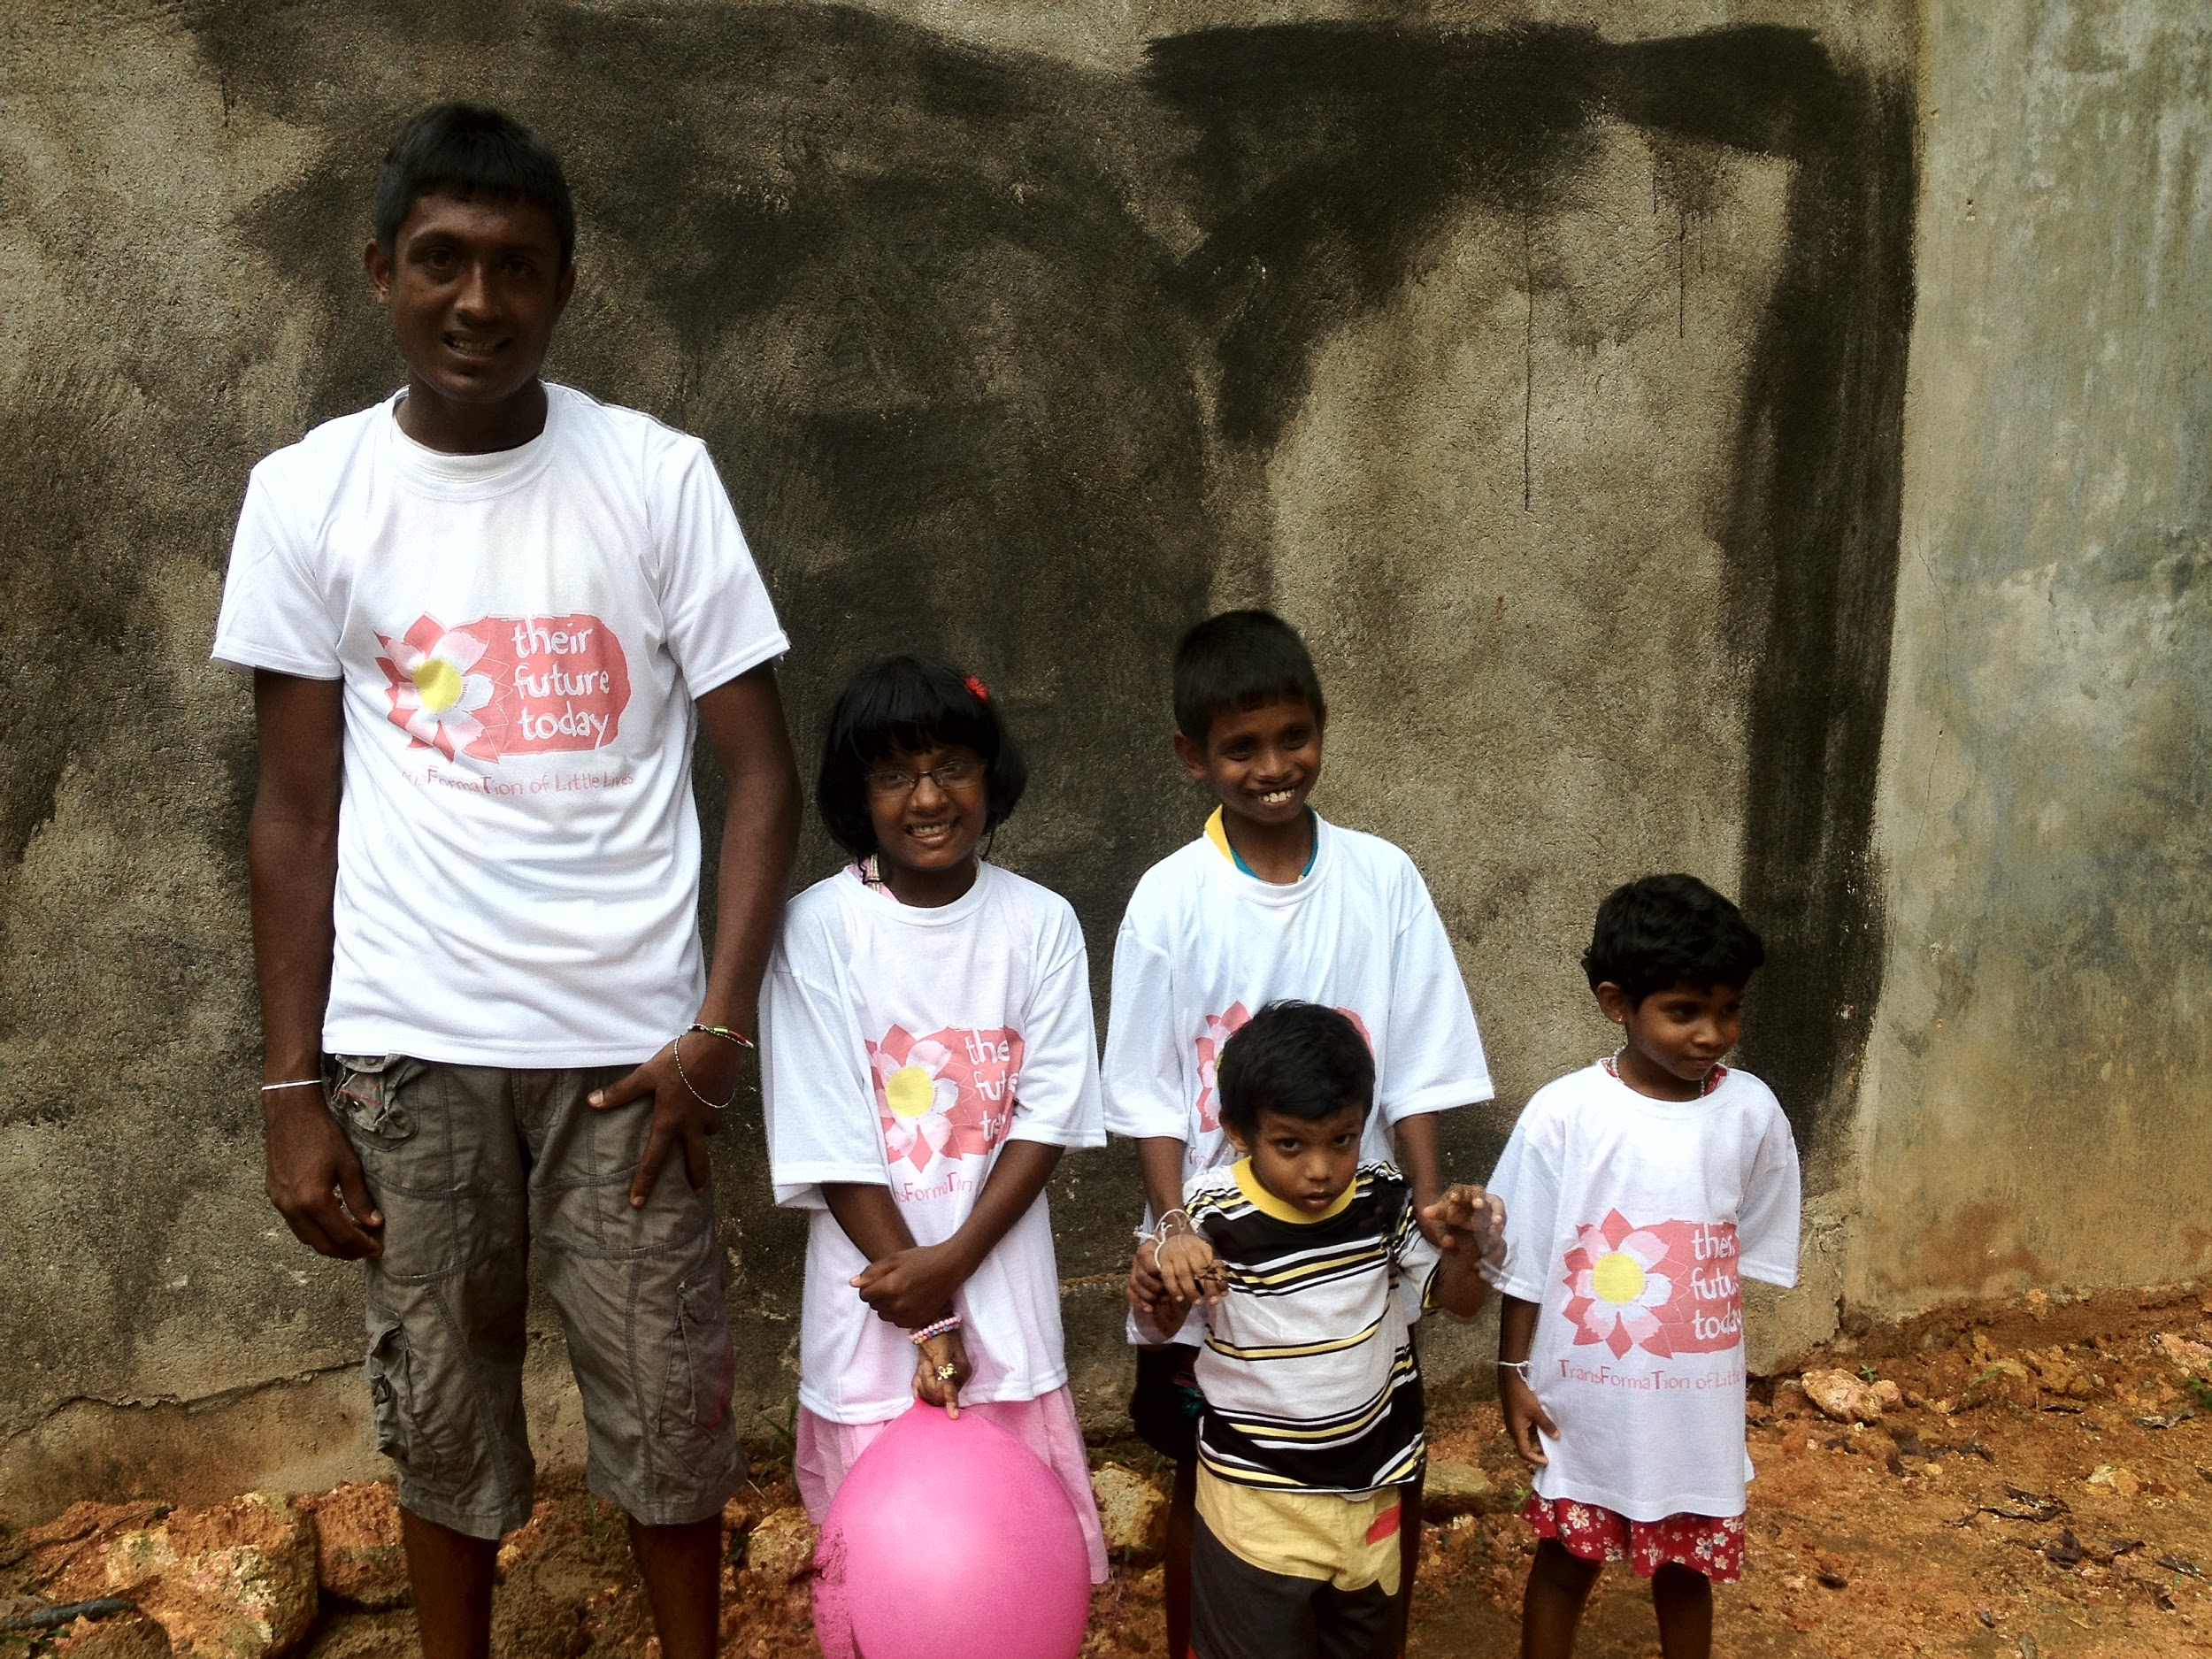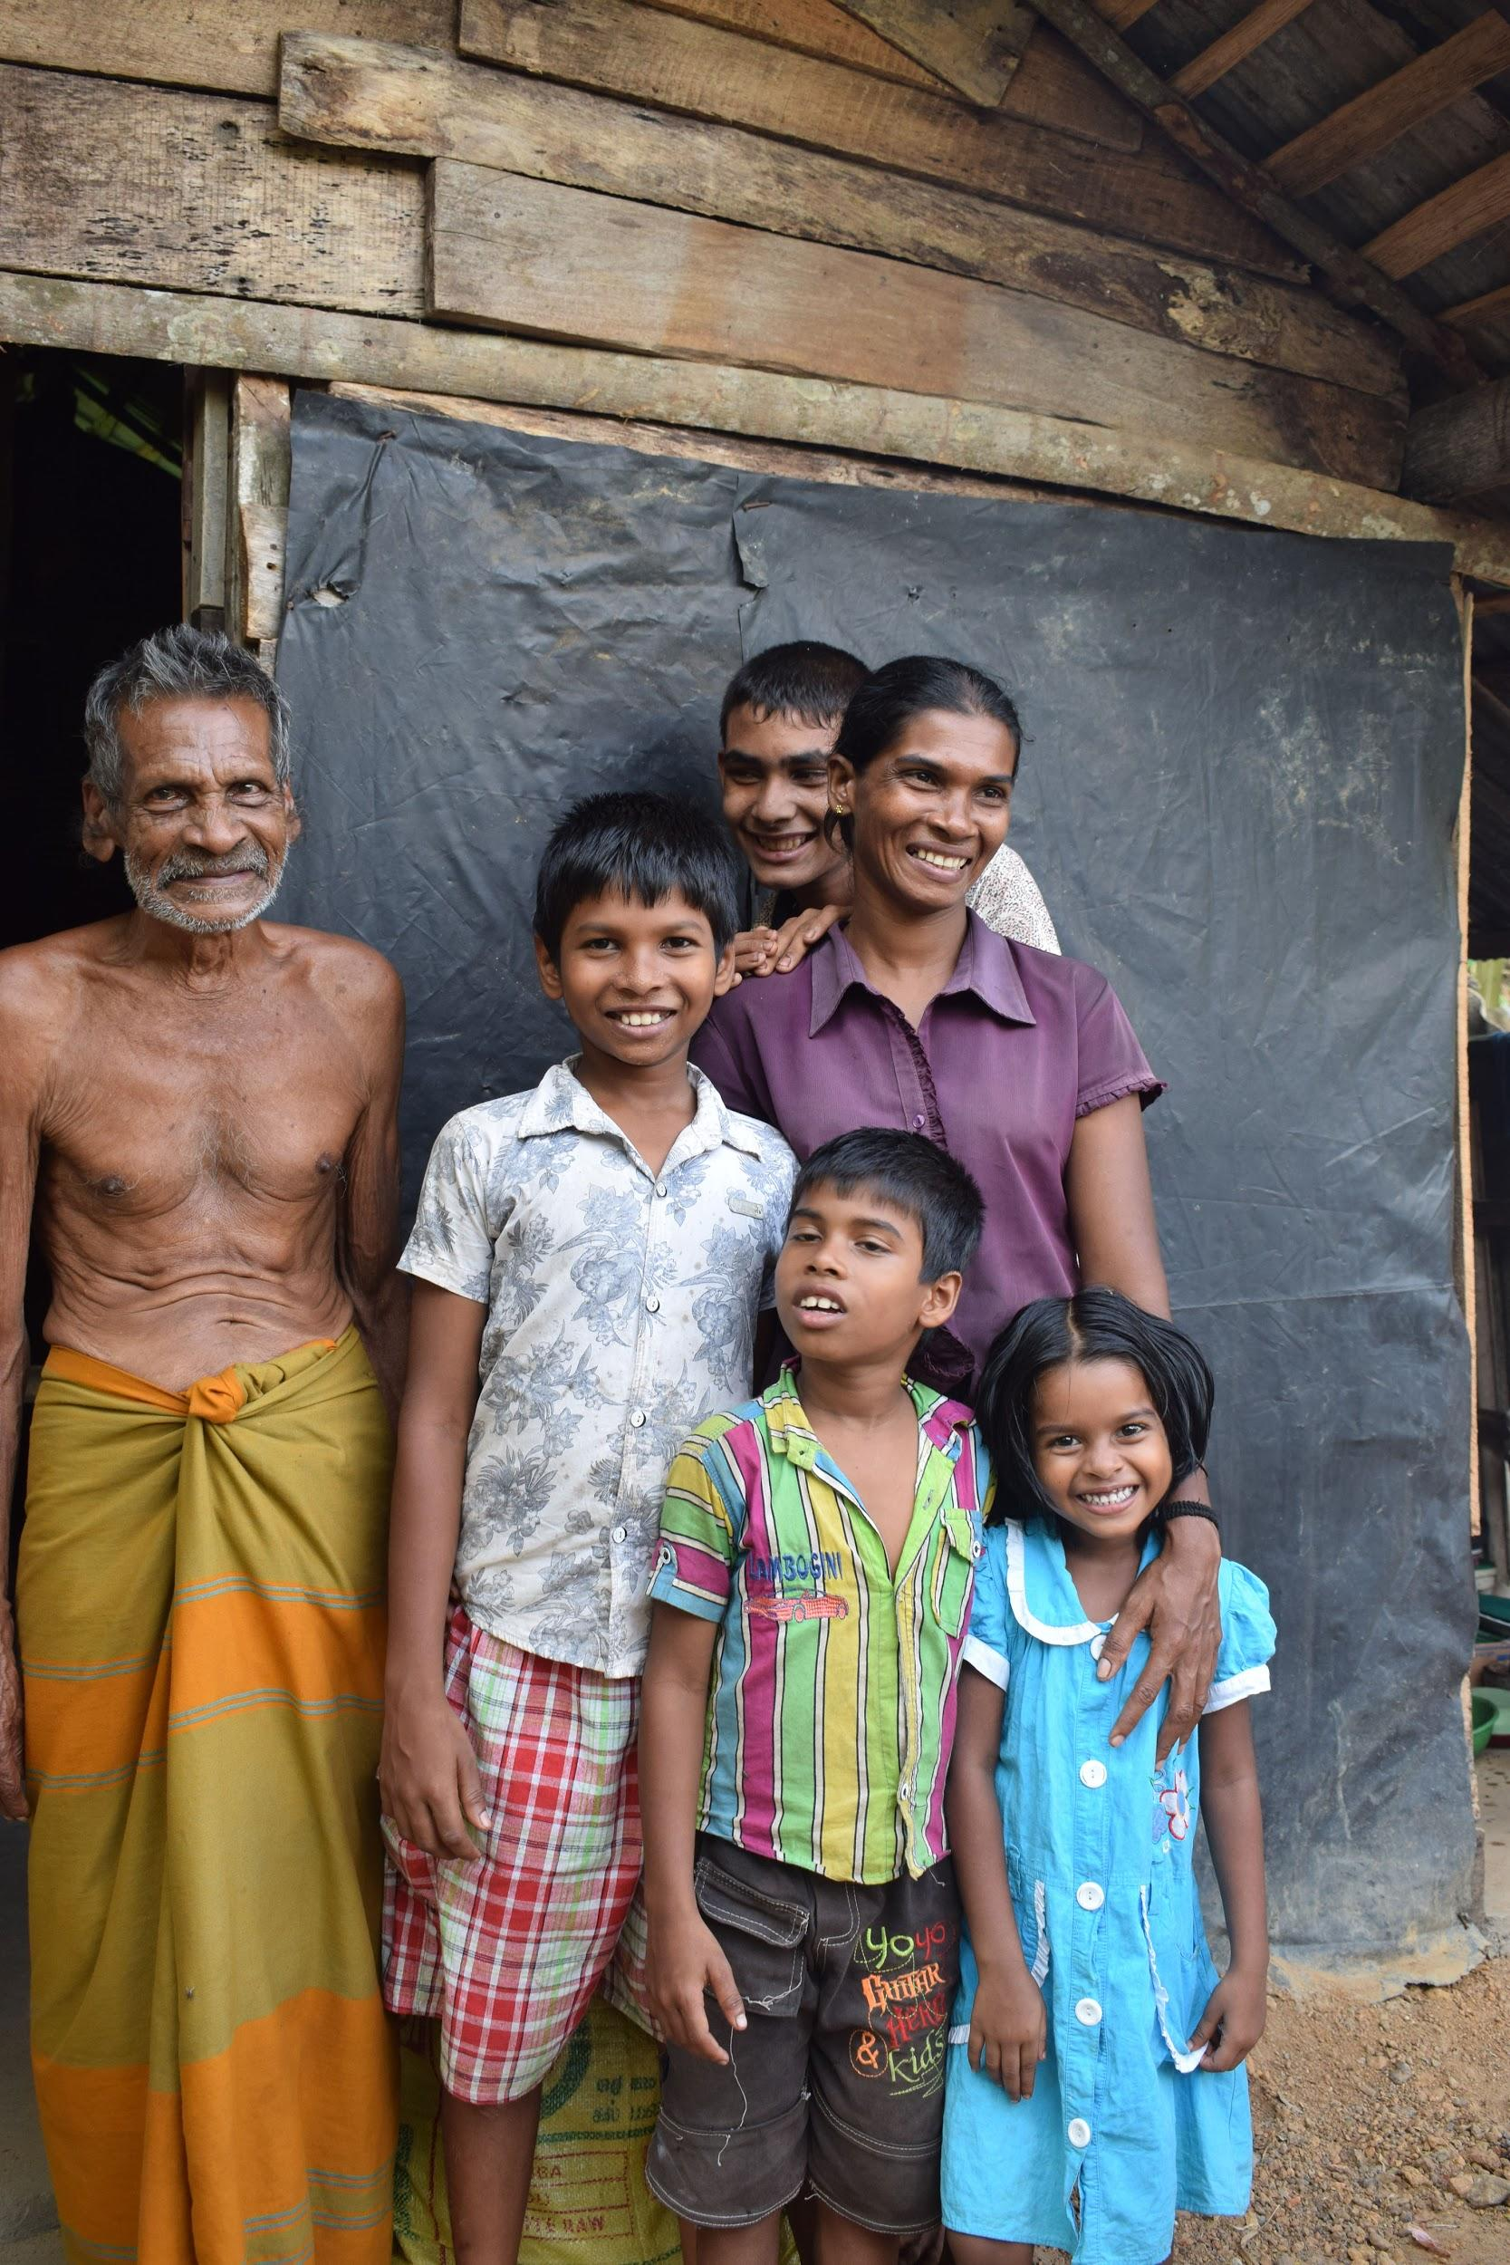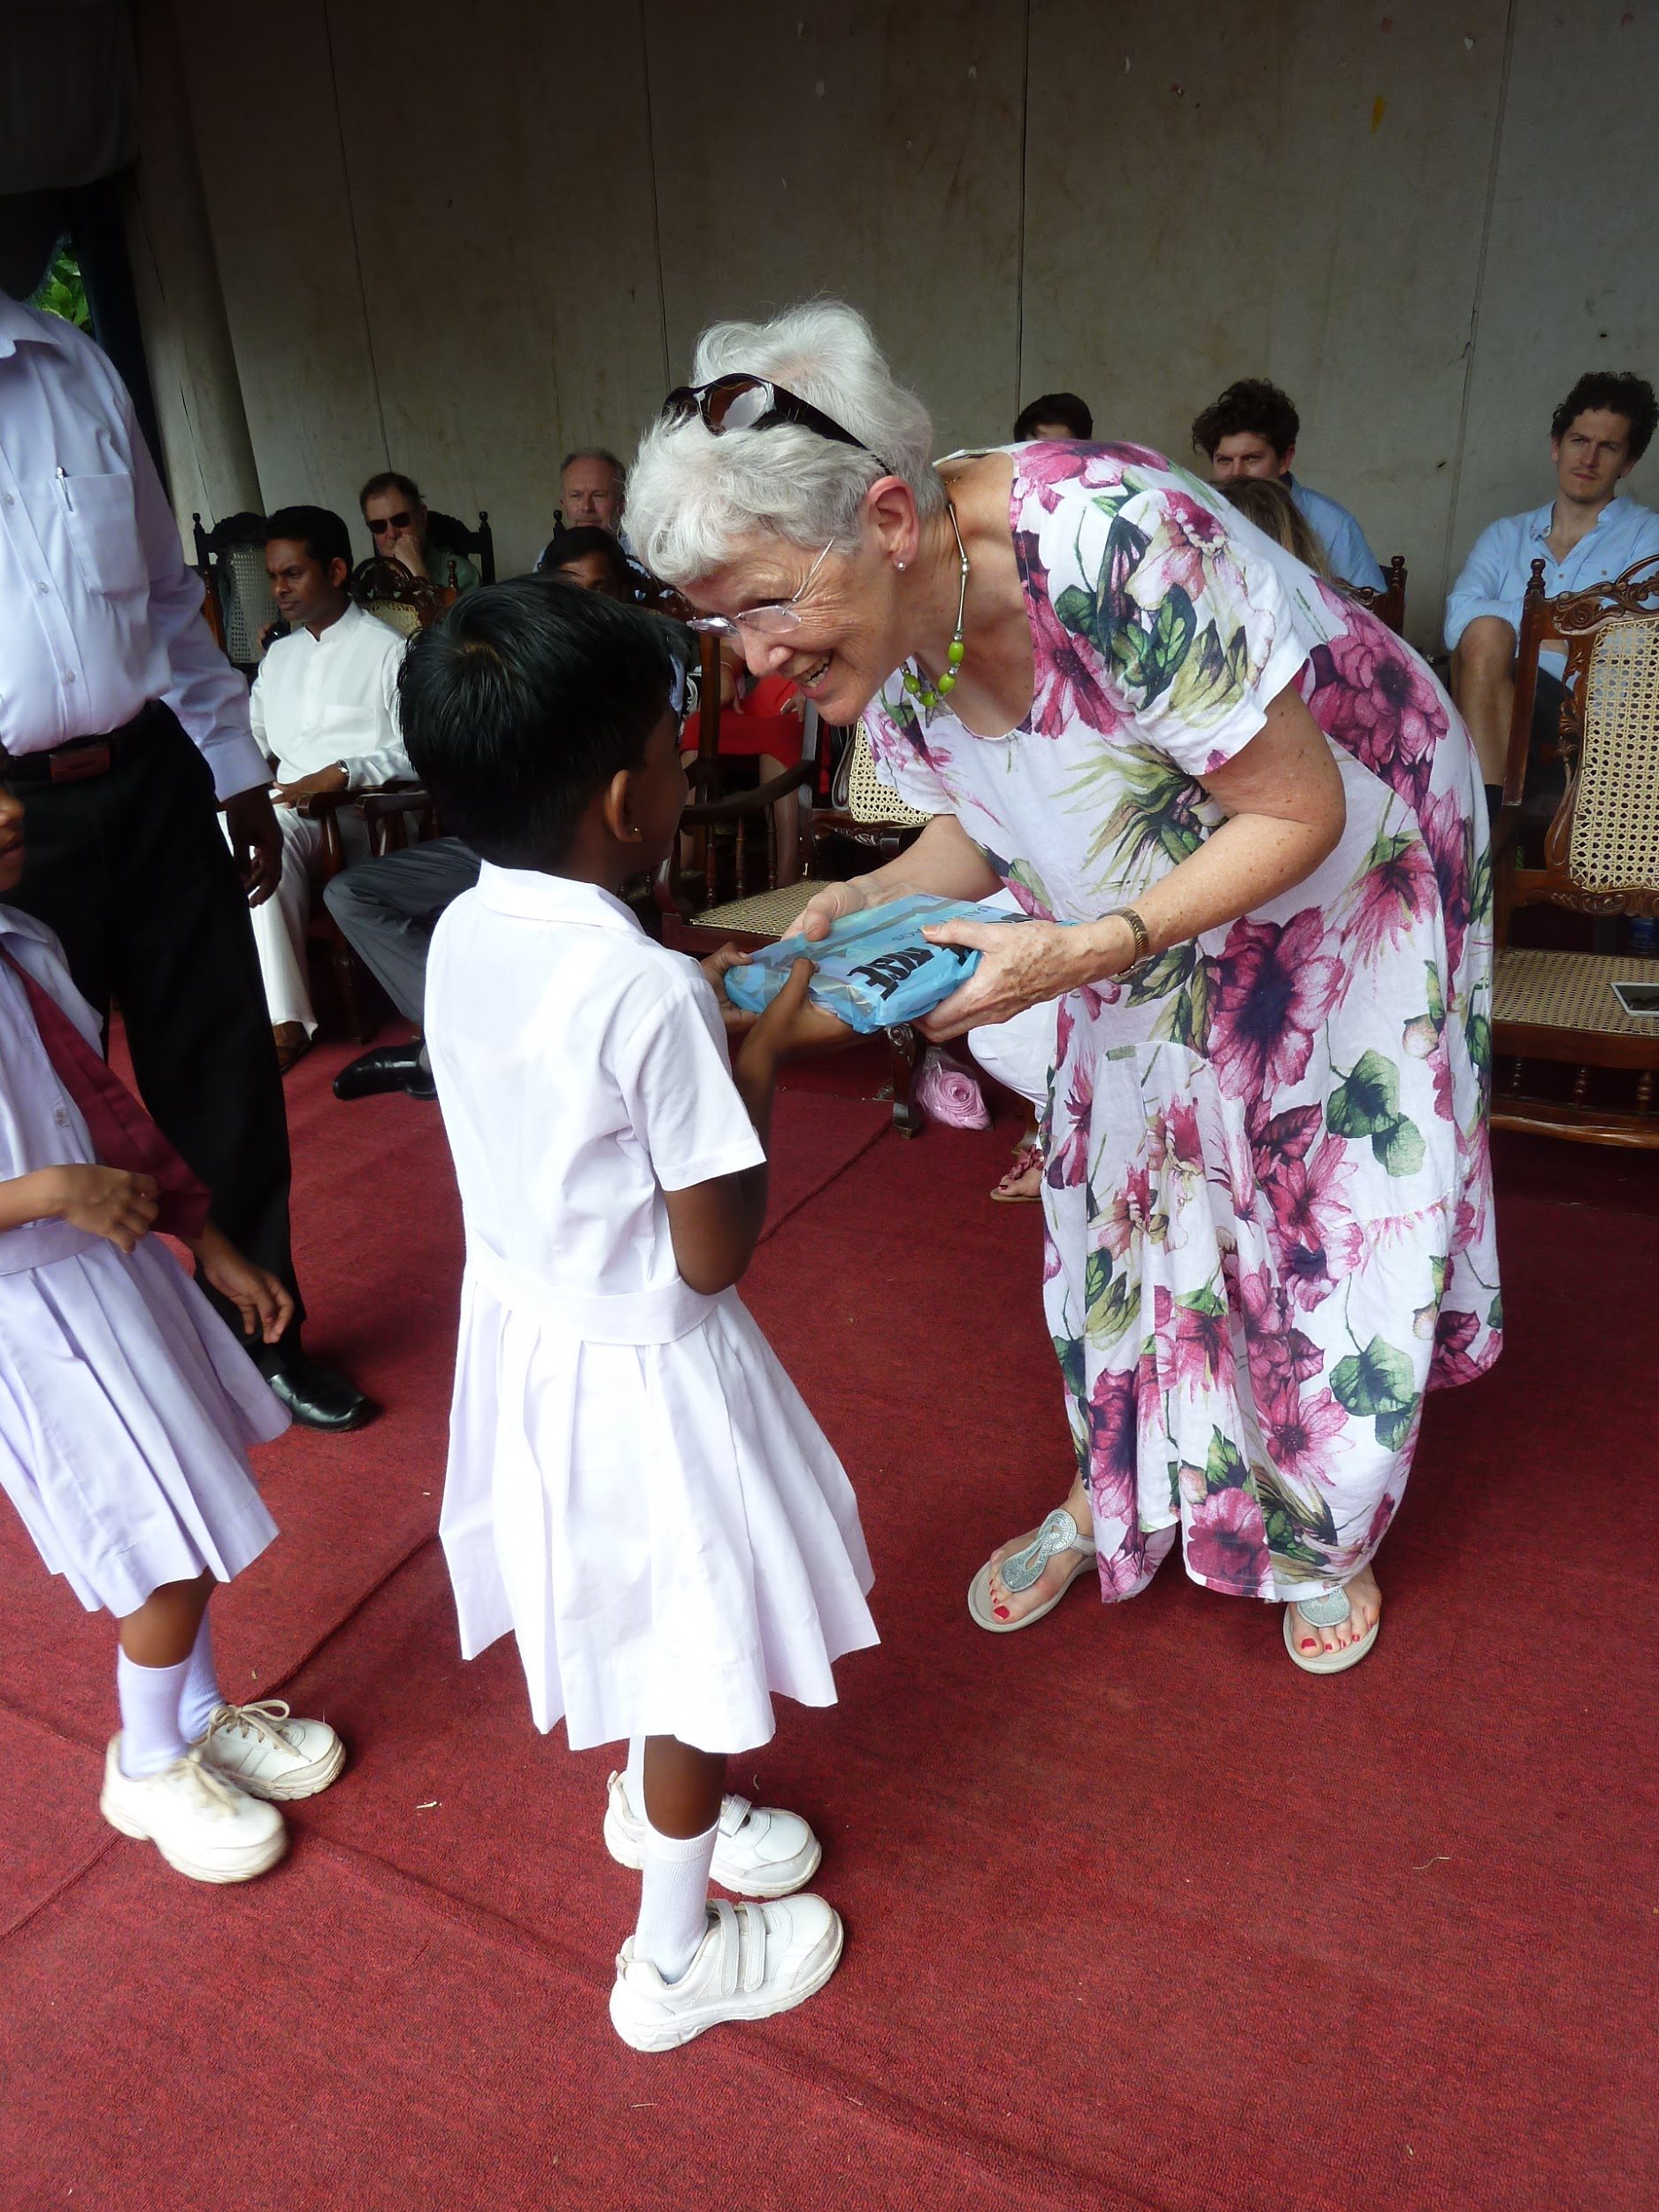

How we operate

We work at a grassroots level, identify areas of need, then our Country Director Mr Percy actively and directly spends funds raised to achieve maximum impact to individuals, to maintain longevity, consistency and sustainability in this support. We work transparently and cost effectively as a non political, non sectarian and not for profit organisation.

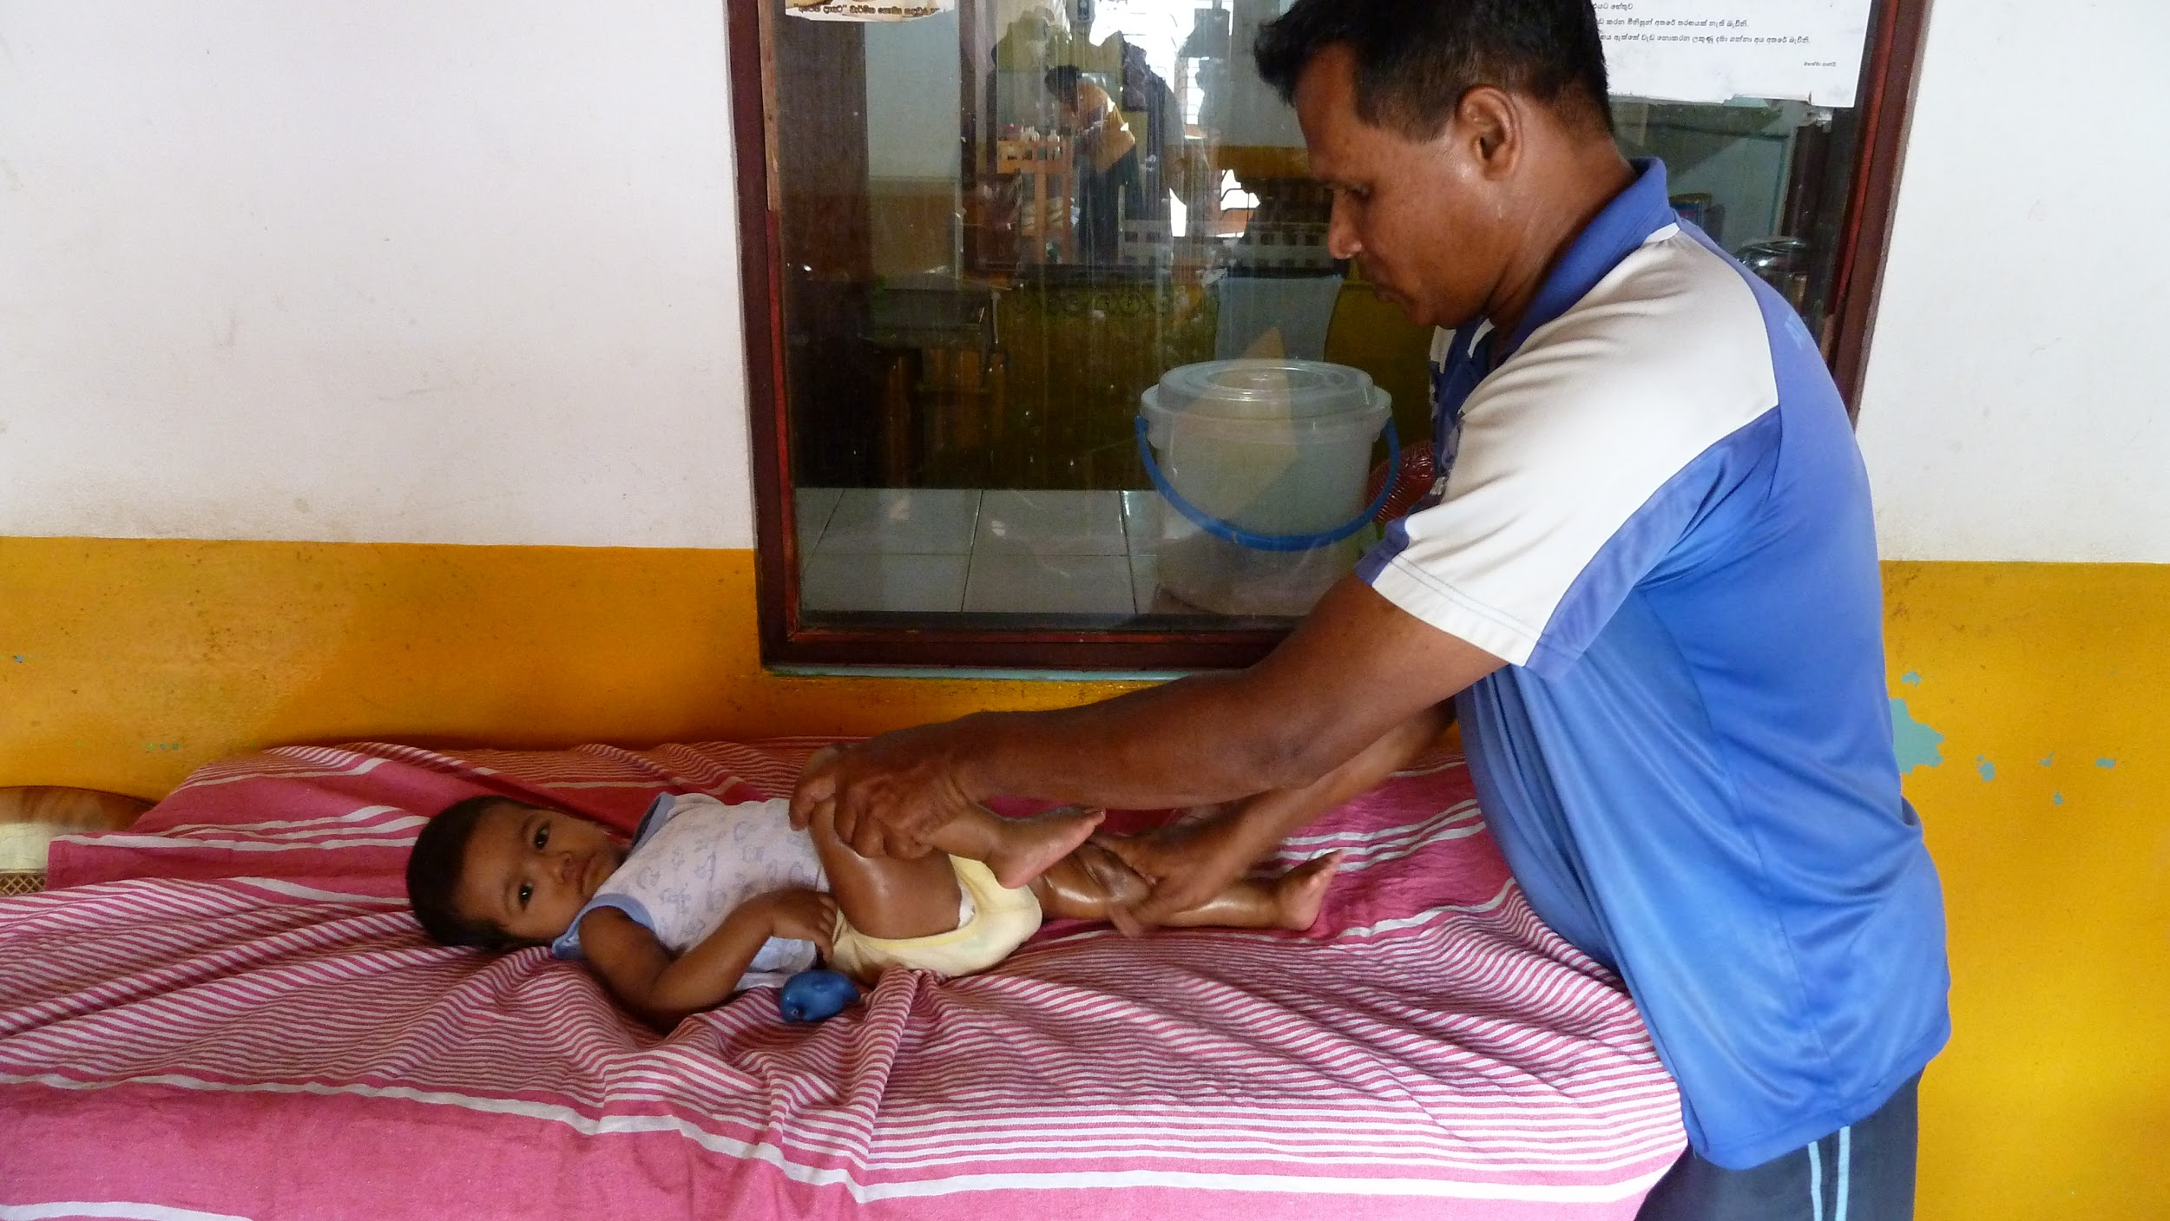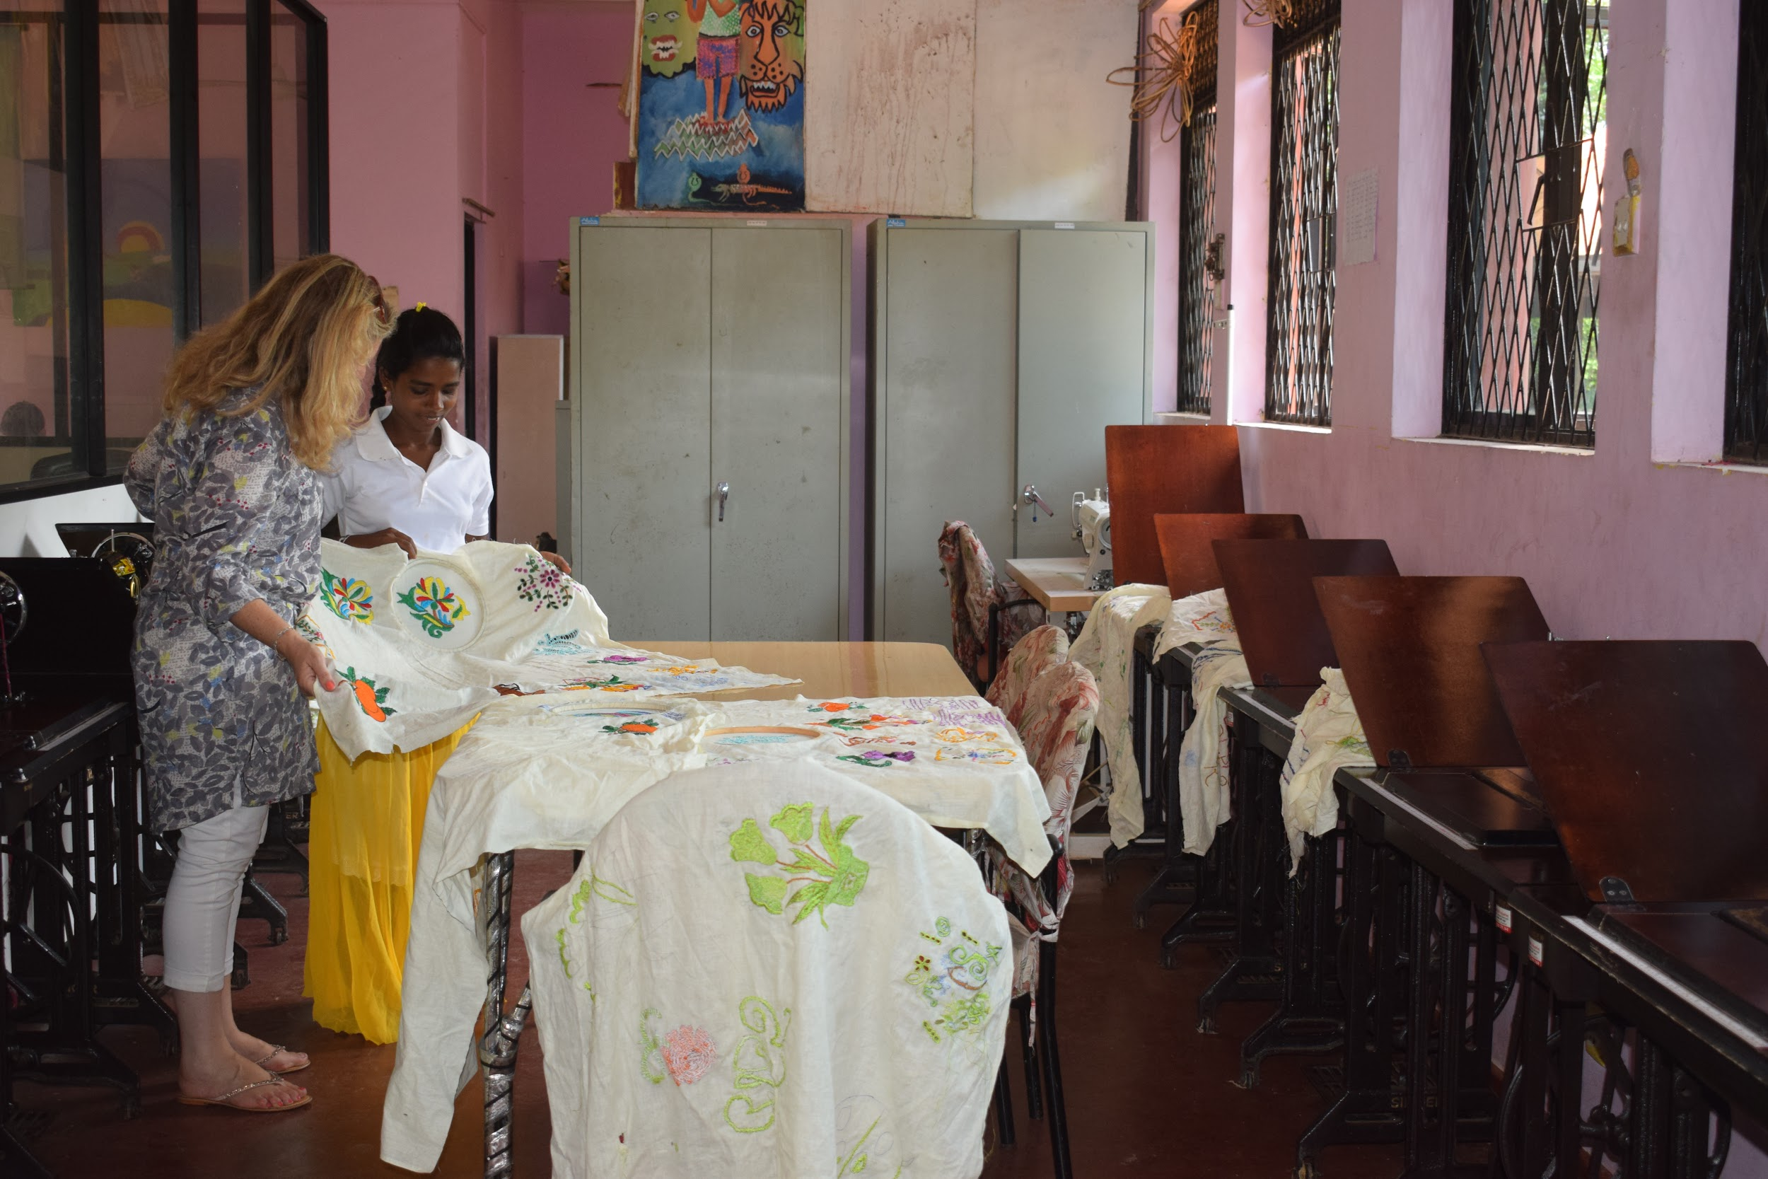

Where we operate

TFT’s core projects are situated around Galle Town (Southern Province) in Sri Lanka. We also have a book giving ceremony in Jaffna (Northern Province).

