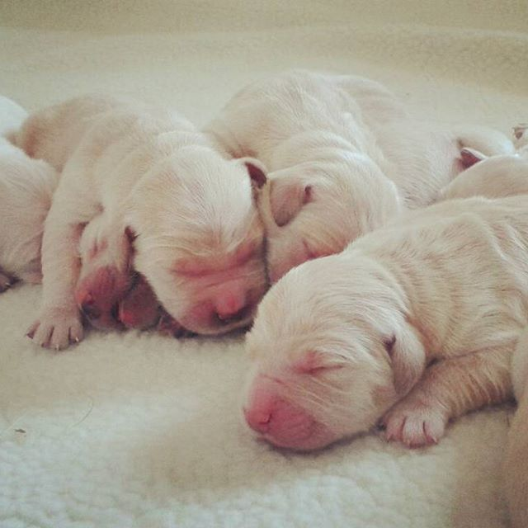\\nas1\Pictures\Pictures Media\Mike Pawley\Guide dogs adjusted\Mike Shots\Tiffs\Guide Dogs-004528.tif