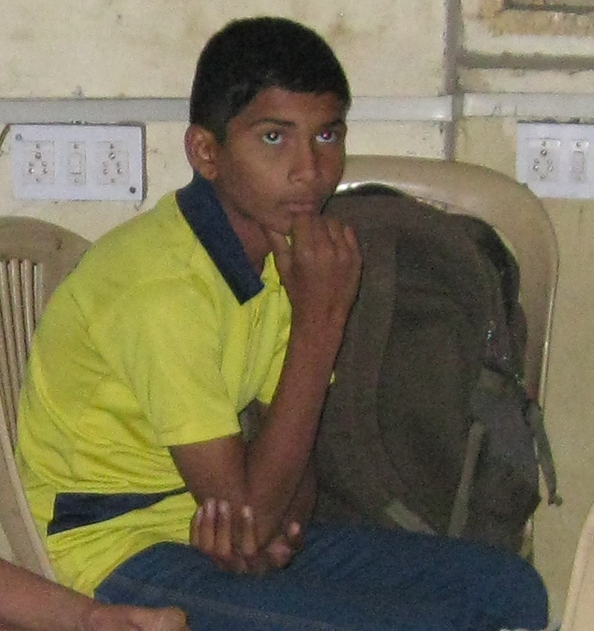
This is Sameer. He is a 13 year old boy who lives with his mother in a slum near Hadapsar village in Pune. His father died in an accident a few years ago, so his mother works as a maid in others' houses from 8:00 am to 6:00 pm to manage her family meals. She sends him to a no fee government school near her house. She wants to make her son an independent and successful person. Sameer is a very talented student. He got 86% in his school exam. He wants to be an engineer and support his family. He is one of the students who has joined Project Udaan classes recently and will be trained for grade 10 next year.
On 17 December 2017, our year long course for grade 9 came to an end with 15 students. In mid December, we contacted no fee schools to enrol an additional batch of bright students and encouraged them to choose their career and described the growth that the students could achieve by studying in our Project Udaan. We motivated the students to set the goal of clearing the IIT-JEE exam. After these efforts, we got 5 very bright students who wanted to be part of Project Udaan. The idea of expanding the batch was made possible because of the generous donations received on GlobalGiving.
In January 2018 we started the extra classes and doubt clearing classes for the old and the new batch of grade 9 students to prepare them through a Bridge course for the next session of Std 10. All these are bright students studying in low income schools. After attending the Bridge course for six weeks, this is what they have to say of our Project:
- Simran : " We get extra knowledge here which is very useful for us".
- Nitish : "Here teachers explain concepts very well and in depth. They clear my every doubt and basic. I am enjoying learning Science and solving Maths here".
- Radhika : " We get more knowledge about Maths & Science which was not given by our school teachers".
- Umesh (from the old batch) : "I want to continue this Project till my grade 12".
- Ritik : " I benefited from the Project and it helped me to get good marks in school".
We thank GlobalGiving from the heart for giving us this wonderful platform to raise funds for our project and help the poorest of the poor realize their dreams through quality education. Your donations have paid for the year long coaching, mentoring and counselling of 15 grade 9 students of the old batch and for the bridge course of 12 weeks of the 5 new grade 9 students. The donation will also partially cover the cost of coaching and training all the 20 students in 2018-19.
"Thank you" Donors.
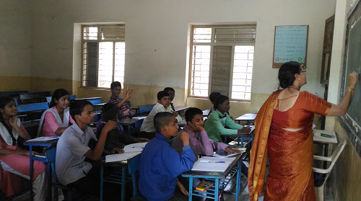
Excellent Teachers, Eager Students
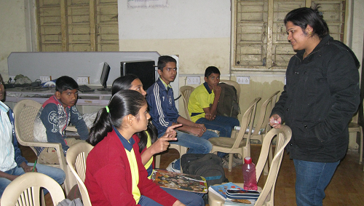
Interactive Math Session with their Teacher Namrata.

