

* The Community of adults with Intellectual Disabilities constitute 2-3% of the world’s population.
* **AMBA addresses the community of adults with moderate to severe intellectual disability who cannot go through the open system of Learning and Employment**
* AMBA Curriculum enables Alternate Education, Functional and Visual, using ICT and Peer Driven Processes appropriate to their challenged ACUMEN.
* AMBA collaborates with Special Institutions helping them become hubs for Learning & Employment.
* Currently present within 435 AMBA Certified Partner Centres (ACPCs) in 25 states in India
* **2017-18: Learning & Skill Development for 4400 peers;**
* **Employment for the above targeted for 2019**
* **2017-18: Employment for 2200 peers;**
* **2017-18: AMBA’s presence in 30 states in India**

**Problem Statement:**

* 30 million intellectually challenged adults in India with IQs below 80 live without the hope or capability of developing as professional, earning adults. Theirs is a life of existential dependence.
* Intellectual Disability is a developmental disorder with extremely delayed milestones and very low cognitive ability. The challenge manifests in impaired ability to reason or recall, behavioural problems and very often results in all the associated challenges such as physical disability, seizures, speech and visual challenges. The disability is seldom genetic, and for this reason it remains largely **‘invisible’** **as appearances rarely show the disability**. Most importantly they do not have the social skills to go out and work within Mainstream jobs.
* The intellectually challenged community is the most marginalised section of society in India. **Most government schools accept and patronize this community up until the age of 14,** following which they are entertained, if the family can afford it, through non-earning vocational practices only until Puberty. Aside of the years of ridicule that AMBA has to offset, the challenge we face lies in assuring that this community has the ability to independently ensure that their future is secure.
* **AMBA addresses within this community, adults with moderate to severe intellectual disabilities!**

**AMBA’s Solution**

AMBA is a Training & Business Hub for adults with moderate to severe intellectual disabilities using Information Technology, Peer Training & Peer Supervision. The hub and spoke with a difference: The AMBA Core Center in Bangalore is the hub that enables the ACPCs with training, monitoring and business. The spokes are the ACPCs pan India.

An Ashoka Fellow driven Social Enterprise, AMBA’s ecosystem of learning and earning is adaptive, visual and functional, appropriate to their acumen, enabling accurate data entry and audit, making them contributors to family & Society. Their lack of social skills limits them from working in mainstream companies, so AMBA’s scaling model is within collaborations with Special Institutions pan India, helping them evolve into hubs for learning & earning, using their infrastructure, administration & trainers, keeping overheads to a minimum.

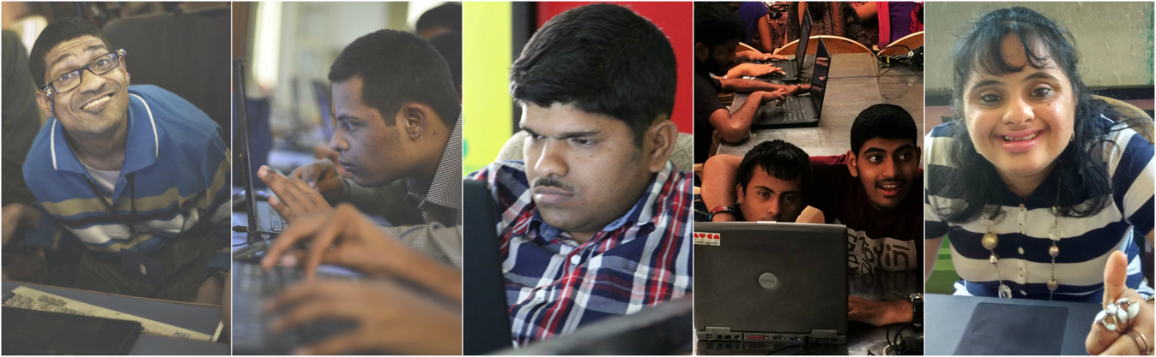

**Research & Development 2004-2014 –**

* AMBA’s new idea for Education and Employment for this niche community evolved over 12 years.
* The process of research; understanding this community; managing stigma and denials; developing the curriculum from scratch; testing out work within pilots; maximizing efficiency, achieving SLA driven processes, has been a long journey of development and understanding for AMBA.

**Accelerated Scale 2015-2017**:

* Learning: **AMBA’s concept has been shared with over 435 Special Institutions in 25 states in India (80% in small towns and villages),** helping them become small hubs for Learning and Earning. The Learning includes simulation processes to maximize efficiency and meet SLAs of the clients AMBA serves.
* Business Development & Back office work: Since 2004 AMBA has serviced TTSL, Airtel, Idea & Reliance from the Telecommunications Industry, SO Bharat, Dinshaw Ice Cream, ING, CMIE, Intel, BESCOM & BESCOM network, IIMB, Proton Sports, UNDP, Census Data entry, SSA, to name a few.
* **The recent disrupt with Global automation has been a challenging setback for work**, but, AMBA team over the last year has evolved **a short term and long term solution** to enable work to match the scale of growth with training within AMBA Core Center and the AMBA Certified Partnerships (ACPCs). **110 ACPCs in work by December 2017**
* Presently doing Pathpartner (Camera based Artificial Intelligence related Face mapping). In discussion for VAD Telecommunications work to meet the present need.
* Exploring AI related possibilities to enhance security within different genres and prevention of accidents using Camera based AI solutions for the future
* **Target to reach 150000 peers within 1500 ACPCs by 2025; 100% Employment by 2030**

**Accolades:** AMBA has been endorsed locally, nationally and internationally for the AMBA Concept and the employment it has and can generate.  However, in the big picture, this is a small beginning, with miles to go...

* *Peer Recipient- CII Woman Exemplar 2017 (Runner - Up); CII Woman’s Exemplar Award 2013 for Education (Peer Recipient)*
* *Digital India Award in the category ‘Good for India-Digital Innovation in Skills and Employment solutions’*
* ***The Collaboration between Oklahoma University, UNHQ & AMBA to take AMBA Global (beginning 2017-18)***
* *Best NGO-KARNATAKA, 2016*
* *Empaneled under United Nations Development Program (UNDP)*
* *Associate Member, CoNGO (The Conference of NGO's in Consultative Relationship with the United Nations).*
* *Helen Keller Award 2016 (Peer Recipient); Helen Keller Awards 2015 (AMBA)*
* *Global Sourcing Council 3S Awards under Impact Sourcing category presented at the United Nations Headquarters, New York.*
* *NIMHANS Felicitation-*
* *DeRozio Award 2007*
* *Ashoka Fellowship*

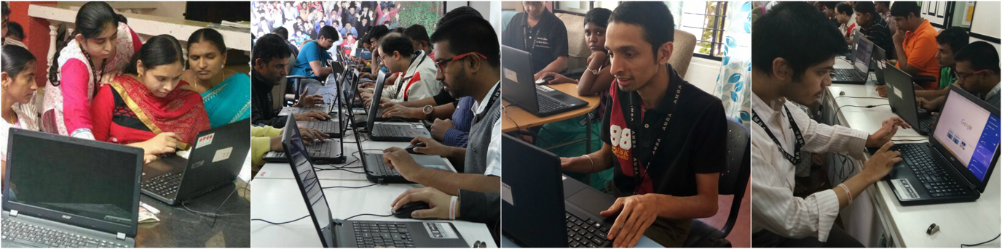

**Support Required:**

* **11.98 crore rupees (Approximately Rs 27000= 1 Laptop+ Rs 7000, per peer).**
* **AMBA is looking for multiple Partner Support to cover the requirement at AMBA.**
* **Support one AMBA Beneficiary Collectively (Two or More Donors collectively contribute and donate Rs 25000)**
* **Support One AMBA Beneficiary = Rs 25000.**
* **Support Multiple AMBA Beneficiaries (Multiples of Rs 25000)**

**Funding for the financial year 2017-18 will cover:**

* **Set up of 200 ACPCs for Learning in 30 states in India**
* **4400 peers educated within these ACPCs using AMBA Curriculum**
* **100% Employment to these ACPCs by 2019 at the outset**
* **AMBA Core Centre in Bangalore supports the 200 ACPCs by:**
  + Identifying and doing orientations within India’s States/UTs and at the Core Centre for Head of Institutions; 21 laptops to each ACPC to include taxes and three-year maintenance; 6-day Residential Training at the AMBA Core Centre in Bangalore by AMBA peers for one Special Educator and two peers from visiting ACPCs; Signing an MOU for a better understanding and accountability; Sharing and Training to use the AMBA Curriculum; Three stages of Training at ACPC closely monitored by monitoring Staff at the AMBA Core Centre using ICT; Quarterly visits to ACPCs by Managers, Monitoring Staff and Peers from the AMBA Core Centre; Exploring, Developing Pilots and Developing Business for ACPCs; Customising Simulation Software to meet Live work requirements; Maximising Efficiency to meet SLAs of Clients, Enabling QC, QA and completion of residual work

**Partnership with AMBA:**

* Tax exemption-80G Registration Number: DIT(E)BLR/80G/158/AABTA4764G/ITO(E)-1/Vol2011-2012 on 50% of your donation.
* Partners will be showcased on the AMBA Website which is being modified to meet the requirement.
* 12A Registration: DIT(E)/12A/Vol.IV/A-1021/W-1/05-06
* FCRA Registration: 094421635
* Trust Deed: 68/04-05
* Your Partnership with AMBA will bring dignity and Joy to a vulnerable community, while enabling huge Social Impact.

Thank you for your consideration. For more information, kindly contact:

Shyam Coutinho

Director - Marketing, AMBA

M| +91-8867856555

[shyam@ambaforlife.org](mailto:shyam@ambaforlife.org)

**Chaitra Hegde**  
General Manager - Business Development & HR  
M| +91-9845234490

[chaitra@ambaforlife.org](mailto:chaitra@ambaforlife.org)

**www.ambaforlife.org**

Sugandha Sukrutaraj

(Ashoka Fellow)

Founder & CEO (Hon)

M | 8971200795

[ssr@ambaforlife.org](mailto:ssr@ambaforlife.org)