IVO’s Community Economic Development plan will outline the ways that IVO will focus on empowering local people to create positive social, economic and environmental benefits through the creation of a community hub.

Introduction
This Community Economic Development (CED) Plan is submitted by the Innovative Vision Organisation (IVO) and aims to map out how IVO can work towards achieving sustainable economic change in the Tottenham Hale and surrounding area through the establishment of an Enterprise hub.
For the past 19 years IVO has provided care, supported volunteering, children’s activities and support services for the disadvantaged, especially BME communities who are perceived as “hard to reach”. During this time IVO has engaged with over 2,000 people predominately from High Cross Estate, Hail Village, Ferry Lane, Chestnut, Markfield Road Estate, and Broad Lane N17, Tottenham Hale, which is one of the most deprived wards in Haringey. This has taken place in premises which are rented from London Borough of Haringey.
IVO plans to re-launch this building as a community asset to make their plan of a community hub for enterprise and employment a reality.
  - Innovative Vision Organisation
IVO are a well-established charity who has been working to benefit the local community in Tottenham and neighbourhoods since 1995 working from their current premises in Tottenham from 1997. Over the past 20 years IVO has been awarded a number of accolades for work on social and cultural issues affecting Ethnic Minorities with a particular focus on HIV /AIDS prevention, advocacy and campaigning. Within this IVO have provided advice, support and information to statutory organisations as well as support to the community.
IVO is proud to have built up a strong relationship with the African and Caribbean communities of North London. IVO have a wealth of experience, understanding changing community needs and have built trust in the community.
Everything that IVO have achieved so far has been as a charity responding to needs with a focus on HIV /AIDS prevention, advocacy, campaigning andchildren activities. Developing into an enterprise is a new step in IVO’s journey and alongside the potential successes of this development are challenges around building a sustainable enterprise that supports the local economy, the rapid need to support local disadvantaged people, and become more resilient alongside skilling up Trustees/Directors for the new proposed enterprise.
1.2 Challenges
Before discussing the aspirations of the plan it is important that IVO recognise there are the following challenges to overcome:
Internal Challenges
Governance: There have been challenges sustaining the numbers of active trustees that IVO have during the planning process. IVO are also setting up a CIC to run alongside the existing Charity. IVO need to strengthen their Board in order to meet the Governance requirements of a charity, while also identifying Board members for the CIC.
Capacity: IVO have no paid staff and are fully reliant on volunteer leadership. This takes its toll and puts a lot of pressure on a small organisation. This being the case it means that the development and implementation will take longer than IVO would hope for unless sufficient funding can be obtained.
Income: The income for the plan implementation is uncertain, specifically for the first year when IVO will be reliant on grants to set up the enterprise and upgrade the asset. IVO have a number of grants applications and a Crowdfunding Campaign which IVO intend to further promote.
Making a Difference: IVO are a small grassroots organisation engaging actively with the community. IVO have made a strong impact on the lives of those the organisation has engaged with, but as many of the peopleIVO work with are isolated or seldom heard it makes it hard for IVO to tell their story and really capture the impact. IVO have done their best to demonstrate the impact and need in their CED Plan but know that this just scratches the surface.
An impact survey was carried out by volunteers in January 2015 where they interviewed in depth 12 service users. Thepreliminary results from this have shown that IVO have been able to improve the outcomes for their service users in nine distinct areas: Physical health and self care • Self esteem • Wellbeing • Work, education and positive activities • Relationships • Information and knowledge • Risky behaviour and impulsiveness • Positive mental and physical outlook • Resilience.
External Challenges
Partnership Engagement: Throughout the process of writing this plan IVO have worked with residents and partner organisations to develop ideas that reflect local need and aspirations for the local economy as well as engaging with wider change and regeneration occurring in the area. This plan has been developed by IVO with the knowledge and support of their current partners including residents, community groups, Housing Associations, the CVS and the Local Authority. IVO recognise that some partnerships that IVO has developed are at the early stages and it will take time to establish formal partners to the plan. There are also others such as Housing Associations and local businesses that it will be important for IVO to engage in time and this forms an integral part of the CED plan.
Regeneration in the Area: There is a lot of regeneration taking place in Tottenham Hale as described later on in the plan. IVO need to carry on working closely with the Regeneration team to ensure the community will have a say. Local accountability in any regeneration scheme is vital and IVO need to position themselves to be a part of that process and also ensure that any social or economic opportunities as a result of the regeneration are targeted back at local people.
1.3 Aspirations
When IVO discuss strengthening the local economy this means helping all residents to have a good standard of living and recognising how the choices of where IVO use their resources such as time and money can help to create this.
The longer term vision once the Enterprise Hub is launched is:
An empowered, skilled and confident community creating a culture of enterprise and employment, awareness of environmental issues leading to increased health and well-being and the relief of poverty
IVO has recognised a changing need for communities and a need to be more sustainable and IVO want to use the knowledge theyhave of the local community to support employment and enterprise in response to local need. IVO are in a strong position to lead this CED Plan by building on current experience, engagement and networks within harder to reach communities. IVO have specific links with residents and businesses in local estates and those most in need of support. IVO will also build further links with other businesses and partners.
In more recent years IVO have worked to establish ourselves as an organisation that responds to local need for employment help for local people affected by HIV/AIDs. In addition, IVO have worked to increase digital inclusion locally by helping disadvantaged communities to get online.
Whilst creating anEnterprise hub will be a new area for IVO, we are able to build on past experience and to strengthen services to work together with partners in creating a unique and needed offer within the Tottenham Hale area.

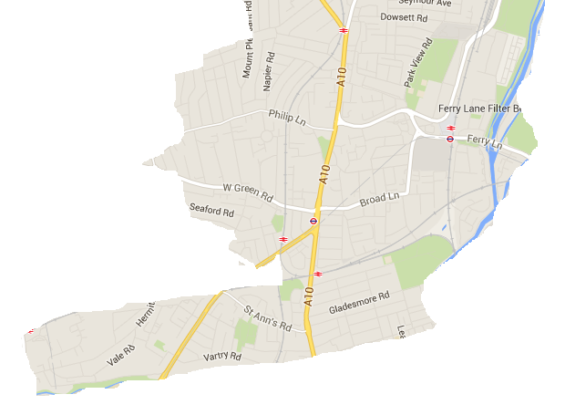
The Geographic Area

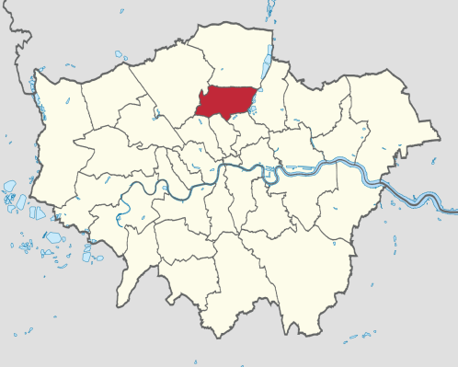

Figure 1: Maps to highlight the area concerned, clockwise from the top: the area in which this plan will apply; Haringey’s position in London; and where these areas fall within the London Borough of Haringey

The area covered by this plan includes the following wards in South Tottenham in their entirety: Tottenham Green andSeven Sisters,and also parts of both Bruce Grove and Tottenham Hale wards which are most applicable as shown on the map above. These are all within the London Borough of Haringey situated in north London.
The LBH Plan for Tottenham has highlighted that this is an area which has high public land ownership and low land values. South Tottenham is a key strategic growth area within the Upper Lee Valley Opportunity Area and the London-Stansted-Peterborough growth corridor. It is well connected by road and rail to the City and the West End of London.
The Plan for Tottenham outlines that Tottenham’s economic geography is based upon various centres of economic activity on the transport corridor of the High Road (A1010) which connects Tottenham and the M25, the City and central London. These centres include Tottenham Hale and the gateway to Tottenham at Seven Sisters in the south.
Whilst IVO already have connections with the four wards of Tottenham Green, Tottenham Hale, Seven Sisters and Bruce Grove there will also be a continued focus on the closest estates of: Hale Village, Ferry Lane Estate, Chestnut Estate,Markfield Estate, Broad Lane Bruce Grove, andHigh Cross estate.
These four wards are covered due the spread of current connections that IVO has in these areas as well as the spread of estates and areas of both need and opportunity within them. The proposed hub sits at the edge of Tottenham Green Ward,whilst in Tottenham Hale Ward across the road has both a retail park and estates with residents who use their services
population trends have estimated that by 2028 the population in the four wards will be 73100, a growth of 42% of the population in 2001.Whilst the area is a facing a number of issues such as deprivation, growing inequality and poor health, it has good transport links and the opportunity of regeneration plans.
There is a strong case for the Hub, which would link public, corporate and community services together and link local people to local employment and enterprise in the Tottenham Hale area.
There are a number of social housing landlords present within the area including Homes for Haringey, Newlon, St Mungos and Circle.
This plan aims to build upon these links to strengthen existing connections but to also reach out to the Retail Park and new developments occurring as part of the regeneration. Through doing so IVO will be able to ensure that the local economy is strengthened through residents benefiting from and being able to seize opportunities from developments in their area, as well as developing a range of social enterprises to meet the needs of the community and develop a culture of social entrepreneurs. A community hub will help share innovation and creativity and facilitate peer support and involvement as well as being a central point for those providing services and support around employment and enterprise.

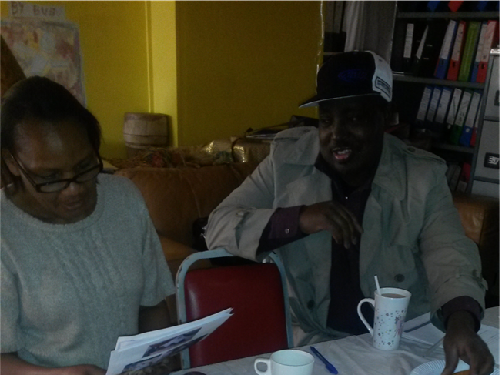

Outcomes

What is the vision?
IVO’s vision below was set out by its volunteers, along with partners attending two of the partnership meetings held. As stated in the introduction the vision is:
“An empowered, skilled and confident community creating a
culture of enterprise and employment as well as awareness of environmental issues leading to increased health and well-being
and the relief of poverty “

In order to consider the full impact of this vision IVO need to consider outcomes (or positive changes) that will achieve social, economic and environmental benefits both in the short and long term.

Social Benefits
Short Term - up to 1 year
Building Confidence:IVO will work with residents by running series of workshops to help to initially build confidence.

Raising Awareness and Aspirations: IVO will map other agencies and opportunities in order to make the local community aware and deliver workshops and one to one sessions to raise awareness of opportunities and build the aspirations of community members.

Medium Term – 2 to 3 years
Encouraging Local Connections to Build Resilience and Tackle Social Isolation: The hub will create a space for new and old residents from across the four wards to come together and get the help and support they need. This will allow stronger local connections to be built.

Empowering Hard to Reach Groups to Access Employment or Enterprise Help: IVO has a strong connection within the local African and Afro-Caribbean communities of the wider plan area. Through using these networks IVO and their partners are able to access these harder to reach groups and tailor services to them.

Provide Opportunities for Women to Access Help and Advice: Within this plan IVO are responding to a local need for women to be able to have a safe place for children to play whilst they access services to apply for work or develop enterprise. Whilst they will still be responsible for looking after the children in their care, the business plan provides an opportunity for women to access help and advice at times in the day when their children can be there in a small play area.Their target service users are long term unemployed women,single mothers, people living with long term illness and the long term unemployed.

Build Upon IVO’s Knowledge to Become a Hub of Information: IVO are an established group within the community. By building upon this and developing the asset into a hub, there is the opportunity to encourage more people to use this hub for signposting to other services. This will be a starting point for entrepreneurs and access point for local providers to the hard to reach residents.

Long Term – 3 years’ plus
Encouraging and Enabling Women into Paid Work and Enterprise:By helping women to access services to develop enterprise and find out about employment opportunities, the Hub will create long term opportunities for women to be better able to support themselves and their families.

Encouraging and Supporting Businesses and Services that Reflect Local Need:By helping local people to develop enterprise the hub will create a space which will allow businesses and services in the area to reflect upon local needs. In this way small local businesses are better places to respond to the unique multicultural needs of the wider plan area.

Encouraging an Increase in Volunteering:The IVO hub will encourage an increase in volunteers both for IVO and other local community organisations. Whilst this will have a positive effect on volunteers’ employability, it will also create a positive social value for South Tottenham.

Economic Benefits
Short Term – up to 1 year
Investment drawn into the area through fundraising:IVO are applying for a number of grants and will draw funding into the area.

Establishing and business planning around the CIC (Community Interest Company): During this first year IVO plan to establish their CIC and carry out further planning based on the connections highlighted above.

Medium Term – 2 to 3 years
Help Residents into Sustainable Employment: Through helping residents into sustainable work the hub will help to increase the income of local residents.

Encourage a Culture of Enterprise: By the provision of a space with training, support and hot desk facilities there will be the creation of a can do culture where people can gain confidence and experience in developing either social or business enterprises.

Have a Better Skilled Workforce: This plan will involve linking users to training opportunities or undertaking some training within the centre. A better skilled workforce locally will encourage positive social outcomes.

Long Term- 3 years’ plus
Keeping Money in the Local Economy:Through the creation of local enterprise there will be more opportunities for local people to spend their money where it will stay within the community. In building connections with the Retail Park and helping local residents find work locally this will ensure that local residents are able to financially benefit from the money that is being spent within this space.

Help Create New Businesses Leading to More Local Jobs:By helping local people to create their own enterprisesthat will grow when successful and a greater number of local people will benefit.

Save the Public Purse Money: Through helping people into work there will be a considerable saving to the public purse. HACT have estimated that for each person who is helped into full time work the saving is £10,767, and for each person helped into part time work the saving is £1,229. For those who are helped to develop their own business and become self-employed the average saving to the public purse is £11,588. For each regular volunteer the value is £2,357.For the vocational training that IVO will help to link residents to the value is £1,124, and for each employed parent of a child (11-15) the value is £1,700. This shows a large social value provided by this work.

Ensure New Enterprise is able to Survive: Many new businesses find the first few years challenging. Creating a space where they can access tailored advice and support will aid businesses to grow and thrive

Ensure that Parade of Shops Where the Hub is Becomes a Thriving Community Space:The IVO hub sits on a parade of shops which is currently facing decline. Whilst there have been a number of attempts of businesses to grow within this space they have found this difficult. Through the hub being a vibrant space that encourages people to the area there is an opportunity for this parade to be better used. There is also the potential for enterprise supported by the Hub to become paying tenants of this parade and benefit from this effect.

Create a Model for Use Elsewhere:This plan for a community hub led by a community organisation and partners hopes to become a model for success to be implemented and built upon across the borough. In this way the hub can have a knock on effect for other local economies in north London.

Environmental Benefits
Short Term- Up to one year
Forge Links to the Wider Regeneration Context:IVO will use this opportunity to build better community links to ensure long term sustainability.

Integrate IVO better in local decision making structures: This will work to ensure that IVO are able to take an active role within local decisions that are being made.

Undertake an Eco-Audit of the Hub: As part of the refurbishment of the Hub,IVO will apply to the City Bridge Trust for a free eco-audit. This will reduce running costs for IVO as well as provide an environmental benefit of reducing energy loss.

Medium Term – 2 to 3 years
Ensure the Building is Well Looked After:IVO are currently looking after this site and a refurbishment of this space will ensure that this building is well cared for and is used for the benefit of the local community.

Help Local People Get Jobs Close To Home To Cut Down On Travel:By helping residents to gain employment locally and start their own enterprises then they will not have to face travel which is costly financially and environmentally. This will be promoted through IVO encouraging active travel with residents walking or cycling to the hub and to work.

Long Term- Three years’ plus
Build more local jobs to cut down on travel to work:Through helping enterprises develop and linking local people to local jobs there will be the creation of more local jobs ensuring that local residents will not need to make long journeys to work.

Planned Activities

Activities for before the hub opens
Build partnerships to support the Hub long term
- Development of new networks and strengthening existing of IVO’s networks

Develop the Hub
- Fundraise for start-up costs
- Refurbishment of hub

Business plan for long term sustainability of the Hub
- Market research to establish paying demand for services
- Additional research on local employment withmore links with job centre plus and regeneration team and business start-up needs
- Research with local businesses

Activities for opened Hub
2016 -2018
Between June 2016 – 2018, once the Hub has opened IVO will aim to provide:
- Co-located community space - The Hub will be a location in the community from which partners and other agencies can deliver projects, provide services or consult with the community in exchange for sharing the running costs of the Hub.
- Meeting & training room hire -Single large room can hold 20 people seated, 30-40 standing. Also possible to divide into 2 smaller spaces. When enterprise and employment support or hot desking services are being delivered, room hire will be limited.
- Equipment hire - Currently African drums and artefacts are available to hire from IVO to community groups. This offer will develop as demand is identified and opportunities spotted.
- Elders social evening - These will be set up with the aim to have 20-25 people attending at £2.50 a head. Once the social evenings have been established IVO will then develop a digital inclusion training subject to funding.
- Hot desking -After the refurbishment the Hub will be able to offer desk space in the meeting room space for 3 days a week. These desks will come with power, free internet and access to computers if required. This will be rented out to be people for hot-desking with an extra charge for copying and printing.
- Enterprise support - Subject to being awarded grant funding IVO will run a pilot project to develop enterprise support with the aim to develop a social enterprise incubator at the Hub.
- Financial inclusion & budgeting classes - Subject to being awarded grant funding IVO will run a pilot project to develop financial inclusion and budgeting support.
Future developments, 2018 onwards
IVO aim to carry out the following activities from 2018 (they are however dependent on demand and funding):
- Budgeting classes – This is reliant on funding but with the aim of being a service that will be provided free at the point of delivery subject
- Employability support – IVO’s aim is to deliver a project that runs 2 days per week to a cohort of 15 people each 6 months. The service will develop participants' confidence and employability skills such as interview techniques and CV writing. They will also undergo English and numeracy assessments. At the end of the 6-month phase, participants will be matched to employers with vacancies or opportunities through JobCentrePlus. They will also be provided with ongoing volunteering and work experience opportunities plus assistance with job searches.
Each week,1 day of the project will be focused on personal development, delivered by the project management staff team, and 1 day will be focused on technical employability skills delivered by a specialist. Participants will also be able to access hot desk facilities while on the programme. This project will be delivered in the main hot desking/meeting space 2 days a week.
- Enterprise support – Subject to funding and demand IVO are aiming for a project cohort of 5-7 people. These people will access one-to-one support 1 day a week for 6 months and carry out self-directed work on their new businesses during the rest of the week. Personal development support will focus on English language and building confidence. Once a month group sessions will provide specialist support and advice. This activity will be delivered in the front office and/or hot desk/meeting space.
- After school club – IVO need to carry out further market research among the community to establish demand and ability to pay for this service however IVO are aiming to provide a supervised homework club 2 days per week from 4 – 6 pm. This activity will be delivered in meeting room/ hot desking space.
- Piano lessons – IVO has a piano and will carry out feasibility and market research to establish if this asset can be turned into modest income generation and a service to benefit local children.
Creche facility – This is not a service in its own right, but feature of delivery, comprising of a play space in the front office for people to leave their children while they are using the employability/enterprise service. This facility will address a significant barrier for their users in accessing the services and will only be available to people using those services.

Business Case for Activities

The offer
The Hub will provide a space in the community where people can access advice and support, access to meeting/training rooms, hot desking and some social activities.
- IVO is rooted within the local community, physically and culturally, and is able to provide translation and interpretation into French, Somali and Arabic.
- The Hub will provide access to “hard to reach” communities through existing contacts and provision of a site where agencies can come to the community rather than trying to get the community to come to them.
- IVO's ability to effectively access the community makes them an ideal partner for projects addressing labour market disadvantage, entrepreneurialism & regeneration e.g. though EU funding.
- The Hub will be cheaper than other room hire offers in the area.
- The existence of the Hub with a secure tenure will provide the launching pad from which IVO can start other activities or projects and draw down extra resources to improve the area.
- For other agencies and partners, the Hub provides added value from complementary service delivery, leveraging more resources into the community and making the most of the human potential within the community.
Co-located community space: Considerably cheaper than hiring office space that is not always in use. It is located within the community and is accessible.
Meeting and training room hire: Research indicates that there is no local hall that is cheaper than £40 per hour. TChances is fully booked at the weekends (£60 per hour). The Dream Hall Town Hall Approach is £1500 for either morning or afternoon - underutilised local residents cannot afford this rate. Bernie Grant Arts Centre (£50 -60 per hour) is underutilised as local residents cannot afford it.
Equipment hire: Existing customers. Unaware of any comparable offer.
Elders social evening: Nothing comparable exists since the Caribbean centre closed.
Hot desking: 369 High Road Enterprise centre. Too expensive. But potentially better location. This is attracting already established enterprises.

The market
Service | Market
Co-located community space | Housing associations  Haringey Regeneration team  Aim to have them involved as partners
Meeting & training room hire | Local community groups and individual members of the community  As competitor analysis indicates, the market cannot afford existing rooms available  Existing customers use on Saturdays and Sundays (BunyoroKitara Development and Cultural group, Tooro).The association has been using the site for free but will now pay the subsidised rates.
Hot desking | Grant funding to run pilot and establish demand before charging directly to:  - Local entrepreneurs  - Local social enterprises  - Local community groups  A local solicitor has already indicated desire to purchase 1 day a week and will make a prepayment.
Equipment hire | Existing customer: St Mungo's hires drums once a month paying a fee of £50.  Potential for others to hire but not factored into business case as marginal.
Elders social evening | Elders in local community  20-25 people used to regularly attend sessions & pay £2.50 each in Caribbean centre. Used to run twice a week indicating sufficient demand for weekly.

Future developments
After school club | Parents are requesting this service but currently not in a position to pay for it due to unemployment. As such this requires further market research.
Employability support | Grant funders  Market research indicates JCP and Housing Associations unlikely to be customers at this stage.  Potential for social impact bonds once capability can be demonstrated.
Enterprise support

Piano lessons | Parents
Budgeting classes | Grant funders
Creche facility | Users of the above services (free facility)

Dance ACTIVITIES ARE HIGH ON DEMAND BY YOUNG PEOPLE AND ELDERLY
During our first phase getting the hall ready for dance is High on agenda

HACT (2014) Measuring the Social Impact of Community Investment

