BUREAU D’AIDE AU DEVELOPPEMENT COMMUNAUTAIRE EN RDC ‘’BADEC-RD CONGO
REPORT OF THE PROJECTS CARRIED OUT BY THE DEVELOPMENT ASSISTANCE OFFICE IN DR Congo''BADEC-DRC
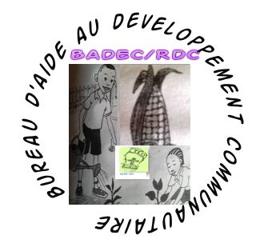
Contexte
Kalonge is an area next to the National Park KAUZI BYEGA crossed by old extinct volcanoes. In addition, this is an area where there has been over time a multitude of armed groups that have left the population in the socio-educational vulnerability (children have not studied for years, burning of schools and offices ), socioeconomic (looting), social (poverty, lack of youth activities, community conflicts, sexual violence, child soldiers ...)
At Kalonge, BADEC-DRC is implanting to Cifunzi and FENDULA, the feet of patients are numerous according to statistics from the Health Zone. We saw some patients' feet. We then found a room in which the feet of the sick will gather every Saturday with the. In this room we will pay $ 20 a month.
I. IDENTIFICATION PROJECT OF THE MOSSY FOOT IN THE ZONE OF HEALTH OF KALONGE, THE GROUPING OF KALONGE, TERRITORY OF KALEHE, PROVINCE OF THE SOUTH-KIVU, DRCONGO
LASTED OF investigation : October 2014 nowadays
Materials used : One camera used in the hold of the pictures, of the pens, the notebooks, a computer, a motorcycle and a vehicle by public tryearsportation, ,
OBJECTIVES OF THE PROJET : to Identify and to count the patients of feet in the zone of health of Kalonge
ACTIVITES : Sensitization, focus groups, visit at home, take photo and commentary, registration,
PRESENTATION OF THE MIDDLE :
- Kalonge is situated in the territory of Kalehe to 60 kilometers of Bukavu.
OTHER PROBLEM IDENTIFIES S: ADDUCTION OF WATER, CONSTRUCTION OF THE SCHOOLS, LITERACY, NON HANDLING OF THE PATIENTS OF FEET AND DEAFNESS, THE FAMINE , SEXUAL VIOLENCES DUE TO THE GROUPS WEAPONS
PHOTO ALBUM MOSSY FOOT
1. BUJENIA MWAMUHIZI | 2. KASHALUKABURHUNGANE | 3. BIRINDWA NYAMULIRI | 4. M.MATANO marijuana
Age : 60years / She/it doesn't know what she/it will offer to the Lord once healed. We want a CLINIC IN KALONGE | 75 years / having suffered a long time know if he/it can heal because not of organization for his/her/its handling | 52years / healer of this illness will come of where because we were in all sanitary structures but in vain | Aged: 50 years / I Like and MOSSY Foot I return thanks to the Lord for what he/it will make to heal me
Adress: LUSHENYI/CIFUNZI | KASHUNO/RAMBO | BUHWIZA | KASHUNO/RAMBO
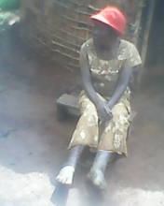 | 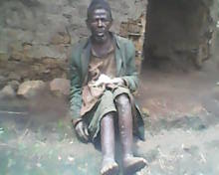 | 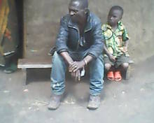 | 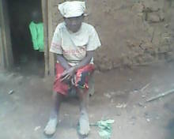
5.MWAKABESHA | 6.NAMAVU MWAKAHARAGU | 7.KALIPALA MUSHARHAMINA | 8.ELIA BAHWINJA
Age:56 years heals me I will make a small trade for my family's survival | 40 years / I will make once testimony healed because I will be in good and in measure to work for my family | 75 years/ healed time, I will have strength to work for my family. | 13 years/ I like MOSSY FOOT because once healed I will continue my scalarity, my year.
Adress: LUSHENYI/CIFUNZI | CIFUNZI/MUSHADU | CIFUNZI/BUGULI | MISINGA RAMBO
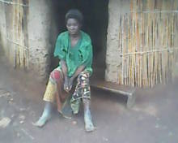 | 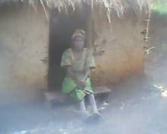 | 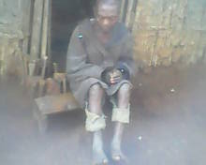 | 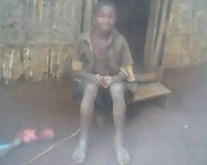
9.BACIBOLA KASHIGE | 10.TULIA MWANDAHAKANA | 11.NAMAVU MWAMULAGO | 12.MUKUZO MWAKAGOLO
Age:45years/ healed time, I will be to take my family in charge | 60 years / once healed, I will occupy myself of agriculture and my children in profiront for their scolarity | 64 years/time gueri,i won't be anymore discrimxé in the society because my feet will be réhabités | 74 years/My worry that I am healed because nomreuses people believe that I was born like that.
Adresse:BULUNGU/CIFUNZI | MUSHINGI/CIFUNZI | CIFUNZI | BUMOGA/CIFUNZI
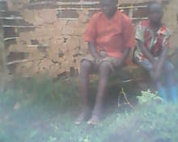 | 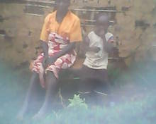 | 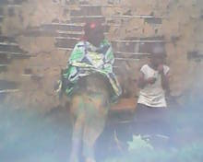 | 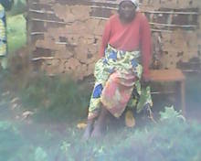
13.MUKENGERE NAMUSHOMBO | 14.SINAWAZIE NAMUGUSHA | 15.NABIRAGI MWACIRWIZA | 16.BASHIZI KARALO
Aged :60 years/ capable to reach where a healed flois I won't fail to glorify the Lord because he/it will have made me respectable in the society in which I was rejected | 46years/ My hope of recovery stays in the Lord who gave the vision to treat the patients of feet in the Dr founding Barlow,le of MOSSY FOOT PROJECT | 70years/ Very engaged / recovery doesn't have an age.toute person has right to the life .I like MOSSY FOOT | 70 years we ask the Lord heart the one that had had the initiative to take care of the illness of FOOT
Adresse:BULUNGU/CIFUNZI | BUSHAYI CIFUNZI | BUGULI | LUHENYI/CIFUNZI
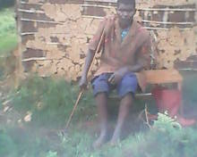 | 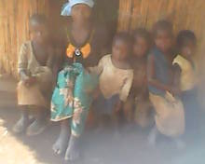 | 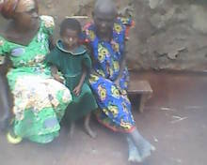 | 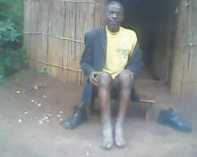
17.NANKAFU M.BIRENGWE | 18.FAIDA MWAMUSHASHIRWA | 19.MUKUZO MWASHANDA | 20.Pascasia NABINWA
Age:50 years / The reinstatement in the society por I am one of my priorities because my feet are in situation of total destruction | 55 years / Several years of suffering, I will work for the Lord and my family after my recovery. | 60 years / That can again treat us this illness of feet because we became in particular of mockery topic in niotre village and in our country in general | 63years / How we will welcome the one that will arrive to Kalonge to take care of us our illness of feet because we suffered a long time from this illness in the RDCongo
Adresse: MULE | KALAMBO/RAMBO | MUSHADU/CIFUNZI | BUSHAI/CIFUNZI
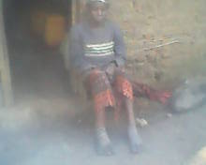 | 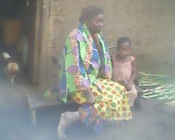 | 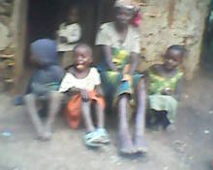 | 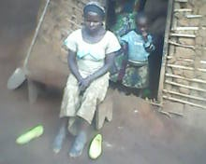
21. RIZIKI Georges | 22. NOELA MWAKASHAMBALA | 23. FARIJI Samuel | 24. FRERE FARIJI Samuel
Age :15 serious years/ very, don't hope if she/it will find some care one day to his/her/its age. We cried while seeing it. | 40 years/ sums of the men as you, have a compassion towards us | 15 years Very engraved and disappointed of this illness and assimilate the illness of foot to the Sorcery. . Same parents that N024 | 13 years/Very disappointed of this illness and assimilate the illness of foot to the sorcery. Same parents that N0 23
Adress:MAGEYO/CIFUNZI | MUHUMBA | MISINGA/RAMBO | MISINGA/RAMBO
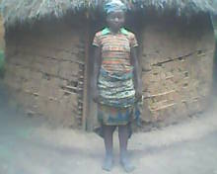 | 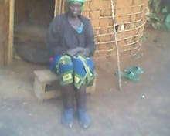 | 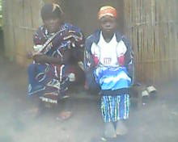 | 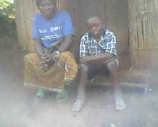
25.MAPENDO MWAKABIRUNDU | 26.ZIRHUMANA MWABIRENGWE | 27.NSIMIE MWAMAROGEZO | 28.FURAHA MATABARO
50years/ Once in history. never had any sponsors to take us in charge. | 35 years/Je is jailed and I am ashamed to present before the healthy people | 22 years/ Very engraved because no of care at the priest by whom she/it hoped for the suitable care | 24 years  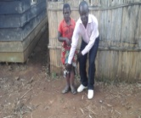
FENDULA/CHEZ MWAMI | CHOLOBERA/CIFUNZI | FENDULA/NTULO | KARAMA/CIFUNZI
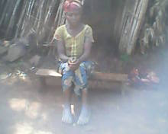 | 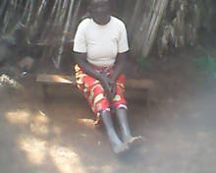 | 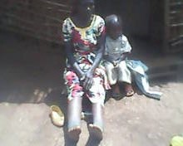 | 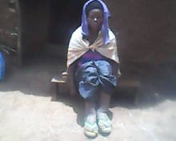
29.MAWAZO M. MWAMAROYI | 30.NAMUKURU M.KAHUNGU | 31.VUMILIA M.KAMPANDA | 32.Rgine MWAMUHIZI
45 years | 40years | 27 years | 50 years
KASHESHA/CIFUNZI | KASHESHA/CIFUNZI | KASHESHA/CIFUNZI | LUSHENYI/CIFUNZI
33.FURAHA M.KABIRUNDU | 34.NANTEMBU MWANKAMBAZA | 35.NZIGIRE MWABIRENGWE | 36.BURIKI LUHASA
35 years | 60 years | 24 years | 35 years
FENDULA/NTULO | CHOLOBERA/CIFUNZI | CHOLOBERA/CIFUNZI | CHOLOBERA/CIFUNZI
37.BAGULA NYAKADEREKA
62 years
We started a tour from 09/15/2016 until 26/09/2016 to Kalonge Bunyakiri and Idjuwi to visit MEMF-DRC activities and especially feet patients.
Let me tell you a surprise to experienced Cifunzi / Kalonge. We were staying at the Director KABAMBA of School Kalonge. Feet of the sick came to greet us and pray with us. At the time of taking pictures, the Director KABAMBA also came knowing it was entered to attend the meeting .At the time of asking patients to show their feet, now is the Director will also declare that he is sick of the feet
We had a brief contact with the area chief doctor for vision for DRC-BADEC he was very interested and promised us support this vision for him is an innovation in the Democratic Republic of Congo.
We also had meetings with , teachers. Here are some pictures below-under:
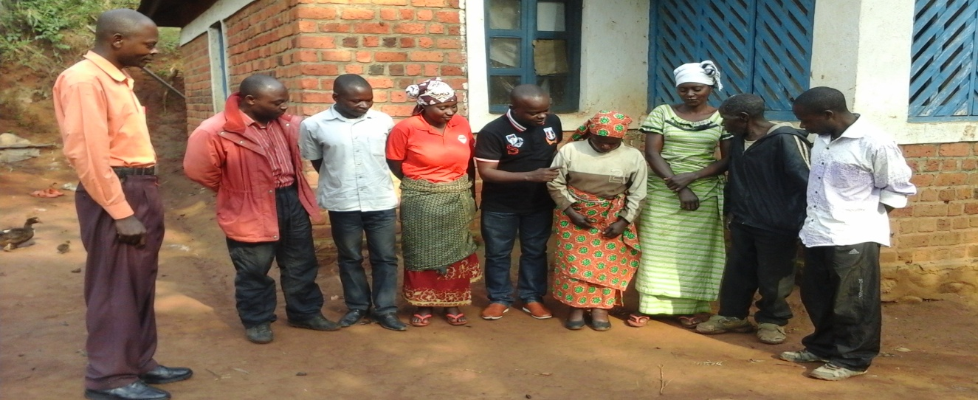

We were in Bunyakiri for contacts with the health authorities, they were very satisfied with the vision BADEC-DRC. These have shown us that the most affected by this mossy foot disease is Ziralo which is on the border with the province of North Kivu. These patients are left without medical care. Bunyakiri is 50 kilometers Kalonge and has almost the same soil characteristics, social, socio-educative, sanitary, ... that Kalonge
Our visit with my Wife WAMUKIKA BITONDO Collette ended with Idjwi to BIRINDI where Muhindo Munguiko began a BADEC-DRC including the following Sunday of images, the 09/25/2016. After worship we visited a mossy foot sick. His name PULEKERIA MWAMONI which here are our pictures taken with it. 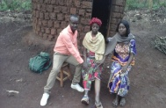

We have had meetings with local leaders and health officials on the vision MOSSY FOOT, all were interested. At the Health Zone Idjwi statistics show that the feet are many sick and abandoned.
At the Hopitalal Provincial General de Bukavu, the foot patient KALUME is hospitalized and abandoned without taking charge. The amputation of his foot is a solution to save his life. The President of BADEC-RD Congo has come to make it visit .
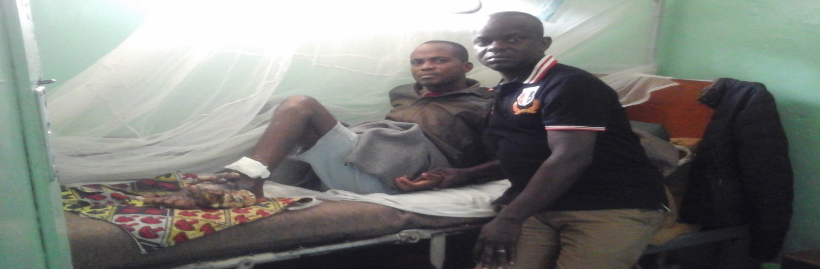

Among the activities of BADEC-RDCongo, is the project of food security in its experimental field of Cifunzi. On September 22, 2016, the Chairman of the Board of Directors of BADEC-DR Congo, on a mission to KALONGE, visited this field under a heavy rain. On his right, Mr. MASUMBUKO Jean, KALONGE, and to his left, Mr. Freddy in charge of projects in this sub-coordination. The president of this under-coordinated Mr. Buchakuzi being ill.
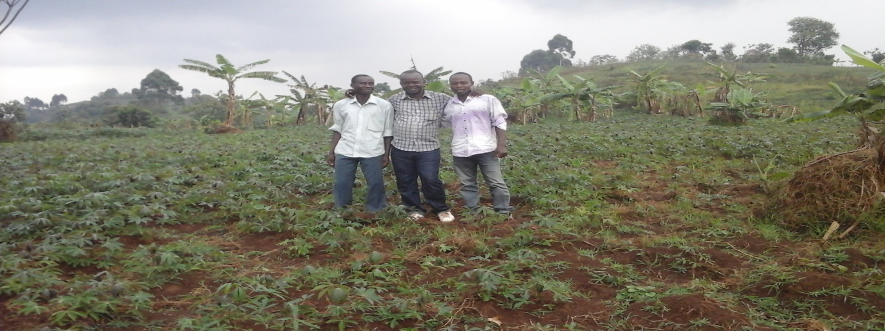
On the same occasion of his service mission to Kalonge, the Chairman of the Board of Directors went on to explain the vulnerability of the majority of Kalonge populations. Widows and abandoned orphans have only the dried leaves from bananas when they are sold to the market, as is illustrated by the images below
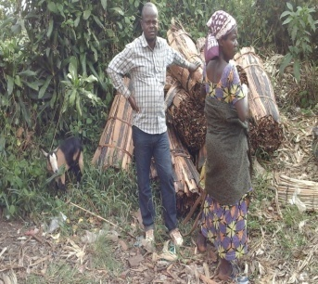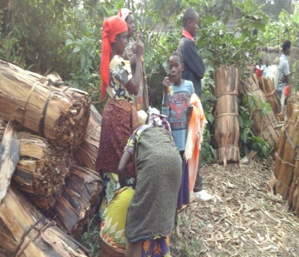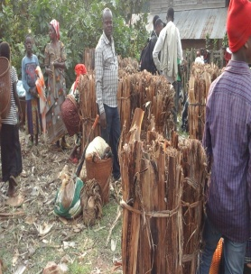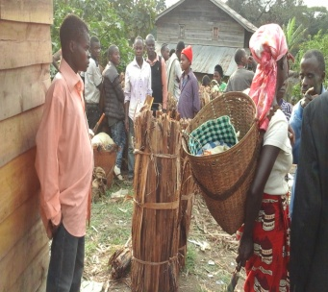
Photo of the President of the Board of Directors of the Development Assistance Office in DR Congo with children, Pygmy women in Idjwi
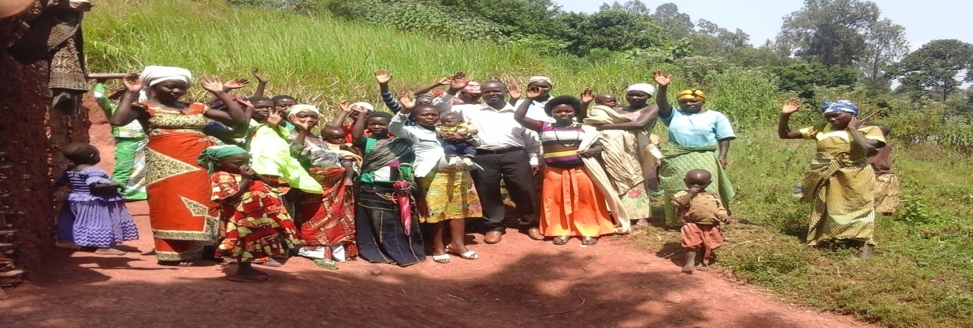

Remittance of soaps and salt to Pygmy leaders in IDJWI / BOMONVU by BADEC-DRC
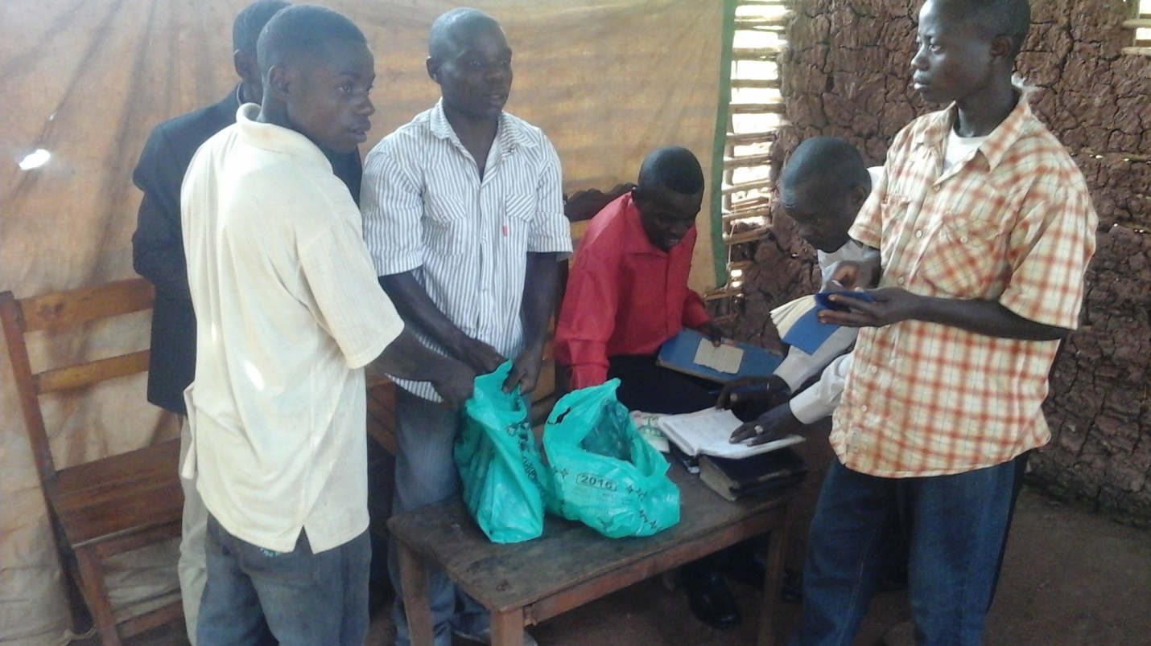
Habitats of KALONGE
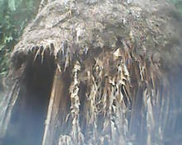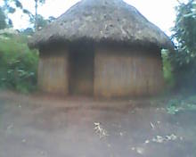
Done at Bukavu this 22nd day of April, 2017
THE PRESIDENT OF THE BOARD OF DIRECTORS OF BADEC-RD CONGO
KALAKUKO KYETILE Edouard

