C.S.F.N
“राष्ट्रको लागि एक कदम”
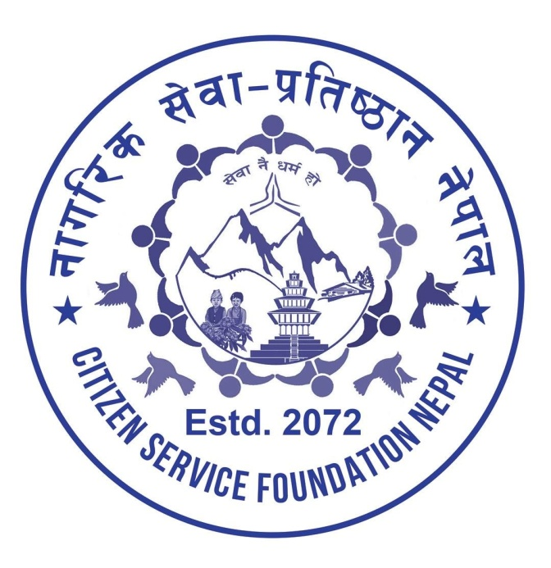

Ward No; 34, Shantinagar,
Kathmandu Metropolitan City,
Kathmandu shantinagar -07,
Kathmandu, Nepal

Social Service Organizations

Workflow/Responsibility
Checklist/assessment form | Responsible for ensuring documents are completed and attached
I . NGO profile | Non-profitable organization
II . HACT Assessment checklist | Head Of Section, Or PO Responsible For  Managing The Project- Mr. Dilman Shrestha/  Project Specialist - Ms. Rumi Pote  Senior Finance Assistant – Mr. Rupesh Adhikari  Operations Manager- Ms. Dhurba Khanal
III. NGO Programme and Financial Management Assessment and Evaluation | Same as above
IV. NGO evaluation of previous experience | Programme Specialist – Ms. Dhurba Khanal
V. Final checklist - review of completed documents | Deputy Representative  Operations Manager
VI. Contractor | Registered with Nepal Government

CSFN is pleased to present you with this welfare proposal for the “Building Construction Work” project. Having duly examined your situation, we are confident that our proposed services will effectively address your support.
Proposal Submittal | Supplier Selection | Project Start | Initial Review | Project Completion
1st September, 2017 | [DATE] | September,2017 | September ,2017 | October, 2017
- Timeline Requirements:

Cost Breakdown
Based on Civil Engineer Mr. Pradhumna Shahi analysis of your needs and the nature our proposed plans, the total funds required are estimated at cost breakdown is detailed in the table below.
Estimated man-hours: 210 hours
Total estimated project duration: 30 days.
sn. | Particular | Amount (USD)
 | Wall | 15000
 | Colouring | 3000
 | Door | 1500
 | Window | 1200
 | Administrative Charges | 2000
 | Miscellaneous | 3000
 | Global Giving Charges | 3855
 | Total | 29555

Thank you .

