O P T I M I S T O R G A N I S A T I O N
A Rescue Foundation

B U D G E T S H E E T

Account Office: Abha Bhar, B. Com
Chief Executive Officer: Phool Singh Dagar, BA
Project: Budget Sheet Emancipation Weeping Girls From Sexual Abuse

S.No. | Particulars | Costs in INR |  | Year 2017  Costs in USD
Activity Expenses A
 | Investigation & Rescue Plan |  | 169,600 | 2,650
 | Nutritious meals for Survivors |  | 224,832 | 3,513
 | Livelihood Training with Tools |  | 141,504 | 2,211
 | Shelter Assistance |  | 140,544 | 2,196
 | Legal Aid |  | 74,560 | 1,165
 | Health Care at Hospital and Home |  | 69,632 | 1,088
 | Counseling Program |  | 105,664 | 1,651
 | Documentation & Reporting |  | 85,248 | 1,332
 | Contingencies |  | 24,640 | 385
Total costs |  |  | 1,036,224 | 16,191

Administration Expenses B
 | Project Coordinator | 60,000 | 937
 | Accountant | 30,000 | 468
 | Doctor (Part Time) | 24,000 | 375
 | Field Educator | 24,000 | 375
 | Field Office Rent with Furniture | 18,000 | 281
 | Display Board 10x15 for Office Site | 20,000 | 312
 | Electricity & Telephone | 12,000 | 187
Total costs |  | 170,000 | 2,935
Expenses |  | Cost in INR | Cost in USD
Activity Expenses |  | 1,036,224 | 16191
Administration Expenses |  | 170,000 | 2935
Total |  | 1,206,224 | 19,126

Verified By;

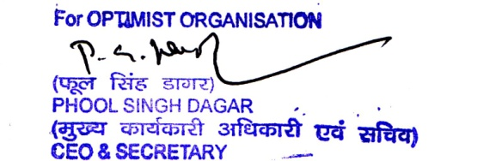

Phool Singh Dagar
CEO

OPTIMIST ORGANISATION
Kh. No. 59/64 VPO Malikpur, Block Najafgarh, New Delhi-110073, INDIA
Tel: +919891812236 Fax: +919211642806

Date and Place: 28th August 27, 2017, Delhi

