Raphael’s Children’s Charity (RCC) STRATEGIC PLAN 2017-2020

BACKGROUND
Raphael’s Children’s Charity (RCC)
RCC is a charity organization with qualified and experienced members, volunteers and staff committed to improving children’s health, education and general well being especially in the rural un-privileged areas of Uganda.
Raphael’s Children’s Charity (RCC)
The organization was formed on the 26th October 2016 by two sisters who saw need to help children especially those who go a day with ought a meal and only survive on the wild fruits and plants that grow in people’s back yards. A child’s performance in life is always reverted back to whether they are happy and comfortable from where they come from
VISION
We envision an empowered community free of poverty and every child with at least an education level that can help them sustain their future
MISSION
To improve the welfare of children and youth using community based initiatives
MOTTO
A happy child makes a brighter future
Our objectives;
Helping the sickly and malnourished children; this includes providing routf to the malnourished children that will help boost their immunity, providing multi vitamins, providing food items, providing mosquito nets, fumigating among other health needs.

Clothing the needy; this includes providing slippers, shoes, clothes and beddings for those in need.
Feeding the hungry; we provide immediate food supply and plan for sustainable methodologies of creating food security for the families that are not able to look after themselves.
Educating the unlearned; Includes providing stationery, paying full or partial school fees depending on the ability of the parents, providing school utilities including chalk, black boards and furniture among others
Basic health skills; this includes printing of different health information, holding health skills lessons and training for both children and parents and counseling among others.
Core Values
We value honesty, transparency and accountability in our actions and work. We value respect for people we serve. We value excellence and integrity in our work and have a spirit of volunteerism and team work. We value the happiness and well being of children and youth. In summary, we the commitment to improve the quality of life for children and youth and realization of our vision
INTRODUCTION
The introduction of Universal Primary Education (UPE) in Uganda has seen a surge is enrolment which has resulted in a Gross enrolment Ratio of 113% (F=113%, M=113%) and the Net enrolment Ratio of 92% (F=92% M=92%) (EMIS 2013). There is however a big disparity between the primary school enrolments in grades 1 and 7, which points to the low survival rate for children in the education system in Uganda (WORLD VISION UGANDA2016). The other problem is the quality of education as shown in the UWEZO report of 2013 which shows that only 40% of children are able to read and write at P3 and P6. Building on the successes to-date and the on the fact that quality education is the prerequisite for achieving equity, the focus will be ensuring that children are able to read and write at all levels and that there is improved retention in schools. The role of parents and family support for learning will also be an integral part of education programming. The high school dropout rate and the high unemployment rate in Uganda demand the need for out of school programs. As a result the education programming will also include life skills.
The 2013, Uganda Annual Crime Report showed that children continue to be vulnerable to abuse, neglect and exploitation. Child neglect, defilement and domestic violence were reported among the top

10 leading crimes in Uganda (Annual Crime Report 2013). Child marriage continues to be a major problem with 12% of young girls getting married at 15 years of age while 57% are married by the age of 18 in Uganda (UNICEF 2014). On a sad note, the Adolescent Birth Rate is 156 per 1000 women (UDHS 2011, UNICEF 2012). In rural areas, Children in rural areas are more affected by child marriage at 33.1% compared to their counterparts in the urban setting (UNICEF 2014). This makes child marriages one of the critical child protection issues in Uganda. In Uganda, only 30% of the children are registered at birth and only 1 in every 5 children has a birth certificate (UNICEF2014). Although government has ensured the legal frame work to guide child protection programming is in place, implementation still remains a challenge. This coupled with cultural norms that are harmful to children exacerbates the child abuse. The focus in this strategy will be the elimination of Child Marriage and that every child has a Birth Certificate.
Although Uganda is making steady progress on improvement of child health, it has made limited progress on maternal mortality. Annual rates of reduction of under-5 mortality increased dramatically from 1.2% per year to 8.1% per year between 2006 and 2011 against a target of 10% reduction per year for MDG 4 (MDG Report, MoFPED, 2013). Infant mortality rates followed a similar trend but Uganda’s neonatal mortality rates have remained largely stagnant. The country is off track for MDG 5 with maternal mortality reducing by a percentage decrease of 13.4% between 1995 and 2011 compared to the reduction of at least 75% needed to meet MDG 5 (MDG Report, MoFPED, 2013). (WORLD VISION UGANDA 2016) Poor nutrition accounts for 60% of deaths among children under-five years of age in Uganda with 14% of children being underweight and 33% stunted (UDHS, 2011). Micro-nutrient deficiencies also remain highly prevalent. Uganda has recently experienced a reversal in the gains made with regard to HIV prevention and control (UAIS, 2011). While Uganda has strong policy frameworks for addressing maternal and child health and nutrition and HIV, there are still huge gaps in the way these frameworks are implemented. The focus will be on systems strengthening for the elimination of maternal death and deaths of children under age of five in the areas where we work, improved child nutrition and zero HIV transmission of mother to child.
Most households in Uganda, particularly in the areas where RCC works, depend on agriculture and agri-business for their livelihoods. Agriculture (including livestock) is a core sector for food security, income enhancement and employment for more than 80% of Uganda’s population (FAO, 2013), majority of whom (68%) are small scale farmers. Subsistence agriculture and more specifically crop farming remains the main source of livelihoods (WORLD VISION UGANDA 2016) for small-scale farmers. However, the subsistence farming practiced is weather dependent and given the current weather unpredictability,

most households face challenges of absorbing and adapting to shocks. The factors that account for weak households’ resilience include; low agricultural production and productivity; low value addition to agricultural produce and limited market access. In addition, the inadequate implementation of agricultural laws and policies and the weak public agricultural institutions undermine household resilience (MAAIF, 2010). The result of this is that most households in Uganda do not consider smallholder farming as a business and this increases their vulnerabilities. In the next strategic period therefore, the focus will be on building household resilience including economic empowerment.

THE STRATEGY
The Goal:
To contribute to improved Protection and Sustained Well-Being of 400,000 Children, especially the most vulnerable by 2020
In the strategic period (2017-2020) the strategic objectives for RCC are as outlined below:
Education in our areas of operation in Uganda.
- To enroll 20,000 in non- formal education and 700 in vocational educational and 9,000 in early childhood development.
- Establish a systematic measurement of the children's academic performance in order to know what the impact is.
- Measurement of impact of non formal education and the conversion rate from non -formal to formal education.
- Provide an equal quality education opportunity for all poor and vulnerable children and improve the student turn up in schools.
- Improving the infrastructure in schools and creating a better education environment for students
- Provision of bursaries and scholastic materials for most in need
- Advocating for children rights
- Encouraging student leadership and helping almost all students get involved in school activities
- We place emphasis on removing the many financial, social, cultural and other systemic barriers that prevent children, including children living with disabilities, from accessing education.
Key Performance Indicators:
- Proportion of adolescents who have a learning opportunity that leads to a productive life
- Proportion of children (girls and boys) currently enrolled in and attending ECD centers
- Proportion of parents and caregivers who promote reading readiness at home.
- Percentage reduction of drop out for girls and boys.
- Proportion of children who have completed basic education in a structured learning environment;
- Children currently enrolled in and attending a structured learning institution
Core project Models:
Various projects to be implemented
Child Protection:

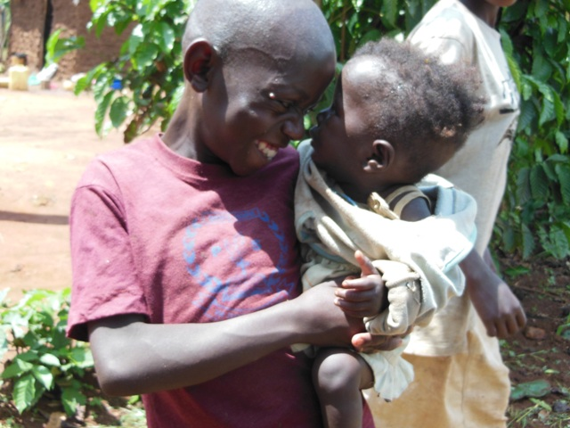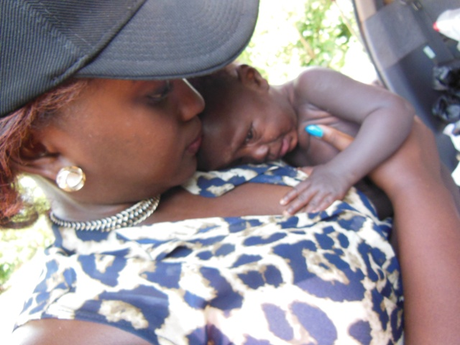
- Establish 70 child protection committees with 2,000 members trained and 8,000 children counseled.
- Reunite unaccompanied children with their families.
- Marginalized children to be provided with an income generation support with a target of 60% expected to successfully make a living.
- Children groups to be formed and children issues to be recognized in development programs.
- Providing a home for the orphans, neglected and abandoned children
- Feeding the hungry and improving livelihood for children
- Providing basic informal education to create a means of survival among the children staying alone with no adults
- To create an environment free from physical and mental child abuse, mental illness due to family negligence, segregation, addictions, incarceration, child labor among others
- Create an emotionally stable, social and educational foundation for all children in the home
Performance Indicator(s):
- %age of children and youth who feel that their community is a safe place
- % age of girls and boys who have experienced sexual violence in the last 12 months
- %age of girls or boys who are married or in union before age 18 yrs
- Proportion of children who feel that their community is a safe place
- Proportion of parents or caregivers who feel that their community is a safe place for children
- %age of children (0-18 years) with birth certificates disaggregated by age, sex and disability
- %age of community members including boys and girls that feel confident that CP actors will take appropriate corrective and or punitive action against perpetrators of child abuse ; Formal and informal community structures identifying and responding to peace and conflict challenges and opportunities appropriately
- %age of children who grow in their awareness and experience of God’s love
- Proportion of caregivers who report that faith leaders participate in the promotion of child well-being activities in their community
- %age of children who rank themselves as thriving on the ladder of life disaggregated by sex and disability
- %age of children and youths groups who report taking action to strengthen protection from the main child protection risks in the community

Core Project Models:
Various projects to be implemented
Health and nutrition:

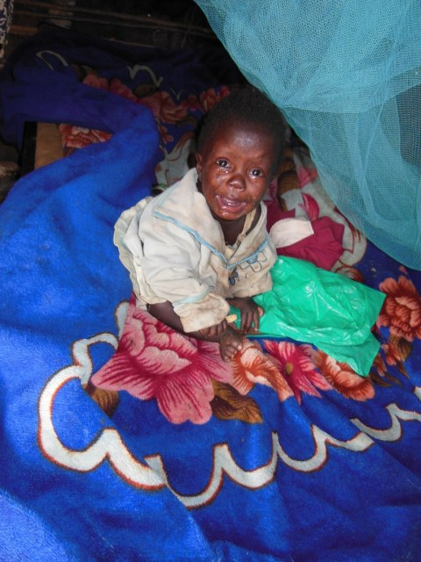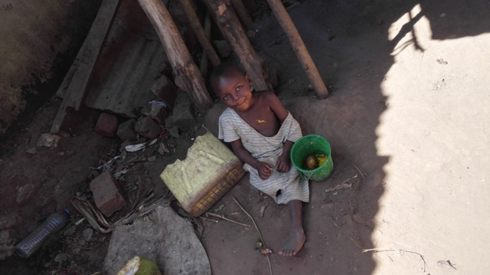

- Reduce the malnutrition rate to below 3.2% (below the emergency threshold)
- Concentrate on developmental support.
- Reach 10,000 children in 3,000 households with seeds, agricultural inputs and training.
- Register 50% increase in food production in over 80% of beneficiaries
- Ensure a healthy and clean environment with proper sanitation for all the families from which the children come.
- Continuous education about practices that promote clean and safe physical environments.
- Provide an adequate and reliable access to health services or first aid
- Encourage communal strong, mutually supportive relationships and networks
- Encourage land and water conservation practices
- Continuous and routine provision of community health and counseling campaigns that will bring services closer to the people
- Create different communal health projects that will get each and every individual in different communities to work together and create an awareness of proper health practices
Performance Indicator(s)
- No child dies before the age of five.
- Prevalence of underweight in children under five
- Prevalence of wasting in children under five
- Prevalence of stunting
- Proportion of children 0-6 months who are exclusively breastfed
- Proportion of mothers whose last delivery was attended by a skilled provider
- Proportion of New-borns who received postnatal care within 48 hrs of birth
- Proportion of infants born to HIV infected women who started on antiretroviral therapy (ART) within two months of birth
- Percentage of children aged 12-23 months who are fully immunized
- Proportion of children 0-59 months with diarrhea who received appropriate treatment
- Proportion of adolescents that report early to sexual debut
- Proportion of households with year round access to sufficient safe water
- Proportion of households with access to inclusive and sustainable sanitation facilities
- Proportion of households with appropriate hand washing behaviors
Core Project Models:
Various projects to be implemented
Food security;

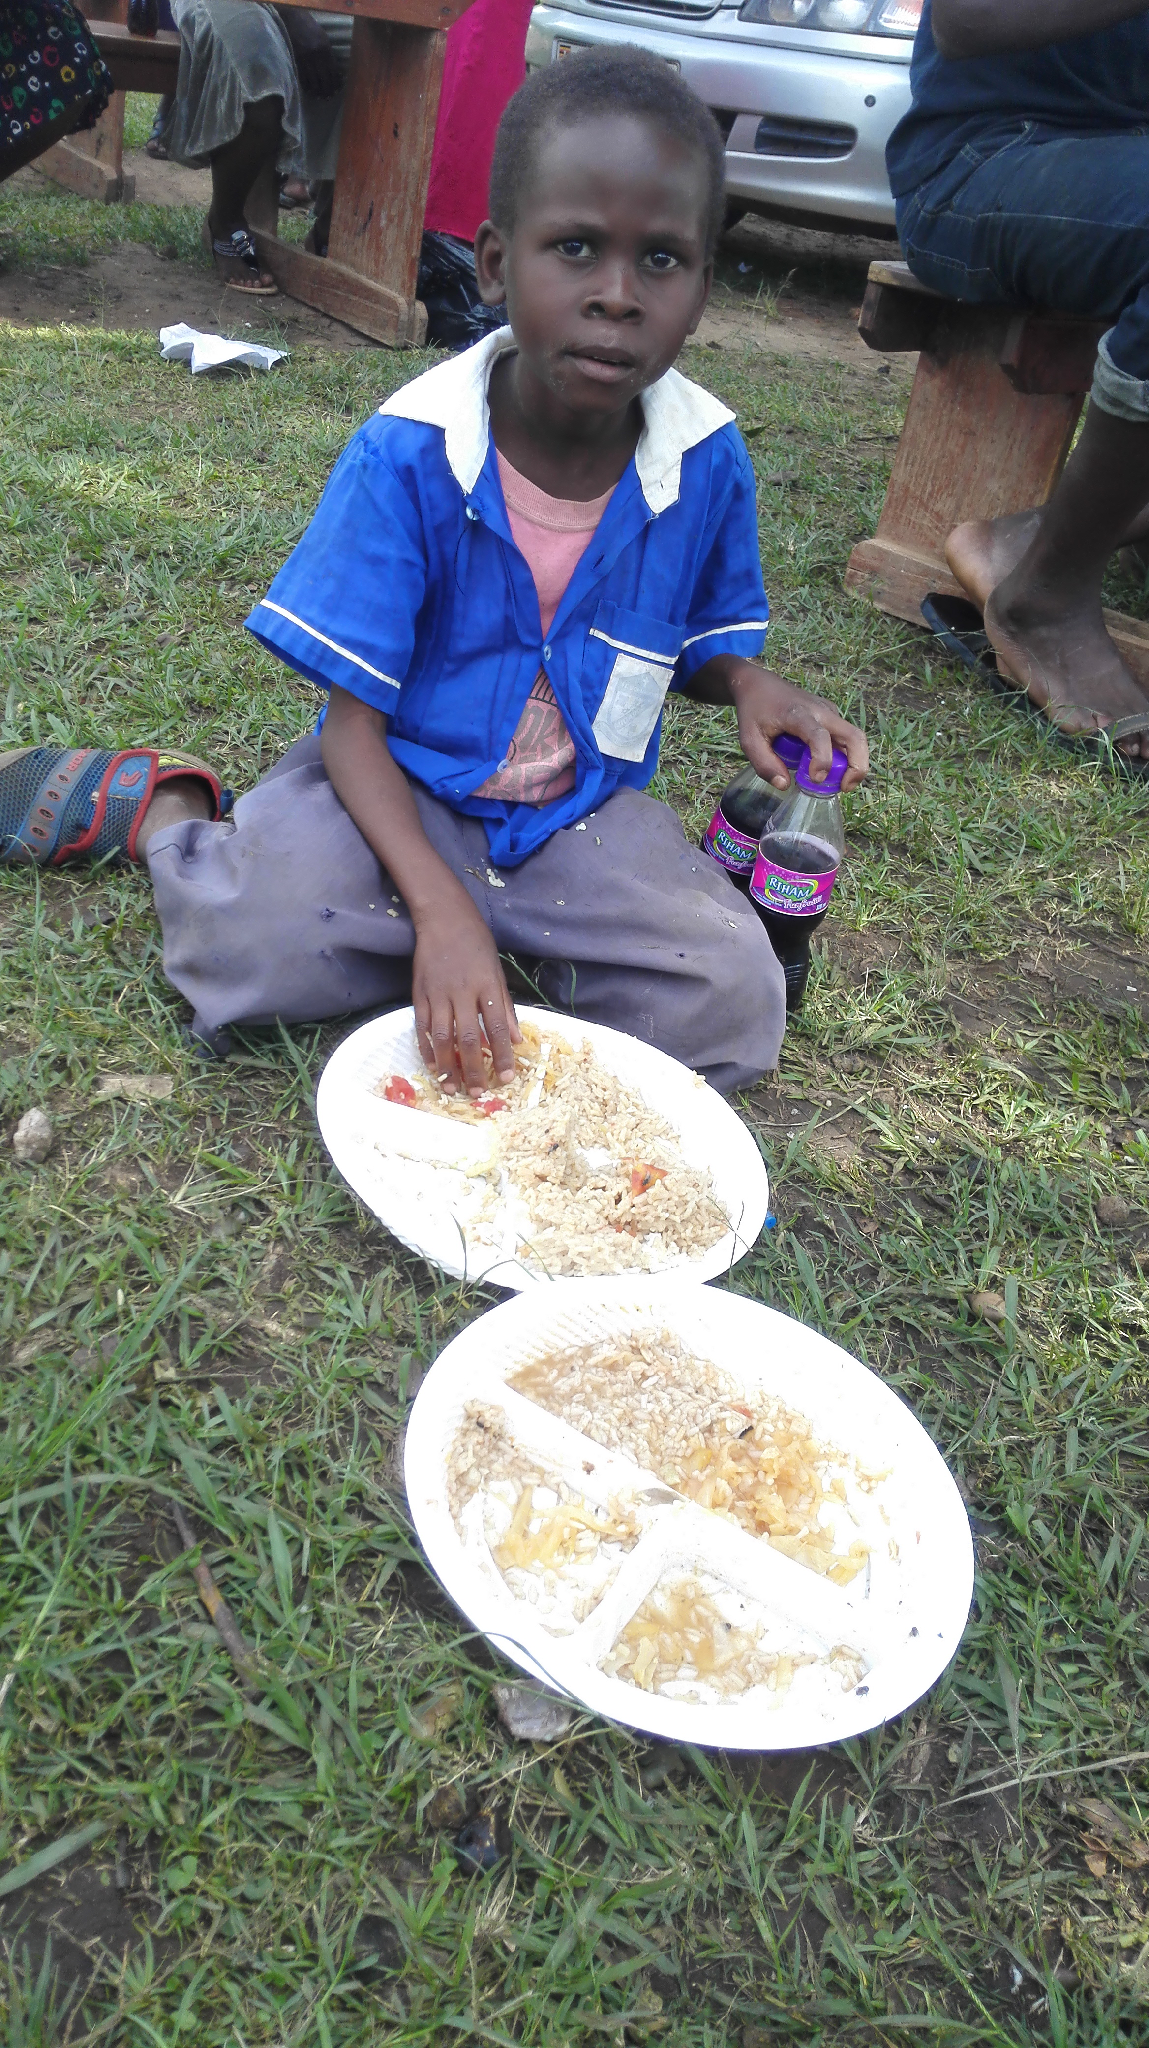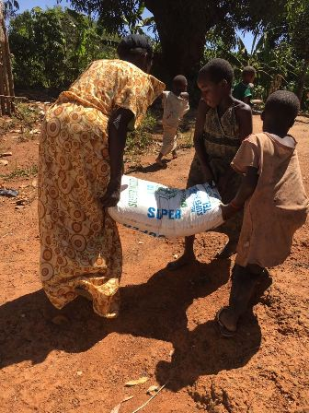
- To ensure reliable accessibility to a sufficient quality of affordable and nutritious food items for 400,000 children from 100,000 poor households at individual and community level for an active and healthy life.
- Encourage proper food storage and limit wasteful use of food
- Engaging children and youth in agriculture so as to experience the usefulness of growing food
- Encouraging environmental conservation and maximum utilization of land
- Encouraging community labor and togetherness in food production.

Key Performance Indicator(s):
- Proportion of households with year round access to sufficient food for the family’s needs
- Proportion of children with minimum dietary diversity score
- Proportion of women with minimum dietary diversity score
- Proportion of HH where one or more adults are earning an income from selected enterprise
- % of Parents or caregivers providing well for their Children
- Poverty Rate amongst targeted HHs as measured by Progress out Of Poverty Index (PPI)
- Proportion of HHs adopting recommended Climate Smart’ and/or environmentally sound principles and practices
- Proportion of HHs who faced a disaster and was able to recover and now live at the level they did before

Core Project Models:
Various to be implemented
Partnerships:
Establish close relationships with joint problem solving partnerships with public and civil society organizations; with the parliamentary forum for children and the children's commission of the Ministry of gender Labor and Social Development
Contribution to government Strategy: Contribute to national policy in education and child protection. Contribute to education enrollment and education quality in operational areas.
RCC capacity building: RCC to have capacity to successfully manage a more than 1 Million dollar donor funded program for children through training of RCC staff and use of management applications

