Dear GlobalGiving Community,

Thank you for your continued interest in supporting Girls To Women and most importantly the girls we serve who are well on their to a successful womanhood. We are glad to provide you with the following update on Girls To Women's Fall 2010 after-school program.

Best wishes,
G2W Staff
***************************
During this first half of the 2010-2011 school year, Girls To Women participants have been busy with school work and, setting and meeting the personal goals they set for themselves. Families continue to come to us with specific goals for their girls, whether it be that extra help in math, science or English. As always Girls To Women makes the aspirations of these girls and their families, the aspirations of Girls To Women. The staff and volunteers are dedicated to seeing all of the participants succeed and will go the extra mile in supporting the girls. During winter break, one of the staff members met with Madeleine, 3rd grader, to work one-on-one on Madeleine's reading. Madeleine said the following on why she enjoys attending Girls To Women's after-school program, "My favorite thing about Girls To Women is that I love that they help me with my homework. I am getting more stars and happy faces from my teacher, and that makes me happy."
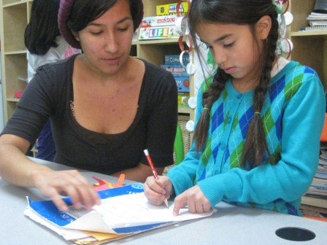
Academic Focus

Many parents have voiced the concern of not being able to help their daughters at home with homework either because they lack the knowledge or simply don't have enough time. This is why there has been a refocus of program to homework completion. When girls walk in they get snack, have a few minutes of relaxation so they can get settled in and afterward start their homework. "Homework time" is from 3:30 to 4:30, like last year, since we do realize that the younger girls do finish their homework during this allotted one hour period. However, for those girls who still have homework to complete after "homework time" they continue working on homework with the help/supervision of a staff member and/or a volunteer.

For those girls who finish homework before the one hour is over, they are required to read for at least 10 minutes and it must be a book that is at their reading level (the reading room has been organized so that books are separated by grade level). During this reading time girls either read alone, with a volunteer, or with a small group of girls. Our goal is to make reading a fun and interactive habit. If the girls have time after reading, they can play an educational board game or do worksheets.

Activities

Cooking and Gardening: This fall the cooking and gardening activity continued through G2W's collaboration with Collective Roots. Sara from Collective Roots, who also came last year, lead the twice a week workshop for six weeks. Participants were divided into two groups and each group did the same cooking/gardening activity on different days of the week. The girls continued to learn about growing their own organic garden and about eating healthy.

Appreciation Envelopes: The appreciation envelopes activity is a week long activity during which the girls write appreciation notes to one another throughout the week and place them in the appropriate envelopes. Each girl has her own envelope with her name and individual decoration, and all of the envelopes are taped onto the "Appreciation Wall" in the program's main room. The girl wearing the appreciation "hat" each week is in charge of ensuring that each girl has at least one note and then passes out the notes on Fridays. This activity allows the girls to take time to appreciate and value one another.

Circle Time: As in past years, circle time takes place once a week (on Wednesdays since it is the longest day). During circle time, both the staff and participants are given the space and time to make announcements. These announcements can be relevant to the day, week, or whatever may be going on in the girls' lives. Staff also uses this time to discuss topics such as respect .

Outdoor activities/group games: The outdoor activities/group games usually take place three times a week after homework time. The activities/games vary from capture the flag, sharks and minnows, tag, and red light, green light, to relay races, trust activities, and a parachute teambuilding activity.

We are in the process of developing the following two activities:
- Science workshops: the science workshops will take place once a week during program and will be lead by volunteer Lisa Dorn. Lisa is a long time resident of East Palo Alto and recently graduated from UC Davis with a PHD in Ecology, with a focus on behavioral ecology. Now that she is out of school, she is interested in working with girls to inspire an interest in science and wildlife at a young age.

- Basketball League: G2W staff is in the process of recruiting girls ages 12-14 in the East Palo Alto/Menlo Park neighborhood to participate in a basketball league. This league will be used as an outlet for girls to relieve stress, learn skills such as leadership and teamwork, and build a family-like connection with one another. This basketball league will be separate from the after-school and summer programs; however, girls currently enrolled in g2W's after-school program who are in the 12-14 age group will be invited to join. In order to be in the basketball league girls will have to maintain a certain grade point average. Logistics are still to be determined. A potential collaboration with the YMCA starting April is being considered. The basketball activity will be lead by staff member Brianna Clay who was a part of her college basketball team at Saint Mary's College (where she majored in Sociology/Anthropology) and who has coached the Palo Alto High School basketball team for the past two years.

NIA Project

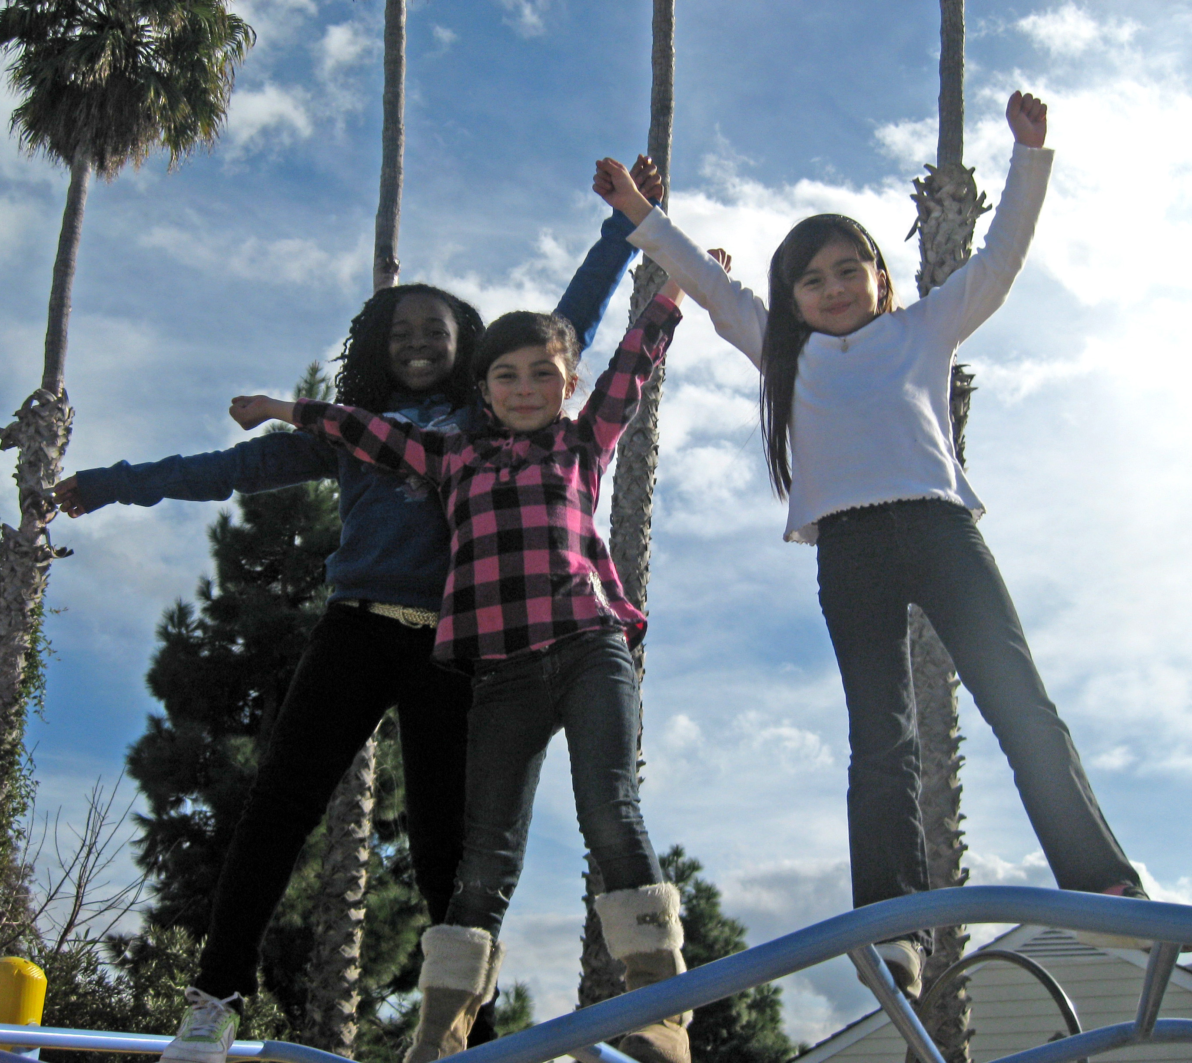
As part of the Margaret Geis Wright Wellness program that supports young women and their families in forming positive physical, mental, and emotional wellness skills, the Nia Project this year will be a series of three workshops for pre-teen and teen girls ages 10-13. The workshops are in line with Girls To Women's mission of supporting girls as they design their futures for successful womanhood.

The purpose of the workshops is to empower girls during the critical stage of pre adolescence in which they struggle with physical changes, strong emotions and self-esteem issues. The workshops will feature engaging activities that promote confidence-boosting skills that participants can use for self-awareness as they transition into adolescence and beyond.

The three self-discovery workshops will cover the following:
- Building A Healthy Self-Esteem: Girls will discover their unique selves though engaging activities and facilitated discussions.
- Constructive Conflict-Resolution: We will examine how to express feelings appropriately during conflict, and identify effective approaches to resolution.
- What Makes A Positive Role Model? Can I Be One? Girls will explore the qualities of persons they admire, discover the qualities they share with their role models, and recognize their individual strengths.

