Report to
Our GlobalGiving Community
From
Girls To Women, East Palo Alto, CA
For
“Academic Support & Mentoring for Underserved Girls”

Dear Readers,

This report will provide you with an update on Girls to Women's Summer Program 2010. For a basic rundown on this program that covers our basic objectives and has a Project Description, please read one of the earlier Progress Reports, for example from January 2010.
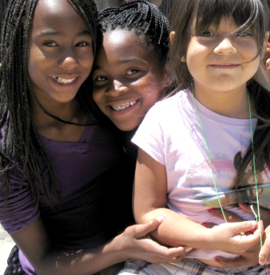
We thank you for your interest in Girls To Women, and for supporting the high-potential but low-income girls we serve!

  

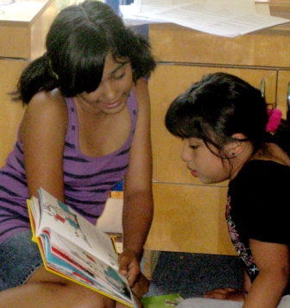
Girls to Women's six-week Summer Program 2010 had a total enrollment of 28 girls from African American (43%), Latina (also 43%), and Pacific Islander (14%) cultural groups, and in grade levels from K-8th grade. Six high-school aged young women from similar cultural backgrounds also served as interns, and helped to further develop leadership, problem-solving, work ethic, and organizational skills.
Summer Program was multi-themed inclusive of arts and fitness activities but definitely included academics, especially literacy-building. Every morning all participants played group games outdoors to build teamwork, fitness, and overall health. Summer Program also included a daily hour of "Reading Time" during which participants either read to themselves or in a group for twenty minutes. After Reading Time was over participants could either continue reading or engage in a learning game for the rest of the hour. We found that the older girls enjoyed reading with younger girls, and these interactions clearly helped to make literacy a fun and bonding experience. Furthermore, every Wednesday participants participated in activities such as “Wheel of Fortune” and “Minute to Win It” races that emphasized problem-solving, numerical reasoning, and vocabulary skills-building.

Each week participants learned about and explored various art forms. The themes were:

- Tessellations & mosaics
- Poetry
- “Personality boxes”
- Clay sculpture
- Art techniques (Pointallism, Pop Art, Watercolor Weaving, and Foil Art).

By our End-of-Summer Celebration, the participants had created all the pieces needed for an extensive art show for parents, family and friends.

Participants particularly enjoyed the “personality boxes” and the poetry. Personality boxes are cubes made out of cardboard upon each side of which an aspect of the participant's personality is displayed in artistic form. Participants had endless possibilities as to how to represent their personalities in this medium, from favorite numbers, colors, sports, to favorite hero, quotations, etc. The personality boxes activity gave participants time for self-exploration, as the girls had to put thought into how to describe who they were as individuals.

The goal of poetry week was to create a poetry book that included the six different types of poems participants learned to write:

- Name poems
- Acrostic poems
- Limericks
- Haiku
- Rhyming poems
- Friendship poems

Participants demonstrated great interest in poetry as they helped one another write the poems, read them out loud to one another, and decorating their own poetry books. At End-of-Summer Celebration each girl read at least one of their poems (one girl read 3 poems) to family and friends during the “poetry slam.” The poetry slam allowed the younger girls to practice reading out loud, and shy and quieter girls encountered a safe and supportive environment in which to extend themselves and present their own work. The participants were able to showcase their individuality, sensitivity, and creativity through poetry writing and presentation.

Older Girls (Grades 6th - 8th): Surveys and College

Although all of the girls participated in the preceding activities, our older girls focused on two other projects just for them. The first project imparted scientific method- and information technology-based learning through online survey development. Twice a week, for 90 minutes each session, the girls met with a research group from Stanford Research Institute (SRI) in conjunction with Kids Survey Network (KSN). The goal was for the girls to learn about compiling their own online surveys based on topics of interest to them, distributing such surveys among their peers, and generating conclusions based on the survey results. Participating girls learned about:

- The kinds of questions to ask
- How to compile results
- Use of graphs to present and interpret data.

In the process, participants – most of whom don’t have a computer in the home -- deepened their computer usage and information technology skills.

The second project involved development of participants’ dream university; the goal being to get the participants thinking about attending college. As a group, the older girls came up with decisions about:

- Admission requirements
- A school name and mascot
- Location
- Design and construction of a model campus.

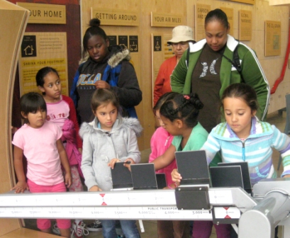
These decisions were based on their research into real-world colleges and universities, and on discussions they had with group leaders as to what makes a good college. Program Director Marquisa Hawkins said of activity, "I really think it opened the girls' eyes into what is going to be expected of them when it is time for them to apply to college."

Field Trips

Girls to Women participants went on three major fieldtrips: The Japanese Garden at Golden Gate Park in San Francisco, Half Moon Bay and the California Academy of Sciences. The girls enjoyed the fieldtrips tremendously. The fieldtrip to the Japanese Tea Garden allowed the girls to explore an outstanding aesthetic and cultural resource, and to experience world-famous Golden Gate Park more generally.

The second fieldtrip was Girls to Women's annual beach trip to Half Moon Bay. This was a day filled with fun! The girls played in the water, ran from the waves, flew kites, played dodge-ball, and barbequed for lunch; many of the girls had seldom visited the ocean.

During the final fieldtrip, we returned to San Francisco to explore the California Academy of Sciences. Participants experienced an amazing indoor rainforest; saw the dazzling array of marine life at the aquarium, and were treated to a planetarium show. Apart from being fun, the field-trips expanded the girls’ horizons in nature, science, and the outdoors.

Wellness: Cooking and Gardening

Summer Program 2010 included our ongoing, twice-weekly cooking and gardening module. All the girls took part in what’s become a central activity here at Girls To Women -- and in the process learned about the links between good nutrition, culture, health, sustainable agriculture, and the simple pleasure in preparing and sharing attractive and nourishing dishes.

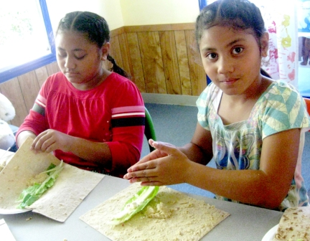
Our volunteer instructor for the cooking activity emphasized simple, nutritious recipes. We encouraged girls to take them home and try them out with their families and many did so with popular results! While some of the food was new to the girls (for example, couscous and humus wraps) they were game and willing to try the new recipes.

Participants raised, tended, and harvested a variety of vegetables and ornamentals from seed, cuttings, and starts. In so-doing they experienced all of the small miracles of gardening – the germination and growth of seedlings; the transformation of yard and food waste into soil-building compost fertilizer; the satisfaction of picking the fruits of their labor and turning them into eye-catching bouquets or tempting dishes.

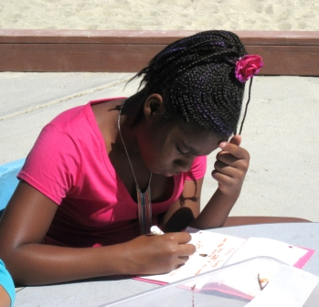
Along the way all of our girls got practical lessons in everything from the importance of keeping to a regular schedule (of watering, weeding, etc.) to the attentive care needed to create an excellent recipe, to self-expression and literacy-building through development of their gardening journals and garden-related art projects.

Summer Session has always been a rich and growing time for our girls, and this our Fourth Consecutive was no exception. It is so heartening to see our participants engage with the many challenging, fun new activities and, through them, continue growing towards the healthy, effective womanhood which we want so much for them to become.

