
“Dedicated to supporting girls as they design their futures for successful womanhood.”

September 9th 2009

Manmeet Mehta
GLOBALGIVING..COM
1816 12th Street NW - 3rd Floor
Washington, DC 20009

Via email to: mmehta@globalgiving.com
Re: Report on our project# 2940 “Academic Support & Mentoring for Underserved Girls”

Ms. Mehta,

We are pleased to present the following Report on our recent Project progress. Furthermore, we wish to reiterate our appreciation for the opportunity to enhance our online fundraising and community-building profile through GlobalGiving.

Yours in Community Service,

Patricia Foster
Founder-Executive Director

P. O. Box 50368 East Palo Alto, CA 94303 Ph 650-799-1653
Eml: patfoster@aol.com
Report to
Our GlobalGiving Community
From
Girls To Women, East Palo Alto, CA
For
“Academic Support & Mentoring for Underserved Girls

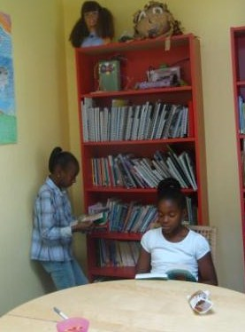

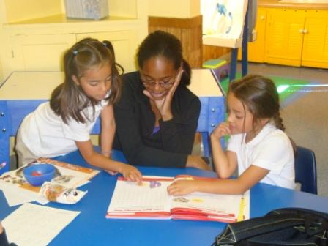

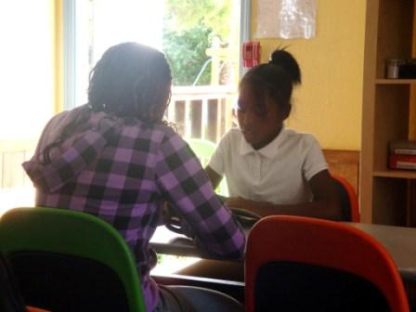

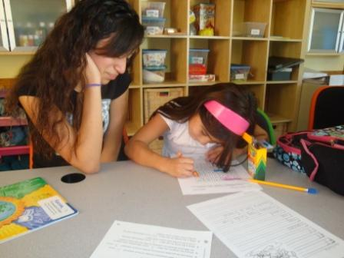

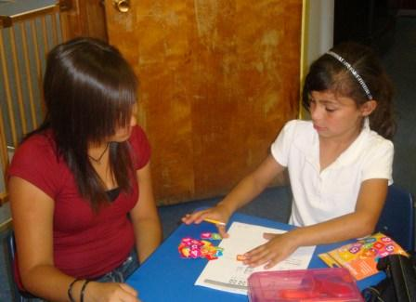

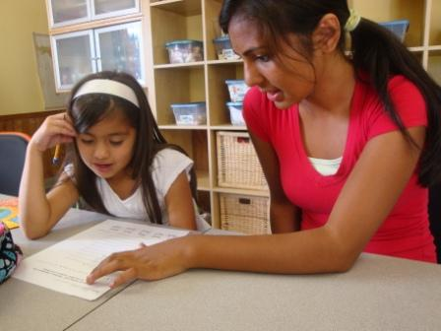

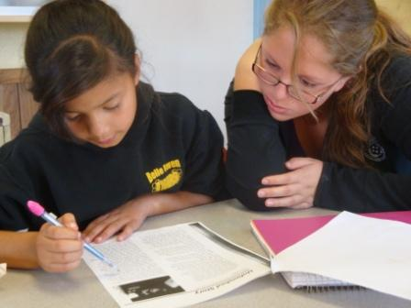

Our combined primary objectives for the Project include:

- Improved academic success for school-year attendees ages 6-14 in 2008-2009.
- Develop tutorial capacity to provide effective homework assistance and academic middle-school placement support for our participants..
- Enhance library and Information Technology resources to support learning.
- Continued leverage of in-kind and volunteer resources from the community on behalf of high-potential but low-income girls' academic development.

1. Improved academic success for school-year attendees ages 6-14 in 2008-2009.

Generally, girls arrived after-school, check-in, obtained a healthy snack and had about a half-hour to chat with staff, volunteers and friends and to relax from their formal school day. We feel that the down-time period and nutritional boost is essential to good learning.

Girls then joined their "cluster" of 4-7 girls based on age and grade-level, overseen by their volunteer tutors and staff Group Leader. They reviewed their homework assignments with the adults (who periodically check with girls' formal classroom teachers).

With an average individual School Year attendance of over 3 times per week and over 10 months per girl, we supported each of the 35 girls we served every schoolday they attended during Fall Semester 2008 and Spring Semester 2009 with the learning resources, tutoring -- including Spanish-English bilingual tutoring -- with from a half-hour to an hour’s academic focus during “Learning Time“ at the start of each school-day afternoon. Girls were generally expected to go over assignments with staff and volunteers and devote this time to them before moving on to other activities. Those who had no assignments generally were expected to read for a half-hour and then demonstrate comprehension with a tutor.

During the academic terms, we provided a daily nutritious snack for all girls each afternoon, and on Wednesdays (their long day) they were given two snacks. Girls were not allowed to bring outside snacks, which would have tended to be considerably less-nutritious. We regularly discussed nutrition and health during Wednesday Circle Time, the weekly plenary, required discussion and announcements period.

2. Develop tutorial capacity to provide effective homework assistance and academic middle-school placement support for our participants.

Midway through the grant period, we recruited a group of 18 high-achieving young women from nearby Eastside College Preparatory School to serve as volunteer tutors. Being as they are closer in age to our girls and more culturally-reflective than our previous generations of tutoring volunteers, the girls looked up to them and related to them as mentors very well overall. Thanks to the participation of Eastside students, we were able to offer 1-on-1 tutoring Mondays thru Thursdays for every girl.. Parents frequently requested assistance on various subjects -- usually reading, spelling, or arithmetic -- and tutors would devote additional time to such skills-building after these girls addressed their formal school assignments.

3. Enhance Library and Information-technology resources to enhance learning.

We established our in-house, wireless internet-capable computer lab during Spring Semester 2009, having only been able to offer girls irregular access to information-technology resources through other youth-serving organizations previously. Each of the 4 computer workstations had educational softwares, and links to online learning resources, in basic English literacy, math, geography, digital arts, history, and other core subjects.

Our in-house library has a stock of math puzzles and manipulative; age-graded literature and literacy support workbooks; and reference resources on a variety of elementary and middle-school level academic subjects, again emphasizing literacy, math, and other basic subjects. Literacy means, among other things reading for the love of it, and we keep as mentioned a number of award-winning books and other proven favorites for youth in our age-range of 6-15.

4. Continued leverage of in-kind and volunteer resources from the community on behalf of high-potential but low-income girls' academic development.

We‘ve already mentioned the Eastside Preparatory School‘s 18 wonderful volunteer tutors. But other volunteers, whether concerned community residents, retired teachers, or girls‘ family members also support girls‘ academic learning and the organization overall through contributions as diverse as donating books or fixing faucets.

Some community contributions that directly affect the success of Academic Support & Mentoring include:

- Infrastructure repair from Kiwanis Club of East Palo Alto
- First Christian Church of Palo Alto - Nutritional support and volunteers
- Eastside College Preparatory School - culturally-reflective academic support tutors.
- IKEA - Donated furnishings for our Beech Street facility.
- One World Children‘s Foundation - Volunteers (in addition to grant support).

Academic Support & Mentoring funders, aside from GlobalGiving, include:Peninsula Congestion Relief Alliance - After-school shuttle transportation
- Atkinson Foundation
- Franklin & Catherine Johnson Foundation
- David & Lucile Packard Foundation
- Silicon Valley Community Foundation

  

