 “Dedicated to supporting girls as they design their
futures for successful womanhood.”

January 12th, 2010

Manmeet Mehta
GLOBALGIVING.COM
1816 12th Street NW - 3rd Floor
Washington, DC 20009

Via email to: mmehta@globalgiving.com
Re: Report on our project# 2940 “Academic Support & Mentoring for Underserved Girls”

Ms. Mehta,

We are pleased to present the following Report on our recent Project progress. Furthermore, we wish to reiterate our appreciation for the opportunity to enhance our online fundraising and community-building profile through GlobalGiving.

Yours in Community Service,
Pat Foster
Patricia Foster
Founder-Executive Director

P.O. Box 50368 East Palo Alto CA 94303
Ph: 650.326.6431 Fx: 650.566.8553
info@girlstowomen.org http://www.girlstowomen.org
Report to
Our GlobalGiving Community
From
Girls To Women, East Palo Alto, CA
For
“Academic Support & Mentoring for Underserved Girls”

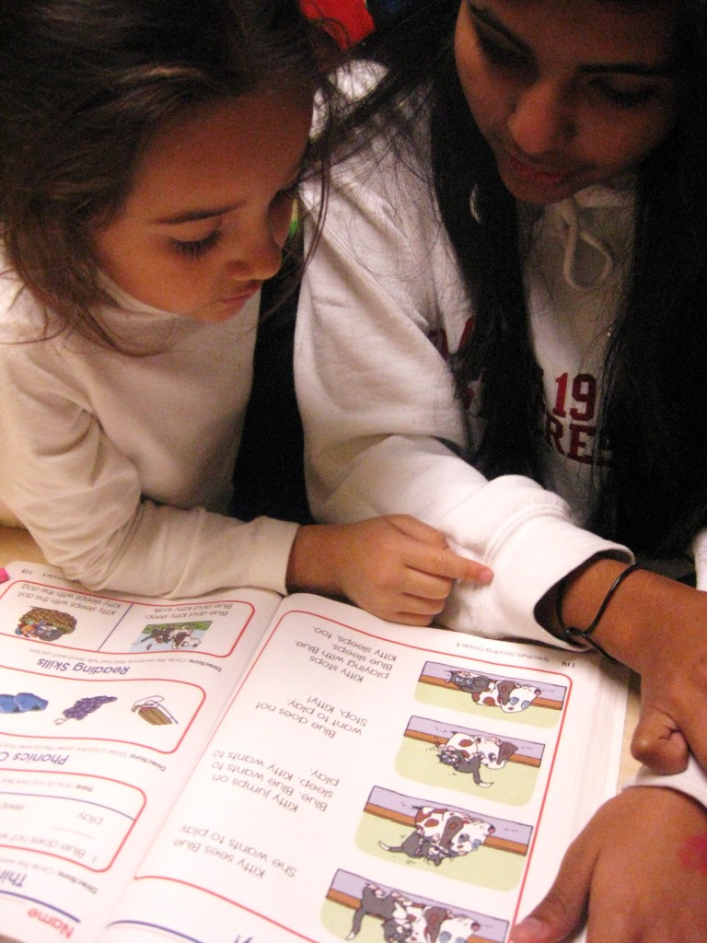

Our combined primary objectives for the Project include:

- Improved academic success for school-year attendees ages 6-14 in 2009-2010.
- Develop tutorial capacity to provide effective homework assistance and academic middle-school placement support for our participants.
- Enhance library and Information Technology resources to support learning.
- Continued leverage of in-kind and volunteer resources from the community on behalf of high-potential but low-income girls' academic development.

1. Improved academic success for school-year attendees ages 6-14 in 2009-2010.

With an average individual School Year attendance of over 3 times per week and over 10 months per girl, we supported each of the 30 girls we served every school-day afternoon they attended during Fall Semester 2009 with the learning resources and tutoring -- including Spanish-English bilingual tutoring -- for a half-hour to an hour’s academic focus during “Learning Time."

Generally, girls arrived after-school, checked-in, and had about a half-hour to chat with staff, volunteers and friends, and to relax from their formal school day. We feel that the down-time period is essential to good learning.

During the academic term, we provided a daily nutritious snack for all girls each afternoon, and on Wednesdays (their long day) they were given two snacks. Girls were not allowed to bring outside snacks, which would have tended to be considerably less-nutritious. We regularly discussed nutrition and health during Wednesday Circle Time, the weekly, required plenary discussion and announcements period.

Girls then joined their "cluster" of 4-7 girls based on age and grade-level, overseen by their volunteer tutors and staff Group Leader. They reviewed, worked on, and (generally) completed their homework assignments with the adults (who periodically check with girls' formal classroom teachers). Girls were generally expected to do so before moving on to other activities. Those who had no assignments generally were expected to read for a half-hour and then demonstrate comprehension with a tutor.

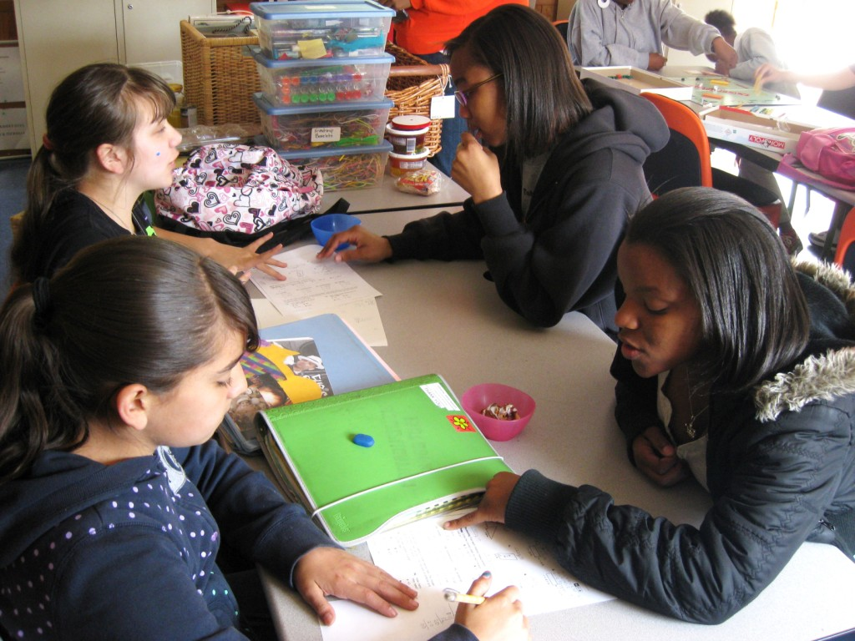

Some Personal Stories from Fall Semester 2009:

Fabiola, mother of Crystal (a 5th Grader), reported that Crystal’s grades improved in math last semester. When Fabiola first mentioned that Crystal needed some extra help in math, we brought in two volunteers from Eastside College Preparatory School, who between them worked with Crystal four days a week. The positive mentoring from high-achieving young women from similar cultural backgrounds constitutes a solid gold development asset that Crystal and all of our girls clearly respond to -- with enhanced self-esteem, self-expectations, and academic skills!

Evarardo asked for us to work with his daughter Viviana on her English pronunciation, which we have been doing by using letter flash-cards.

Maria asked for us to work with her daughter Joanna on counting money, so we have had volunteers work on this practical applied arithmetic exercise with her every day once she has completed her homework.

Karina did very well in math … getting 100% on her math homework sheets . . . and she became a fantastic speller. Karina has been with G2W since first grade, when she was just learning how to read. Now she’s in third grade and hasn’t looked back.

Fifth grader Esmeralda also stated that her favorite subject in school was math, and she too often got 100% on her math assignments.

Esmeralda, Ni'Yha and Jailah all applied to Eastside College Preparatory School and participated in visiting tours in the last couple of weeks with the start of the Spring 2010 Semester. We proudly expect all three to gain admittance to Eastside.

2. Develop tutorial capacity to provide effective homework assistance and academic middle-school placement support for our participants.

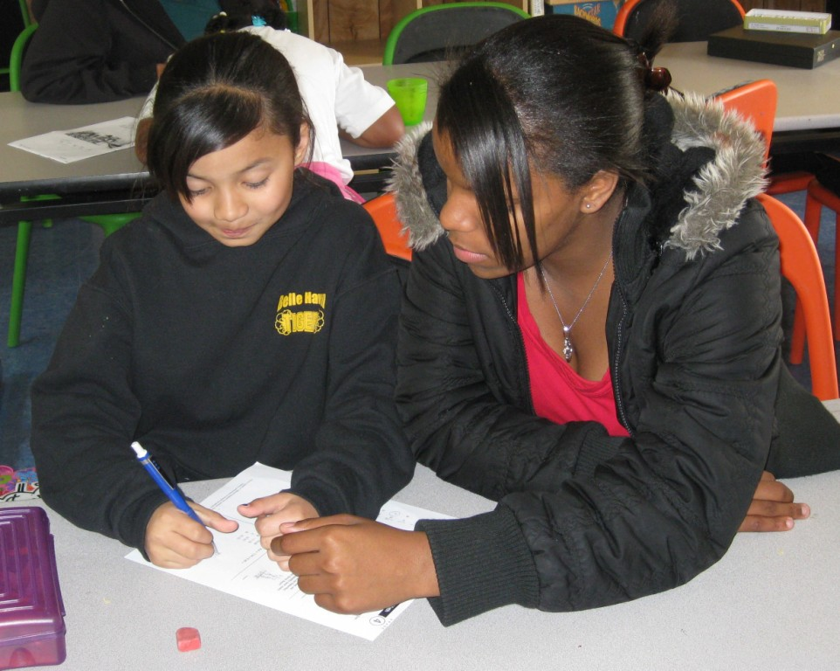

As mentioned, we continue our tutoring collaboration with nearby Eastside College Preparatory School. On-average, 18 high-achieving young women of color are available at any one time to serve as volunteer tutors. Being as they are closer in age to our girls and more culturally-reflective than our previous generations of tutoring volunteers, the girls continue to look up to them and relate to them as mentors very well overall. Thanks to the participation of Eastside students, we were able to offer 1-on-1 tutoring Mondays thru Thursdays for every girl throughout Fall Semester 2009. As the Spring 2010 Semester takes up again, we’re continuing this effective and popular tutoring relationship.

As they had in previous semesters, parents regularly requested assistance on various subjects last semester (see 1., preceding, for examples) -- usually reading, spelling, or arithmetic -- and tutors have been and will continue to devote additional time to such skills-building after these girls address their formal school assignments.

3. Enhance Library and Information-technology resources to enhance learning.

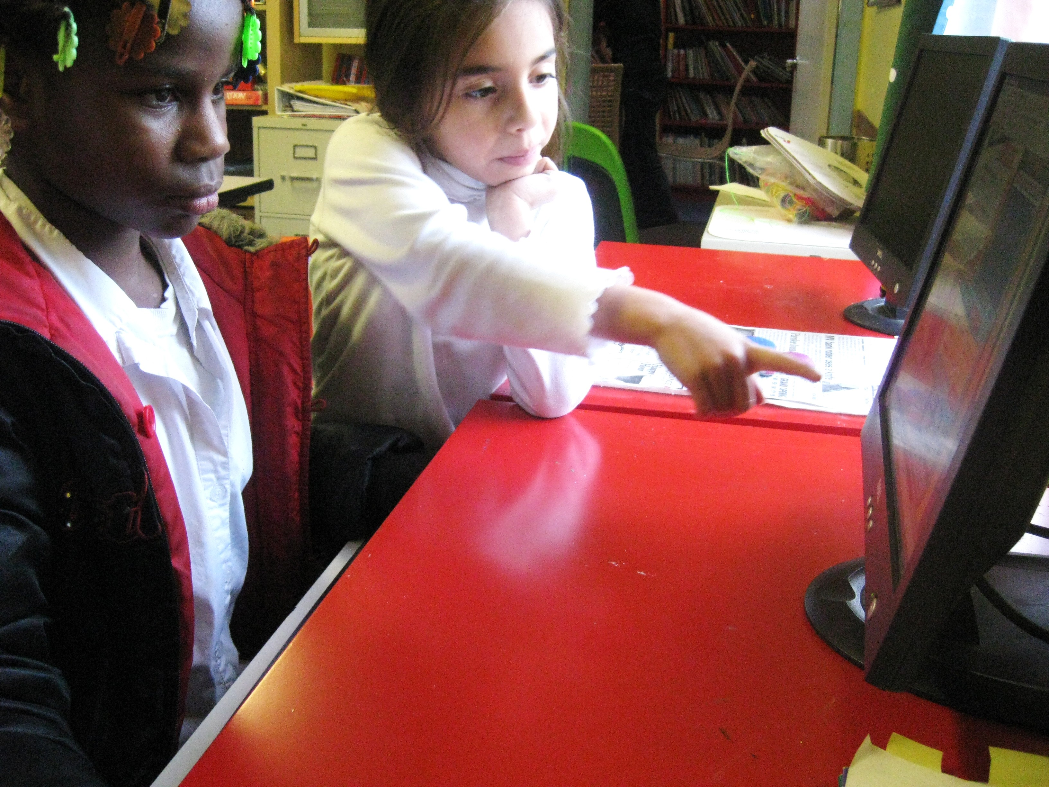

We established our in-house, wireless internet-capable computer lab during Spring Semester 2009, having only been able to offer girls irregular access to information-technology resources through collaborations with other youth-serving organizations previously. Each of the 7 computer workstations has educational software, and links to online learning resources, in basic English literacy, math, geography, digital arts, history, and other core subjects.

Throughout Fall Semester 2009 we kept hearing from girls and their families that the computerized resources we have made a big difference to our young scholars, particularly with respect to doing research needed to complete written reports on various topics. But girls also use online resources such as Match Magician (http://www.oswego.org/ocsd-web/games/Mathmagician/cathymath.html) to sharpen their skills in this critical area. Likewise girls get help with their language arts learning through ready access to spelling tutorials and games like Spelling City (http://www.spellingcity.com/General/game-games-more-games.html). Only about 5% of our girls have computers at home.

Our in-house hardcopy library has a stock of math puzzles and manipulatives; age-graded literature and literacy support workbooks; and reference resources on a variety of elementary and middle-school level academic subjects, again emphasizing literacy, math, and other basics. During Fall 2009 we received from our supporter and former elementary school classroom teacher Sunita Goldstein a collection of outstanding children and youth literature. The girls now have access to dozens of volumes ranging from beginning readers to young-adult level. We like to think that literacy means, among other things, reading for the love of it, and now we have more than ever in the way of award-winning books and other proven favorites for youth suitable for our age-range of 6-15 years.

4. Continued leverage of in-kind and volunteer resources from the community on behalf of high-potential but low-income girls' academic development.

We've already mentioned the Eastside Preparatory School's 18 wonderful volunteer tutors. But other volunteers, whether concerned community residents, retired teachers, or girls' family members also support girls' academic learning and the organization overall through contributions as diverse as donating books and fixing faucets.

Some community contributions that directly affect the success of Academic Support & Mentoring include:

- Infrastructure repair from Kiwanis Club of East Palo Alto;
- First Christian Church of Palo Alto - Nutritional support and volunteers;
- Eastside College Preparatory School - culturally-reflective academic support tutors;
- IKEA - Donated furnishings for our Beech Street facility;
- One World Children's Foundation - Volunteers (in addition to grant support);
- Peninsula Congestion Relief Alliance - After-school shuttle transportation.
Current Academic Support & Mentoring funders, aside from GlobalGiving, include:

- Atkinson Foundation;
- Franklin & Catherine Johnson Foundation;
- David & Lucile Packard Foundation;
- Silicon Valley Community Foundation.

  

