Bi-Monthly Report
Uplift Community through Football

Friendly Match:
Students of Qurtaba isolated school approached Karachi United and asked to arrange a friendly match. Karachi United asked Qurtaba to invite any team for a match. Qurtaba invited Chakiwara center located on 7th Jan, 2021 at Karachi United stadium. This match was 30 minutes long and both teams showed fabulous performance throughout the match. Jamia Qurtaba scored 5 goals whereas Chakiwara produced 8 goals and won the match. This was the second match which was arranged by Qurtaba. Qurtaba isolated school is very fond of football and they want to polish their football skills. Therefore they engage themselves in friendly matches.

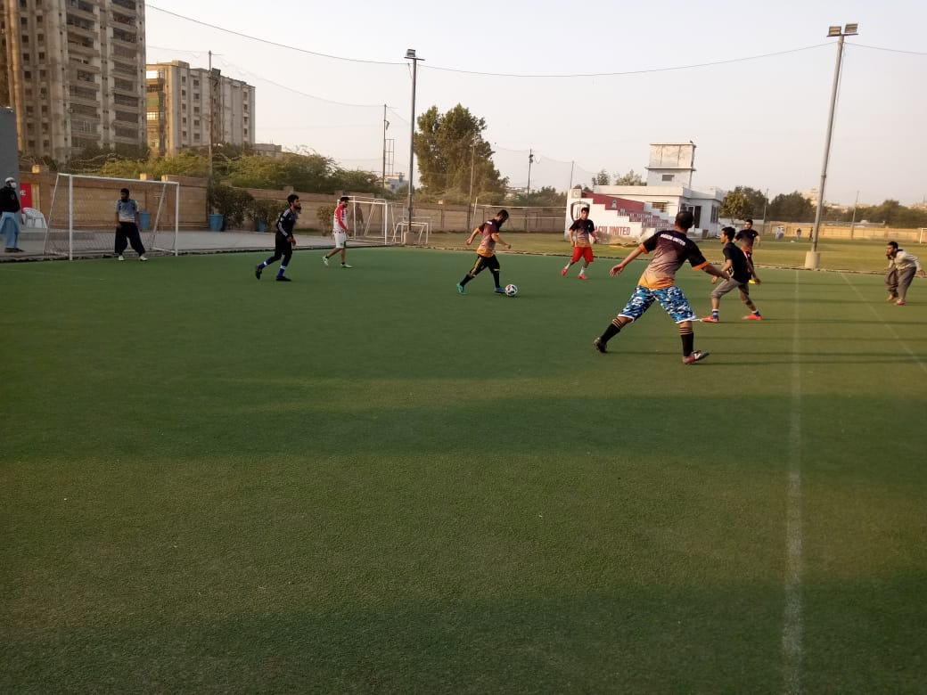
Figure 1 Players are in action during match

Kit Distribution Ceremony:
Karachi United Organized kit distribution ceremony for Lyari general community center in which Karachi United distributed footballs, boots, bags and bottles amongst the children. These kids are very talented. They just need an opportunity and Karachi United is the right place to provide them opportunities for unleashing their potential. Karachi United aims to make football accessible for more kids as part of its community development program. After the ceremony, a friendly match was played between Lyari general and Lyari Chakiwara. Both teams played well and tried their best to win. Lyari Chakiwara scored 2 goals whereas, Lyari general scored 3 goals and won the match.
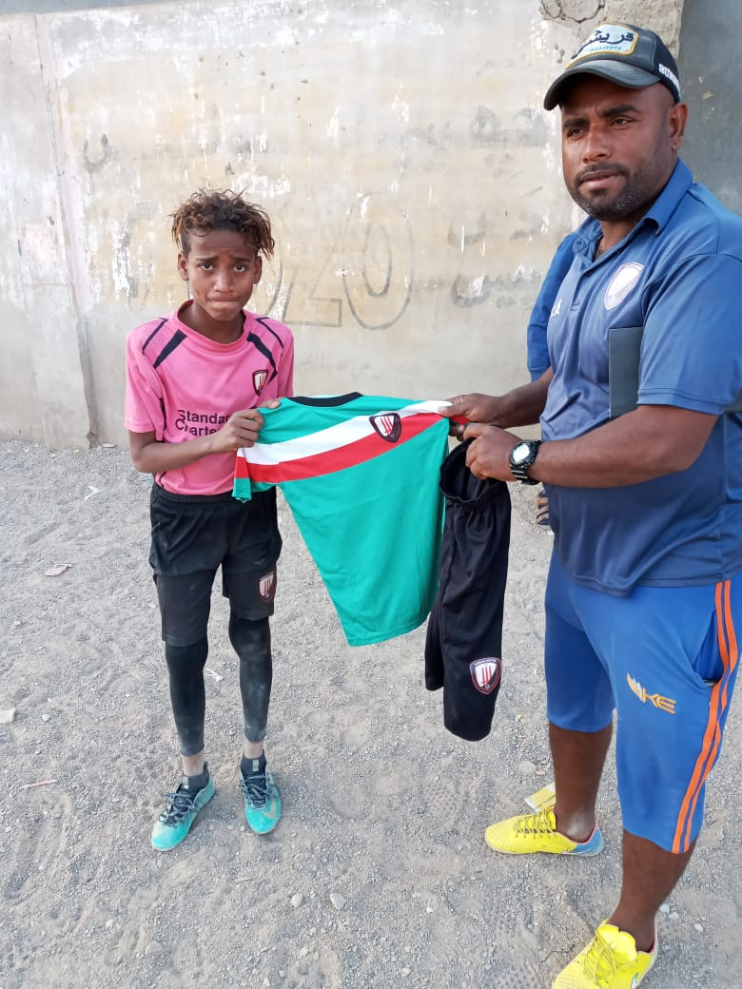
Figure 1 Player is receiving football kit from the coach

