**Quarterly Report**

**Ongoing Football Training and Life Skills session at Orangi Town**

Karachi United provides football and life skills training at 12 community centers thrice a week. The centers are situated in underprivileged areas where the players come from low socio-economic backgrounds and have limited access to quality education. Football training open career paths for aspiring athletes in sports, while life skills sessions aim to boost confidence and leadership skills giving them equal opportunities to succeed in their sports and other aspects of life. Additionally, these sessions promote important values such as leadership, teamwork, communication, problem-solving, and decision-making, which will help the players develop into better individuals and professionals in the future.

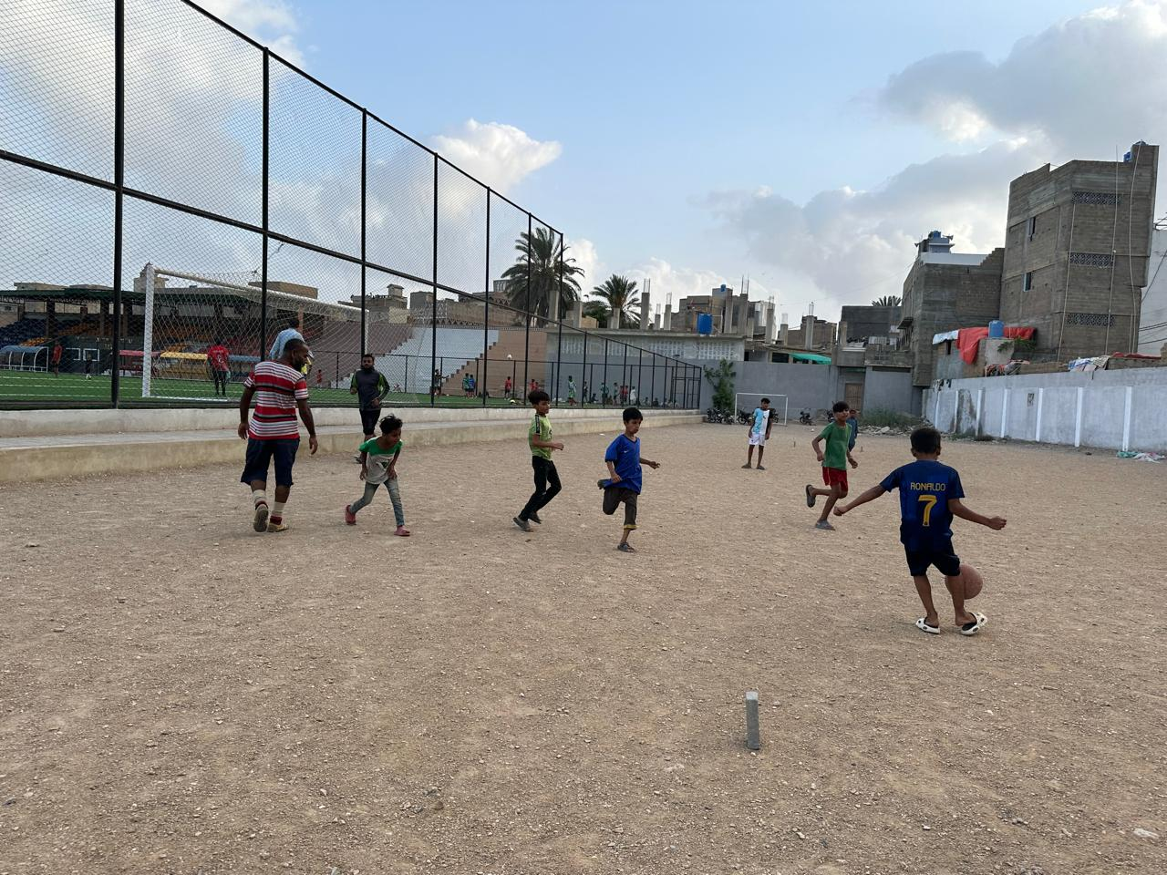 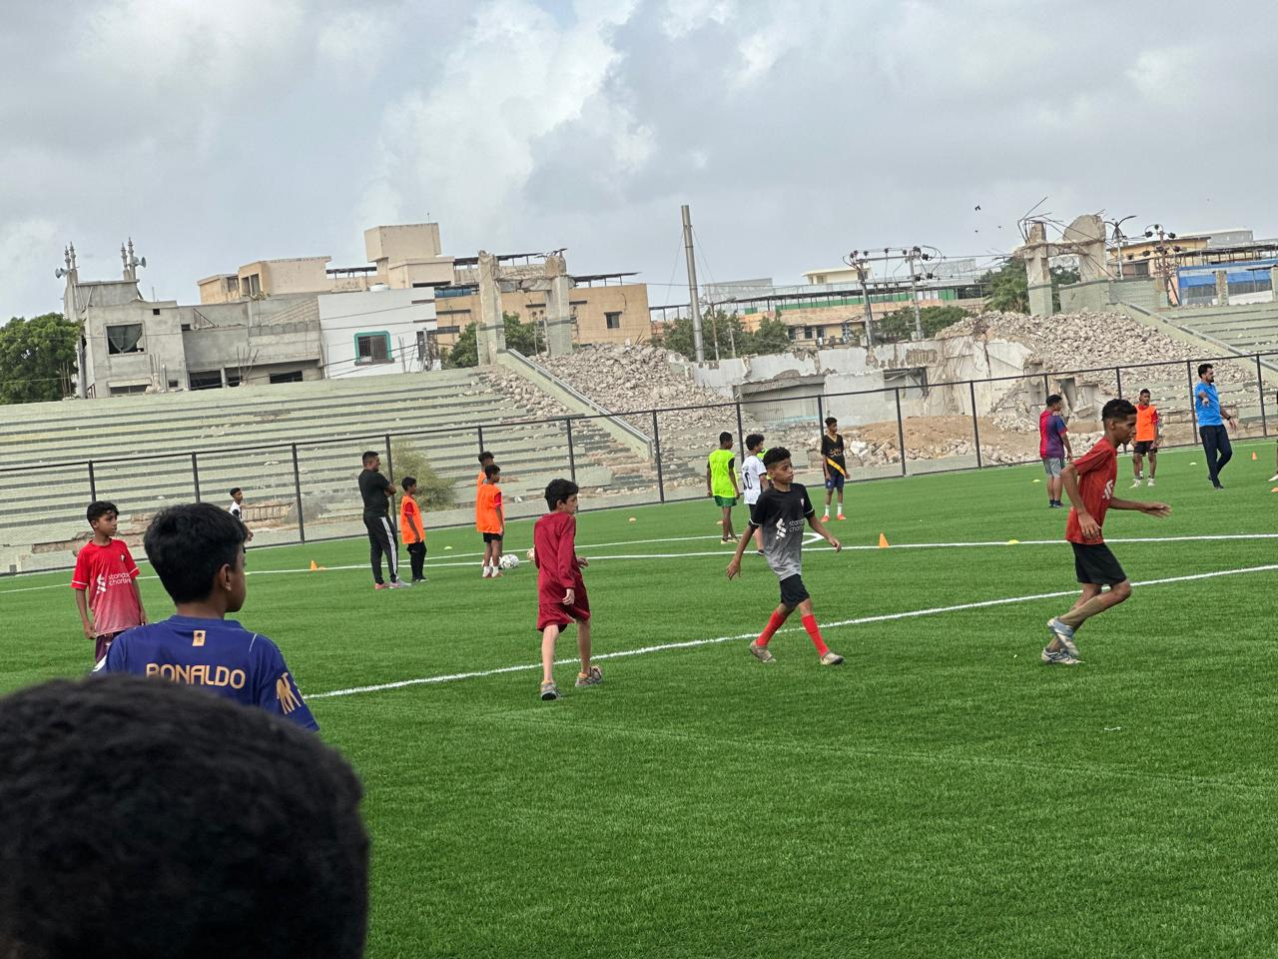

**Mentorship Session at Old Golimar Community**

Karachi United conducted a mentorship session for young players enrolled in Old Golimar community center. The mentorship session was structured to create an open and safe environment where players could freely discuss their daily struggles. Topics ranged from the difficulties they encounter in their football journey—such as balancing practice with academics, dealing with physical and mental fatigue, and managing peer pressure—to more personal challenges, including navigating complex family dynamics and social expectations.

A key focus of the session was to equip these young players with strategies to navigate challenging situations. Mentors shared practical advice on how to stay motivated in the face of setbacks, the importance of maintaining a disciplined routine, and ways to build resilience when confronted with obstacles. The players were encouraged to reflect on their own experiences and share their coping mechanisms, promoting a sense of community and mutual support among the group.

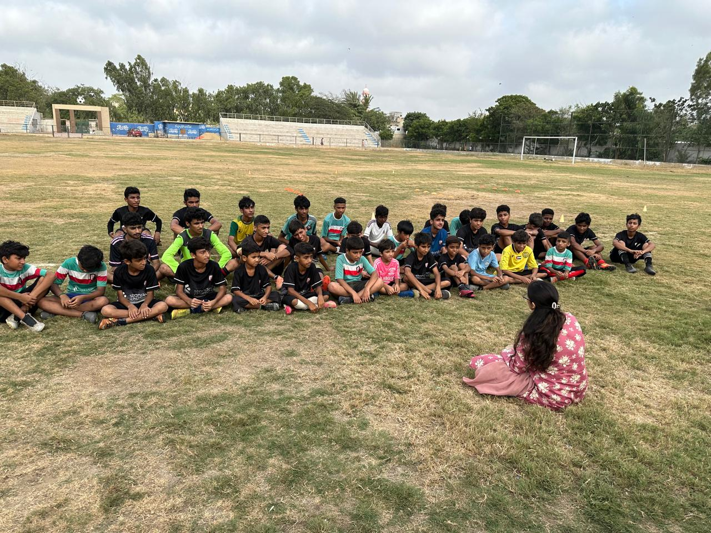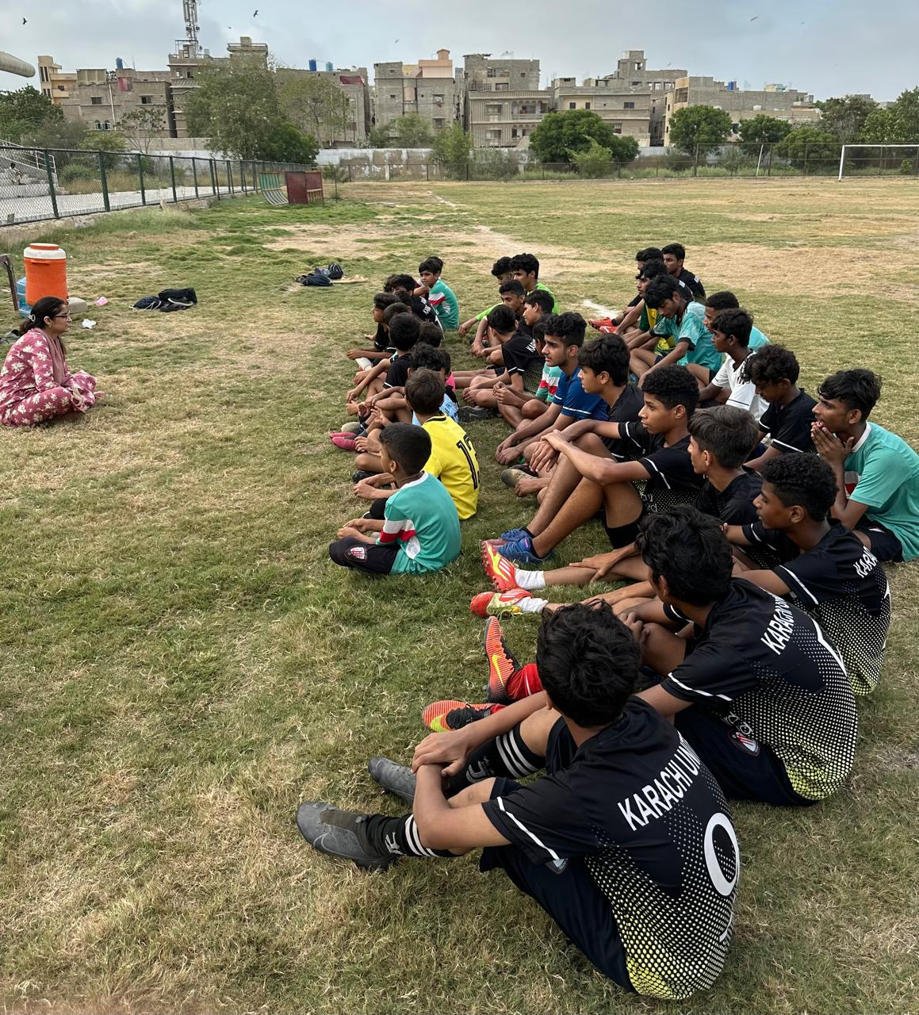

### **Data Collection Initiative**

This year, Karachi United collected data on 500 young players from 12 community centers to monitor their progress and better understand their needs. KU gathered important information, including their family background, school attendance, dropout rates, overall health, and data on other areas of life, to get a clearer picture of each player’s situation.

In addition to collecting data, KU team visited the players' families to have conversations about the challenges they face in their daily lives. These visits allow KU to gain deeper insights into the communities to design more effective and targeted programs. By understanding both the numbers and personal stories, Karachi United is better equipped to support these young players, design targeted initiatives, and make a lasting impact in their communities at the grassroots level.

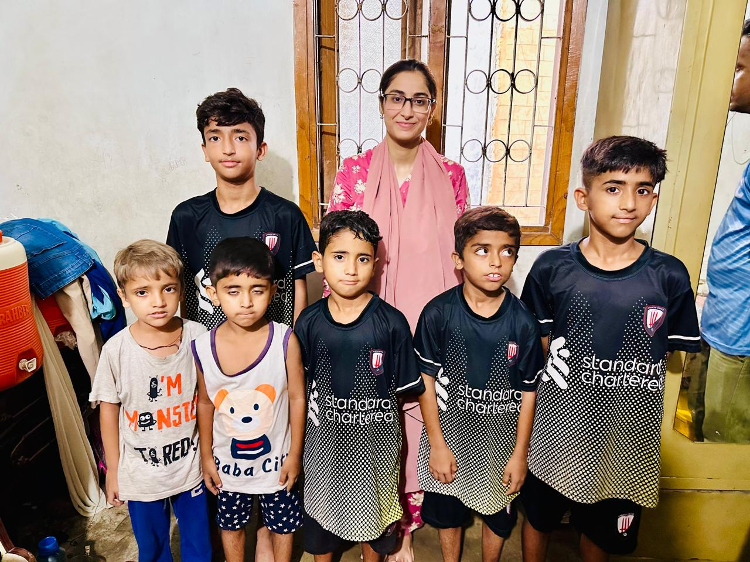 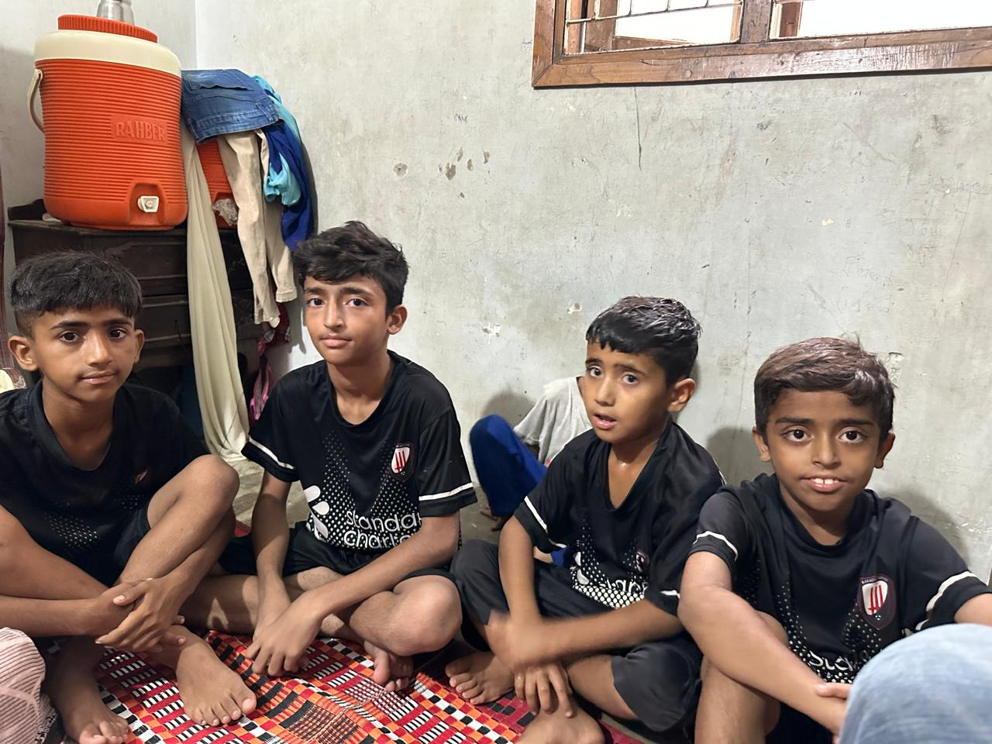

**Health and Wellness Session for Females**

Karachi United recently conducted a two-hour session on health and hygiene, with a special

emphasis on reproductive health, for the female family members of players enrolled in Karachi United Community Centers. The session addressed the significant gaps in the participants’ knowledge about health and hygiene.

The women were educated on essential aspects such as reproductive health,

menstrual hygiene, and general hygiene practices, which are often overlooked in their daily

lives. This education is particularly important because many women in underprivileged areas

cannot access reliable information or resources about these topics. Cultural taboos, lack of

formal education, and limited healthcare access often prevent them from learning about health challenges and seek support when required.

. Moreoever these women got an opportunity to visit Karachi United Academy to participate in wellness sessions and engage in healthy activities, giving them the confidence to make informed decisions about their health and the well-being of their families and while also gaining exposure and access to safe space.

