Quarterly Report

New Community Center in Monghopir

Karachi United's Community Department has recently opened a new center in Manghopir, Karachi, catering specifically to the Hazara community. With a registration count of over 50 children, this center was reintroduced in May 2023, after its previous operation from 2010 to 2014.
With a commitment to inclusivity, Karachi United has integrated the Hazara community into
its community centers alongside other ethnic groups such as Baloch, Sindhi, Pathan, and
Punjabi. This integration fosters cultural exchange and enables interaction among diverse
communities, promoting unity and understanding.

Karachi United is proud to offer football training sessions at the center, held thrice weekly from 5 p.m. to 7 p.m. These sessions aim to engage and empower the Hazara community,
providing them with valuable opportunities for personal growth and skill development.

The Community Department of Karachi United is excited about the positive impact this
program will have on the participants and the wider community. By creating an inclusive
space and promoting football as a means of empowerment, Karachi United strives to make a
meaningful difference in the lives of individuals and foster community cohesion.

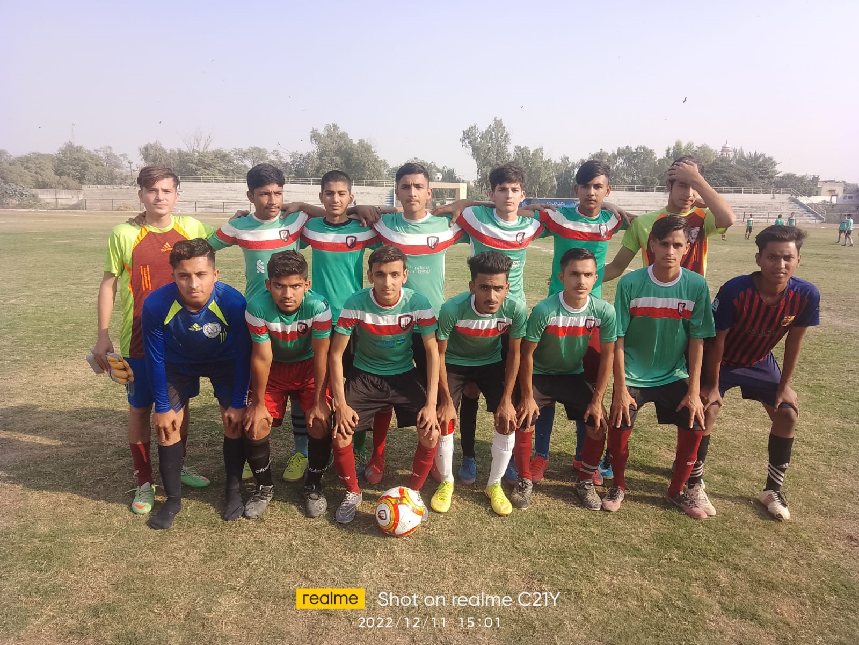

Karachi United x IRD Medical Camp:

Karachi United collaborated with IRD Global, a leading healthcare provider in Pakistan, to establish a medical camp at the Orangi Town community center. This camp catered to the health needs of the local residents, screening over 100 women and children and offering basic health diagnoses, especially Tuberculosis.

This partnership was particularly significant for the athletes who use these facilities, many under 18 and whose mothers form a crucial part of the community. By ensuring their well-being, the collaboration effectively supported these mothers in caring for their young athletes.

Beyond screenings, the camp also promoted awareness of health and hygiene. Young athletes and their families gained insights into disease prevention and maintenance of a healthy lifestyle, empowering them to safeguard their health proactively.

This joint effort by Karachi United and IRD Global showcases their dedication to community welfare and emphasizes the integral connection between health and a thriving athletic community.

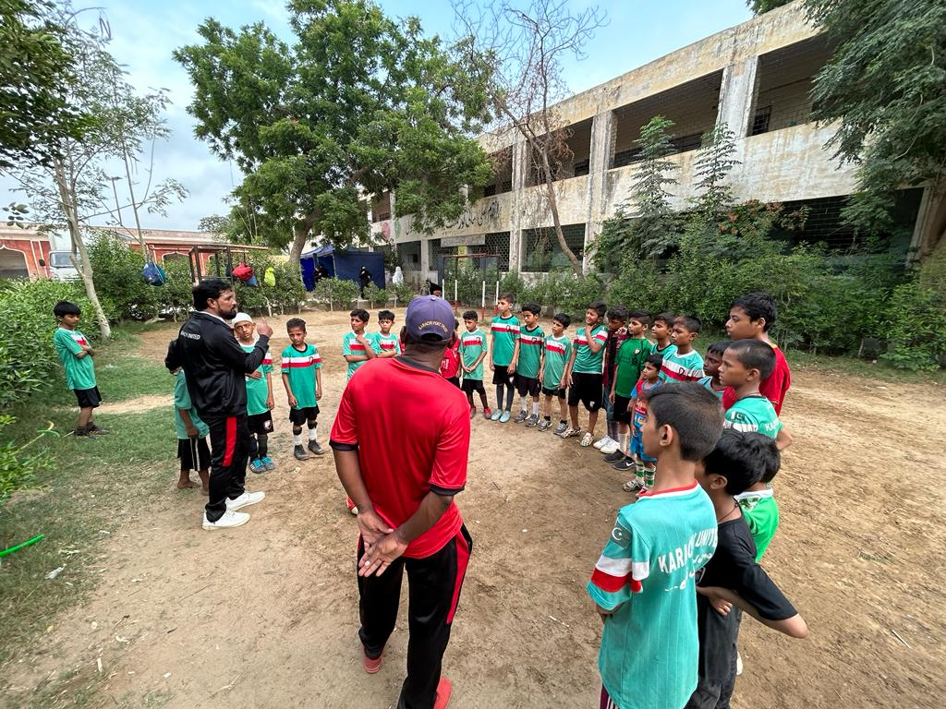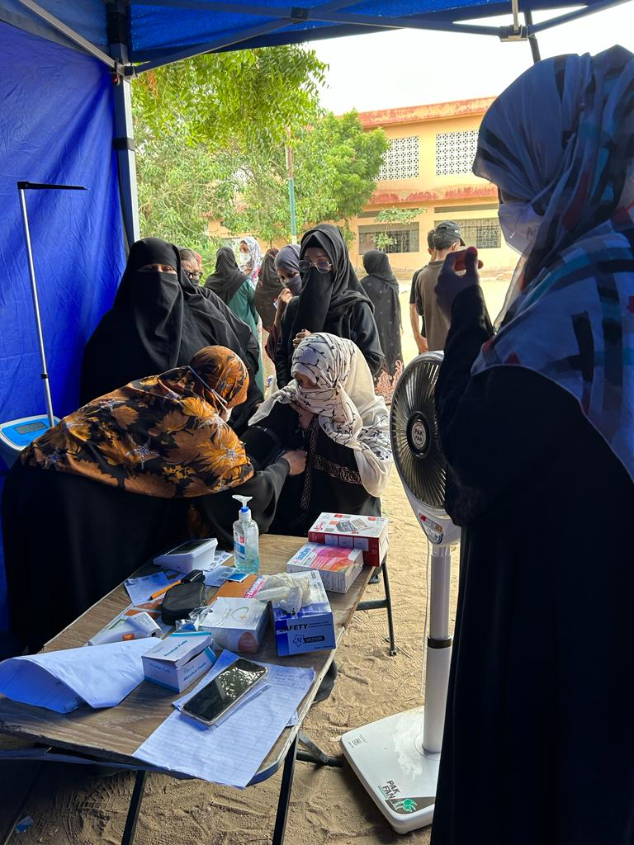

Karachi United and Life Skills Training Sessions:

Karachi United actively offers its players weekly sessions for football and life skill training in all 12 community centers. The football training aims to build the players' confidence and polish their untapped talent, preparing them for success in various football tournaments organized by local clubs, as well as domestic and international competitions. These football sessions also allow young athletes from less privileged backgrounds to engage in positive sports activities, which others only exclusive to limited individuals.

Parallelly, the life skill sessions are designed to instill vital values, cultivating exemplary character traits. Empowering players to confront life's challenges with unwavering confidence and determination, these sessions nurture holistic growth.

